

**Guru Nanak Dev Engineering College,**

**Ludhiana**

**Web Technologies**

**4 Week Training**

**Practical File**

**Submitted by-Rohit Aggarwal**

**CSE-B1**

**U.R.No.-1905039**

**C.R.No.-1915064**

**INDEX**

|  |  |
| --- | --- |
| **Practical** | **Date** |
| 1.1 | 18/07/2021 |
| 1.2 (a) | 20/07/2021 |
| 1.2 (b) | 20/07/2021 |
| 1.3 (a) | 21/07/2021 |
| 1.3 (b) | 21/07/2021 |
| 1.4 (a) | 23/07/2021 |
| 1.4 (b) | 23/07/2021 |
| 1.4 (c) | 23/07/2021 |
| 1.4 (d) | 23/07/2021 |
| 1.5 (a) | 24/07/2021 |
| 1.5 (b) | 24/07/2021 |
| Assignment Week-1 | 26/07/2021 |
| 2.1 (a) | 27/07/2021 |
| 2.1 (b) | 28/07/2021 |
| 2.2 | 28/07/2021 |
| 2.3 (a) | 29/07/2021 |
| 2.3 (b) | 29/07/2021 |
| 2.4 (a) | 30/07/2021 |
| 2.4 (b) | 30/07/2021 |
| 2.5 (a) | 31/07/2021 |
| 2.5 (b) | 31/07/2021 |
| Assignment Week-2 | 02/08/2021 |
| 3.1 | 03/08/2021 |
| 3.2 (a) | 04/08/2021 |
| 3.2 (b) | 04/08/2021 |
| 3.3 | 05/08/2021 |
| 3.4 (a) | 06/08/2021 |
| 3.4 (b) | 06/08/2021 |
| 3.5 | 07/08/2021 |
| Assignment Week-3 | 09/08/2021 |
| 4.1 | 11/08/2021 |
| 4.2 (a) | 11/08/2021 |
| 4.2 (b) | 11/08/2021 |
| 4.4 (a) | 13/08/2021 |
| 4.4 (b) | 13/08/2021 |
| 4.5 | 14/08/2021 |

**Practical 1.1**

**a) Installation of Sublime, Emmet and Package controller.**

**SUBLIME**

Downloading and Installation

Sublime Text can be downloaded from its official site <https://www.sublimetext.com/download>.

To install sublime text , go through the following steps:

Step 1: Open the downloaded setup file from the downloads folder and begin with the installation process.

Step 2: Select the desired location and click on the next button to start installation.

Step 3: If you want Sublime Text to appear in your right-click menu, then mark the checkbox and click on the Next button.

Step 4: Press the install button.

Step 5: Finish with the installation process.

**EMMET**

If you have installed the Sublime Text .  
To enable Emmet follow these steps:

Open the Sublime Text.

Go to Tool-> Command Palette.

Select Install Package by searching "install".

Again new window opens type "Emmet" and select first one.

That's it Emmet is enable in your Sublime Text.

**PACKAGE CONTROLLER**

Use one of the following methods to install Package Control:

Command Palette

Open the command palette  
Win/Linux: ctrl+shift+p, Mac: cmd+shift+p

Type Install Package Control, press enter

or

Menu

Open the Tools menu

Select Install Package Control.

**b) Introduction to www and various terminologies.**

**WWW(World Wide Web)**

A system of Internet servers that support specially formatted documents. The documents are formatted in a language called HTML (HyperText Markup Language) that supports links to other documents, as well as graphics, audio, and video files. This means you can jump from one document to another simply by clicking on hot spots. Not all Internet servers are part of the World Wide Web. Short for World Wide Web Consortium, an international consortium of companies involved with the Internet and the Web. The W3C was founded in 1994 by Tim Berners-Lee, the original architect of the World Wide Web. The organization's purpose is to develop open standards so that the Web evolves in a single direction rather than being splintered among competing factions. The W3C is the chief standards body for HTTP and HTML.

**HTTP**

Short for HyperText Transfer Protocol, the underlying protocol used by the World Wide Web. HTTP defines how messages are formatted and transmitted, and what actions Web servers and browsers should take in response to various commands. For example, when you enter a URL in your browser, this actually sends an HTTP command to the Web server directing it to fetch and transmit the requested Web page. HTTP is called a stateless protocol because each command is executed independently, without any knowledge of the commands that came before it. This is the main reason that it is difficult to implement Web sites that react intelligently to user input. This shortcoming of HTTP is being addressed in a number of new technologies, including ActiveX, Java, JavaScript and cookies. Currently, most Web browsers and servers support HTTP 1.1. One of the main features of HTTP 1.1 is that it supports persistent connections. This means that once a browser connects to a Web server, it can receive multiple files through the same connection. This should improve performance by as much as 20%.

**HYPERTEXT**

Hypertext simply means non linear text. A novel or magazine article is an example of linear text because it is meant to be read from beginning to end. Non linear communication is much harder to create because you must allow for the possibility of each reader accessing the material in a different order.

**HTML**

Short for HyperText Markup Language, the authoring language used to create documents on the World Wide Web. Hypertext, for easy navigation among resources (e.g. HyperText Markup Language or HTML, a standard format for describing the structure of documents for transmission of hypermedia documents). HTML documents are ASCII files with embedded codes for logical markup, format (text styles, document titles, paragraphs, tables) and hyperlinks. Hypertext, for easy navigation among resources (e.g. HyperText Markup Language or HTML, a standard format for describing the structure of documents for transmission of hypermedia documents). HTML documents are ASCII files with embedded codes for logical markup, format (text styles, document titles, paragraphs, tables) and hyperlinks.

**INTERNET**

A global network connecting millions computers. As of 1998, the Internet has more than 100 million users worldwide, and that number is growing rapidly. More than 100 countries are linked into exchanges of data, news and opinions. Unlike online services, which are centrally controlled, the Internet is decentralized by design. Each Internet computer, called a host, is independent. Its operators can choose which Internet services to use and which local services to make available to the global Internet community. Remarkably, this anarchy by design works exceedingly well. There are a variety of ways to access the Internet. Most online services, such as America Online, offer access to some Internet services. It is also possible to gain access through a commercial Internet Service Provider (ISP). For most of its existence the Internet was primarily a research and academic network. More recently, commercial enterprises and a vast number of consumers have come to recognize the Internet's potential. Today people and businesses around the world can use the Internet to retrieve information, communicate and conduct business globally, and access a vast array of services and resources on-line.

**ISP**

Short for Internet Service Provider, a company that provides access to the Internet. For a monthly fee, the service provider gives you a software package, username, password and access phone number. Equipped with a modem, you can then log on to the Internet and browse the World Wide Web and USENET, and send and receive e-mail. In addition to serving individuals, ISPs also serve large companies, providing a direct connection from the company's networks to the Internet. ISPs themselves are connected to one another through Network Access Points (NAPs). ISPs are also called IAPs (Internet Access Providers).

**URL**

URLs make it possible to direct both people and software applications to a variety of information, available from a number of different Internet protocols. Abbreviation of Uniform Resource Locator, the global address of documents and other resources on the World Wide Web. The first part of the address indicates what protocol to use, and the second part specifies the IP address or the domain name where the resource is located. protocol://domain_name.organization_type/full-path-of-file. When working with the WWW, most URLs will appear very similar to this one's overall structure. Note that when using FTP, HTTP, and Gopher URLs, the "full-path-of-file" will sometimes end in a slash. This indicates that the URL is pointing not to a specific file, but a directory. In this case, the server generally returns the "default index" of that directory. This might be just a listing of the files available within that directory, or a default file that the server automatically looks for in the directory. With HTTP servers, this default index file is generally called "index.html", but is frequently seen as "homepage.html", "home.html", "welcome.html", or "default.html".

**Webpage**

A web page (or webpage) is a hypertext document provided by a website and displayed to a user in a web browser. A website typically consists of many web pages linked together in a coherent fashion. The name "web page" is a metaphor of paper pages bound together into a book.

**Website**

A site (location) on the World Wide Web. Each Web site contains a home page, which is the first document users see when they enter the site. The site might also contain additional documents and files. Each site is owned and managed by an individual, company or organization.

**Web server**

A web server is computer software and underlying hardware that accepts requests via HTTP, the network protocol created to distribute web pages or its secure variant HTTPS. A user agent, commonly a web browser or web crawler, initiates communication by making a request for a specific resource using HTTP, and the server responds with the content of that resource or an error message. The server can also accept and store resources sent from the user agent if configured to do so.

**c) Introduction to different layers of OSi and TCP/IP model.**

**OSi model**

OSI stands for Open Systems Interconnection. It has been developed by ISO – ‘International Organization of Standardization‘, in the year 1984. It is a 7 layer architecture with each layer having specific functionality to perform. All these 7 layers work collaboratively to transmit the data from one person to another across the globe.

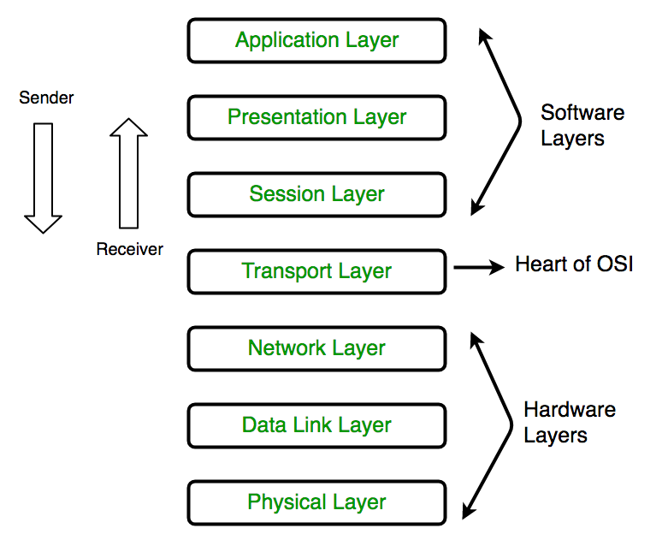

**1. Physical Layer (Layer 1) :**

The lowest layer of the OSI reference model is the physical layer. It is responsible for the actual physical connection between the devices. The physical layer contains information in the form of bits. It is responsible for transmitting individual bits from one node to the next. When receiving data, this layer will get the signal received and convert it into 0s and 1s and send them to the Data Link layer, which will put the frame back together.

**2. Data Link Layer (DLL) (Layer 2) :**

The data link layer is responsible for the node to node delivery of the message. The main function of this layer is to make sure data transfer is error-free from one node to another, over the physical layer. When a packet arrives in a network, it is the responsibility of DLL to transmit it to the Host using its MAC address.  
Data Link Layer is divided into two sub layers :

Logical Link Control (LLC)

Media Access Control (MAC)

The packet received from Network layer is further divided into frames depending on the frame size of NIC(Network Interface Card). DLL also encapsulates Sender and Receiver’s MAC address in the header.

The Receiver’s MAC address is obtained by placing an ARP(Address Resolution Protocol) request onto the wire asking “Who has that IP address?” and the destination host will reply with its MAC address.

**3. Network Layer (Layer 3) :**

Network layer works for the transmission of data from one host to the other located in different networks. It also takes care of packet routing i.e. selection of the shortest path to transmit the packet, from the number of routes available. The sender & receiver’s IP address are placed in the header by the network layer.

**4. Transport Layer (Layer 4) :**

Transport layer provides services to application layer and takes services from network layer. The data in the transport layer is referred to as Segments. It is responsible for the End to End Delivery of the complete message. The transport layer also provides the acknowledgement of the successful data transmission and re-transmits the data if an error is found.  
• At sender’s side:  
Transport layer receives the formatted data from the upper layers, performs Segmentation and also implements Flow & Error control to ensure proper data transmission. It also adds Source and Destination port number in its header and forwards the segmented data to the Network Layer.  
• At receiver’s side:  
Transport Layer reads the port number from its header and forwards the Data which it has received to the respective application. It also performs sequencing and reassembling of the segmented data.

**5. Session Layer (Layer 5) :**

This layer is responsible for establishment of connection, maintenance of sessions, authentication and also ensures security.

**6. Presentation Layer (Layer 6) :**

Presentation layer is also called the Translation layer.The data from the application layer is extracted here and manipulated as per the required format to transmit over the network.

**7. Application Layer (Layer 7) :**

At the very top of the OSI Reference Model stack of layers, we find Application layer which is implemented by the network applications. These applications produce the data, which has to be transferred over the network. This layer also serves as a window for the application services to access the network and for displaying the received information to the user.

**TCP/IP model**

The OSI Model we just looked at is just a reference/logical model. It was designed to describe the functions of the communication system by dividing the communication procedure into smaller and simpler components. But when we talk about the TCP/IP model, it was designed and developed by Department of Defense (DoD) in 1960s and is based on standard protocols. It stands for Transmission Control Protocol/Internet Protocol. The TCP/IP model is a concise version of the OSI model. It contains four layers, unlike seven layers in the OSI model. The layers are:

Process/Application Layer

Host-to-Host/Transport Layer

Internet Layer

Network Access/Link Layer

The diagrammatic comparison of the TCP/IP and OSI model is as follows :

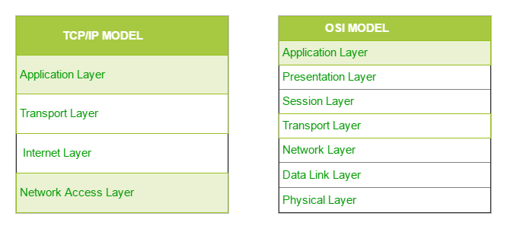

**1. Network Access Layer –**

This layer corresponds to the combination of Data Link Layer and Physical Layer of the OSI model. It looks out for hardware addressing and the protocols present in this layer allows for the physical transmission of data.  
We just talked about ARP being a protocol of Internet layer, but there is a conflict about declaring it as a protocol of Internet Layer or Network access layer. It is described as residing in layer 3, being encapsulated by layer 2 protocols.

**2. Internet Layer –**

This layer parallels the functions of OSI’s Network layer. It defines the protocols which are responsible for logical transmission of data over the entire network. The main protocols residing at this layer are :

IP – stands for Internet Protocol and it is responsible for delivering packets from the source host to the destination host by looking at the IP addresses in the packet headers. IP has 2 versions:  
IPv4 and IPv6. IPv4 is the one that most of the websites are using currently. But IPv6 is growing as the number of IPv4 addresses are limited in number when compared to the number of users.

ICMP – stands for Internet Control Message Protocol. It is encapsulated within IP datagrams and is responsible for providing hosts with information about network problems.

ARP – stands for Address Resolution Protocol. Its job is to find the hardware address of a host from a known IP address. ARP has several types: Reverse ARP, Proxy ARP, Gratuitous ARP and Inverse ARP.

**3. Host-to-Host Layer –**

This layer is analogous to the transport layer of the OSI model. It is responsible for end-to-end communication and error-free delivery of data. It shields the upper-layer applications from the complexities of data. The two main protocols present in this layer are :

Transmission Control Protocol (TCP) – It is known to provide reliable and error-free communication between end systems. It performs sequencing and segmentation of data. It also has acknowledgment feature and controls the flow of the data through flow control mechanism. It is a very effective protocol but has a lot of overhead due to such features. Increased overhead leads to increased cost.

User Datagram Protocol (UDP) – On the other hand does not provide any such features. It is the go-to protocol if your application does not require reliable transport as it is very cost-effective. Unlike TCP, which is connection-oriented protocol, UDP is connectionless.

**4. Application Layer –**

This layer performs the functions of top three layers of the OSI model: Application, Presentation and Session Layer. It is responsible for node-to-node communication and controls user-interface specifications. Some of the protocols present in this layer are: HTTP, HTTPS, FTP, TFTP, Telnet, SSH, SMTP, SNMP, NTP, DNS, DHCP, NFS, X Window, LPD.

**d) Introduction to various networking devices like NIC, Switch, Hub, Router, Modem etc.**

**NIC**

A network interface card (NIC) is a hardware component without which a computer cannot be connected over a network. It is a circuit board installed in a computer that provides a dedicated network connection to the computer. It is also called network interface controller, network adapter or LAN adapter.

**Switch**

Switches generally have a more intelligent role than hubs. A switch is a multiport device that improves network efficiency. The switch maintains limited routing information about nodes in the internal network, and it allows connections to systems like hubs or routers. Strands of LANs are usually connected using switches. Generally, switches can read the hardware addresses of incoming packets to transmit them to the appropriate destination.

**Hub**

Hubs connect multiple computer networking devices together. A hub also acts as a repeater in that it amplifies signals that deteriorate after traveling long distances over connecting cables. A hub is the simplest in the family of network connecting devices because it connects LAN components with identical protocols.

**Router**

Routers help transmit packets to their destinations by charting a path through the sea of interconnected networking devices using different network topologies. Routers are intelligent devices, and they store information about the networks they’re connected to. Most routers can be configured to operate as packet-filtering firewalls and use access control lists (ACLs). Routers, in conjunction with a channel service unit/data service unit (CSU/DSU), are also used to translate from LAN framing to WAN framing. This is needed because LANs and WANs use different network protocols. Such routers are known as border routers. They serve as the outside connection of a LAN to a WAN, and they operate at the border of your network.

**Modem**

A modulator-demodulator, or simply a modem, is a hardware device that converts data from a digital format, intended for communication directly between devices with specialized wiring, into one suitable for a transmission medium such as telephone lines or radio. A modem modulates one or more carrier wave signals to encode digital information for transmission, and demodulates signals to decode the transmitted information. The goal is to produce a signal that can be transmitted easily and decoded reliably to reproduce the original digital data.

**Bridge**

Bridges are used to connect two or more hosts or network segments together. The basic role of bridges in network architecture is storing and forwarding frames between the different segments that the bridge connects. They use hardware Media Access Control (MAC) addresses for transferring frames. By looking at the MAC address of the devices connected to each segment, bridges can forward the data or block it from crossing. Bridges can also be used to connect two physical LANs into a larger logical LAN.

**Practical 1.2(a)**

**Create 4 Pages named - Home, About Us, Gallery, Contact Us**

**index.html**

<html>

<head>

<title>Home</title>

</head>

<body>

<hr>

Home

<br>

<a href="about.html">

About Us

</a>

<br>

<a href="gallery.html">

Gallery

</a>

<br>

<a href="contact.html">

Contact us

</a>

<hr>

<h1>Top 3 Winter 2021 Anime</h1>

<ol>

<li>Shingeki no Kyojin: The Final Season

<br>

<img src="../images/aot1.jpeg"width="300px" height="500px">

<br>

Gabii Braun and Falco Grice have been training their entire lives to inherit one of the seven titans under Marley's control and aid their nation in eradicating the Eldians on Paradis. However, just as all seems well for the two cadets, their peace is suddenly shaken by the arrival of Eren Yeager and the remaining members of the Survey Corps.

<br>

Having finally reached the Yeager family basement and learned about the dark history surrounding the titans, the Survey Corps has at long last found the answer they so desperately fought to uncover. With the truth now in their hands, the group set out for the world beyond the walls.

<br>

In Shingeki no Kyojin: The Final Season, two utterly different worlds collide as each party pursues its own agenda in the long-awaited conclusion to Paradis' fight for freedom.

</li>

<br><br>

<li>Horimiya

<br>

<img src="../images/Horimiya2.jpeg" width="500px" height="300px">

<br>

On the surface, the thought of Kyouko Hori and Izumi Miyamura getting along would be the last thing in people's minds. After all, Hori has a perfect combination of beauty and brains, while Miyamura appears meek and distant to his fellow classmates. However, a fateful meeting between the two lays both of their hidden selves bare. Even though she is popular at school, Hori has little time to socialize with her friends due to housework. On the other hand, Miyamura lives under the noses of his peers, his body bearing secret tattoos and piercings that make him look like a gentle delinquent.

<br>

Having opposite personalities yet sharing odd similarities, the two quickly become friends and often spend time together in Hori's home. As they both emerge from their shells, they share with each other a side of themselves concealed from the outside world.

</li>

<br><br>

<li>Mushoku Tensei: Isekai Ittara Honki Dasu

<br>

<img src="../images/mushoku2.jpeg" width="500px" height="300px">

<br>

Despite being bullied, scorned, and oppressed all of his life, a thirty-four-year-old shut-in still found the resolve to attempt something heroic—only for it to end in a tragic accident. But in a twist of fate, he awakens in another world as Rudeus Greyrat, starting life again as a baby born to two loving parents.

<br>

Preserving his memories and knowledge from his previous life, Rudeus quickly adapts to his new environment. With the mind of a grown adult, he starts to display magical talent that exceeds all expectations, honing his skill with the help of a mage named Roxy Migurdia. Rudeus learns swordplay from his father, Paul, and meets Sylphiette, a girl his age who quickly becomes his closest friend.

<br>

As Rudeus' second chance at life begins, he tries to make the most of his new opportunity while conquering his traumatic past. And perhaps, one day, he may find the one thing he could not find in his old world—love.

</li>

</ol>

</body>

</html>

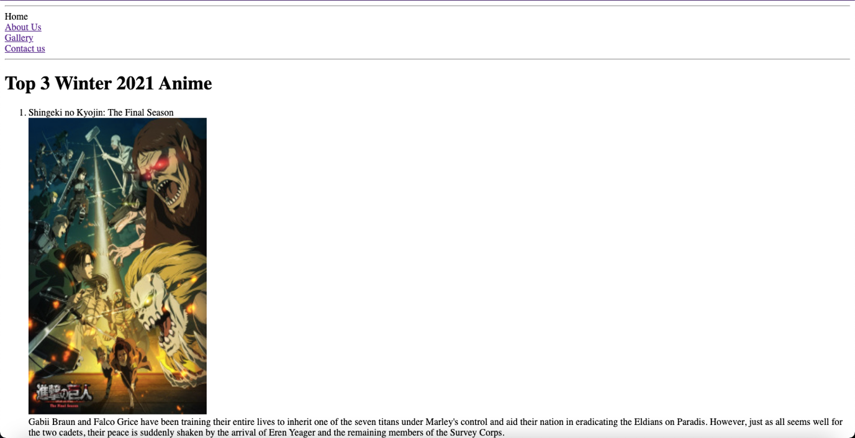

**about.html**

<html>

<head>

<title>About Us</title>

</head>

<body>

<hr>

<a href="index.html">

Home

</a>

<br>

About Us

<br>

<a href="gallery.html">

Gallery

</a>

<br>

<a href="contact.html">

Contact us

</a>

<hr>

This website is managed by group of random people met online.

Want to be part of the team? Contact us for further details.

</body>

</html>

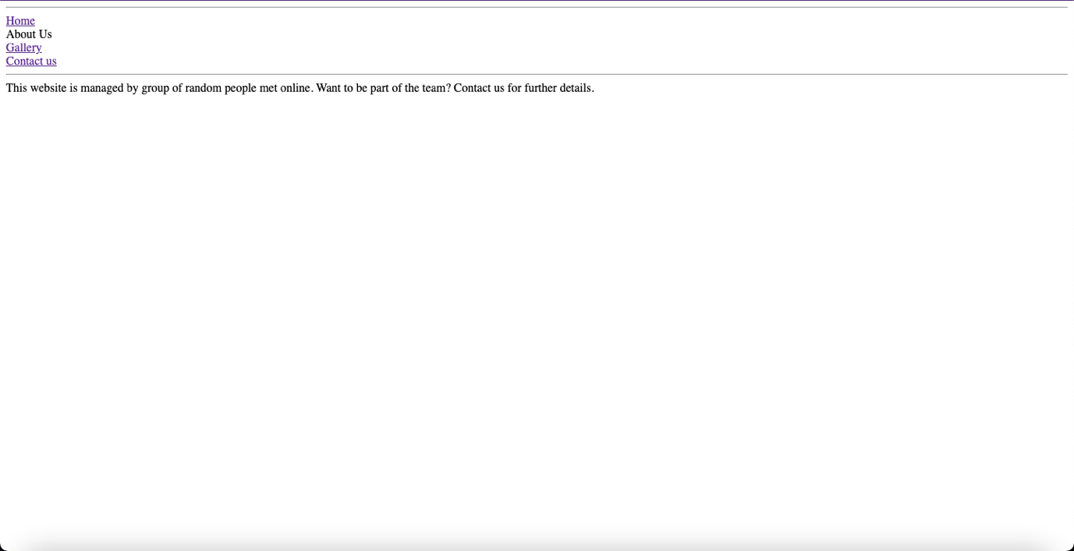

**gallery.html**

<html>

<head>

<title>Gallery</title>

</head>

<body>

<hr>

<a href="index.html">

Home

</a>

<br>

<a href="about.html">

About Us

</a>

<br>

Gallery

<br>

<a href="contact.html">

Contact us

</a>

<hr>

<img src="../images/aot1.jpeg">

<img src="../images/Horimiya2.jpeg">

<img src="../images/mushoku2.jpeg">

</body>

</html>

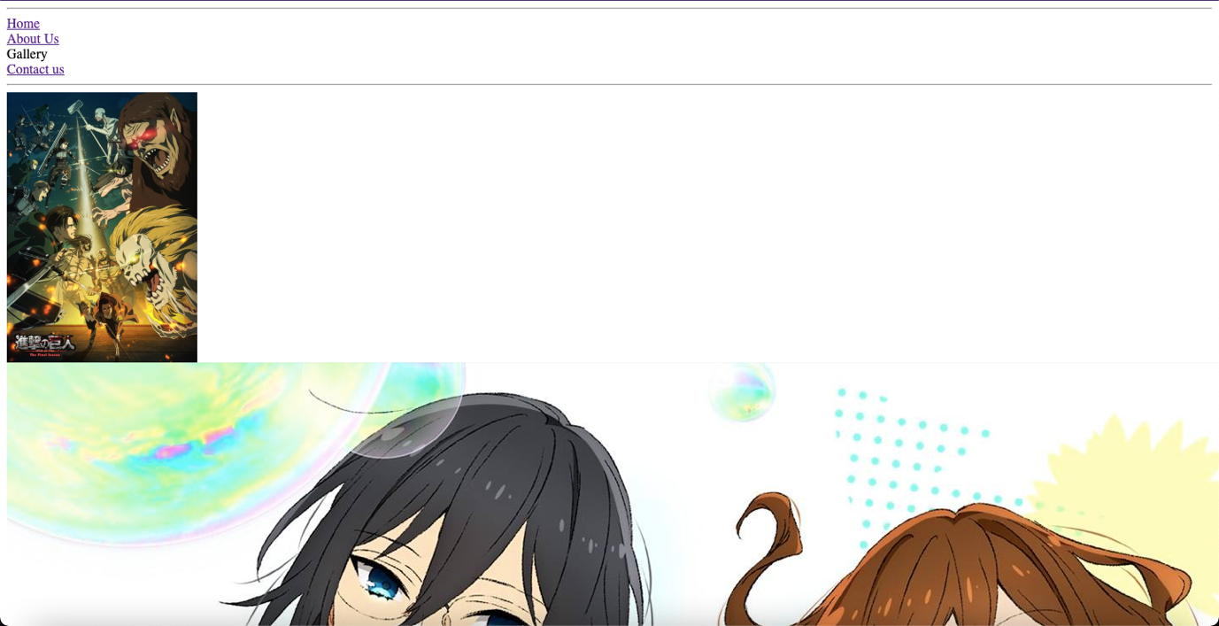

**contact.html**

<html>

<head>

<title>Contact Us</title>

</head>

<body>

<hr>

<a href="index.html">

Home

</a>

<br>

<a href="about.html">

About Us

</a>

<br>

<a href="gallery.html">

Gallery

</a>

<br>

Contact us

<hr>

Contact: <br>

Mail-raggarwal300@gmail.com <br>

Discord-Rohit#9999

</body>

</html>

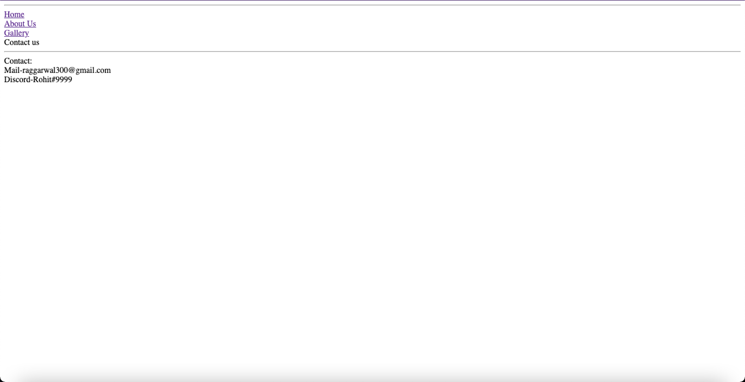

**Practical 1.2(b)**

**Create a same Form**

<html>

<head>

<title>Form</title>

</head>

<body style="background-color: royalblue;">

<form action="">

University: <input type="text" name="" required>

<br><br>

Institute: <input type="text" name="" required>

<br><br>

Branch: <select required>

<option value="select">--select--</option>

<option value="CSE">CSE</option>

<option value="IT">IT</option>

<option value="ME">ME</option>

<option value="CE">CE</option>

<option value="ECE">ECE</option>

<option value="EE">EE</option>

</select>

<br><br>

Degree: <select required>

<option value="select">--select--</option>

<option value="UG">UG</option>

<option value="PG">PG</option>

</select>

<input type="radio" name="status" required>Pursuing

<input type="radio" name="status" required>Completed

<br><br>

Average CPI: <input type="number" min="0" max="10" step="0.1" name="" required> Upto <input type="number" min="1" max="8" name="" required>Th Semester

<br><br>

Experience: <input type="number" min="0" name="" required> Years

<br><br>

Your Website Or Blog: <input type="text" name="" value="http://" required></pre>

<br><br>

<input type="submit" name="">

<input type="reset" name="">

</form>

</body>

</html>

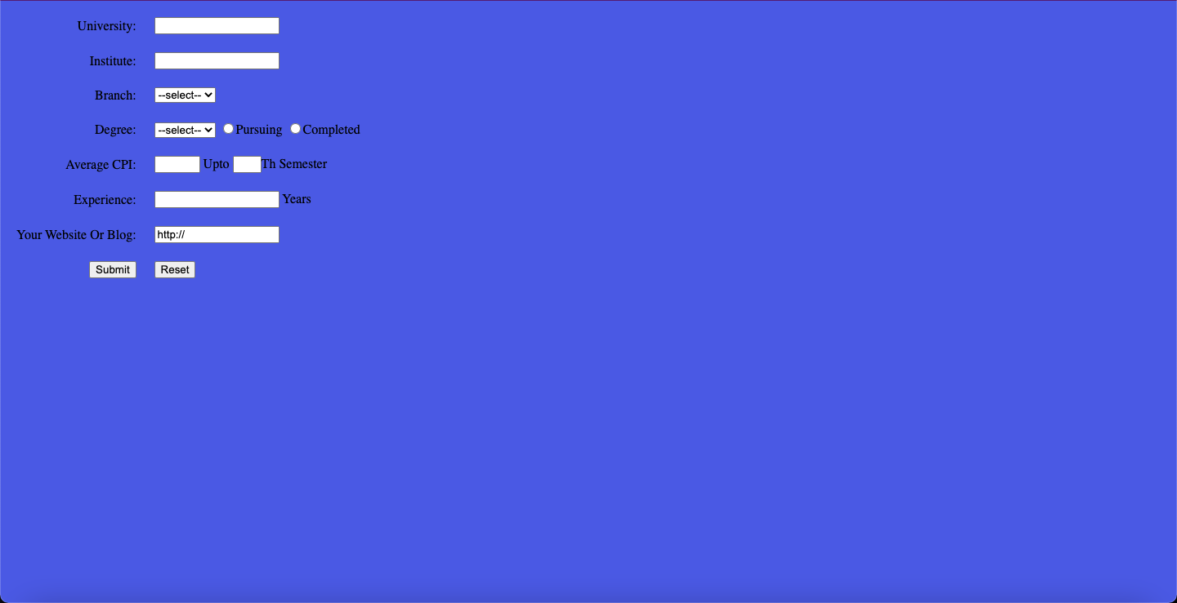

**Practical 1.3(a)**

**Implement the concept of Inline and Internal CSS on different HTML Pages using different CSS Properties**

**index.html**

<html>

<head>

<title>Home</title>

<style>

p{

background-color: #FFEB4D;

font-weight: bold;

font-size: 20;

}

h2{

color: #FFEB4D;

text-align: left;

}

ol{

list-style-type: none;

margin: 20;

padding: 20;

}

</style>

</head>

<body style="background: #BEC7C7;">

<hr>

Home

<br>

<a href="about.html">

About Us

</a>

<br>

<a href="gallery.html">

Gallery

</a>

<br>

<a href="contact.html">

Contact us

</a>

<hr>

<h1 style="color: #ff0000; text-align: center; text-decoration: underline;">Top 3 Winter 2021 Anime</h1>

<ol>

<li><h2>Shingeki no Kyojin: The Final Season</h2>

<br>

<img src="../images/aot1.jpeg"width="300px" height="500px">

<br>

<p>Gabii Braun and Falco Grice have been training their entire lives to inherit one of the seven titans under Marley's control and aid their nation in eradicating the Eldians on Paradis. However, just as all seems well for the two cadets, their peace is suddenly shaken by the arrival of Eren Yeager and the remaining members of the Survey Corps.

<br>

Having finally reached the Yeager family basement and learned about the dark history surrounding the titans, the Survey Corps has at long last found the answer they so desperately fought to uncover. With the truth now in their hands, the group set out for the world beyond the walls.

<br>

In Shingeki no Kyojin: The Final Season, two utterly different worlds collide as each party pursues its own agenda in the long-awaited conclusion to Paradis' fight for freedom.</p>

</li>

<br><br>

<li><h2>Horimiya</h2>

<br>

<img src="../images/Horimiya2.jpeg" width="500px" height="300px">

<br>

<p>On the surface, the thought of Kyouko Hori and Izumi Miyamura getting along would be the last thing in people's minds. After all, Hori has a perfect combination of beauty and brains, while Miyamura appears meek and distant to his fellow classmates. However, a fateful meeting between the two lays both of their hidden selves bare. Even though she is popular at school, Hori has little time to socialize with her friends due to housework. On the other hand, Miyamura lives under the noses of his peers, his body bearing secret tattoos and piercings that make him look like a gentle delinquent.

<br>

Having opposite personalities yet sharing odd similarities, the two quickly become friends and often spend time together in Hori's home. As they both emerge from their shells, they share with each other a side of themselves concealed from the outside world.</p>

</li>

<br><br>

<li><h2>Mushoku Tensei: Isekai Ittara Honki Dasu</h2>

<br>

<img src="../images/mushoku2.jpeg" width="500px" height="300px">

<br>

<p>Despite being bullied, scorned, and oppressed all of his life, a thirty-four-year-old shut-in still found the resolve to attempt something heroic—only for it to end in a tragic accident. But in a twist of fate, he awakens in another world as Rudeus Greyrat, starting life again as a baby born to two loving parents.

<br>

Preserving his memories and knowledge from his previous life, Rudeus quickly adapts to his new environment. With the mind of a grown adult, he starts to display magical talent that exceeds all expectations, honing his skill with the help of a mage named Roxy Migurdia. Rudeus learns swordplay from his father, Paul, and meets Sylphiette, a girl his age who quickly becomes his closest friend.

<br>

As Rudeus' second chance at life begins, he tries to make the most of his new opportunity while conquering his traumatic past. And perhaps, one day, he may find the one thing he could not find in his old world—love.</p>

</li>

</ol>

</body>

</html>

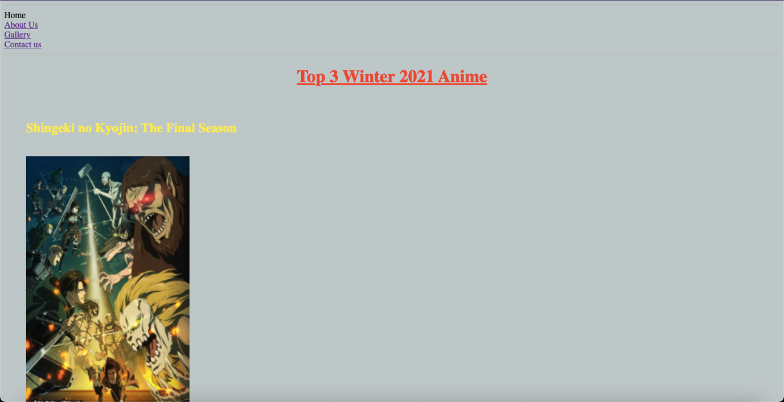

**Practical 1.3(b)**

**Create a Webpage using External CSS and CSS Selectors, also use background-image property**

**index.html**

<html>

<head>

<title>Home</title>

<link rel="stylesheet" type="text/css" href="../css/style.css">

</head>

<body>

<center>

<a href="https://en.wikipedia.org/wiki/The_Weeknd" class="toplinks">WIKIPEDIA</a>

<a href="https://www.youtube.com/channel/UC0WP5P-ufpRfjbNrmOWwLBQ" class="toplinks">YOUTUBE</a>

<a href="https://twitter.com/theweeknd" class="toplinks">TWITTER</a>

<a href="https://www.instagram.com/theweeknd/" class="toplinks">INSTAGRAM</a>

<br>

<h1>THE WEEKEND</h1>

<video width=600 height=400 controls>

<source src="../videos/video.mp4" type="video/mp4">

</video>

</center>

<br><br>

<p class="p1">

Abel Makkonen Tesfaye (born February 16, 1990), known professionally as the Weeknd, is a Canadian singer, songwriter, and record producer. Born in Toronto and raised in Scarborough, Tesfaye began his recording career in 2009 by anonymously uploading his song "Do It" to YouTube.[1] Two years later, he met music executives Sal Slaiby and Amir Esmailian, with whom he founded XO Records.[2] He chose his stage name in tribute to when he, along with a friend, dropped out of high school at seventeen years old, took his mattress, and "left one weekend and never came home". However, his estranged former producer Jeremy Rose claims the name was his idea.[3][4] The letter E was excluded to avoid trademark problems with Canadian band the Weekend.[5][3]

Under XO, Tesfaye released his debut mixtapes: House of Balloons, Thursday, and Echoes of Silence. He quickly earned a following and critical recognition from several mainstream publications due to his dark style of Contemporary R&B and the mystique surrounding his identity.[6] In 2012, he signed with Republic Records and re-released the mixtapes in the compilation album, Trilogy. His debut studio album, Kiss Land, was released in 2013. His sophomore album, Beauty Behind the Madness (2015), with the Billboard Hot 100 number-one singles "Can't Feel My Face" and "The Hills", won Best Urban Contemporary Album and was nominated for Album of the Year at the 2016 Grammy Awards. It was among the best-selling albums of 2015.[7]

Tesfaye's third album Starboy (2016) was a similar commercial success and included the number-one single of the same name, and also won Best Urban Contemporary Album at the 2018 Grammy Awards. His fourth album, After Hours (2020), featured the Billboard Hot 100 number-one singles "Heartless", "Save Your Tears", and "Blinding Lights", the latter of which has become the first song in history to spend over a year in the top ten of the Billboard Hot 100,[8][9] and was the most streamed song on Spotify in 2020.[10]

</p><br>

<p class="p2">Among the world's best selling musical artists with over 75 million records sold[11] and on the list of most-streamed artists on Spotify,[12] Tesfaye has won many accolades, including three Grammy Awards, five American Music Awards, nineteen Billboard Music Awards, two MTV Video Music Awards, fifteen Juno Awards, five SOCAN awards and one Brit Award, and has been nominated for an Academy Award.[13] He holds several chart records, being the first artist to simultaneously hold the top three positions on the Billboard Hot R&B Songs chart with "Can't Feel My Face", "Earned It", and "The Hills".[14] In February 2015, he was awarded the Allan Slaight Award by Canada's Walk of Fame.[15] In 2017, he was featured on the cover of Forbes for his annual earnings of $92 million.[16] Elton John listed him as one of the 100 Most Influential People of 2020 in Time.[17] Tesfaye has a notable voice with a soaring falsetto and its singular tremolo.[18] He has influenced artists in many contemporary music styles including pop,[19] hip hop, and R&B.[20]</p><br>

<a href="https://www.youtube.com/watch?v=4NRXx6U8ABQ" class="bottomlinks">Blinding Lights</a><br>

<a href="https://www.youtube.com/watch?v=34Na4j8AVgA" class="bottomlinks">Starboy</a><br>

<a href="https://www.youtube.com/watch?v=yzTuBuRdAyA" class="bottomlinks">The Hills</a><br>

<a href="https://www.youtube.com/watch?v=KEI4qSrkPAs" class="bottomlinks">Cant't Feel My Face</a><br>

<a href="https://www.youtube.com/watch?v=waU75jdUnYw" class="bottomlinks">Earned It</a><br>

<audio controls>

<source src="../audio/audio.mp3" type="audio/mp3">

</audio>

</p><br>

<h1 align="center">THE WEEKEND</h2>

</body>

</html>

**style.css**

*{

padding: 10px;

margin: 0px;

}

body{

background-image: url(../images/the-weeknd.jpeg) ;

}

.toplinks{

color: black;

background-color: #CABAAB;

line-height: 40px;

font-size: 20px;

font-family: century gothic;

text-decoration: none;

padding: 5px 10px;

margin: 15px 15px;

border: 3px solid black;

}

.toplinks:hover{

color: antiquewhite;

border-color: #BF04A0;

}

.bottomlinks{

color: antiquewhite;

background-color: #7D6B7D;

line-height: 50px;

font-size: 22px;

font-family: century gothic;

border-radius: 10px;

text-decoration: none;

padding: 8px 20px;

margin: 15px 5px;

}

.bottomlinks:hover{

color: black;

background-color: whitesmoke;

text-decoration: underline;

}

h1{

background-color: #FFF587;

color: #FF665A;

font-family: calibri;

font-size: 50px;

}

.p1{

font-family: century schoolbook;

font-weight: bold;

font-size: 24px;

border: 5px solid black;

border-color: black;

color: #9ACFDD;

line-height: 75px;

margin: 15px;

padding: 15px;

background-color: #D90B1C;

background-size: 512px 800px;

background-blend-mode: overlay;

}

.p2{

font-family: sans-serif;

font-weight: bolder;

font-size: 21px;

border-radius: 20px;

color: #93A603;

line-height: 50px;

padding: 20px 30px;

margin: 15px;

background-color: #45594E;

}

audio{

margin: 5px;

height: 30px;

background-color: magenta;

border-radius: 10px;

}

video{

border: 2px solid darkmagenta;

border-radius: 30px;

margin-top: 50px;

}

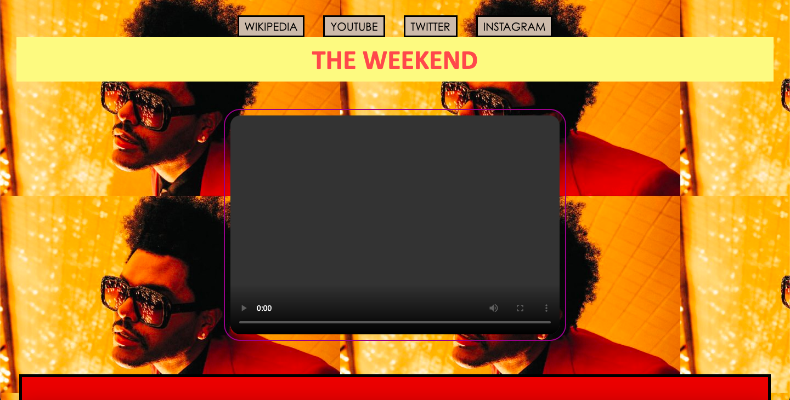

**Practical 1.4(a)**

**index.html**

<html>

<head>

<title></title>

<link rel="stylesheet" type="text/css" href="../css/style.css">

</head>

<body><div class="container">

<div class="row1">

<div class="col1"></div>

<div class="col2"></div>

</div>

<div class="row2">

<div class="col1"></div>

<div class="col2"></div>

</div>

<div class="row1">

<div class="col1"></div>

<div class="col2"></div>

</div>

<div class="row2">

<div class="col1"></div>

<div class="col2"></div>

</div>

<div class="row1">

<div class="col1"></div>

<div class="col2"></div>

</div>

<div class="row2">

<div class="col1"></div>

<div class="col2"></div>

</div>

</div>

</body>

</html>

**style.css**

.container{

width: 1170px;

height: auto;

margin: 0 auto;

}

.container .row1{

width: 1170px;

height: 300px;

}

.container .row1 .col1{

width: 585px;

height: 300px;

background-color: #356AA0;

float: left;

}

.container .row1 .col2{

width: 585px;

height: 300px;

background-color: #17334F;

float: left;

}.container .row2{

width: 1170px;

height: 300px;

float: left;

}

.container .row2 .col1{

width: 585px;

height: 300px;

background-color: #000000;

float: left;

}

.container .row2 .col2{

width: 585px;

height: 300px;

background-color: #B4D400;

float: left;

}

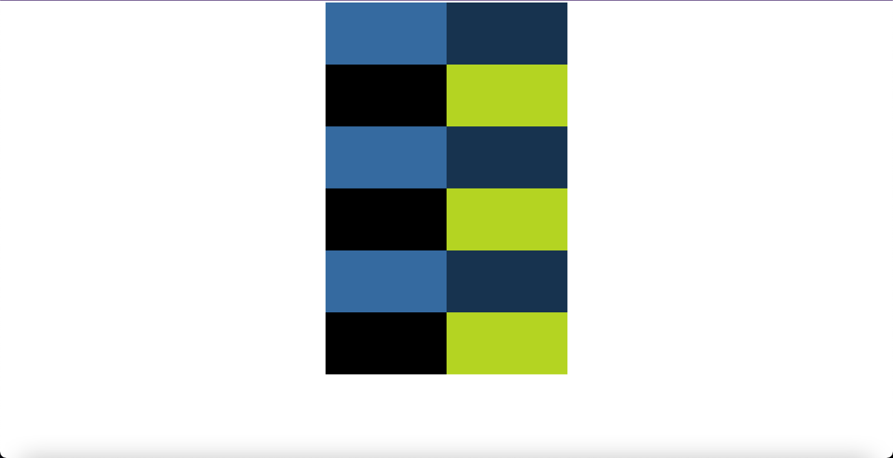

**Practical 1.4(b)**

**index.html**

<html>

<head>

<title></title>

<link rel="stylesheet" type="text/css" href="../css/style.css">

</head>

<body><div class="container">

<div class="row1">

<div class="col1"></div>

<div class="col2"></div>

<div class="col3"></div>

<div class="col4"></div>

</div><div class="row2">

<div class="col1"></div>

<div class="col2"></div>

<div class="col3"></div>

</div><div class="row3">

<div class="col1"></div>

<div class="col2"></div>

<div class="col3"></div>

<div class="col4"></div>

</div>

<div class="row4">

<div class="col1"></div>

<div class="col2"></div>

<div class="col3"></div>

<div class="col4"></div>

</div><div class="row5">

<div class="col1"></div>

<div class="col2"></div>

<div class="col3"></div>

</div><div class="row6">

<div class="col1"></div>

<div class="col2"></div>

<div class="col3"></div>

<div class="col4"></div>

</div>

</div>

</body>

</html>

**style.css**

.container{

width: 1170px;

height: auto;

margin: 0 auto;

}

.container .row1{

width: 1170px;

height: 200px;

}

.container .row1 .col1{

width: 300px;

height: 200px;

background-color: #356ba0;

float: left;

}

.container .row1 .col2{

width: 300px;

height: 200px;

background-color: #57b74e;

float: left;

}.container .row1 .col3{

width: 300px;

height: 200px;

background-color: #0b1401;

float: left;

}

.container .row1 .col4{

width: 270px;

height: 200px;

background-color: #c9f427;

float: left;

}

.container .row2{

width: 1170px;

height: 200px;

}

.container .row2 .col1{

width: 300px;

height: 200px;

background-color: #57a036;

float: left;

}.container .row2 .col2{

width: 600px;

height: 200px;

background-color: #1733b5;

float: left;

}

.container .row2 .col3{

width: 270px;

height: 200px;

background-color: #3a8775;

float: left;

}

.container .row3{

width: 1170px;

height: 200px;

}

.container .row3 .col1{

width: 450px;

height: 200px;

background-color: #c03724;

float: left;

}

.container .row3 .col2{

width: 450px;

height: 200px;

background-color: #8eb618;

float: left;

}

.container .row3 .col3{

width: 130px;

height: 200px;

background-color: #eb5bd6;

float: left;

}

.container .row3 .col4{

width: 140px;

height: 200px;

background-color: #55860a;

float: left;

}

.container .row4{

width: 1170px;

height: 200px;

}

.container .row4 .col1{

width: 300px;

height: 200px;

background-color: #356ba0;

float: right;

}

.container .row4 .col2{

width: 300px;

height: 200px;

background-color: #57b74e;

float: right;

}.container .row4 .col3{

width: 300px;

height: 200px;

background-color: #0b1401;

float: right;

}

.container .row4 .col4{

width: 270px;

height: 200px;

background-color: #c9f427;

float: right;

}

.container .row5{

width: 1170px;

height: 200px;

}

.container .row5 .col1{

width: 300px;

height: 200px;

background-color: #57a036;

float: right;

}.container .row5 .col2{

width: 600px;

height: 200px;

background-color: #1733b5;

float: right;

}

.container .row5 .col3{

width: 270px;

height: 200px;

background-color: #3a8775;

float: right;

}

.container .row6{

width: 1170px;

height: 200px;

}

.container .row6 .col1{

width: 450px;

height: 200px;

background-color: #c03724;

float: right;

}

.container .row6 .col2{

width: 450px;

height: 200px;

background-color: #8eb618;

float: right;

}

.container .row6 .col3{

width: 130px;

height: 200px;

background-color: #eb5bd6;

float: right;

}

.container .row6 .col4{

width: 140px;

height: 200px;

background-color: #55860a;

float: right;

}

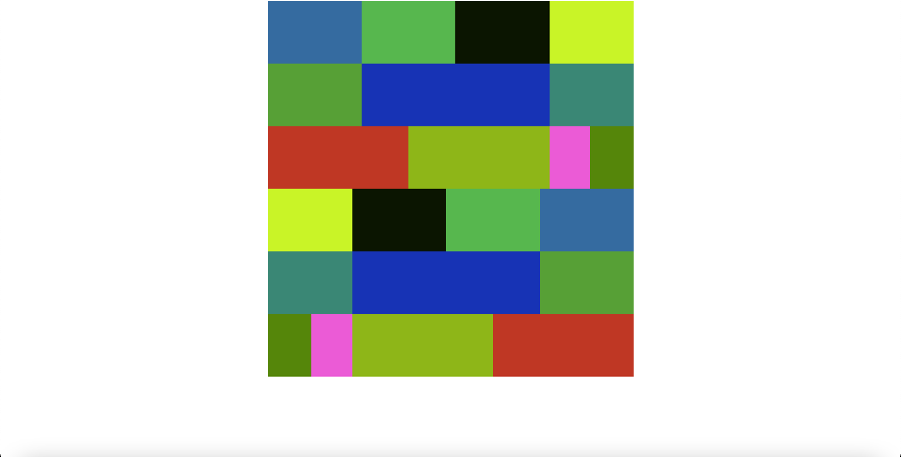

**Practical 1.4(c)**

**index.html**

<html>

<head>

<title></title>

<link rel="stylesheet" type="text/css" href="../css/style.css">

</head>

<body><div class="container">

<div class="row1">

<div class="col1"></div>

<div class="col2">

<div class="rowa"></div>

<div class="rowb"></div>

</div>

<div class="col3"></div>

</div><div class="row2">

<div class="col1"></div>

<div class="col2"></div>

<div class="col3">

<div class="rowa"></div>

<div class="rowb">

<div class="cola"></div>

<div class="colb"></div>

</div>

</div>

</div>

<div class="row3">

<div class="col1"></div>

<div class="col2"></div>

<div class="col3"></div>

<div class="col4">

<div class="rowa"></div>

<div class="rowb"></div>

<div class="rowa"></div>

</div>

</div>

<div class="row4">

<div class="col1"></div>

<div class="col2"></div>

<div class="col3">

<div class="rowa"></div>

<div class="rowb"></div>

<div class="rowa"></div>

</div>

<div class="col4"></div>

</div><div class="row5">

<div class="col1"></div>

<div class="col2">

<div class="rowa"></div>

<div class="rowb"></div>

</div>

<div class="col3"></div>

<div class="col4"></div>

</div><div class="row6">

<div class="col1">

<div class="rowa"></div>

<div class="rowb"></div>

<div class="rowa"></div>

</div>

<div class="col2"></div>

<div class="col3"></div>

<div class="col4"></div>

</div>

</div>

</body>

</html>

**style.css**

.container{

width: 1170px;

height: auto;

margin: 0 auto;

}

.container .row1{

width: 1170px;

height: 200px;

}

.container .row1 .col1{

width: 300px;

height: 200px;

background-color: #356ba0;

float: left;

}

.container .row1 .col2{

width: 600px;

height: 200px;

float: left;

}

.container .row1 .col2 .rowa{

width: 600px;

height: 100px;

background-color: #a03779;

float: left;

}

.container .row1 .col2 .rowb{

width: 600px;

height: 100px;

background-color: #2b1752;

float: left;

}

.container .row1 .col3{

width: 270px;

height: 200px;

background-color: #c9f427;

float: left;

}

.container .row2{

width: 1170px;

height: 200px;

}

.container .row2 .col1{

width: 300px;

height: 200px;

background-color: #57a036;

float: left;

}.container .row2 .col2{

width: 600px;

height: 200px;

background-color: #1733b5;

float: left;

}

.container .row2 .col3{

width: 270px;

height: 200px;

float: left;

}

.container .row2 .col3 .rowa{

width: 270px;

height: 100px;

background-color: #2b1752;

float: left;

}

.container .row2 .col3 .rowb{

width: 270px;

height: 100px;

float: left;

}

.container .row2 .col3 .rowb .cola{

width: 135px;

height: 100px;

background-color: #205352;

float: left;

}

.container .row2 .col3 .rowb .colb{

width: 135px;

height: 100px;

background-color: #3a8775;

float: left;

}

.container .row3{

width: 1170px;

height: 200px;

}

.container .row3 .col1{

width: 450px;

height: 200px;

background-color: #c03724;

float: left;

}

.container .row3 .col2{

width: 450px;

height: 200px;

background-color: #8eb618;

float: left;

}

.container .row3 .col3{

width: 130px;

height: 200px;

background-color: #eb5bd6;

float: left;

}

.container .row3 .col4{

width: 140px;

height: 200px;

float: left;

}

.container .row3 .col4 .rowa{

width: 140px;

height: 70px;

background-color: #459308;

float: left;

}.container .row3 .col4 .rowb{

width: 140px;

height: 60px;

background-color: #1e6393;

float: left;

}

.container .row4{

width: 1170px;

height: 200px;

}

.container .row4 .col1{

width: 300px;

height: 200px;

background-color: #356ba0;

float: right;

}

.container .row4 .col2{

width: 300px;

height: 200px;

background-color: #57b74e;

float: right;

}

.container .row4 .col3{

width: 300px;

height: 200px;

float: right;

}

.container .row4 .col3 .rowa{

width: 300px;

height: 70px;

background-color: #0b1401;

float: right;

}

.container .row4 .col3 .rowb{

width: 300px;

height: 60px;

background-color: #1e6393;

float: right;

}

.container .row4 .col4{

width: 270px;

height: 200px;

background-color: #c9f427;

float: right;

}

.container .row5{

width: 1170px;

height: 200px;

}

.container .row5 .col1{

width: 300px;

height: 200px;

background-color: #57a036;

float: right;

}

.container .row5 .col2{

width: 300px;

height: 200px;

float: right;

}

.container .row5 .col2 .rowa{

width: 300px;

height: 100px;

background-color: #2b83bd;

float: right;

}.container .row5 .col2 .rowb{

width: 300px;

height: 100px;

background-color: #1733b5;

float: right;

}

.container .row5 .col3{

width: 300px;

height: 200px;

background-color: #1733b5;

float: right;

}

.container .row5 .col4{

width: 270px;

height: 200px;

background-color: #3a8775;

float: right;

}

.container .row6{

width: 1170px;

height: 200px;

}

.container .row6 .col1{

width: 450px;

height: 200px;

float: right;

}

.container .row6 .col1 .rowa{

width: 450px;

height: 70px;

background-color: #c03724;

float: right;

}

.container .row6 .col1 .rowb{

width: 450px;

height: 60px;

background-color: #2b83bd;

float: right;

}

.container .row6 .col2{

width: 450px;

height: 200px;

background-color: #8eb618;

float: right;

}

.container .row6 .col3{

width: 130px;

height: 200px;

background-color: #eb5bd6;

float: right;

}

.container .row6 .col4{

width: 140px;

height: 200px;

background-color: #55860a;

float: right;

}

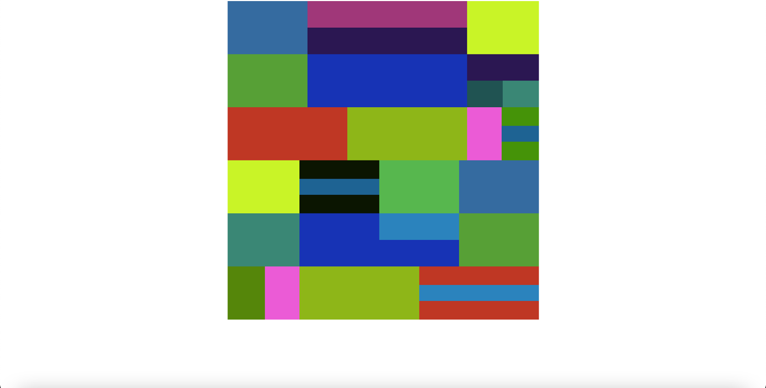

**Practical 1.4(d)**

**Implementation of Navigation Bar with active link.**

**index.html**

<html>

<head>

<title>Navigation Bar</title>

<link rel="stylesheet" type="text/css" href="../css/style.css">

</head>

<body>

<div class="container">

<div class="navigation">

<ul>

<li><a href="index.html" class="active">Home</a></li>

<li><a href="about.html">About Us</a></li>

<li><a href="gallery.html">Gallery</a></li>

<li><a href="contact.html">Contact Us</a></li>

</ul>

</div>

</div>

</body>

</html>

**style.css**

.container{

width: 1170px;

height: 500px;

margin: 0 auto;

background-color: #ff0000;

}

.navigation{}

.navigation ul{}

.navigation ul li{

list-style: none;

}

.navigation ul li a{

float: left;

padding: 10px 20px;

color: #506AD4;

background-color: #A3CDD9;

border: 2px solid #C2B8AD;

border-radius: 20px;

text-decoration: none;

}

.navigation ul li a:hover{

color: #C2B8AD;

background-color: #F2CC39;

text-decoration: underline;

}

.navigation ul li a.active {

background-color: #F2CC39;

}

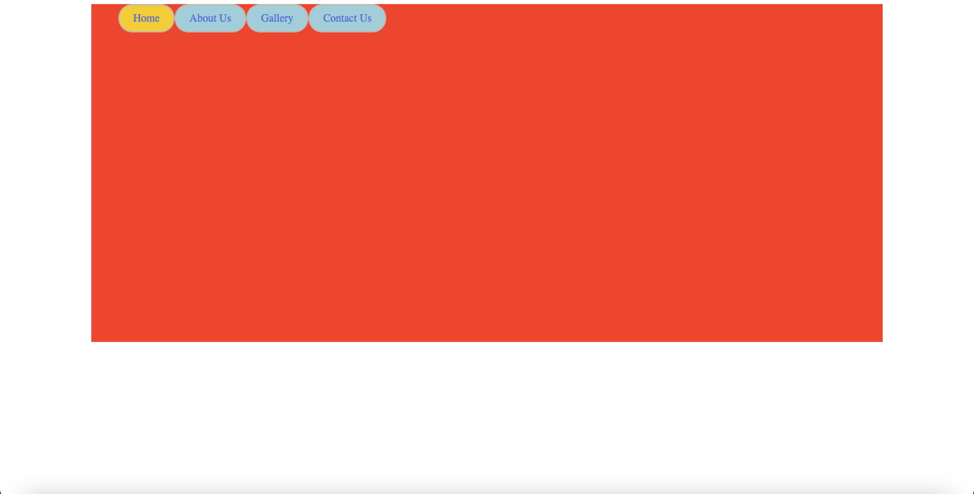

**Practical 1.5(a)**

**index.html**

<html>

<head>

<title>Facebook - Log in or Sign up</title>

<link rel="stylesheet" type="text/css" href="../css/style.css">

</head>

<body>

<div class="wrapper">

<div class="header">

<div class="sitename"></div>

<form>

<ul>

<li><div class="sitename">facebook</div></li>

<li>Email or Phone<br><input type="text" name="email"></li>

<li>Password<br><input type="password" name="password"><br><a href="#">Forgotten account?</a></li>

<li><br><input type="submit" name="login" value="Log In"></li>

</ul>

</form>

</div>

</div>

<div class="create">

<table>

<tr><td valign="top"><div class="img">

<p class="p1">Facebook helps you connect and share with the<br> people in your life.</p>

<img src="../images/image.jpeg">

</div>

</td>

<td>

<div class="form">

<p class="p2">Create an account

</p>

<p class="p3">It's free and always will be.

</p>

<li><input type="text" name="First name" placeholder="First name"><input type="text" name="Surname" placeholder="Surname"></li>

<li><input type="email" name="email" placeholder="Mobile number or email address"></li>

<li><input type="password" name="password" placeholder="New password"></li>

<li><p class="p3">Birthday</p>

<select>

<option value="1">1</option>

<option value="2">2</option>

<option value="3">3</option>

<option value="4">4</option>

<option value="5">5</option>

<option value="6">6</option>

<option value="7">7</option>

<option value="8">8</option>

<option value="9">9</option>

</select>

<select>

<option value="January">Jan</option>

<option value="February">Feb</option>

<option value="March">Mar</option>

<option value="April">Apr</option>

<option value="May">May</option>

<option value="June">Jun</option>

<option value="July">Jul</option>

<option value="August">Aug</option>

<option value="September">Sep</option>

<option value="October">Oct</option>

<option value="November">Nov</option>

<option value="December">Dec</option>

</select>

<select>

<option value="1993">1993</option>

<option value="1994">1994</option>

<option value="1995">1995</option>

<option value="1996">1996</option>

<option value="1997">1997</option>

<option value="1998">1998</option>

</select>

<a href="#" >Why do i need to provide my date of birth?</a></li>

<li><input type="radio" name="gender">Female

<input type="radio" name="gender">Male</li>

<li><p class="p4">By clicking Sign Up, you agree to our <a href="#">Terms, Data Policy</a>

and<br><a href="#">Cookie Policy</a>. You may receive SMS notifications from us and<br> can opt out any time</p></li>

<li><input type="submit" name="Sign Up"></li>

</div>

</td></tr>

</table>

</div>

</body>

</html>

**style.css**

body{

width: 100%;

margin: 0 auto;

padding: 0;

font-family: sans-serif;

background-color: #d7dcea;

}

.wrapper{

width: 100%;

min-width: 1170px;

background-color: #3b5998;

}

.header{

width: 1170px;

margin: 0 auto;

padding: 0;

height: 90px;

}

.header ul{}

.header ul li{

margin-top: 15px;

list-style: none;

float: left;

text-align: left;

color: white;

padding-left: 10;

}

.header ul li a{

color: #7d91bb;

}

.header ul li .sitename{

margin-top: 10px;

margin-right: 550;

color: white;

font-size: 35px;

font-weight: 900;

}

.create{

width: 1170px;

margin: 0 auto;

padding-top: 50px;

}

.create .img{

}

.create .img .p1{

text-align: left;

font-size: 25;

color: #0b2b54;

}

.create .img img{

width: 530px;

}

.create .form{

padding-left:200 ;

margin: 0 auto;

text-align:left ;

}

.create .form .p2{

font-size: 35;

color: #2a303c;

}

.create .form li{

padding: 5;

list-style: none;

}

.create .form li input[type="text"]{

margin-top:3px;

margin-bottom:3px;

width:150px;

border:1px solid #08298A;

height:25px;

padding-left:3px;

}

.create .form li input[type="email"]{

margin-top:3px;

margin-bottom:3px;

width:300px;

border:1px solid #08298A;

height:25px;

padding-left:3px;

}

.create .form li input[type="password"]{

margin-top:3px;

margin-bottom:3px;

width:300px;

border:1px solid #08298A;

height:25px;

padding-left:3px;

}

.create .form li .p3{

font-size: 20px;

color: #19181c;

}

.create .form li a{

font-size: 10px;

color: #7d91bb;

}

.create .form li .p4{

font-size: 10px;

color: grey;

}

.create .form li input[type="submit"]{

width:205px;

height:45px;

text-align:center;

font-size:19px;

margin-top: 10px;

margin-bottom: 10px;

font-family: 'Freight Sans Bold', helvetica, arial, sans-serif !important;

font-weight: bold !important;

background: linear-gradient(#67ae55, #578843);

background-color: #69a74e;

box-shadow: inset 0 1px 1px #a4e388;

border-color: #3b6e22 #3b6e22 #2c5115;

border: 1px solid;

border-radius: 5px;

color: #fff;

cursor: pointer;

display: inline-block;

position: relative;

text-shadow: 0 1px 2px rgba(0,0,0,.5);

}

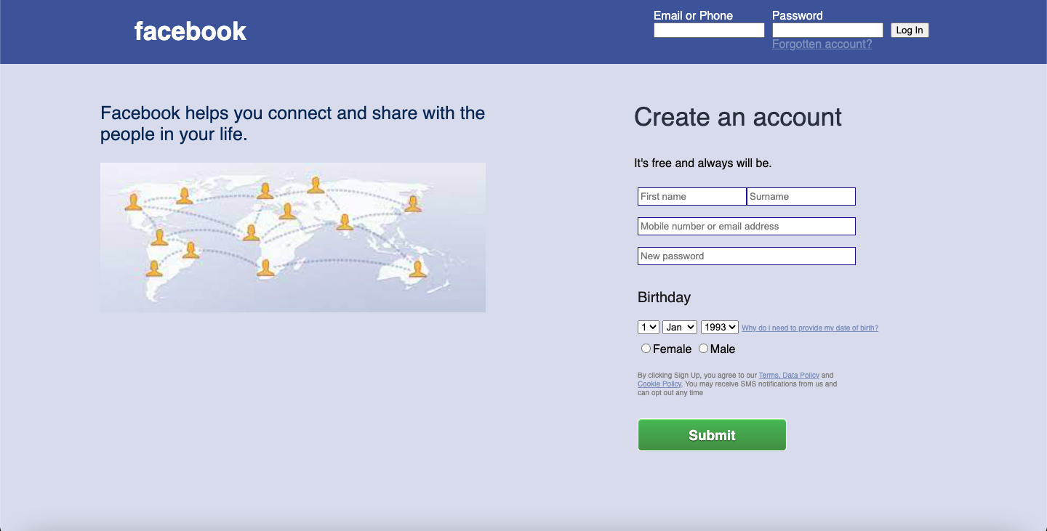

**Practical 1.5(b)**

**index.html**

<html>

<head>

<title>Facebook - Log in or Sign up</title>

<link rel="stylesheet" href="../css/style.css">

</head>

<body>

<div class="container">

<div class="left">

<img src="../images/logo.svg" height=110 width=320>

<p class="p1">Facebook helps you connect and share<br>with the people in your life.</p>

</div>

<div class="right">

<div class="box">

<form>

<input type="text" placeholder="Email address or phone number"><br>

<input type="password" placeholder="Password"><br>

<input type="submit" value="Log In">

<a href="#" class="link1">Forgotten password?</a>

<hr size=1>

<input type="reset" value="Create New Account">

</form>

</div>

<p class="p2">

<a href="#" class="link2">Create a Page</a> for a celebrity, brand or business.

</p>

</div>

</div>

</body>

</html>

**style.css**

* {

margin: 0;

padding: 0;

}

.container {

margin: 0 auto;

height: auto;

width: 1170px;

}

.left {

float:left;

margin-top: 180px;

margin-left: 50px;

}

.right {

float: right;

text-align: center;

margin: 135px 100px 0 0;

}

.box {

float: left;

height: 340px;

width: 375px;

box-shadow: 0 3px 8px rgba(0,0,0,0.2);

border-radius: 10px;

padding: 16px;

background-color: white;

font-family: sans-serif;

text-align: center;

margin-bottom: 30px;

}

body {

background-color: #F0F2F5;

}

img {

margin-bottom: -7px;

}

.p1 {

margin-left: 32px;

font-size: 28px;

font-family: sans-serif;

line-height: 35px;

}

.p2 {

font-size: 14px;

font-family: sans-serif;

}

a {

text-decoration: none;

}

a:hover {

text-decoration: underline;

}

input[type=text] {

padding-left: 15px;

height: 55px;

border-radius: 8px;

width: 375px;

font-size: 17px;

border: 1px solid lightgrey;

color: dimgrey;

font-family: sans-serif;

}

input[type=password] {

margin-top: 15px;

padding-left: 15px;

height: 55px;

border-radius: 8px;

width: 375px;

font-size: 17px;

border: 1px solid lightgrey;

color: dimgrey;

font-family: sans-serif;

}

input[type=submit] {

margin-top: 15px;

height: 50px;

border-radius: 8px;

width: 375px;

font-size: 20px;

background-color: #1877F2;

color: white;

font-weight: bold;

font-family: sans-serif;

border: 0;

}

input[type=submit]:hover {

background-color: #166FE5;

cursor: pointer;

}

input[type=reset] {

margin-top: 25px;

height: 50px;

border-radius: 8px;

width: 215px;

font-size: 18px;

color: white;

font-weight: bold;

font-family: sans-serif;

border: 0;

background-color: #42B72A;

}

input[type=reset]:hover {

background-color: #36A420;

cursor: pointer;

}

.link1 {

color: #1877F2;

display: block;

padding: 22px;

}

.link2 {

font-weight: bold;

color: black;

}

hr {

color: #DADDE1;

}

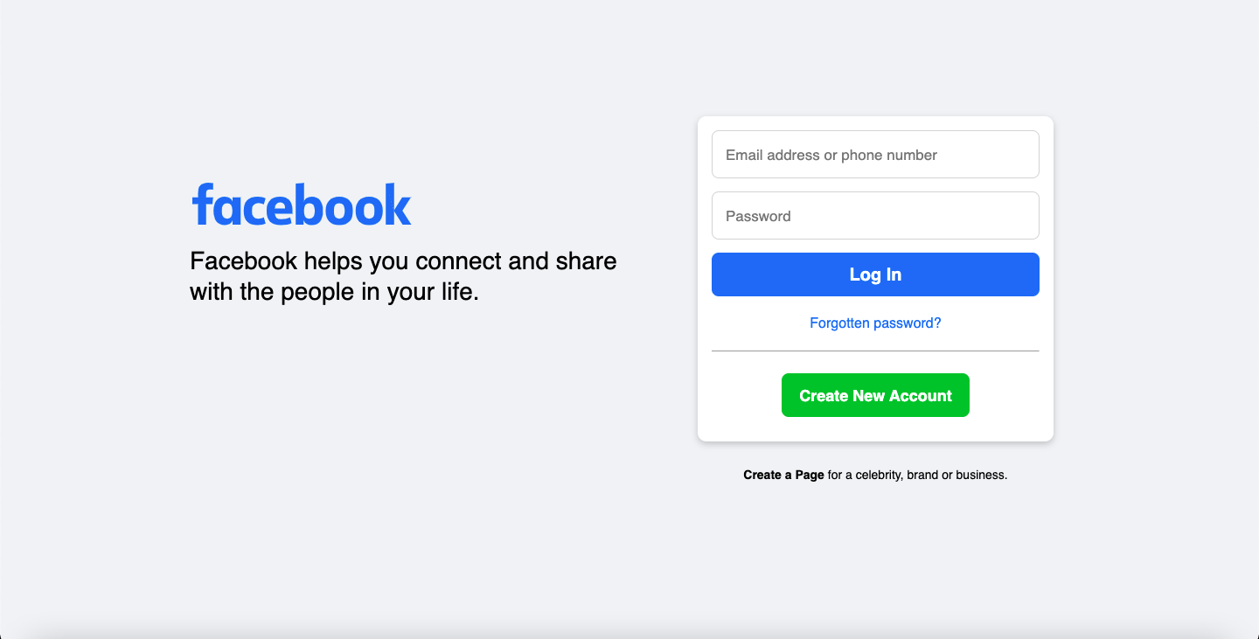

**Assignment Week-1**

**Create a same Webpage using HTML and CSS**

**index.html**

<html>

<head>

<title>Home</title>

<link rel="stylesheet" href="../css/style.css">

<link rel="stylesheet" href="https://www.w3schools.com/w3css/4/w3.css">

<link rel="stylesheet" href="https://cdnjs.cloudflare.com/ajax/libs/font-awesome/4.7.0/css/font-awesome.min.css">

<link rel="stylesheet" href="https://fonts.googleapis.com/icon?family=Material+Icons">

</head>

<body>

<div class="row1">

<div class="topbar">

<i class="material-icons">mail_outline</i> example@example.com<i class="material-icons">place</i>1st Floor New World.<i class="material-icons">phone_enabled</i>+880 320 432 242

<div class="right">

<i class="material-icons">facebook</i>

<i class="fa fa-twitter w3-xlarge"></i>

<i class="fa fa-instagram w3-xlarge"></i>

<i class="material-icons">language</i>

</div>

</div>

</div>

<div class="row2">

<img src="../images/logo.png" width=200 height=100>

<div class="right">

<ul>

<li><a href="#">Home<i class="fa fa-angle-down gry"></i></a></li>

<li><a href="#">Company<i class="fa fa-angle-down gry"></i></a></li>

<li><a href="#">Services<i class="fa fa-angle-down gry"></i></a></li>

<li><a href="#">Project<i class="fa fa-angle-down gry"></i></a></li>

<li><a href="#">Blog<i class="fa fa-angle-down gry"></i></a></li>

<li><a href="#">Contact</a></li>

<li><button type="button">Get Consultant</button></li>

</ul>

</div>

</div>

<div class="p1">

<h2 class="boldH">SECURE & IT SERVICES</h2><br>

<h1 class="bolderH">Excellent IT services<br>for your success</h1><br>

<p class="p1p1">

Pellentesque at posuere tellus phasellus scelerisque porem.</p>

<br>

<button type="button" class="lmB">Learn More<i class="fa fa-angle-right"></i></button>

<button type="button" class="playB"><i class="fa fa-play-circle"></i></button>

</div>

<div class="about">

<div class="left1">

<img class="leftImg" src="https://ak3.picdn.net/shutterstock/videos/1006363/thumb/1.jpg?ip=x480" height="300px" width="350px">

<img class="rightImg" src="https://c.files.bbci.co.uk/3D3F/production/_103097651_gettyimages-693641324.jpg" height="200px" width="300px">

</div>

<div class="right1">

<h2 class="aboutcmp">// ABOUT COMPANY</h2>

<h1 class="aboutH">We Deal With The Aspects Of<br>Professional <b><font color="#ff3d00">IT Services</font></b></h1><hr>

<h3><font color="#9c9e9e">ITSoft is the partner of choice for many of the world's leading<br>enterprises, SMEs and technology challengers. We help businesses<br> elevate their value through custom software development.</font></h3>

<div class="abtText rightalign">

<h2 class="aboutH">User Experience</h2>

<h3><font color="#9c9e9e">Skilled professionals are always ready to provide<br>reliable services to our clients!</font></h3>

</div>

<div class="abtText rightalign">

<h2 class="aboutH">Quick Support</h2>

<h3><font color="#9c9e9e">Branches are situated in major metro cities and<br>overseas, always open for you!</font></h3>

</div>

</div>

</div>

<div class="services">

<div class="left2">

<h2 class="aboutcmp">// OUR SERVICES</h2>

<h1 class="aboutH">What We Provide</h1>

</div>

<div class="right2">

Lorem ipsum dolor, sit amet consectetur adipisicing elit. Temporibus maiores quo<br>voluptatem voluptate doloremque,adipisci sapiente, earum. Cum illum iure<br>esse rem ullam quisquam. Pariatur, deleniti, odio? Debitis, nostrum dignissimos.

</div>

<div class="service_center">

<div class="service_box">

<img src="https://upload.wikimedia.org/wikipedia/commons/b/b2/New_office.jpg" height="200px" width="315px" style="border-radius: 8px;">

<h3 class="boxAlign">IT Consultancy</h3>

<p class="boxAlign">Nullam tincidunt augue eget densis<br>volt tpat, vitae ultri ces lectus and<br>posuere. Duis urna lacus</p>

<div class="service_boxButtons">

<div class="service_boxButtonsLeft">

<h3>Read more<i class="fa fa-angle-right" style="color: black;"></i></h3>

</div>

<div class="service_boxButtonsRight"><i class="fa fa-arrow-right w3-xlarge" style="color: white; padding-top: 8px;"></i>

</div>

</div>

</div>

<div class="service_box">

<img src="https://www.eastwestbank.com/ReachFurther/NewsArticleStore/375/Employee-retention-top.jpg" alt="first" height="200px" width="315px" style="border-radius: 8px;">

<h3 class="boxAlign">IT Management</h3>

<p class="boxAlign">Nullam tincidunt augue eget densis<br>volt tpat, vitae ultri ces lectus and<br>posuere. Duis urna lacus</p>

<div class="service_boxButtons">

<div class="service_boxButtonsLeft">

<h3>Read more<i class="fa fa-angle-right" style="color: black;"></i></h3>

</div>

<div class="service_boxButtonsRight">

<i class="fa fa-arrow-right w3-xlarge" style="color: white; padding-top: 8px;"></i>

</div>

</div>

</div>

<div class="service_box">

<img src="https://www.crushpixel.com/big-static10/preview4/smiling-business-people-work-office-593295.jpg" alt="first" height="200px" width="315px" style="border-radius: 8px;">

<h3 class="boxAlign">Product Design</h3>

<p class="boxAlign">Nullam tincidunt augue eget densis<br>volt tpat, vitae ultri ces lectus and<br>posuere. Duis urna lacus</p>

<div class="service_boxButtons">

<div class="service_boxButtonsLeft">

<h3>Read more<i class="fa fa-angle-right" style="color: black;"></i></h3>

</div>

<div class="service_boxButtonsRight">

<i class="fa fa-arrow-right w3-xlarge" style="color: white; padding-top: 8px;"></i>

</div>

</div>

</div>

</div>

<div class="team">

<div class="left2">

<h2 class="aboutcmp">// PROFESSIONAL TEAM</h2>

<h1 class="aboutH">Our Dedicated Team</h1>

</div>

<div class="right2">

Lorem ipsum dolor, sit amet consectetur adipisicing elit. Temporibus maiores quo<br>voluptatem voluptate doloremque,adipisci sapiente, earum. Cum illum iure<br>esse rem ullam quisquam. Pariatur, deleniti, odio? Debitis, nostrum dignissimos.

</div>

<div class="centerteam">

<div class="imgbox">

<img src="../images/AZ.jpg">

</div>

<div class="imgbox">

<img src="../images/SW.jpg">

</div>

<div class="imgbox">

<img src="../images/FH.jpg">

</div>

</div>

</div>

<div class="consult">

<div class="leftside"><img src="../images/consult.jpg"></div>

<div class="rightside">

<h1 style="font-weight: bold;">Request Free Consultation</h1>

<h3 style="color: dimgrey; text-align: center;">Get in touch and discover how we can help. We aim to be in<br>touch for a consultation</h3>

<form>

<input type="text" placeholder="Name"><br>

<input type="text" placeholder="Email Address"><br><br>

<textarea rows=5 cols=76 placeholder="Your Message"></textarea><br>

<input type="submit" value="Send Message">

</form>

</div>

</div>

<div class="work">

<h2 class="aboutcmp">// HOW IT WORKS</h2>

<h1 class="aboutH">Check Out Our Work Process</h1>

<hr>

<div class="round">

<img src="https://www.softwaresuggest.com/blog/wp-content/uploads/2019/01/Why-to-Choose-Online-Service-Desk-Software-FB-Image.jpg" height="175px" width="175px"><br>

<h3>Choose a Service</h3>

<p>Lorem ipsum dolor sit amet<br>elit at natus neque</p>

</div>

<div class="round">

<img src="https://www.salesforce.com/content/dam/blogs/ca/Blog%20Posts/shake-up-sales-meeting-og.jpg" height="175px" width="175px"><br>

<h3>Request a Meeting</h3>

<p>Lorem ipsum dolor sit amet<br>elit at natus neque</p>

</div>

<div class="round">

<img src="https://assets.entrepreneur.com/content/3x2/2000/20150512050128-shutterstock-124904123.jpeg" height="175px" width="175px"><br>

<h3>Receive Custom Plan</h3>

<p>Lorem ipsum dolor sit amet<br>elit at natus neque</p>

</div>

<div class="round">

<img src="https://pngimage.net/wp-content/uploads/2018/06/thumbs-up-guy-png-3.png" height="175px" width="175px"><br>

<h3>Let's Make it Happen</h3>

<p>Lorem ipsum dolor sit amet<br>elit at natus neque</p>

</div>

</div>

<div class="solution">

<i class="material-icons w3-xxlarge">pause_circle_filled</i><br>

<h2>We Deliver Solutions With The Goal Of</h2>

<h1>A Trusting Relationship</h1>

<p>Appropriate for your specific business, making it easy<br>for you to have quality IT services.</p><br>

<button type="button">Watch More</button>

</div>

<div class="quotes">

<img src="https://deadline.com/wp-content/uploads/2020/11/Stephen-Lang-Headshot-Matt-Sayles-e1605093774374.jpg" width="125px" height="125px"><br>

<p>"Lorem ipsum dolor sit amet, consectetur adipisicing elit. Officia quae tempora amet veniam at ullam aut velit consequatur impedit fugit."</p><br>

<h3>John Abraham</h3><h3 class="hbottom">Web Developer</h3>

</div>

<div class="quotes">

<img src="https://i.pinimg.com/originals/8c/f8/dd/8cf8dd82286d9dd643e1a2368d04a970.jpg" width="125px" height="125px"><br>

<p>"Lorem ipsum dolor sit amet, consectetur adipisicing elit. Officia quae tempora amet veniam at ullam aut velit consequatur impedit fugit."</p><br>

<h3>Ellen Erye</h3><h3 class="hbottom">Project Manager</h3>

</div>

<div class="quotes">

<img src="https://st.depositphotos.com/1144472/1971/i/600/depositphotos_19714321-stock-photo-young-happy-smiling-business-man.jpg" width="125px" height="125px"><br>

<p>"Lorem ipsum dolor sit amet, consectetur adipisicing elit. Officia quae tempora amet veniam at ullam aut velit consequatur impedit fugit."</p><br>

<h3>Shene Watsan</h3><h3 class="hbottom">Founder</h3>

</div>

<div class="blogs">

<div class="header">

<h2 class="aboutcmp">// OUR BLOGS</h2>

<h1 class="aboutH">Resources & Latest <font color="orangered">News</font></h1>

<hr>

</div>

<div class="bounding">

<div class="blogbox">

<img src="https://i.guim.co.uk/img/media/b0e7d29ce0912708d5b72f562ce81c275b836871/0_1584_4480_2760/master/4480.jpg?width=445&quality=45&auto=format&fit=max&dpr=2&s=39dcf83e56dbbe263dbf3eff7f1c97fd" width="365px" height="250px">

<p class="date">Itsoft - January 01,2021</p>

<h3>Plan Your Project with Your<br>Software</h3>

<p class="desc">Lorem ipsum dolor sit amet<br>consectetur adipisicing Voluptates,<br>provident, illum enim explicabo.</p><br>

<div class="blog_boxButtonsLeft">

<h3>Read more<i class="fa fa-angle-right" style="color: orangered;"></i></h3>

</div>

</div>

<div class="blogbox">

<img src="https://cdn.mos.cms.futurecdn.net/6t8Zh249QiFmVnkQdCCtHK.jpg" width="365px" height="250px">

<p class="date">Itsoft - January 01,2021</p>

<h3>You have a Great Business<br>Idea?</h3>

<p class="desc">Lorem ipsum dolor sit amet<br>consectetur adipisicing Voluptates,<br>provident, illum enim explicabo.</p><br>

<div class="blog_boxButtonsLeft">

<h3>Read more<i class="fa fa-angle-right" style="color: orangered;"></i></h3>

</div>

</div>

<div class="blogbox">

<img src="https://www.cnet.com/a/img/aSO51FDIwDdzFFnKp7y6RGHKxh0=/1200x630/2019/07/22/b80931f8-fa56-44ea-abed-0f106c40b1f0/keyboard-enter-laptop-computer7923.jpg" width="365px" height="250px">

<p class="date">Itsoft - January 01,2021</p>

<h3>How to Make Website WCAG<br>Compliant?</h3>

<p class="desc">Lorem ipsum dolor sit amet<br>consectetur adipisicing Voluptates,<br>provident, illum enim explicabo.</p><br>

<div class="blog_boxButtonsLeft">

<h3>Read more<i class="fa fa-angle-right" style="color: orangered;"></i></h3>

</div>

</div>

</div>

</div>

<div class="footer">

<div class="footerleft">

<i class="material-icons w3-jumbo">language</i><h3>Sign Up To Get Latest Updates</h3></div>

<div class="footerright">

<input type="text" placeholder="Enter Your Email...."><button type="button">Subscribe</button>

</div>

<div class="centerfooter">

<hr>

<div class="div1">

<img src="../images/logobw.png" width=200 height=100><br>

<p>We are the best world Information<br>Technology Company. Providing<br>the highest quality.<br><br><br>

<i class="material-icons">facebook</i>

<i class="fa fa-twitter w3-xlarge"></i>

<i class="fa fa-pinterest w3-xlarge"></i>

<i class="fa fa-linkedin w3-xlarge"></i>

</div>

<div class="div1">

<h3>Quick Links</h3>

<ul>

<li>&nbsp;&nbsp;Customer Services</li>

<li>&nbsp;&nbsp;IT Department</li>

<li>&nbsp;&nbsp;About Our Company</li>

<li>&nbsp;&nbsp;Business Growth</li>

<li>&nbsp;&nbsp;Make An Appointment</li>

</ul>

</div>

<div class="div1">

<h3>Contacts</h3>

<p><b>Address:</b> 27 Division St, New York, NY 10002,USA<br><br>

<b>Phone:</b> +8 91230 456 789<br>Fax: +8 91230 456 788<br><br>

<b>Email:</b> example@mail.com<br>Website: your website.com</p>

</div>

<div class="div1">

<h3>Popular Posts</h3>

<img src="https://i.guim.co.uk/img/media/b0e7d29ce0912708d5b72f562ce81c275b836871/0_1584_4480_2760/master/4480.jpg?width=445&quality=45&auto=format&fit=max&dpr=2&s=39dcf83e56dbbe263dbf3eff7f1c97fd" width="100px" height="100px"><h4 class="posts">Plan Your Project<br>With Your<br>Software</h4><p class="posts footdates" style="margin-top: -45px; margin-right: 70px;">January 01, 2021</p><br>

<img src="https://cdn.mos.cms.futurecdn.net/6t8Zh249QiFmVnkQdCCtHK.jpg" width="100px" height="100px"><h4 class="posts">You have a Great<br>Business Idea?</h4><p class="posts footdates" style="margin-top: -75px; margin-right: 70px;">January 01, 2021</p>

</div>

</div>

<div class="footfoot">

<hr>

<i class="material-icons" style="margin-left: 20px;">copyright</i>2021 - itsoft all rights reserved.

<p style="float: right; margin-right: 25px">About Us&nbsp;&nbsp;&nbsp;&nbsp;Privacy Policy&nbsp;&nbsp;&nbsp;&nbsp;Services</p>

</div>

</div>

</body>

</html>

**style.css**

* {

padding: 0;

margin: 0;

}

body {

background-color: #f3f3f3;

}

.container {

margin: 0 auto;

height: auto;

width: 1170px;

}

.row1 {

height: 55px;

width: 100%;

background: linear-gradient(115deg,#ff3d00 60%,#252628 40%);

}

.row2 {

height: 55px;

width: 100%;

padding: 15px 90px;

}

.topbar {

padding: 15px 0 0 90px;

color: white;

font-family: sans-serif;

font-size: 17px;

}

.right {

float: right;

padding-right: 90px;

}

i {

margin: 0 10px;

}

.row2 ul li {

list-style-type: none;

margin: 0;

display: inline;

}

.row2 a {

float: left;

font-family: sans-serif;

text-align: center;

padding: 40px 10px;

text-decoration: none;

font-size: 16px;

}

.row2 button {

background-color: #ff3d00;

margin: 30px 0 30px -75px;

color: white;

font-family: sans-serif;

border: 0;

padding: 8px 20px;

border-radius: 5px;

font-size: 18px;

margin-right: -80px;

margin-left: 25px;

}

.row2 a:hover {

color: #ff3d00;

}

.gry {

color: grey;

}

.p1 {

background-image: url("../images/img1.jpg");

height: 700px;

margin: 90px 0 0 0;

background-repeat: no-repeat;

padding: 150px 0 0 90px;

font-family: sans-serif;

}

.p1p1 {

color: grey;

font-size: 23px;

margin-top: 10px;

}

.boldH {

font-size: 25px;

font-weight: bold;

letter-spacing: 2px;

text-decoration: overline;

text-decoration-color: #ff3d00;

}

.bolderH {

line-height: 75px;

font-size: 65px;

font-weight: bolder;

}

.lmB {

background-color: #ff3d00;

color: white;

padding: 10px 20px 10px 30px;

border: 0;

font-size: 18px;

border-radius: 5px;

margin-top: 25px;

}

.playB {

background-color: #ff3d00;

color: white;

border-radius: 50%;

padding: 8px 2px;

border: 0;

font-size: 35px;

margin-left: 20px;

}

.about {

margin: 0 auto;

height: auto;

width: 1170px;

}

.left1 {

float: left;

}

.right1 {

float: right;

margin: -300px 0 0 0;

}

.leftImg {

position: relative;

left: 0px;

top: 0px;

z-index: -1;

margin-top: 75px;

}

.rightImg {

position: relative;

left: -450px;

top: 135px;

z-index: -1;

border: 10px solid #fff;

border-bottom-left-radius: 20px;

}

.aboutcmp {

color: orangered;

font-weight: bold;

}

.aboutH {

line-height: 60px;

font-size: 47px;

font-weight: bold;

}

.rightalign {

margin-left: 200px;

padding-top: 35px;

}

.services {

margin: 0 auto;

height: auto;

width: 1520px;

background-color: #f4f7fc;

float: left;

margin-top: 100px;

}

.left2 {

margin: 10px;

padding: 65px 90px;

}

.right2 {

float: right;

color: #9c9e9e;

margin-top: -200px;

padding-right: 100px;

font-size: 19px;

line-height: 40px;

}

.service_center {

text-align: center;

}

.service_box {

float: left;

border-radius: 10px;

padding: 18px;

text-align: justify;

background-color: #fefefe;

margin: 50px;

margin-left: 90px;

width: 350px;

}

.service_box p {

color: grey;

}

.service_box h3 {

font-weight: bold;

}

.service_boxButtons {

background: linear-gradient(115deg,#f4f7fc 65%,#ff3d00 35%);

height: 50px;

padding: 0 0 0 20px;

margin-top: 30px;

margin-right: 0;

}

.service_boxButtonsleft h3 {

font-weight: normal;

padding-top: 5px;

}

.service_boxButtonsright {

float: right;

margin-top: -45px;

margin-right: 20px;

}

.boxAlign {

padding-left: 20px;

}

.team {

background-color: white;

}

.centerteam {

text-align: center;

margin-left: 90px;

}

.imgbox {

float: left;

text-align: center;

padding: 25px 110px 0 0;

}

.consult {

height: 643px;

background-color: white;

}

.consult img {

background-size: cover;

background-repeat: no-repeat;

background-position: center;

position: relative;

left: 90px;

top: 90px;

}

.rightside {

position: absolute;

display: flex;

width: 775px;

height: 620px;

flex-direction: column;

align-items: center;

right: 255px;

top: 3315px;

background-color: white;

box-shadow: 0 5px 15px 0 rgba(0,0,0,0.3);

padding: 40px;

}

.rightside input[type="text"] {

width: 635px;

margin-top: 20px;

border-radius: 5px;

border: 1px solid #f3f0e8;

height: 50px;

padding: 0 0 0 15px;

}

.rightside input[type="submit"] {

width: 635px;

margin-top: 20px;

border-radius: 5px;

border: 0;

height: 50px;

margin: 30px 0;

background-color: #ff3d00;

color: white;

}

textarea {

border-radius: 5px;

border: 1px solid #f3f0e8;

padding: 10px 0 0 15px;

}

.work {

text-align: center;

position: relative;

top: 550px;

background-color: ;

}

.round {

float: left;

margin: 0 0 0 130px;

}

.round img {

position: relative;

top: 75px;

border-radius: 50%;

border: 12px solid white;

box-shadow: 0 5px 15px 0 rgba(0,0,0,0.1);

margin-bottom: 85px;

}

.round h3 {

font-weight: bold;

}

.round p {

color: dimgrey;

padding-bottom: 75px;

}

.solution {

position: relative;

top: 975px;

height: 750px;

text-align: center;

background-color: #16161D;

background-blend-mode: soft-light;

background-image: url("https://www.qualityformationsblog.co.uk/wp-content/uploads/2020/04/QCF_Meeting-1.jpg");

}

.solution i {

background-color: white;

color: #ff3d00;

padding: 35px;

border-radius: 50%;

margin-top: -375px;

}

.solution h2 {

color: white;

font-weight: bolder;

font-size: 40px;

line-height: 20px;

position: relative;

top: -193px;

}

.solution h1 {

color: white;

font-weight: bolder;

font-size: 50px;

position: relative;

top: -193px;

}

.solution p {

color: white;

font-size: 18px;

position: relative;

top: -193px;

}

.solution button {

background-color: #ff3d00;

font-family: sans-serif;

padding: 13px 28px;

border: 0;

border-radius: 5px;

color: white;

position: relative;

top: -193px;

}

.quotes {

float: left;

position: relative;

top: 800px;

left: 90px;

background-color: white;

text-align: center;

padding: 35px;

width: 365px;

margin-left: 57px;

border-radius: 15px;

border: 1px solid antiquewhite;

}

.quotes img {

border-radius: 50%;

margin-bottom: 40px;

}

.quotes p {

color: dimgrey;

}

.quotes h3 {

font-weight: bold;

}

.hbottom {

color: #ff3d00;

}

.blogs {

text-align: center;

}

.header {

float: left;

position: relative;

top: 900px;

margin: 0 500px;

}

.header h1 {

font-size: 40px;

}

.bounding {

background-color: #f3f3f3;

margin-left: 90px;

}

.blogbox {

float: left;

position: relative;

text-align: left;

top: 950px;

background-color: white;

border-radius: 12px;

margin-left: 50px;

}

.blogbox img {

border-top-left-radius: 12px;

border-top-right-radius: 12px;

}

.blogbox h3 {

font-weight: bold;

padding: 5px 0 0 30px;

font-size: 20px;

}

.desc {

color: grey;

padding: 10px 0 0 30px;

}

.date {

color: grey;

padding: 30px 0 0 30px;

}

.blog_boxButtonsleft h3 {

font-weight: normal;

margin-top: -10px;

color: orangered;

padding-bottom: 20px;

}

.footer {

background-color: #252628;

float: left;

position: relative;

top: 1100px;

color: white;

width: 100%;

padding-top: 75px;

}

.footerleft {

float: left;

margin-left: 90px;

padding-bottom: 60px;

}

.footerleft i {

color: #ff3d00;

}

.footerleft h3 {

margin-left: 100px;

margin-top: -50px;

font-weight: bold;

}

.footerright {

float: right;

margin-right: 125px;

background-color: white;

border-radius: 4px;

padding: 3px 5px;

}

.footerright input[type=text] {

border: 0;

width: 400px;

height: 50px;

}

.footerright button {

border: 0;

font-weight: bolder;

border-radius: 4px;

width: 150px;

height: 50px;

background-color: #ff3d00;

color: white;

}

.centerfooter {

float: left;

padding: 10px 90px;

}

.centerfooter i {

border: 1px solid white;

padding: 10px;

border-radius: 4px;

}

.div1 {

float: left;

width: 310px;

margin-right: 20px;

margin-top: 50px;

}

.div1 ul {

list-style-type: none;

color: white;

margin-left: 25px;

line-height: 47px;

}

.div1 p {

line-height: 30px;

}

.div1 ul li:before {

content: '\2014';

position: absolute;

margin-left: -20px;

}

.div1 h3 {

font-weight: bold;

margin-bottom: 25px;

}

.div1 h4 {

font-size: 16px;

font-weight: bold;

margin-right: 55px;

margin-top: 0px;

line-height: 20px;

}

.div1 img {

border-radius: 8px;

margin-bottom: 25px;

}

.posts {

float: right;

}

.footdates {

color: darkgrey;

font-size: 13px;

}

.footfoot {

float: left;

padding: 40px 90px;

width: 96%;

}





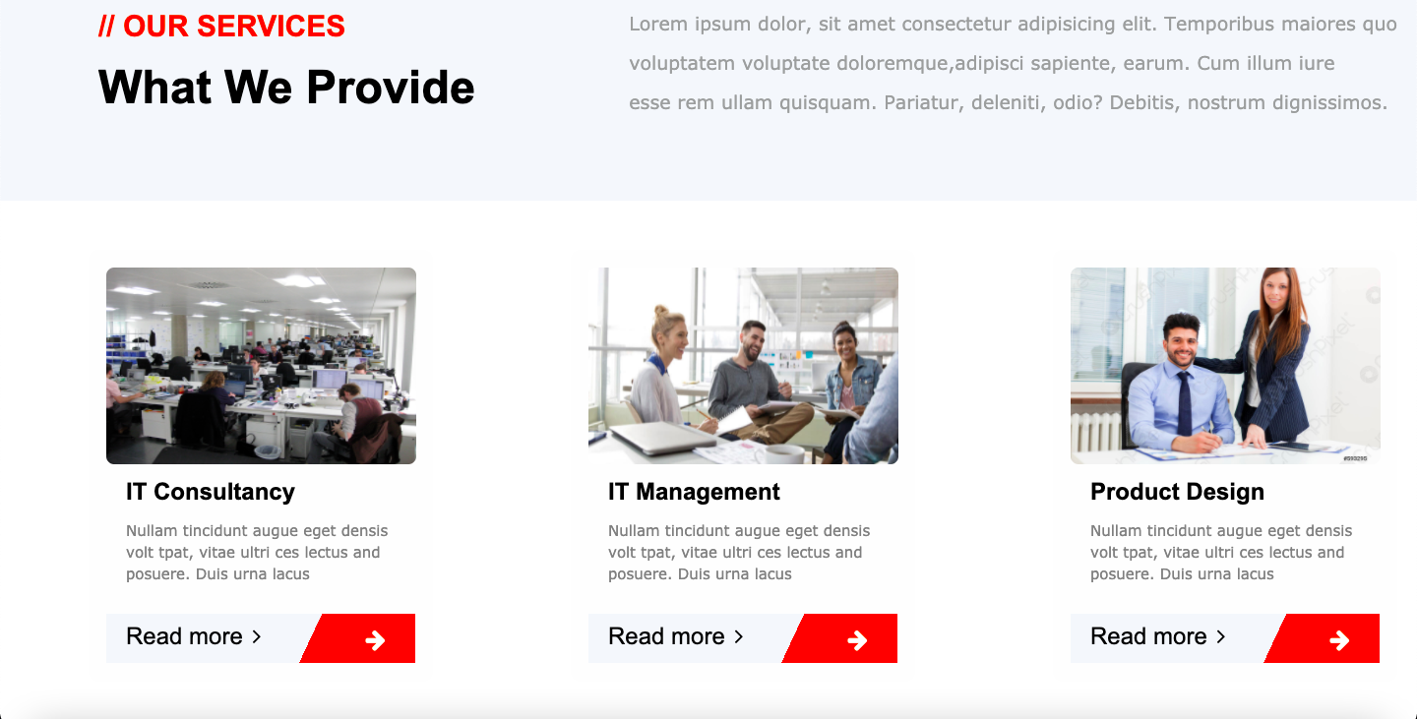

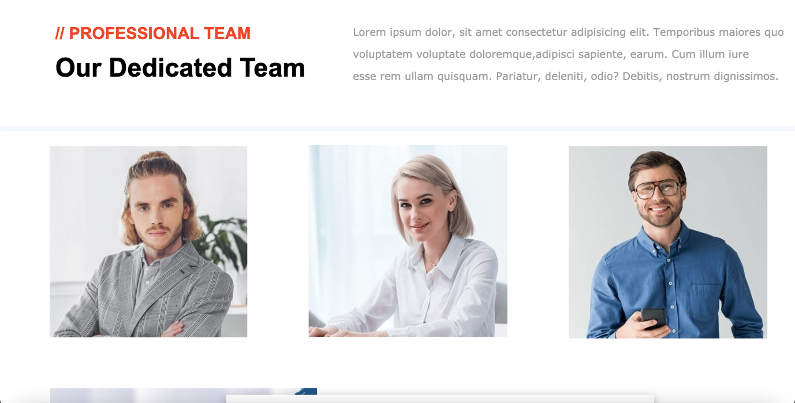

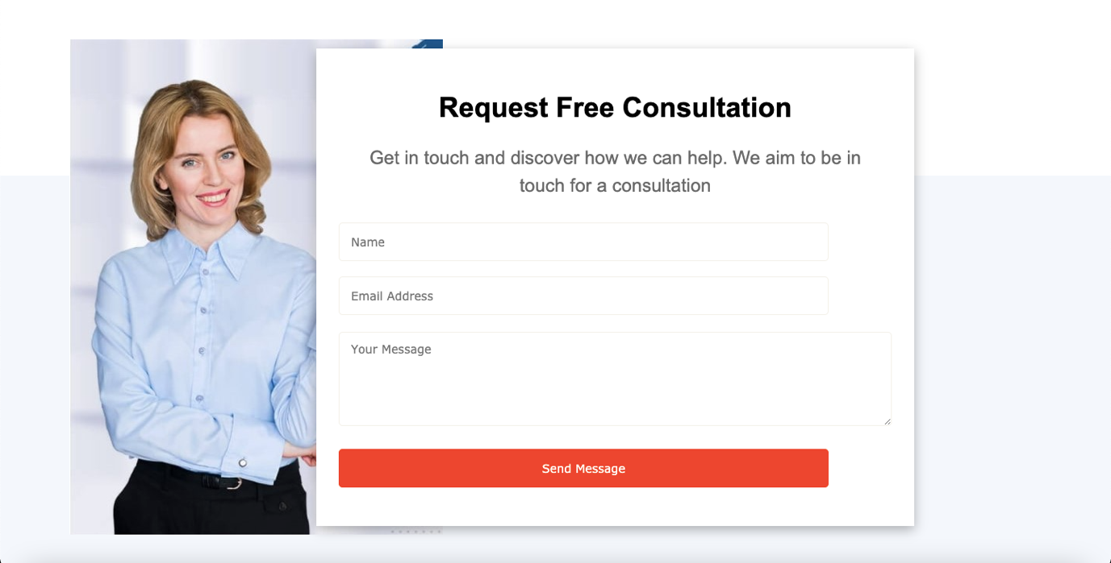

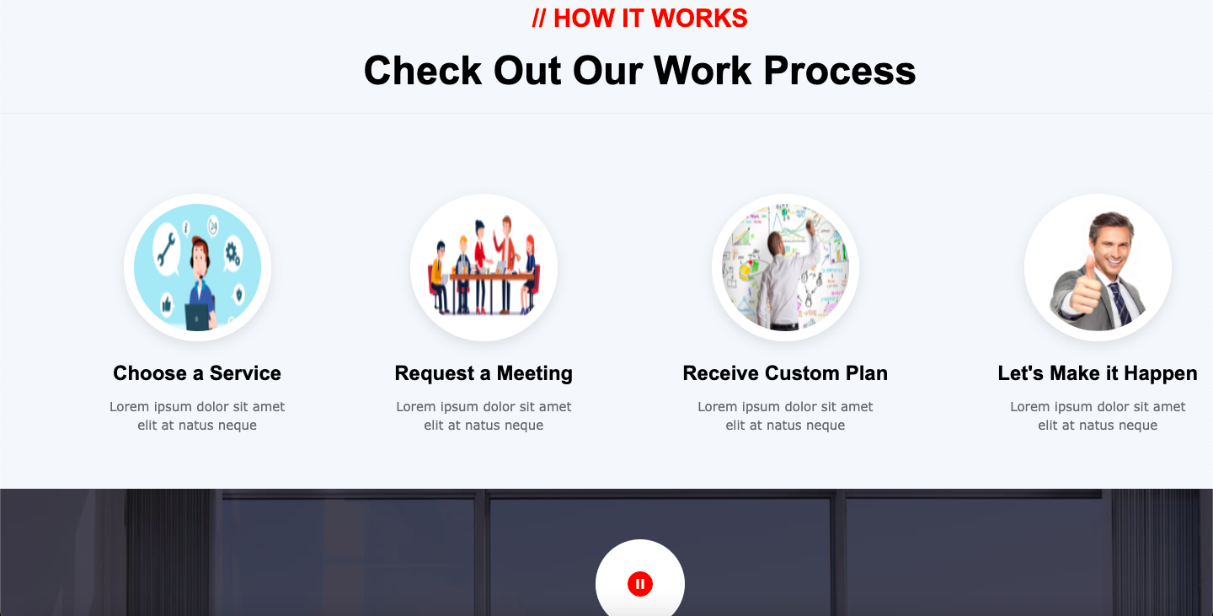



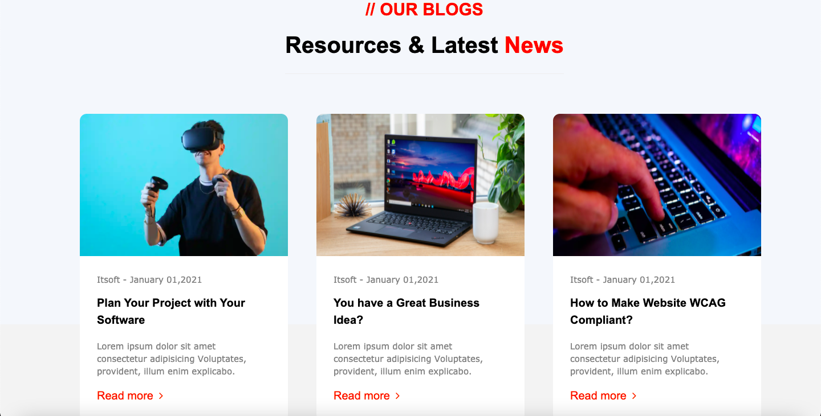

**Practical 2.1(a)**

1. **Implementation of Inline Tags**
2. **Generate Webfonts and use it in Weekly Assignment1**

**index.html**

<html>

<head>

<title>Home</title>

<link rel="stylesheet" type="text/css" href="../css/style.css">

</head>

<body>

<center>

<a href="https://en.wikipedia.org/wiki/The_Weeknd" class="toplinks">WIKIPEDIA</a>

<a href="https://www.youtube.com/channel/UC0WP5P-ufpRfjbNrmOWwLBQ" class="toplinks">YOUTUBE</a>

<a href="https://twitter.com/theweeknd" class="toplinks">TWITTER</a>

<a href="https://www.instagram.com/theweeknd/" class="toplinks">INSTAGRAM</a>

<br>

<h1><strong>THE WEEKEND</strong></h1>

<!--<video width=600 height=400 controls>

<source src="../videos/video.mp4" type="video/mp4">

</video>-->

</center>

<br><br>

<article>

<p class="p1">

<big>Abel Makkonen Tesfaye</big> (born February 16, 1990), known professionally as the Weeknd, is a Canadian singer, songwriter, and record producer. Born in Toronto and raised in Scarborough, Tesfaye began his recording career in 2009 by anonymously uploading his song "Do It" to YouTube.[1] Two years later, he met music executives Sal Slaiby and Amir Esmailian, with whom he founded XO Records.[2] He chose his stage name in tribute to when he, along with a friend, dropped out of high school at seventeen years old, took his mattress, and "left one weekend and never came home". However, his estranged former producer Jeremy Rose claims the name was his idea.[3][4] The letter E was excluded to avoid trademark problems with Canadian band the Weekend.[5][3]

Under XO, Tesfaye released his debut mixtapes: House of Balloons, Thursday, and Echoes of Silence. He quickly earned a following and critical recognition from several mainstream publications due to his dark style of Contemporary R&B and the mystique surrounding his identity.[6] In 2012, he signed with Republic Records and re-released the mixtapes in the compilation album, Trilogy. His debut studio album, Kiss Land, was released in 2013. His sophomore album, Beauty Behind the Madness (2015), with the Billboard Hot 100 number-one singles "Can't Feel My Face" and "The Hills", won Best Urban Contemporary Album and was nominated for Album of the Year at the 2016 Grammy Awards. It was among the best-selling albums of 2015.[7]

Tesfaye's third album Starboy (2016) was a similar commercial success and included the number-one single of the same name, and also won Best Urban Contemporary Album at the 2018 Grammy Awards. His fourth album, After Hours (2020), featured the Billboard Hot 100 number-one singles "Heartless", "Save Your Tears", and "Blinding Lights", the latter of which has become the first song in history to spend over a year in the top ten of the Billboard Hot 100,[8][9] and was the most streamed song on Spotify in 2020.[10]

</p><br>

<p class="p2"><em>Among the world's best selling musical artists with over 75 million records sold[11] and on the list of most-streamed artists on Spotify,[12] Tesfaye has won many accolades, including three Grammy Awards, five American Music Awards, nineteen Billboard Music Awards, two MTV Video Music Awards, fifteen Juno Awards, five SOCAN awards and one Brit Award, and has been nominated for an Academy Award.</em>[13] He holds several chart records, being the first artist to simultaneously hold the top three positions on the Billboard Hot R&B Songs chart with "Can't Feel My Face", "Earned It", and "The Hills".[14] In February 2015, he was awarded the Allan Slaight Award by Canada's Walk of Fame.[15] In 2017, he was featured on the cover of Forbes for his annual earnings of $92 million.[16] Elton John listed him as one of the 100 Most Influential People of 2020 in Time.[17] Tesfaye has a notable voice with a soaring falsetto and its singular tremolo.[18] He has influenced artists in many contemporary music styles including pop,[19] hip hop, and R&B.[20]</p><br></article>

<a href="https://www.youtube.com/watch?v=4NRXx6U8ABQ" class="bottomlinks">Blinding Lights</a><br>

<a href="https://www.youtube.com/watch?v=34Na4j8AVgA" class="bottomlinks">Starboy</a><br>

<a href="https://www.youtube.com/watch?v=yzTuBuRdAyA" class="bottomlinks">The Hills</a><br>

<a href="https://www.youtube.com/watch?v=KEI4qSrkPAs" class="bottomlinks">Cant't Feel My Face</a><br>

<a href="https://www.youtube.com/watch?v=waU75jdUnYw" class="bottomlinks">Earned It</a><br>

<!--<audio controls>

<source src="../audio/audio.mp3" type="audio/mp3">

</audio>-->

</p><br>

<h1 align="center"><strong>THE WEEKEND</strong></h2>

</body>

</html>

**style.css**

*{

padding: 10px;

margin: 0px;

}

body{

background-image: url(../images/the-weeknd.jpeg) ;

}

.toplinks{

color: black;

background-color: #CABAAB;

line-height: 40px;

font-size: 20px;

font-family: century gothic;

text-decoration: none;

padding: 5px 10px;

margin: 15px 15px;

border: 3px solid black;

}

.toplinks:hover{

color: antiquewhite;

border-color: #BF04A0;

}

.bottomlinks{

color: antiquewhite;

background-color: #7D6B7D;

line-height: 50px;

font-size: 22px;

font-family: century gothic;

border-radius: 10px;

text-decoration: none;

padding: 8px 20px;

margin: 15px 5px;

}

.bottomlinks:hover{

color: black;

background-color: whitesmoke;

text-decoration: underline;

}

h1{

background-color: #FFF587;

color: #FF665A;

font-family: calibri;

font-size: 50px;

}

.p1{

font-family: century schoolbook;

font-weight: bold;

font-size: 24px;

border: 5px solid black;

border-color: black;

color: #9ACFDD;

line-height: 75px;

margin: 15px;

padding: 15px;

background-color: #D90B1C;

background-size: 512px 800px;

background-blend-mode: overlay;

}

.p2{

font-family: sans-serif;

font-weight: bolder;

font-size: 21px;

border-radius: 20px;

color: #93A603;

line-height: 50px;

padding: 20px 30px;

margin: 15px;

background-color: #45594E;

}

audio{

margin: 5px;

height: 30px;

background-color: magenta;

border-radius: 10px;

}

video{

border: 2px solid darkmagenta;

border-radius: 30px;

margin-top: 50px;

}

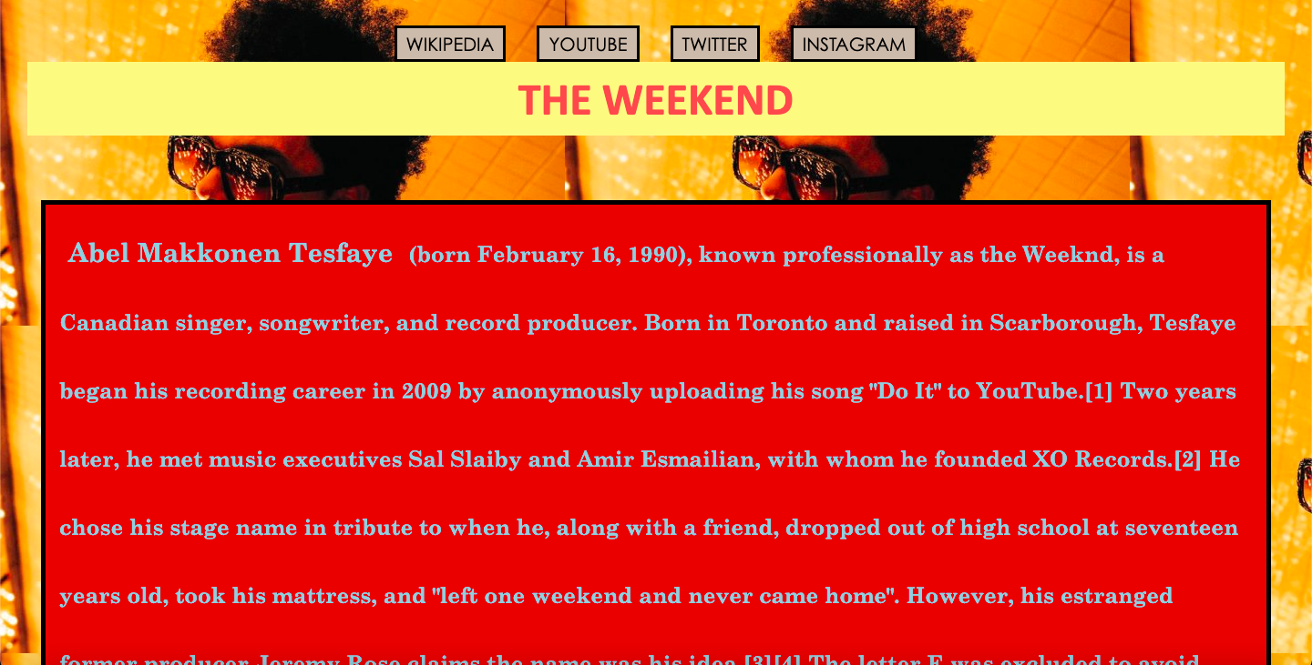

**Practical 2.1(b)**

**Implement the Concept of Sliders on 5 different webpages, each webpage must have a different type of slider. Also, Use OWL Slider in Weekly Assignment 1.**

**index.html**

<html>

<head>

<title>Home</title>

<link rel="stylesheet" type="text/css" href="../css/stylesheet.css">

</head>

<body class="b1">

<h1><a href="index.html">Sliders</a></h1>

<ul>

<li><a href="nivo.html">nivo slider</a></li>

<li><a href="bx.html">bx slider</a></li>

<li><a href="mini.html">mini slider</a></li>

<li><a href="window.html">window slider</a></li>

<li><a href="tinycircle.html">tiny slider</a></li>

</ul>

</body>

</html>

**stylesheet.css**

.b1{

background-color: #90CBFB;

text-align: center;

}

h1{

font-size: 70;

font-family: sans-serif;

color: #110066;

background-color: #FFFFFF;

}

h1 a{

text-decoration: none;

}

ul{}

ul li{

list-style-type: none;

float: left;

font-size: 25;

color: #110066;

padding-left: 40;

}

ul li a{

text-decoration: none;

}

ul li a:hover{

background-color: #FFFFFF;

}

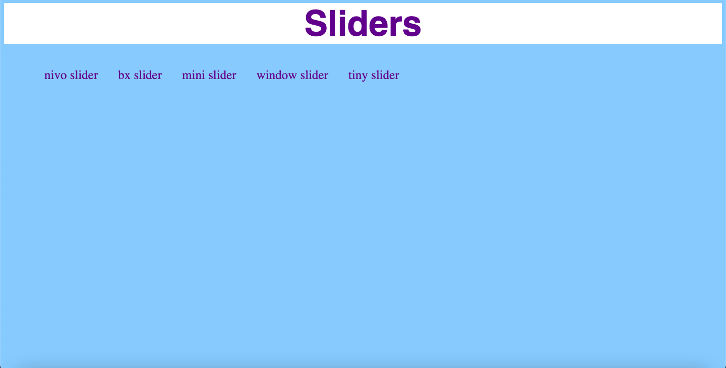

**nivo.html**

<html>

<head>

<title>nivo</title>

<link rel="stylesheet" type="text/css" href="../css/stylesheet.css">

<link rel="stylesheet" href="../themes/default/default.css" type="text/css" media="screen" />

<link rel="stylesheet" href="../themes/light/light.css" type="text/css" media="screen" />

<link rel="stylesheet" href="../themes/dark/dark.css" type="text/css" media="screen" />

<link rel="stylesheet" href="../themes/bar/bar.css" type="text/css" media="screen" />

<link rel="stylesheet" href="../css/nivo-slider.css" type="text/css" media="screen" />

<link rel="stylesheet" href="../demo/style.css" type="text/css" media="screen" />

</head>

<body class="b1">

<h1><a href="index.html">Sliders</a></h1>

<ul>

<li><a href="nivo.html">nivo slider</a></li>

<li><a href="bx.html">bx slider</a></li>

<li><a href="mini.html">mini slider</a></li>

<li><a href="window.html">window slider</a></li>

<li><a href="tinycircle.html">tiny slider</a></li>

</ul>

<div id="wrapper">

<div class="slider-wrapper theme-default">

<div id="slider" class="nivoSlider"> <img src="../demo/images/toystory.jpg" data-thumb="../demo/images/toystory.jpg" alt="" /> <a href=""><img src="../demo/images/up.jpg" data-thumb="../demo/images/up.jpg" alt="" title="" /></a> <img src="../demo/images/walle.jpg" data-thumb="../demo/images/walle.jpg" alt="" data-transition="slideInLeft" /> <img src="../demo/images/nemo.jpg" data-thumb="../demo/images/nemo.jpg" alt="" title="" /> </div>

</div>

</div>

<script src="http://ajax.googleapis.com/ajax/libs/jquery/1.10.2/jquery.min.js"></script>

<script type="text/javascript" src="../js/jquery.nivo.slider.js"></script>

<script type="text/javascript">

$(window).load(function() {

$('#slider').nivoSlider();

});

</script>

<script type="text/javascript">

var _gaq = _gaq || [];

_gaq.push(['_setAccount', 'UA-36251023-1']);

_gaq.push(['_setDomainName', 'jqueryscript.net']);

_gaq.push(['_trackPageview']);

(function() {

var ga = document.createElement('script'); ga.type = 'text/javascript'; ga.async = true;

ga.src = ('https:' == document.location.protocol ? 'https://ssl' : 'http://www') + '.google-analytics.com/ga.js';

var s = document.getElementsByTagName('script')[0]; s.parentNode.insertBefore(ga, s);

})();

</script>

</body>

</html>

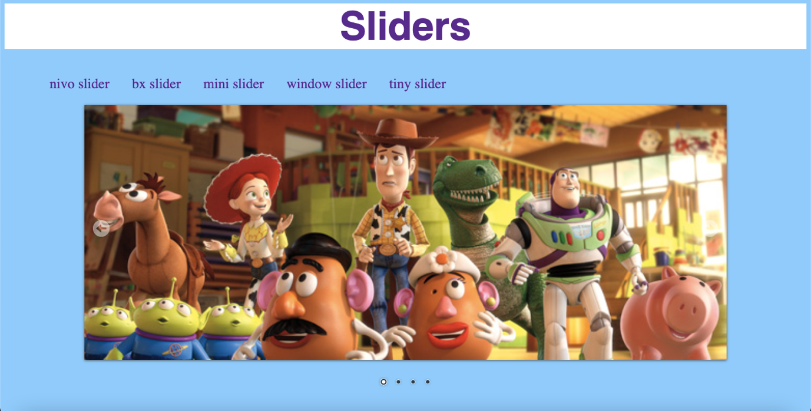

**bx.html**

<html>

<head>

<title>bx</title>

<link rel="stylesheet" type="text/css" href="../css/stylesheet.css">

<link rel="stylesheet" href="https://cdn.jsdelivr.net/bxslider/4.2.12/jquery.bxslider.css">

<script src="https://ajax.googleapis.com/ajax/libs/jquery/3.1.1/jquery.min.js"></script>

<script src="https://cdn.jsdelivr.net/bxslider/4.2.12/jquery.bxslider.min.js"></script>

<script>

$(document).ready(function(){

$('.slider').bxSlider();

});

</script>

</head>

<body class="b1">

<h1><a href="index.html">Sliders</a></h1>

<ul>

<li><a href="nivo.html">nivo slider</a></li>

<li><a href="bx.html">bx slider</a></li>

<li><a href="mini.html">mini slider</a></li>

<li><a href="window.html">window slider</a></li>

<li><a href="tinycircle.html">tiny slider</a></li>

</ul>

<br>

<br>

<br>

<div class="slider" align="center">

<div><img src="../images/hdr2.jpg" /></div>

<div><img src="../images/hdr1.jpg" /></div>

<div><img src="../images/hdr4.jpg" /></div>

</div>

</body>

</html>

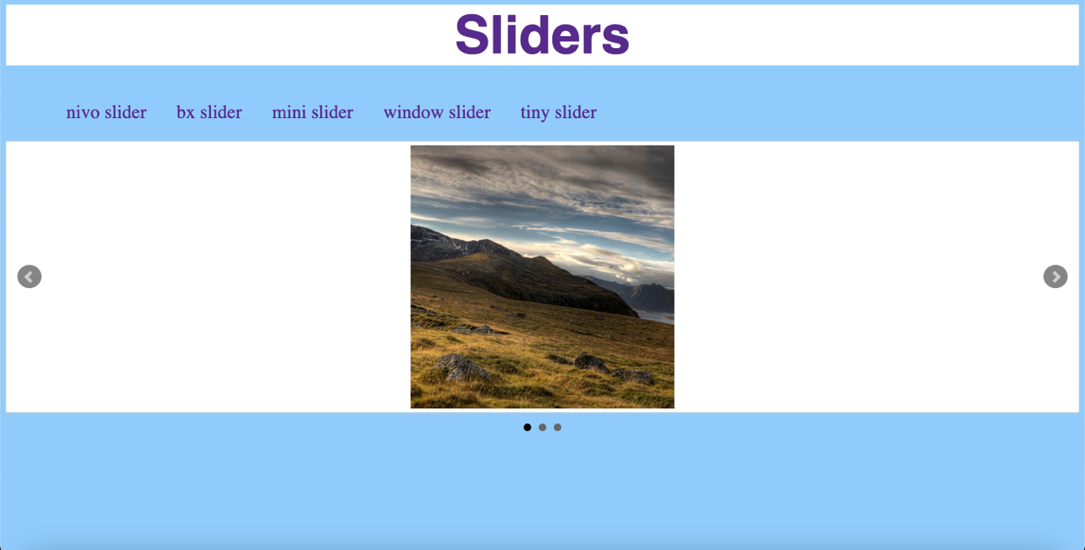

**mini.html**

<html>

<head>

<title>mini</title>

<link rel="stylesheet" type="text/css" href="../css/stylesheet.css">

<link rel="stylesheet" href="../css/site.css">

<script src="http://html5shiv.googlecode.com/svn/trunk/html5.js"></script>

</head>

<body class="b1">

<h1><a href="index.html">Sliders</a></h1>

<ul>

<li><a href="nivo.html">nivo slider</a></li>

<li><a href="bx.html">bx slider</a></li>

<li><a href="mini.html">mini slider</a></li>

<li><a href="window.html">window slider</a></li>

<li><a href="tinycircle.html">tiny slider</a></li>

</ul>

<br>

<br>

<br>

<div id="main">

<div id="main-inner">

<div id="slider">

<img src="../images/mini-slider-1.jpeg" width="958" height="298" />

<img src="../images/mini-slider-2.jpeg" width="958" height="298" />

<img src="../images/mini-slider-3.jpeg" width="958" height="298" />

<img src="../images/mini-slider-4.jpeg" width="958" height="298" />

</div>

</div>

<footer>

</footer>

</div>

<!-- end of #container -->

<script src="../js/jquery.min.js"></script>

<script src="../js/miniSlider.js"></script>

<script>

$(function() {

$('#slider').miniSlider();

});

</script>

</body>

</html>

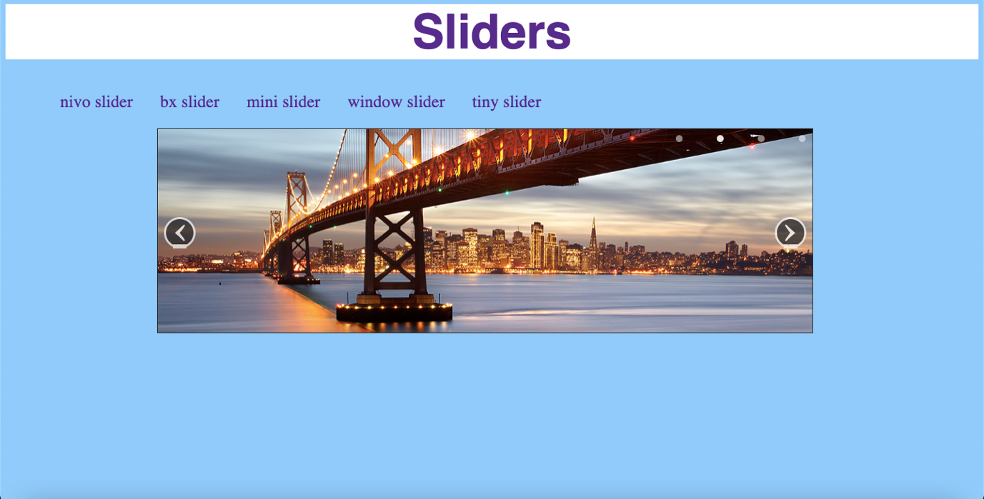

**window.html**

<html>

<head>

<title>window</title>

<link rel="stylesheet" type="text/css" href="../css/stylesheet.css">

<link rel="stylesheet" type="text/css" href="../css/window.slider.css"/>

</head>

<body class="b1">

<h1><a href="index.html">Sliders</a></h1>

<ul>

<li><a href="nivo.html">nivo slider</a></li>

<li><a href="bx.html">bx slider</a></li>

<li><a href="mini.html">mini slider</a></li>

<li><a href="window.html">window slider</a></li>

<li><a href="tinycircle.html">tiny slider</a></li>

</ul>

<br>

<br>

<br>

<div id="slider-1" class="window-slider">

<!-- TOP LEFT SLIDER -->

<div class="tl-window">

<img src="https://placeimg.com/400/250/tech/sepia">

<img src="https://placeimg.com/400/250/tech">

</div>

<!-- TOP RIGHT SLIDER -->

<div class="tr-window">

<img src="https://placeimg.com/400/250/nature/grayscale">

<img src="https://placeimg.com/400/250/nature">

</div>

<!-- BOTTOM LEFT SLIDER -->

<div class="bl-window">

<img src="https://placeimg.com/400/250/arch">

<img src="https://placeimg.com/400/250/arch/sepia">

</div>

<!-- BOTTOM RIGHT SLIDER -->

<div class="br-window">

<img src="https://placeimg.com/400/250/animals">

<img src="https://placeimg.com/400/250/animals/grayscale">

</div>

</div>

<link rel="stylesheet" type="text/css" href="../css/window.slider.css"/>

<script src="//ajax.googleapis.com/ajax/libs/jquery/1.7.1/jquery.min.js"></script>

<script src="../js/window.slider.js"></script>

<script type="text/javascript">

$(document).ready(function() {

$('#slider-1').windowSlider();

});

</script>

</body>

</html>

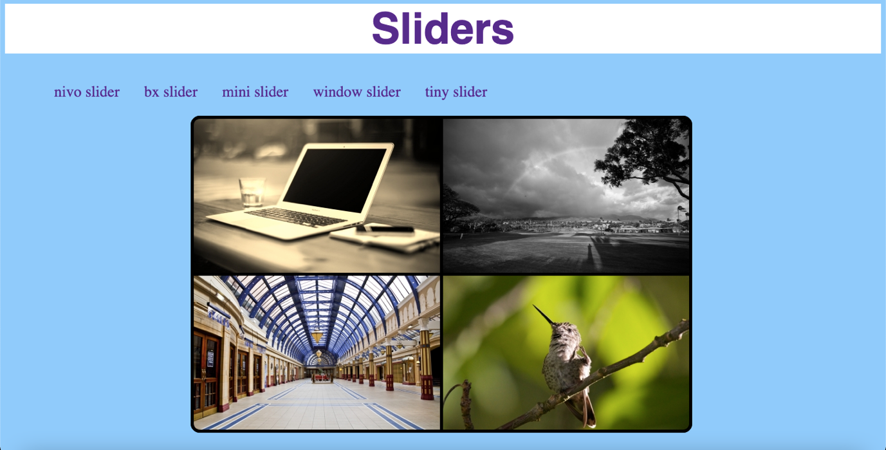

**tinycircle.html**

<html>

<head>

<title>tiny</title>

<link rel="stylesheet" type="text/css" href="../css/stylesheet.css">

<link rel="stylesheet" href="../css/tinycircleslider.css" type="text/css" media="screen"/>

<script type="text/javascript" src="https://ajax.googleapis.com/ajax/libs/jquery/1.7.2/jquery.min.js"></script>

<!-- build:js jquery.tinycircleslider.js -->

<script type="text/javascript" src="../js/jquery.tinycircleslider.js"></script>

<!-- /build -->

<script type="text/javascript">

$(document).ready(function()

{

$('#rotatescroll').tinycircleslider({ interval: true, dotsSnap: true, dotsHide: false });

});

</script>

</head>

<body class="b1">

<h1><a href="index.html">Sliders</a></h1>

<ul>

<li><a href="nivo.html">nivo slider</a></li>

<li><a href="bx.html">bx slider</a></li>

<li><a href="mini.html">mini slider</a></li>

<li><a href="window.html">window slider</a></li>

<li><a href="tinycircle.html">tiny slider</a></li>

</ul>

<br>

<br>

<br>

<div id="rotatescroll">

<div class="viewport">

<ul class="overview">

<li><img src="../images/hdr3.jpg" /></li>

<li><img src="../images/hdr2.jpg" /></li>

<li><img src="../images/hdr1.jpg" /></li>

<li><img src="../images/hdr4.jpg" /></li>

<li><img src="../images/hdr5.jpg" /></li>

</ul>

</div>

<div class="dot"></div>

<div class="overlay"></div>

<div class="thumb"></div>

</div>

</body>

</html>

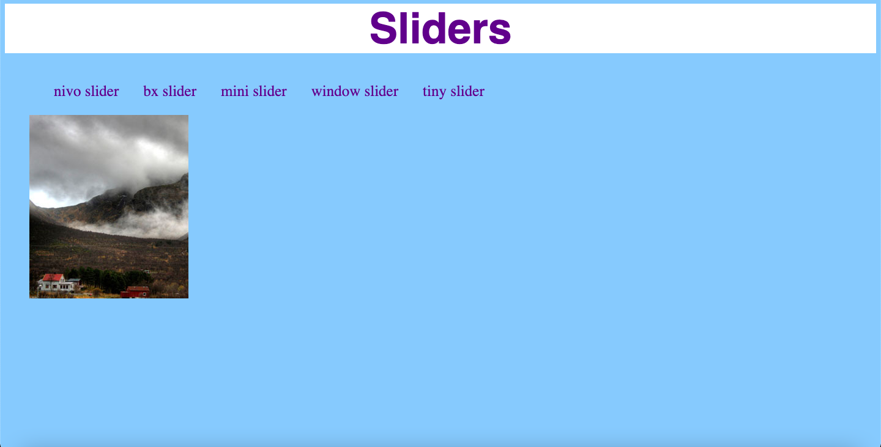

**Practical 2.2**

**1. Create a Dropdown Link in Navigation Bar (Hint - Use Nesting of List)**

**2. Do Styling of Form**

**3. Place Border of Table using CSS also implement different CSS properties on Tables**

**index.html**

<html>

<head><title>Home</title>

<link rel="stylesheet" href="../css/style.css">

</head>

<body>

<nav>

<a class="links" href="#">Home</a>

<div class="dropdown-menu">

<button class="menu-btn">Open</button>

<div class="menu-content">

<a class="links-hidden" href="#">Contact Us</a>

<a class="links-hidden" href="#">Visit Us</a>

<a class="links-hidden" href="#">About Us</a>

</div>

</div>

</nav>

<br>

<div class="container">

<form action="">

<div class="row">

<div class="col-25">

<label for="fname">First Name:</label>

</div>

<div class="col-75">

<input type="text" id="fname" name="firstname" placeholder="Your name..">

</div>

</div>

<div class="row">

<div class="col-25">

<label for="lname">Last Name:</label>

</div>

<div class="col-75">

<input type="text" id="lname" name="lastname" placeholder="Your last name..">

</div>

</div>

<div class="row">

<div class="col-25">

<label for="country">Country:</label>

</div>

<div class="col-75">

<select id="country" name="country">

<option value="">--select--</option>

<option value="india">India</option>

<option value="australia">Australia</option>

<option value="canada">Canada</option>

<option value="usa">USA</option>

</select>

</div>

</div>

<div class="row">

<div class="col-25">

<label for="subject">Message:</label>

</div>

<div class="col-75">

<textarea id="subject" name="subject" placeholder="Your message.." style="height:200px"></textarea>

</div>

</div>

<div class="row">

<input type="submit" value="Submit">

</div>

</form>

</div>

<br>

<table>

<tr>

<th>First name</th>

<th>Last name</th>

<th>Country</th>

</tr>

<tr>

<td>Rahul</td>

<td>Arora</td>

<td>India</td>

</tr>

<tr>

<td>Mark</td>

<td>Jackson</td>

<td>USA</td>

</tr>

</table>

</body>

</html>

**style.css**

.menu-btn {

background-color: #000;

color: white;

padding: 16px;

font-size: 20px;

font-weight: bolder;

font-family: sans-serif;

border: none;

}

.dropdown-menu {

position: relative;

display: inline-block;

}

.menu-content {

display: none;

position: absolute;

background-color: #9ACFDD;

min-width: 160px;

}

nav{

background-color: #9ACFDD;

}

.links,.links-hidden{

display: inline-block;

color: rgb(255, 255, 255);

padding: 12px 16px;

text-decoration: none;

font-size: 18px;

font-weight: bold;

}

.links-hidden{

display: block;

}

.links{

display: inline-block;

}

.links-hidden:hover,.links:hover {

background-color: #3e8e41;

}

.dropdown-menu:hover .menu-content {

display: block;

}

.dropdown-menu:hover .menu-btn {

background-color: #3e8e41;

}

input[type=text], select, textarea{

width: 100%;

padding: 12px;

border: 1px solid #ccc;

border-radius: 4px;

box-sizing: border-box;

resize: vertical;

}

label {

padding: 12px 12px 12px 0;

display: inline-block;

color: white;

}

input[type=submit] {

background-color: #0056AE;

color: white;

padding: 12px 20px;

border-radius: 4px;

float: right;

}

.container {

border-radius: 5px;

background-color: #CABAAB;

padding: 20px;

}

.col-25 {

float: left;

width: 25%;

margin-top: 6px;

}

.col-75 {

float: left;

width: 75%;

margin-top: 6px;

}

.row:after {

content: "";

display: table;

clear: both;

}

table{

width: 100%;

height: 200px;

background-color: #FAF566;

color: #D90B1C;

}

table, th, td {

border: 1px solid #CABAAB;

}

th{

padding: 10;

}

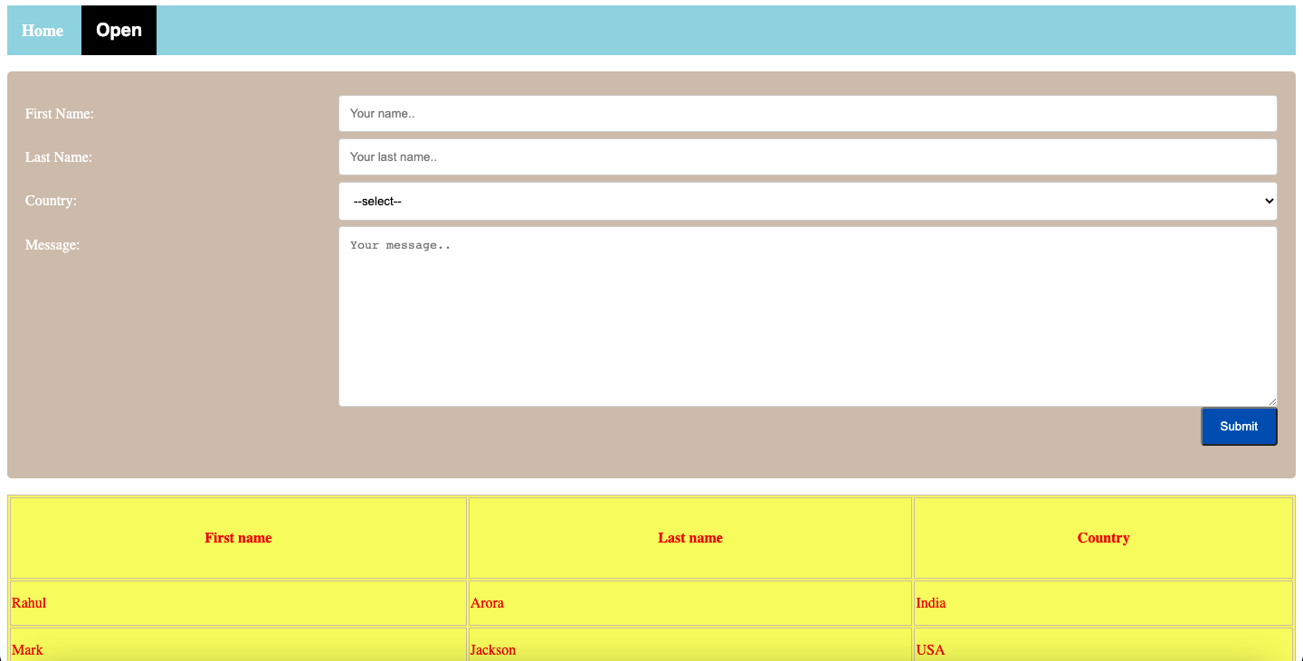

**Practical 2.3(a)**

**Implement LightBox and other 2-3 Image Gallery Platforms**

**index.html**

<html>

<head>

<title>Gallery</title>

<link rel="stylesheet" href="../css/lightbox.min.css">

<link rel="stylesheet" type="text/css" href="../css/hexagon.css">

<link rel="stylesheet" type="text/css" href="../css/flip.css">

</head>

<body style="color: EEEEEE; background-color: 00C1D4; height: 100%; margin: 40;">

<h1>Image Gallery</h1>

<br>

<h3>Lightbox</h3>

<div>

<a class="example-image-link" href="http://lokeshdhakar.com/projects/lightbox2/images/image-3.jpg" data-lightbox="example-set" data-title="Click the right half of the image to move forward."><img class="example-image" src="http://lokeshdhakar.com/projects/lightbox2/images/thumb-3.jpg" alt=""/></a>

<a class="example-image-link" href="http://lokeshdhakar.com/projects/lightbox2/images/image-4.jpg" data-lightbox="example-set" data-title="Or press the right arrow on your keyboard."><img class="example-image" src="http://lokeshdhakar.com/projects/lightbox2/images/thumb-4.jpg" alt="" /></a>

<a class="example-image-link" href="http://lokeshdhakar.com/projects/lightbox2/images/image-5.jpg" data-lightbox="example-set" data-title="The next image in the set is preloaded as you're viewing."><img class="example-image" src="http://lokeshdhakar.com/projects/lightbox2/images/thumb-5.jpg" alt="" /></a>

<a class="example-image-link" href="http://lokeshdhakar.com/projects/lightbox2/images/image-6.jpg" data-lightbox="example-set" data-title="Click anywhere outside the image or the X to the right to close."><img class="example-image" src="http://lokeshdhakar.com/projects/lightbox2/images/thumb-6.jpg" alt="" /></a>

</div>

<script src="..//js/lightbox-plus-jquery.min.js"></script>

<br>

<h3>Hexagon</h3>

<div class="hexagon">

<div class = "gallery">

<div class="clipped-border">

<img src="https://proxy.duckduckgo.com/iu/?u=http%3A%2F%2Fwww.gettyimages.com.au%2Fgi-resources%2Fimages%2Ffrontdoor%2Fcreative%2FPanoramicImagesRM%2FFD_image.jpg&f=1" id="clipped">

</div>

<div class="clipped-border">

<img src="https://proxy.duckduckgo.com/iu/?u=http%3A%2F%2Fbpucette.b.p.pic.centerblog.net%2Ffv86ll9r.jpg&f=1" id="clipped">

</div>

<div class="clipped-border">

<img src="https://proxy.duckduckgo.com/iu/?u=https%3A%2F%2Fimagejournal.org%2Fwp-content%2Fuploads%2Fbb-plugin%2Fcache%2F23466317216_b99485ba14_o-panorama.jpg&f=1" id="clipped">

</div>

<div class="clipped-border">

<img src="https://proxy.duckduckgo.com/iu/?u=http%3A%2F%2Fwww.lokeshdhakar.com%2Fprojects%2Flightbox2%2Fimages%2Fimage-4.jpg&f=1" id="clipped">

</div>

<div class="clipped-border">

<img src="https://images.pexels.com/photos/932638/pexels-photo-932638.jpeg?auto=compress&cs=tinysrgb&dpr=2&h=750&w=1260" id="clipped">

</div>

<div class = "shadow"></div>

</div>

</div>

<h3>Split</h3>

<div class="flip">

<ul>

<li>

<span>New York</span>

<img src='http://i1276.photobucket.com/albums/y465/gaeowyn/new_york_city_2-wallpaper-960x540_zpsce336d7f.jpg' /></li>

<li>

<span>London</span>

<img src='http://i1276.photobucket.com/albums/y465/gaeowyn/london_in_black_and_white-wallpaper-960x540_zpsa7fa9d45.jpg' /></li>

<li>

<span>Poznań</span>

<img src='http://i1276.photobucket.com/albums/y465/gaeowyn/poznan_poland-wallpaper-960x540_zps6a5470ed.jpg' /></li>

<li>

<span>Chicago</span>

<img src='http://i1276.photobucket.com/albums/y465/gaeowyn/cityscape_skyline_chicago_sculpture-wallpaper-960x540_zps19c2d09d.jpg' />

</li>

<li>

<span>Golden Gate</span>

<img src='http://i1276.photobucket.com/albums/y465/gaeowyn/golden_gate_in_fog-wallpaper-960x540_zps1f6fc1af.jpg' />

</li>

</ul></body>

<div>

</body>

</html>

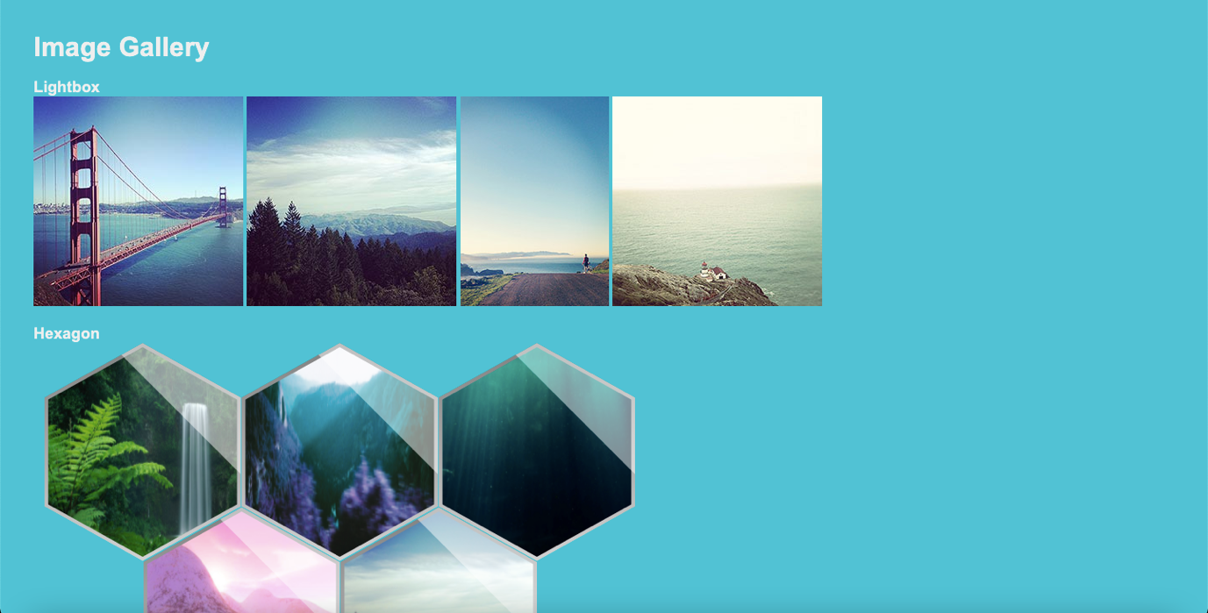

**Practical 2.3(b)**

**Create this webpage with exact spacing, use Fluid and Container Concept.**

**Font to be Used – OpenSans**

**index.html**

<html>

<head>

<title>Home</title>

<link rel="stylesheet" type="text/css" href="../css/style.css">

<!-- font -->

<link rel="preconnect" href="https://fonts.googleapis.com">

<link rel="preconnect" href="https://fonts.gstatic.com" crossorigin>

<link href="https://fonts.googleapis.com/css2?family=Open+Sans&display=swap" rel="stylesheet">

<!-- icon -->

<link href = "https://fonts.googleapis.com/icon?family=Material+Icons" rel = "stylesheet">

<!-- slider -->

<link rel="stylesheet" href="../css/slider.css" type="text/css" media="screen" />

<!-- image galley -->

<link rel="stylesheet" type="text/css" href="../css/lightbox.min.css">

</head>

<body>

<div class="header">

<i class = "material-icons">public</i>

Email-abc@xyz.com<br> Call-123112

</div>

<div class="navbar">

<a href="#home">Home</a>

<a href="#news">About Us</a>

<div class="dropdown">

<button class="dropbtn">Dropdown

<i class="fa fa-caret-down"></i>

</button>

<div class="dropdown-content">

<a href="#">Link 1</a>

<a href="#">Link 2</a>

<a href="#">Link 3</a>

</div>

</div>

</div>

<div class="h">

Lorem ipsum dolor, sit amet, consectetur adipisicing elit. Corrupti officiis necessitatibus recusandae sequi ab incidunt neque nemo fugiat, laudantium sit asperiores, reiciendis consequatur assumenda exercitationem nostrum odit. Laudantium corrupti, nulla.<br>

<br><br><br>

<a href="tel:123112">Call us</a><br><br>

<a href="mailto:123112">Email us</a>

</div>

<div>

<table>

<tr>

<td><img src="https://encrypted-tbn0.gstatic.com/images?q=tbn:ANd9GcRH1kzCIvgCKQy7lQB8W99K5NHJ61quuqnPZw&usqp=CAU"></td>

<td>Lorem ipsum dolor, sit amet consectetur, adipisicing elit. Ullam, quos. Earum temporibus minus architecto officia nostrum accusamus veritatis quasi sed nam dicta enim corrupti necessitatibus voluptatem, iusto, aspernatur minima commodi.</td>

</tr>

<tr>

<td>Lorem ipsum dolor sit amet consectetur adipisicing, elit. Eum, necessitatibus. Veniam repellendus impedit facere provident vitae iste, eveniet quos nulla facilis eius ex atque dignissimos. Magnam quis doloribus voluptate, architecto.</td>

<td>

<style>

.fadein { position:relative; height:300px; width:500px; }

.fadein img { position:absolute; left:0; top:0; }

</style>

<script type="text/javascript" src="http://www.hscripts.com/jquery.js"></script>

<script type="text/javascript">

$(function(){

$('.fadein img:gt(0)').hide();

setInterval(function(){$('.fadein :first-child').fadeOut().next('img').fadeIn().end().appendTo('.fadein');}, 2000);

});

</script>

<div class="fadein">

<img src="https://cdn.vox-cdn.com/thumbor/Ohs67lw4c_o3gsdWjwgRCmWdm6U=/1400x788/filters:format(jpeg)/cdn.vox-cdn.com/uploads/chorus_asset/file/13074037/hs-2014-27-a-print.0.0.1486275780.jpg" alt="Image Slideshow Script">

<img src="https://static.theprint.in/wp-content/uploads/2020/03/minor-planets.jpg" alt="Image Slideshow Script">

<img src="https://encrypted-tbn0.gstatic.com/images?q=tbn:ANd9GcTtiVrERaLq5dpJ14TbtTVEmaisX9gFUk8hhg&usqp=CAU" alt="Image Slideshow Script">

</div>

</td>

</tr>

</table>

</div>

<div>

<div class="slideshow-container">

<div class="mySlides">

<q>I love you the more in that I believe you had liked me for my own sake and for nothing else</q>

<p class="author">- John Keats</p>

</div>

<div class="mySlides">

<q>But man is not made for defeat. A man can be destroyed but not defeated.</q>

<p class="author">- Ernest Hemingway</p>

</div>

<div class="mySlides">

<q>I have not failed. I've just found 10,000 ways that won't work.</q>

<p class="author">- Thomas A. Edison</p>

</div>

<a class="prev" onclick="plusSlides(-1)">❮</a>

<a class="next" onclick="plusSlides(1)">❯</a>

</div>

<div class="dot-container">

<span class="dot" onclick="currentSlide(1)"></span>

<span class="dot" onclick="currentSlide(2)"></span>

<span class="dot" onclick="currentSlide(3)"></span>

</div>

<script>

var slideIndex = 1;

showSlides(slideIndex);

function plusSlides(n) {

showSlides(slideIndex += n);

}

function currentSlide(n) {

showSlides(slideIndex = n);

}

function showSlides(n) {

var i;

var slides = document.getElementsByClassName("mySlides");

var dots = document.getElementsByClassName("dot");

if (n > slides.length) {slideIndex = 1}

if (n < 1) {slideIndex = slides.length}

for (i = 0; i < slides.length; i++) {

slides[i].style.display = "none";

}

for (i = 0; i < dots.length; i++) {

dots[i].className = dots[i].className.replace(" active", "");

}

slides[slideIndex-1].style.display = "block";

dots[slideIndex-1].className += " active";

}

</script>

</div>

<div class="gallery">

<strong>Image Gallery</strong>

<div>

<a class="example-image-link" href="https://africanews.space/wp-content/uploads/2021/01/space-debris-junk-africa-cleanup.jpg" data-lightbox="example-set"><img class="example-image" src="https://africanews.space/wp-content/uploads/2021/01/space-debris-junk-africa-cleanup.jpg" alt=""/></a>

<a class="example-image-link" href="https://static.independent.co.uk/2021/06/04/10/DESY_GRB_still_1.jpeg?width=1200" data-lightbox="example-set"><img class="example-image" src="https://static.independent.co.uk/2021/06/04/10/DESY_GRB_still_1.jpeg?width=1200" alt="" /></a>

<a class="example-image-link" href="https://thumbs-prod.si-cdn.com/5IC2_-4TL008uHd3srmFFYh_LwU=/800x450/filters:focal(2989x1536:2990x1537)/https://public-media.si-cdn.com/filer/35/3b/353b17c0-cd7b-4625-9f97-f3c3ef59055e/gettyimages-1229960181.jpg" data-lightbox="example-set" ><img class="example-image" src="https://thumbs-prod.si-cdn.com/5IC2_-4TL008uHd3srmFFYh_LwU=/800x450/filters:focal(2989x1536:2990x1537)/https://public-media.si-cdn.com/filer/35/3b/353b17c0-cd7b-4625-9f97-f3c3ef59055e/gettyimages-1229960181.jpg" alt="" /></a>

<a class="example-image-link" href="https://encrypted-tbn0.gstatic.com/images?q=tbn:ANd9GcTna_QMTdrKfaibyBB8CeN2vQ4H6Iq4kU2RHg&usqp=CAU" data-lightbox="example-set"><img class="example-image" src="https://encrypted-tbn0.gstatic.com/images?q=tbn:ANd9GcTna_QMTdrKfaibyBB8CeN2vQ4H6Iq4kU2RHg&usqp=CAU" alt="" /></a>

<a class="example-image-link" href="https://cdn.mos.cms.futurecdn.net/Gw9wVjyJYuLAuaeM6z4n6W-1200-80.jpg" data-lightbox="example-set"><img class="example-image" src="https://cdn.mos.cms.futurecdn.net/Gw9wVjyJYuLAuaeM6z4n6W-1200-80.jpg" alt="" /></a>

<a class="example-image-link" href="https://images.ctfassets.net/cnu0m8re1exe/2DYsgTu86tZd9Yh3CfwToQ/971c67e0330015b3fd371a2f1767311b/heic0301a.jpg?fm=jpg&fl=progressive&w=660&h=433&fit=fill" data-lightbox="example-set"><img class="example-image" src="https://images.ctfassets.net/cnu0m8re1exe/2DYsgTu86tZd9Yh3CfwToQ/971c67e0330015b3fd371a2f1767311b/heic0301a.jpg?fm=jpg&fl=progressive&w=660&h=433&fit=fill" alt="" /></a>

</div>

<script src="../js/lightbox-plus-jquery.min.js"></script>

</div>

<div class="footer">

<hr>

<div class="divf">

<div class="f">

<h2>Explore</h2>

<a href="">Home</a><br>

<a href="">About Us</a><br>

<a href="">Contact Us</a>

</div>

<div class="f">

<h2>Visit</h2>

Address-#abc,st.-4,qaz<br>

Email-abc@xyz.com<br>

Phone no.-123112

</div>

<div class="f">

<h2>Follow</h2>

<a href="">Twitter</a><br>

<a href="">Instagram</a><br>

<a href="">Linkedin</a>

</div>

<div class="f">

<h2>Legal</h2>

<a href="">Terms</a><br>

<a href="">Policies</a><br><br><br>

</div>

</div>

<hr>

<i class="material-icons">copyright</i>2021 Rohit. All Rights Reserved.

</div>

</body>

</html>

**style.css**

body{

font-family: 'Open Sans', sans-serif;

}

/* header */

.header{

padding: 10px;

background-color: #5A37A6;

color: white;

display: flex;

justify-content: space-between;

}

/* Navbar */

.navbar {

overflow: hidden;

background-color: #121926;

}

.navbar a {

float: left;

font-size: 16px;

color: white;

text-align: center;

padding: 14px 16px;

text-decoration: none;

}

.dropdown {

float: left;

overflow: hidden;

}

.dropdown .dropbtn {

font-size: 16px;

border: none;

outline: none;

color: white;

padding: 14px 16px;

background-color: inherit;

margin: 0;

}

.navbar a:hover, .dropdown:hover .dropbtn {

background-color: #0D0D0D;

}

.dropdown-content {

display: none;

position: absolute;

background-color: #f9f9f9;

min-width: 160px;

box-shadow: 0px 8px 16px 0px rgba(0,0,0,0.2);

z-index: 1;

}

.dropdown-content a {

float: none;

color: black;

padding: 12px 16px;

text-decoration: none;

display: block;

text-align: left;

}

.dropdown-content a:hover {

background-color: #ddd;

}

.dropdown:hover .dropdown-content {

display: block;

}

/* header2 */

.h{

height: 200px;

background-image: url(https://image.shutterstock.com/image-photo/full-panorama-milky-way-260nw-151365275.jpg);

color: white;

padding: 30;

font-size: 20;

}

.h a{

text-decoration: none;

color: white;

}

.h a:hover{

background-color: #777E8C;

padding: 5px;]

}

table{

margin:20px auto;

width: 80%;

font-size: 23px;

}

table td {

width: 40%;

padding: 20px;

vertical-align: top;

}

table img{

width: 500px;

height: 300px;

}

.gallery{

background-color: #5A37A6;

color: white;

text-align: center;

font-size: 25px;

padding-top: 10;

}

.gallery img{

height: 300px;

width: 470px;

}

.footer{

background-color: #0D0D0D;

color: white;

padding: 30px;

}

.divf{

width: 100%;

}

.f{

width: 25%;

float: left;

}

.f a{

text-decoration: none;

color: white;

}

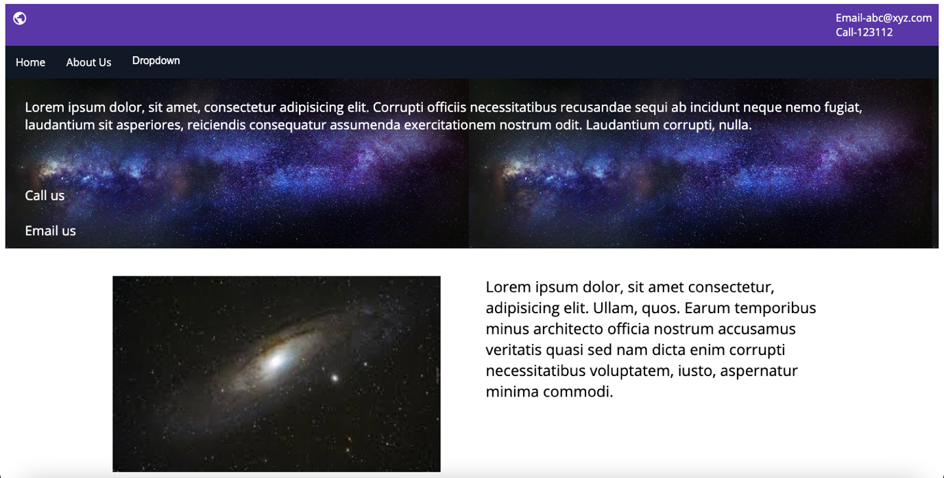

**Practical 2.4(a)**

**Implement Parallax Effect using Parallax.js and without Parallax.js**

**index.html**

<html>

<head>

<title>Home</title>

<link rel="stylesheet" type="text/css" href="../css/style.css">

<!-- font -->

<link rel="preconnect" href="https://fonts.googleapis.com">

<link rel="preconnect" href="https://fonts.gstatic.com" crossorigin>

<link href="https://fonts.googleapis.com/css2?family=Open+Sans&display=swap" rel="stylesheet">

<!-- icon -->

<link href = "https://fonts.googleapis.com/icon?family=Material+Icons" rel = "stylesheet">

<!-- slider -->

<link rel="stylesheet" href="../css/slider.css" type="text/css" media="screen" />

<!-- image galley -->

<link rel="stylesheet" type="text/css" href="../css/lightbox.min.css">

<!-- parallax -->

</head>

<body>

<div class="header">

<i class = "material-icons">public</i>

Email-abc@xyz.com<br> Call-123112

</div>

<div class="navbar">

<a href="#home">Home</a>

<a href="#news">About Us</a>

<div class="dropdown">

<button class="dropbtn">Dropdown

<i class="fa fa-caret-down"></i>

</button>

<div class="dropdown-content">

<a href="#">Link 1</a>

<a href="#">Link 2</a>

<a href="#">Link 3</a>

</div>

</div>

</div>

<div class="h">

Lorem ipsum dolor, sit amet, consectetur adipisicing elit. Corrupti officiis necessitatibus recusandae sequi ab incidunt neque nemo fugiat, laudantium sit asperiores, reiciendis consequatur assumenda exercitationem nostrum odit. Laudantium corrupti, nulla.<br>

<br><br><br>

<a href="tel:123112">Call us</a><br><br>

<a href="mailto:123112">Email us</a>

</div>

<div class="parallax"></div>

<div>

<table>

<tr>

<td><img src="https://encrypted-tbn0.gstatic.com/images?q=tbn:ANd9GcRH1kzCIvgCKQy7lQB8W99K5NHJ61quuqnPZw&usqp=CAU"></td>

<td>Lorem ipsum dolor, sit amet consectetur, adipisicing elit. Ullam, quos. Earum temporibus minus architecto officia nostrum accusamus veritatis quasi sed nam dicta enim corrupti necessitatibus voluptatem, iusto, aspernatur minima commodi.</td>

</tr>

<tr>

<td>Lorem ipsum dolor sit amet consectetur adipisicing, elit. Eum, necessitatibus. Veniam repellendus impedit facere provident vitae iste, eveniet quos nulla facilis eius ex atque dignissimos. Magnam quis doloribus voluptate, architecto.</td>

<td>

<style>

.fadein { position:relative; height:300px; width:500px; }

.fadein img { position:absolute; left:0; top:0; }

</style>

<script type="text/javascript" src="http://www.hscripts.com/jquery.js"></script>

<script type="text/javascript">

$(function(){

$('.fadein img:gt(0)').hide();

setInterval(function(){$('.fadein :first-child').fadeOut().next('img').fadeIn().end().appendTo('.fadein');}, 2000);

});

</script>

<div class="fadein">

<img src="https://cdn.vox-cdn.com/thumbor/Ohs67lw4c_o3gsdWjwgRCmWdm6U=/1400x788/filters:format(jpeg)/cdn.vox-cdn.com/uploads/chorus_asset/file/13074037/hs-2014-27-a-print.0.0.1486275780.jpg" alt="Image Slideshow Script">

<img src="https://static.theprint.in/wp-content/uploads/2020/03/minor-planets.jpg" alt="Image Slideshow Script">

<img src="https://encrypted-tbn0.gstatic.com/images?q=tbn:ANd9GcTtiVrERaLq5dpJ14TbtTVEmaisX9gFUk8hhg&usqp=CAU" alt="Image Slideshow Script">

</div>

</td>

</tr>

</table>

</div>

<div class="parallax"></div>

<div>

<div class="slideshow-container">

<div class="mySlides">

<q>I love you the more in that I believe you had liked me for my own sake and for nothing else</q>

<p class="author">- John Keats</p>

</div>

<div class="mySlides">

<q>But man is not made for defeat. A man can be destroyed but not defeated.</q>

<p class="author">- Ernest Hemingway</p>

</div>

<div class="mySlides">

<q>I have not failed. I've just found 10,000 ways that won't work.</q>

<p class="author">- Thomas A. Edison</p>

</div>

<a class="prev" onclick="plusSlides(-1)">❮</a>

<a class="next" onclick="plusSlides(1)">❯</a>

</div>

<div class="dot-container">

<span class="dot" onclick="currentSlide(1)"></span>

<span class="dot" onclick="currentSlide(2)"></span>

<span class="dot" onclick="currentSlide(3)"></span>

</div>

<script>

var slideIndex = 1;

showSlides(slideIndex);

function plusSlides(n) {

showSlides(slideIndex += n);

}

function currentSlide(n) {

showSlides(slideIndex = n);

}

function showSlides(n) {

var i;

var slides = document.getElementsByClassName("mySlides");

var dots = document.getElementsByClassName("dot");

if (n > slides.length) {slideIndex = 1}

if (n < 1) {slideIndex = slides.length}

for (i = 0; i < slides.length; i++) {

slides[i].style.display = "none";

}

for (i = 0; i < dots.length; i++) {

dots[i].className = dots[i].className.replace(" active", "");

}

slides[slideIndex-1].style.display = "block";

dots[slideIndex-1].className += " active";

}

</script>

</div>

<div class="parallax"></div>

<div class="gallery">

<strong>Image Gallery</strong>

<div>

<a class="example-image-link" href="https://africanews.space/wp-content/uploads/2021/01/space-debris-junk-africa-cleanup.jpg" data-lightbox="example-set"><img class="example-image" src="https://africanews.space/wp-content/uploads/2021/01/space-debris-junk-africa-cleanup.jpg" alt=""/></a>

<a class="example-image-link" href="https://static.independent.co.uk/2021/06/04/10/DESY_GRB_still_1.jpeg?width=1200" data-lightbox="example-set"><img class="example-image" src="https://static.independent.co.uk/2021/06/04/10/DESY_GRB_still_1.jpeg?width=1200" alt="" /></a>

<a class="example-image-link" href="https://thumbs-prod.si-cdn.com/5IC2_-4TL008uHd3srmFFYh_LwU=/800x450/filters:focal(2989x1536:2990x1537)/https://public-media.si-cdn.com/filer/35/3b/353b17c0-cd7b-4625-9f97-f3c3ef59055e/gettyimages-1229960181.jpg" data-lightbox="example-set" ><img class="example-image" src="https://thumbs-prod.si-cdn.com/5IC2_-4TL008uHd3srmFFYh_LwU=/800x450/filters:focal(2989x1536:2990x1537)/https://public-media.si-cdn.com/filer/35/3b/353b17c0-cd7b-4625-9f97-f3c3ef59055e/gettyimages-1229960181.jpg" alt="" /></a>

<a class="example-image-link" href="https://encrypted-tbn0.gstatic.com/images?q=tbn:ANd9GcTna_QMTdrKfaibyBB8CeN2vQ4H6Iq4kU2RHg&usqp=CAU" data-lightbox="example-set"><img class="example-image" src="https://encrypted-tbn0.gstatic.com/images?q=tbn:ANd9GcTna_QMTdrKfaibyBB8CeN2vQ4H6Iq4kU2RHg&usqp=CAU" alt="" /></a>

<a class="example-image-link" href="https://cdn.mos.cms.futurecdn.net/Gw9wVjyJYuLAuaeM6z4n6W-1200-80.jpg" data-lightbox="example-set"><img class="example-image" src="https://cdn.mos.cms.futurecdn.net/Gw9wVjyJYuLAuaeM6z4n6W-1200-80.jpg" alt="" /></a>

<a class="example-image-link" href="https://images.ctfassets.net/cnu0m8re1exe/2DYsgTu86tZd9Yh3CfwToQ/971c67e0330015b3fd371a2f1767311b/heic0301a.jpg?fm=jpg&fl=progressive&w=660&h=433&fit=fill" data-lightbox="example-set"><img class="example-image" src="https://images.ctfassets.net/cnu0m8re1exe/2DYsgTu86tZd9Yh3CfwToQ/971c67e0330015b3fd371a2f1767311b/heic0301a.jpg?fm=jpg&fl=progressive&w=660&h=433&fit=fill" alt="" /></a>

</div>

<script src="../js/lightbox-plus-jquery.min.js"></script>

</div>

<div class="parallax"></div>

<div class="footer">

<hr>

<div class="divf">

<div class="f">

<h2>Explore</h2>

<a href="">Home</a><br>

<a href="">About Us</a><br>

<a href="">Contact Us</a>

</div>

<div class="f">

<h2>Visit</h2>

Address-#abc,st.-4,qaz<br>

Email-abc@xyz.com<br>

Phone no.-123112

</div>

<div class="f">

<h2>Follow</h2>

<a href="">Twitter</a><br>

<a href="">Instagram</a><br>

<a href="">Linkedin</a>

</div>

<div class="f">

<h2>Legal</h2>

<a href="">Terms</a><br>

<a href="">Policies</a><br><br><br>

</div>

</div>

<hr>

<i class="material-icons">copyright</i>2021 Rohit. All Rights Reserved.

</div>

</body>

</html>

**style.css**

body{

font-family: 'Open Sans', sans-serif;

}

/* header */

.header{

padding: 10px;

background-color: #5A37A6;

color: white;

display: flex;

justify-content: space-between;

}

/* Navbar */

.navbar {

overflow: hidden;

background-color: #121926;

}

.navbar a {

float: left;

font-size: 16px;

color: white;

text-align: center;

padding: 14px 16px;

text-decoration: none;

}

.dropdown {

float: left;

overflow: hidden;

}

.dropdown .dropbtn {

font-size: 16px;

border: none;

outline: none;

color: white;

padding: 14px 16px;

background-color: inherit;

margin: 0;

}

.navbar a:hover, .dropdown:hover .dropbtn {

background-color: #0D0D0D;

}

.dropdown-content {

display: none;

position: absolute;

background-color: #f9f9f9;

min-width: 160px;

box-shadow: 0px 8px 16px 0px rgba(0,0,0,0.2);

z-index: 1;

}

.dropdown-content a {

float: none;

color: black;

padding: 12px 16px;

text-decoration: none;

display: block;

text-align: left;

}

.dropdown-content a:hover {

background-color: #ddd;

}

.dropdown:hover .dropdown-content {

display: block;

}

/* header2 */

.h{

height: 200px;

background-image: url(https://image.shutterstock.com/image-photo/full-panorama-milky-way-260nw-151365275.jpg);

color: white;

padding: 30;

font-size: 20;

}

.h a{

text-decoration: none;

color: white;

}

.h a:hover{

background-color: #777E8C;

padding: 5px;]

}

table{

margin:20px auto;

width: 80%;

font-size: 23px;

}

table td {

width: 40%;

padding: 20px;

vertical-align: top;

}

table img{

width: 500px;

height: 300px;

}

.gallery{

background-color: #5A37A6;

color: white;

text-align: center;

font-size: 25px;

padding-top: 10;

}

.gallery img{

height: 300px;

width: 470px;

}

.footer{

background-color: #0D0D0D;

color: white;

padding: 30px;

}

.divf{

width: 100%;

}

.f{

width: 25%;

float: left;

}

.f a{

text-decoration: none;

color: white;

}

.parallax {

/* The image used */

background-image: url("https://thumbor.forbes.com/thumbor/960x0/https%3A%2F%2Fspecials-images.forbesimg.com%2Fdam%2Fimageserve%2F765877054%2F960x0.jpg%3Ffit%3Dscale");

/* Set a specific height */

min-height: 200px;

/* Create the parallax scrolling effect */

background-attachment: fixed;

background-position: center;

background-repeat: no-repeat;

background-size: cover;

}

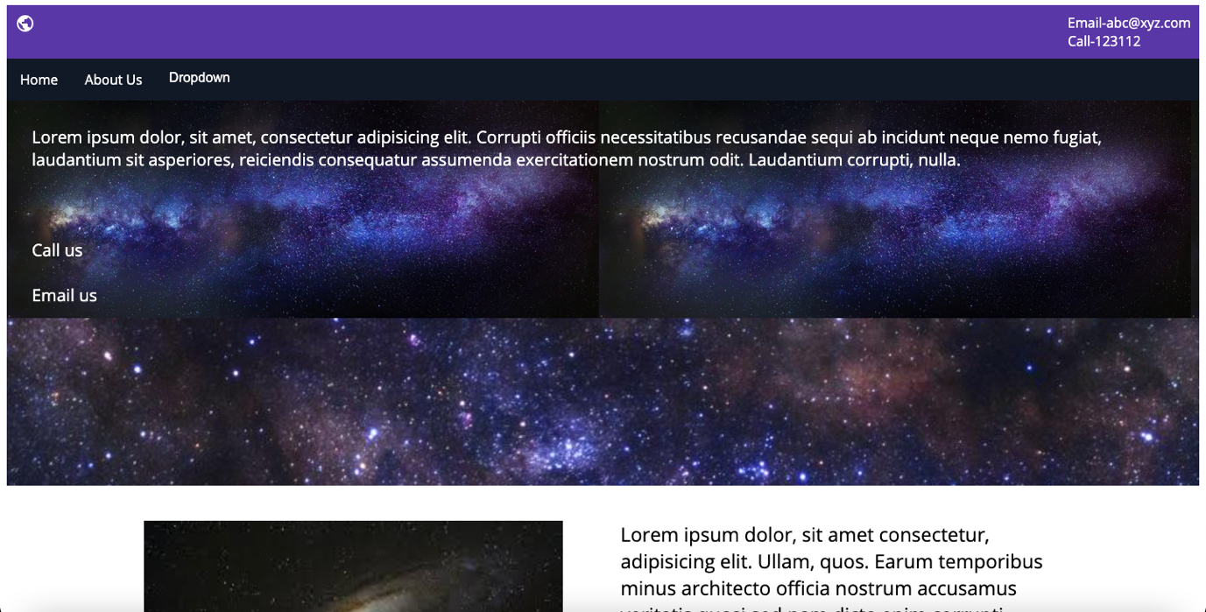

**Practical 2.4(b)**

**Create a New Page with new layout and add into Practical 2.3(b)**

**about.html**

<html>

<head>

<title>About Us</title>

<link rel="stylesheet" type="text/css" href="../css/style.css">

<!-- font -->

<link rel="preconnect" href="https://fonts.googleapis.com">

<link rel="preconnect" href="https://fonts.gstatic.com" crossorigin>

<link href="https://fonts.googleapis.com/css2?family=Open+Sans&display=swap" rel="stylesheet">

<!-- icon -->

<link href = "https://fonts.googleapis.com/icon?family=Material+Icons" rel = "stylesheet">

</head>

<body>

<header class="header">

<i class = "material-icons">public</i>

Email-abc@xyz.com<br> Call-123112

</header>

<nav class="navbar">

<a href="index.html">Home</a>

<a href="#">About Us</a>

<div class="dropdown">

<button class="dropbtn">Dropdown

<i class="fa fa-caret-down"></i>

</button>

<div class="dropdown-content">

<a href="#">Link 1</a>

<a href="#">Link 2</a>

<a href="#">Link 3</a>

</div>

</div>

</nav>

<div class="parallax"></div>

<section>

<h2>About Company</h2>

<article>Lorem, ipsum dolor sit amet consectetur adipisicing elit. Architecto eveniet tempora adipisci velit explicabo error dolorem, sed cumque vitae possimus odit reiciendis et distinctio ipsam consequatur quos sint enim, facere. Lorem, ipsum dolor sit amet consectetur adipisicing elit. Magnam libero saepe, unde architecto asperiores nisi aut molestias hic nihil ea ut eveniet dolorum dicta qui non quis assumenda laborum adipisci!</article><br><br>

<div class="parallax"></div>

<h2>About Devs</h2>

<article>Lorem ipsum, dolor sit amet consectetur adipisicing elit. Dignissimos voluptatem porro vero quae, ex iure, debitis repudiandae quidem natus, amet blanditiis omnis quibusdam quasi recusandae fugiat distinctio. Sed in, molestiae.</article>

</section>

<br>

<div class="parallax"></div>

<footer class="footer">

<hr>

<div class="divf">

<div class="f">

<h2>Explore</h2>

<a href="">Home</a><br>

<a href="">About Us</a><br>

<a href="">Contact Us</a>

</div>

<div class="f">

<h2>Visit</h2>

Address-#abc,st.-4,qaz<br>

Email-abc@xyz.com<br>

Phone no.-123112

</div>

<div class="f">

<h2>Follow</h2>

<a href="">Twitter</a><br>

<a href="">Instagram</a><br>

<a href="">Linkedin</a>

</div>

<div class="f">

<h2>Legal</h2>

<a href="">Terms</a><br>

<a href="">Policies</a><br><br><br>

</div>

</div>

<hr>

<i class="material-icons">copyright</i>2021 Rohit. All Rights Reserved.

</footer>

</body>

</html>

**style.css**

body{

font-family: 'Open Sans', sans-serif;

}

/* header */

.header{

padding: 10px;

background-color: #5A37A6;

color: white;

display: flex;

justify-content: space-between;

}

/* Navbar */

.navbar {

overflow: hidden;

background-color: #121926;

}

.navbar a {

float: left;

font-size: 16px;

color: white;

text-align: center;

padding: 14px 16px;

text-decoration: none;

}

.dropdown {

float: left;

overflow: hidden;

}

.dropdown .dropbtn {

font-size: 16px;

border: none;

outline: none;

color: white;

padding: 14px 16px;

background-color: inherit;

margin: 0;

}

.navbar a:hover, .dropdown:hover .dropbtn {

background-color: #0D0D0D;

}

.dropdown-content {

display: none;

position: absolute;

background-color: #f9f9f9;

min-width: 160px;

box-shadow: 0px 8px 16px 0px rgba(0,0,0,0.2);

z-index: 1;

}

.dropdown-content a {

float: none;

color: black;

padding: 12px 16px;

text-decoration: none;

display: block;

text-align: left;

}

.dropdown-content a:hover {

background-color: #ddd;

}

.dropdown:hover .dropdown-content {

display: block;

}

/* header2 */

.h{

height: 200px;

background-image: url(https://image.shutterstock.com/image-photo/full-panorama-milky-way-260nw-151365275.jpg);

color: white;

padding: 30;

font-size: 20;

}

.h a{

text-decoration: none;

color: white;

}

.h a:hover{

background-color: #777E8C;

padding: 5px;]

}

table{

margin:20px auto;

width: 80%;

font-size: 23px;

}

table td {

width: 40%;

padding: 20px;

vertical-align: top;

}

table img{

width: 500px;

height: 300px;

}

.gallery{

background-color: #5A37A6;

color: white;

text-align: center;

font-size: 25px;

padding-top: 10;

}

.gallery img{

height: 300px;

width: 470px;

}

.footer{

background-color: #0D0D0D;

color: white;

padding: 30px;

}

.divf{

width: 100%;

}

.f{

width: 25%;

float: left;

}

.f a{

text-decoration: none;

color: white;

}

.parallax {

/* The image used */

background-image: url("https://thumbor.forbes.com/thumbor/960x0/https%3A%2F%2Fspecials-images.forbesimg.com%2Fdam%2Fimageserve%2F765877054%2F960x0.jpg%3Ffit%3Dscale");

/* Set a specific height */

min-height: 200px;

/* Create the parallax scrolling effect */

background-attachment: fixed;

background-position: center;

background-repeat: no-repeat;

background-size: cover;

}

article{

background-color:#5A37A6 ;

color: white;

padding: 20px;

}

section{

font-size: 25px;

}

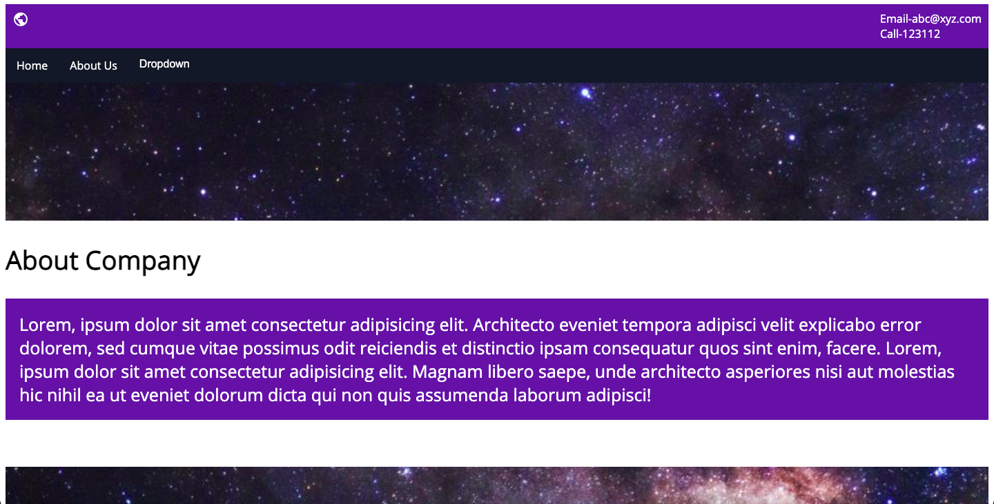

**Practical 2.5(a)**

**Implement the concept of Hover.css and also use other Image or Section Hover effects.**

**index.html**

<html>

<head>

<title>Home</title>

<link rel="stylesheet" type="text/css" href="../css/style.css">

<link rel="stylesheet" type="text/css" href="../css/hover.css">

<!-- font -->

<link rel="preconnect" href="https://fonts.googleapis.com">

<link rel="preconnect" href="https://fonts.gstatic.com" crossorigin>

<link href="https://fonts.googleapis.com/css2?family=Open+Sans&display=swap" rel="stylesheet">

<!-- icon -->

<link href = "https://fonts.googleapis.com/icon?family=Material+Icons" rel = "stylesheet">

<!-- slider -->

<link rel="stylesheet" href="../css/slider.css" type="text/css" media="screen" />

<!-- image galley -->

<link rel="stylesheet" type="text/css" href="../css/lightbox.min.css">

<!-- parallax -->

</head>

<body>

<div class="header">

<i class = "material-icons">public</i>

Email-abc@xyz.com<br> Call-123112

</div>

<div class="navbar">

<a href="#home">Home</a>

<a href="about.html">About Us</a>

<div class="dropdown">

<button class="dropbtn">Dropdown

<i class="fa fa-caret-down"></i>

</button>

<div class="dropdown-content">

<a href="#">Link 1</a>

<a href="#">Link 2</a>

<a href="#">Link 3</a>

</div>

</div>

</div>

<div class="h">

<p class="hvr-sink">Lorem ipsum dolor, sit amet, consectetur adipisicing elit. Corrupti officiis necessitatibus recusandae sequi ab incidunt neque nemo fugiat, laudantium sit asperiores, reiciendis consequatur assumenda exercitationem nostrum odit. Laudantium corrupti, nulla.</p><br>

<br><br><br>

<a href="tel:123112" class="hvr-skew">Call us</a><br><br>

<a href="mailto:123112" class="hvr-buzz-out">Email us</a>

</div>

<div class="parallax"></div>

<div>

<table>

<tr>

<td><img src="https://encrypted-tbn0.gstatic.com/images?q=tbn:ANd9GcRH1kzCIvgCKQy7lQB8W99K5NHJ61quuqnPZw&usqp=CAU" class="hvr-grow"></td>

<td class="hvr-sweep-to-right">Lorem ipsum dolor, sit amet consectetur, adipisicing elit. Ullam, quos. Earum temporibus minus architecto officia nostrum accusamus veritatis quasi sed nam dicta enim corrupti necessitatibus voluptatem, iusto, aspernatur minima commodi.</td>

</tr>

<tr>

<td class="hvr-sweep-to-left">Lorem ipsum dolor sit amet consectetur adipisicing, elit. Eum, necessitatibus. Veniam repellendus impedit facere provident vitae iste, eveniet quos nulla facilis eius ex atque dignissimos. Magnam quis doloribus voluptate, architecto.</td>

<td>

<style>

.fadein { position:relative; height:300px; width:500px; }

.fadein img { position:absolute; left:0; top:0; }

</style>

<script type="text/javascript" src="http://www.hscripts.com/jquery.js"></script>

<script type="text/javascript">

$(function(){

$('.fadein img:gt(0)').hide();

setInterval(function(){$('.fadein :first-child').fadeOut().next('img').fadeIn().end().appendTo('.fadein');}, 2000);

});

</script>

<div class="fadein">

<img src="https://cdn.vox-cdn.com/thumbor/Ohs67lw4c_o3gsdWjwgRCmWdm6U=/1400x788/filters:format(jpeg)/cdn.vox-cdn.com/uploads/chorus_asset/file/13074037/hs-2014-27-a-print.0.0.1486275780.jpg" alt="Image Slideshow Script">

<img src="https://static.theprint.in/wp-content/uploads/2020/03/minor-planets.jpg" alt="Image Slideshow Script">

<img src="https://encrypted-tbn0.gstatic.com/images?q=tbn:ANd9GcTtiVrERaLq5dpJ14TbtTVEmaisX9gFUk8hhg&usqp=CAU" alt="Image Slideshow Script">

</div>

</td>

</tr>

</table>

</div>

<div class="parallax"></div>

<div>

<div class="slideshow-container">

<div class="mySlides">

<q>I love you the more in that I believe you had liked me for my own sake and for nothing else</q>

<p class="author">- John Keats</p>

</div>

<div class="mySlides">

<q>But man is not made for defeat. A man can be destroyed but not defeated.</q>

<p class="author">- Ernest Hemingway</p>

</div>

<div class="mySlides">

<q>I have not failed. I've just found 10,000 ways that won't work.</q>

<p class="author">- Thomas A. Edison</p>

</div>

<a class="prev" onclick="plusSlides(-1)">❮</a>

<a class="next" onclick="plusSlides(1)">❯</a>

</div>

<div class="dot-container">

<span class="dot" onclick="currentSlide(1)"></span>

<span class="dot" onclick="currentSlide(2)"></span>

<span class="dot" onclick="currentSlide(3)"></span>

</div>

<script>

var slideIndex = 1;

showSlides(slideIndex);

function plusSlides(n) {

showSlides(slideIndex += n);

}

function currentSlide(n) {

showSlides(slideIndex = n);

}

function showSlides(n) {

var i;

var slides = document.getElementsByClassName("mySlides");

var dots = document.getElementsByClassName("dot");

if (n > slides.length) {slideIndex = 1}

if (n < 1) {slideIndex = slides.length}

for (i = 0; i < slides.length; i++) {

slides[i].style.display = "none";

}

for (i = 0; i < dots.length; i++) {

dots[i].className = dots[i].className.replace(" active", "");

}

slides[slideIndex-1].style.display = "block";

dots[slideIndex-1].className += " active";

}

</script>

</div>

<div class="parallax"></div>

<div class="gallery">

<strong class="hvr-grow">Image Gallery</strong>

<div class="hvr-shrink">

<a class="example-image-link" href="https://africanews.space/wp-content/uploads/2021/01/space-debris-junk-africa-cleanup.jpg" data-lightbox="example-set"><img class="example-image" src="https://africanews.space/wp-content/uploads/2021/01/space-debris-junk-africa-cleanup.jpg" alt=""/></a>

<a class="example-image-link" href="https://static.independent.co.uk/2021/06/04/10/DESY_GRB_still_1.jpeg?width=1200" data-lightbox="example-set"><img class="example-image" src="https://static.independent.co.uk/2021/06/04/10/DESY_GRB_still_1.jpeg?width=1200" alt="" /></a>

<a class="example-image-link" href="https://thumbs-prod.si-cdn.com/5IC2_-4TL008uHd3srmFFYh_LwU=/800x450/filters:focal(2989x1536:2990x1537)/https://public-media.si-cdn.com/filer/35/3b/353b17c0-cd7b-4625-9f97-f3c3ef59055e/gettyimages-1229960181.jpg" data-lightbox="example-set" ><img class="example-image" src="https://thumbs-prod.si-cdn.com/5IC2_-4TL008uHd3srmFFYh_LwU=/800x450/filters:focal(2989x1536:2990x1537)/https://public-media.si-cdn.com/filer/35/3b/353b17c0-cd7b-4625-9f97-f3c3ef59055e/gettyimages-1229960181.jpg" alt="" /></a>

<a class="example-image-link" href="https://encrypted-tbn0.gstatic.com/images?q=tbn:ANd9GcTna_QMTdrKfaibyBB8CeN2vQ4H6Iq4kU2RHg&usqp=CAU" data-lightbox="example-set"><img class="example-image" src="https://encrypted-tbn0.gstatic.com/images?q=tbn:ANd9GcTna_QMTdrKfaibyBB8CeN2vQ4H6Iq4kU2RHg&usqp=CAU" alt="" /></a>

<a class="example-image-link" href="https://cdn.mos.cms.futurecdn.net/Gw9wVjyJYuLAuaeM6z4n6W-1200-80.jpg" data-lightbox="example-set"><img class="example-image" src="https://cdn.mos.cms.futurecdn.net/Gw9wVjyJYuLAuaeM6z4n6W-1200-80.jpg" alt="" /></a>

<a class="example-image-link" href="https://images.ctfassets.net/cnu0m8re1exe/2DYsgTu86tZd9Yh3CfwToQ/971c67e0330015b3fd371a2f1767311b/heic0301a.jpg?fm=jpg&fl=progressive&w=660&h=433&fit=fill" data-lightbox="example-set"><img class="example-image" src="https://images.ctfassets.net/cnu0m8re1exe/2DYsgTu86tZd9Yh3CfwToQ/971c67e0330015b3fd371a2f1767311b/heic0301a.jpg?fm=jpg&fl=progressive&w=660&h=433&fit=fill" alt="" /></a>

</div>

<script src="../js/lightbox-plus-jquery.min.js"></script>

</div>

<div class="parallax"></div>

<div class="footer">

<hr>

<div class="divf">

<div class="f">

<h2>Explore</h2>

<a href="">Home</a><br>

<a href="">About Us</a><br>

<a href="">Contact Us</a>

</div>

<div class="f">

<h2>Visit</h2>

Address-#abc,st.-4,qaz<br>

Email-abc@xyz.com<br>

Phone no.-123112

</div>

<div class="f">

<h2>Follow</h2>

<a href="">Twitter</a><br>

<a href="">Instagram</a><br>

<a href="">Linkedin</a>

</div>

<div class="f">

<h2>Legal</h2>

<a href="">Terms</a><br>

<a href="">Policies</a><br><br><br>

</div>

</div>

<hr>

<i class="material-icons">copyright</i>2021 Rohit. All Rights Reserved.

</div>

</body>

</html>

**style.css**

body{

font-family: 'Open Sans', sans-serif;

}

/* header */

.header{

padding: 10px;

background-color: #5A37A6;

color: white;

display: flex;

justify-content: space-between;

}

/* Navbar */

.navbar {

overflow: hidden;

background-color: #121926;

}

.navbar a {

float: left;

font-size: 16px;

color: white;

text-align: center;

padding: 14px 16px;

text-decoration: none;

}

.dropdown {

float: left;

overflow: hidden;

}

.dropdown .dropbtn {

font-size: 16px;

border: none;

outline: none;

color: white;

padding: 14px 16px;

background-color: inherit;

margin: 0;

}

.navbar a:hover, .dropdown:hover .dropbtn {

background-color: #0D0D0D;

}

.dropdown-content {

display: none;

position: absolute;

background-color: #f9f9f9;

min-width: 160px;

box-shadow: 0px 8px 16px 0px rgba(0,0,0,0.2);

z-index: 1;

}

.dropdown-content a {

float: none;

color: black;

padding: 12px 16px;

text-decoration: none;

display: block;

text-align: left;

}

.dropdown-content a:hover {

background-color: #ddd;

}

.dropdown:hover .dropdown-content {

display: block;

}

/* header2 */

.h{

height: 200px;

background-image: url(https://image.shutterstock.com/image-photo/full-panorama-milky-way-260nw-151365275.jpg);

color: white;

padding: 30;

font-size: 20;

}

.h a{

text-decoration: none;

color: white;

}

.h a:hover{

background-color: #777E8C;

padding: 5px;]

}

table{

margin:20px auto;

width: 80%;

font-size: 23px;

}

table td {

width: 40%;

padding: 20px;

vertical-align: top;

}

table img{

width: 500px;

height: 300px;

}

.gallery{

background-color: #5A37A6;

color: white;

text-align: center;

font-size: 25px;

padding-top: 10;

}

.gallery img{

height: 300px;

width: 470px;

}

.footer{

background-color: #0D0D0D;

color: white;

padding: 30px;

}

.divf{

width: 100%;

}

.f{

width: 25%;

float: left;

}

.f a{

text-decoration: none;

color: white;

}

.parallax {

/* The image used */

background-image: url("https://thumbor.forbes.com/thumbor/960x0/https%3A%2F%2Fspecials-images.forbesimg.com%2Fdam%2Fimageserve%2F765877054%2F960x0.jpg%3Ffit%3Dscale");

/* Set a specific height */

min-height: 200px;

/* Create the parallax scrolling effect */

background-attachment: fixed;

background-position: center;

background-repeat: no-repeat;

background-size: cover;

}

article{

background-color:#5A37A6 ;

color: white;

padding: 20px;

}

section{

font-size: 25px;

}

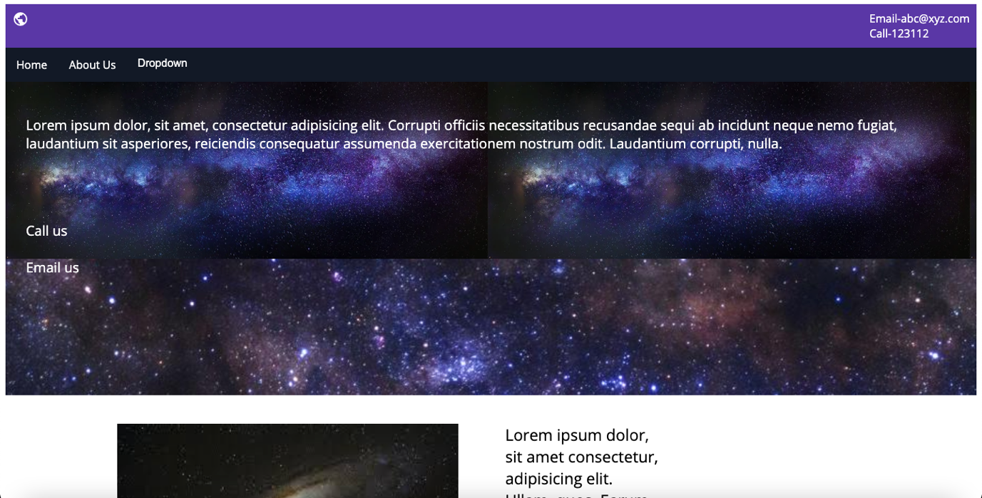

**about.html**

<html>

<head>

<title>About Us</title>

<link rel="stylesheet" type="text/css" href="../css/style.css">

<link rel="stylesheet" type="text/css" href="../css/hover.css">

<!-- font -->

<link rel="preconnect" href="https://fonts.googleapis.com">

<link rel="preconnect" href="https://fonts.gstatic.com" crossorigin>

<link href="https://fonts.googleapis.com/css2?family=Open+Sans&display=swap" rel="stylesheet">

<!-- icon -->

<link href = "https://fonts.googleapis.com/icon?family=Material+Icons" rel = "stylesheet">

</head>

<body>

<header class="header">

<i class = "material-icons">public</i>

Email-abc@xyz.com<br> Call-123112

</header>

<nav class="navbar">

<a href="index.html">Home</a>

<a href="#">About Us</a>

<div class="dropdown">

<button class="dropbtn">Dropdown

<i class="fa fa-caret-down"></i>

</button>

<div class="dropdown-content">

<a href="#">Link 1</a>

<a href="#">Link 2</a>

<a href="#">Link 3</a>

</div>

</div>

</nav>

<div class="parallax"></div>

<section class="hvr-shrink">

<h2 class="hvr-bubble-bottom">About Company</h2>

<article class="hvr-skew">Lorem, ipsum dolor sit amet consectetur adipisicing elit. Architecto eveniet tempora adipisci velit explicabo error dolorem, sed cumque vitae possimus odit reiciendis et distinctio ipsam consequatur quos sint enim, facere. Lorem, ipsum dolor sit amet consectetur adipisicing elit. Magnam libero saepe, unde architecto asperiores nisi aut molestias hic nihil ea ut eveniet dolorum dicta qui non quis assumenda laborum adipisci!</article><br><br>

<div class="parallax"></div>

<h2 class="hvr-bubble-bottom">About Devs</h2>

<article class="hvr-skew">Lorem ipsum, dolor sit amet consectetur adipisicing elit. Dignissimos voluptatem porro vero quae, ex iure, debitis repudiandae quidem natus, amet blanditiis omnis quibusdam quasi recusandae fugiat distinctio. Sed in, molestiae.</article>

</section>

<br>

<div class="parallax"></div>

<footer class="footer">

<hr>

<div class="divf">

<div class="f">

<h2>Explore</h2>

<a href="">Home</a><br>

<a href="">About Us</a><br>

<a href="">Contact Us</a>

</div>

<div class="f">

<h2>Visit</h2>

Address-#abc,st.-4,qaz<br>

Email-abc@xyz.com<br>

Phone no.-123112

</div>

<div class="f">

<h2>Follow</h2>

<a href="">Twitter</a><br>

<a href="">Instagram</a><br>

<a href="">Linkedin</a>

</div>

<div class="f">

<h2>Legal</h2>

<a href="">Terms</a><br>

<a href="">Policies</a><br><br><br>

</div>

</div>

<hr>

<i class="material-icons">copyright</i>2021 Rohit. All Rights Reserved.

</footer>

</body>

</html>

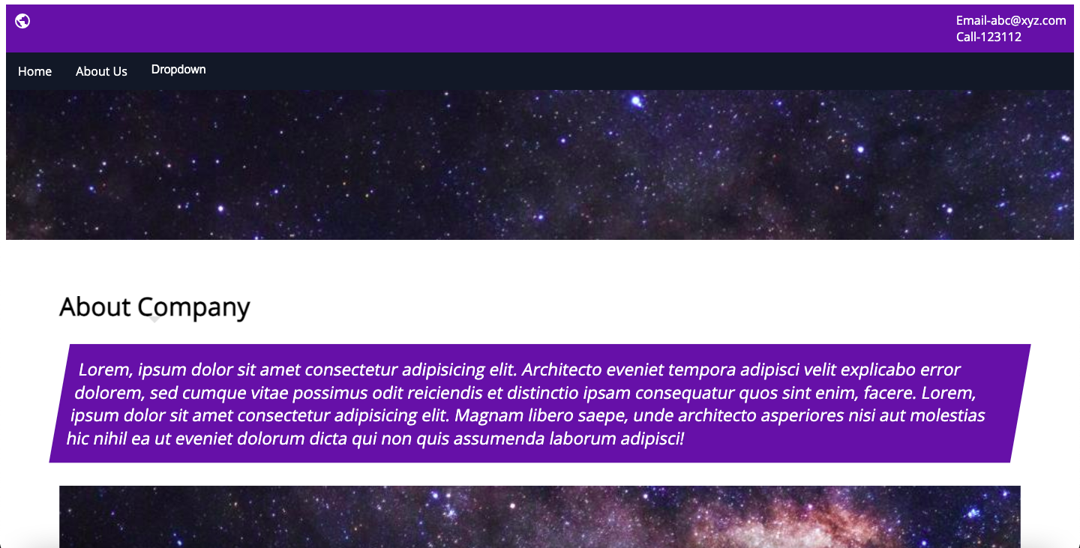

**Practical 2.5(b)**

**Use Animate.css and Wow.js in webpage.**

**index.html**

<html>

<head>

<title>Home</title>

<link rel="stylesheet" type="text/css" href="../css/style.css">

<!-- font -->

<link rel="preconnect" href="https://fonts.googleapis.com">

<link rel="preconnect" href="https://fonts.gstatic.com" crossorigin>

<link href="https://fonts.googleapis.com/css2?family=Open+Sans&display=swap" rel="stylesheet">

<!-- icon -->

<link href = "https://fonts.googleapis.com/icon?family=Material+Icons" rel = "stylesheet">

<!-- slider -->

<link rel="stylesheet" href="../css/slider.css" type="text/css" media="screen" />

<!-- image galley -->

<link rel="stylesheet" type="text/css" href="../css/lightbox.min.css">

<link rel="stylesheet" type="text/css" href="https://cdnjs.cloudflare.com/ajax/libs/animate.css/4.1.1/animate.min.css">

<link rel="stylesheet" type="text/css" href="../css/animate.css">

</head>

<body>

<div class="header">

<i class = "material-icons">public</i>

Email-abc@xyz.com<br> Call-123112

</div>

<div class="navbar">

<a href="#home">Home</a>

<a href="about.html">About Us</a>

<div class="dropdown">

<button class="dropbtn">Dropdown

<i class="fa fa-caret-down"></i>

</button>

<div class="dropdown-content">

<a href="#">Link 1</a>

<a href="#">Link 2</a>

<a href="#">Link 3</a>

</div>

</div>

</div>

<div class="h">

<p class="animate__animated animate__backInDown">Lorem ipsum dolor, sit amet, consectetur adipisicing elit. Corrupti officiis necessitatibus recusandae sequi ab incidunt neque nemo fugiat, laudantium sit asperiores, reiciendis consequatur assumenda exercitationem nostrum odit. Laudantium corrupti, nulla.</p><br>

<a href="tel:123112">Call us</a><br><br>

<a href="mailto:123112">Email us</a>

</div>

<div class="parallax"></div>

<div>

<table class="wow pulse">

<tr>

<td><img src="https://encrypted-tbn0.gstatic.com/images?q=tbn:ANd9GcRH1kzCIvgCKQy7lQB8W99K5NHJ61quuqnPZw&usqp=CAU"></td>

<td class="animate__animated animate__headShake">Lorem ipsum dolor, sit amet consectetur, adipisicing elit. Ullam, quos. Earum temporibus minus architecto officia nostrum accusamus veritatis quasi sed nam dicta enim corrupti necessitatibus voluptatem, iusto, aspernatur minima commodi.</td>

</tr>

<tr>

<td class="animate__animated animate__headShake">Lorem ipsum dolor sit amet consectetur adipisicing, elit. Eum, necessitatibus. Veniam repellendus impedit facere provident vitae iste, eveniet quos nulla facilis eius ex atque dignissimos. Magnam quis doloribus voluptate, architecto.</td>

<td>

<style>

.fadein { position:relative; height:300px; width:500px; }

.fadein img { position:absolute; left:0; top:0; }

</style>

<script type="text/javascript" src="http://www.hscripts.com/jquery.js"></script>

<script type="text/javascript">

$(function(){

$('.fadein img:gt(0)').hide();

setInterval(function(){$('.fadein :first-child').fadeOut().next('img').fadeIn().end().appendTo('.fadein');}, 2000);

});

</script>

<div class="fadein">

<img src="https://cdn.vox-cdn.com/thumbor/Ohs67lw4c_o3gsdWjwgRCmWdm6U=/1400x788/filters:format(jpeg)/cdn.vox-cdn.com/uploads/chorus_asset/file/13074037/hs-2014-27-a-print.0.0.1486275780.jpg" alt="Image Slideshow Script">

<img src="https://static.theprint.in/wp-content/uploads/2020/03/minor-planets.jpg" alt="Image Slideshow Script">

<img src="https://encrypted-tbn0.gstatic.com/images?q=tbn:ANd9GcTtiVrERaLq5dpJ14TbtTVEmaisX9gFUk8hhg&usqp=CAU" alt="Image Slideshow Script">

</div>

</td>

</tr>

</table>

</div>

<div class="parallax"></div>

<div class="wow slideInLeft">

<div class="slideshow-container">

<div class="mySlides">

<q>I love you the more in that I believe you had liked me for my own sake and for nothing else</q>

<p class="author">- John Keats</p>

</div>

<div class="mySlides">

<q>But man is not made for defeat. A man can be destroyed but not defeated.</q>

<p class="author">- Ernest Hemingway</p>

</div>

<div class="mySlides">

<q>I have not failed. I've just found 10,000 ways that won't work.</q>

<p class="author">- Thomas A. Edison</p>

</div>

<a class="prev" onclick="plusSlides(-1)">❮</a>

<a class="next" onclick="plusSlides(1)">❯</a>

</div>

<div class="dot-container">

<span class="dot" onclick="currentSlide(1)"></span>

<span class="dot" onclick="currentSlide(2)"></span>

<span class="dot" onclick="currentSlide(3)"></span>

</div>

<script>

var slideIndex = 1;

showSlides(slideIndex);

function plusSlides(n) {

showSlides(slideIndex += n);

}

function currentSlide(n) {

showSlides(slideIndex = n);

}

function showSlides(n) {

var i;

var slides = document.getElementsByClassName("mySlides");

var dots = document.getElementsByClassName("dot");

if (n > slides.length) {slideIndex = 1}

if (n < 1) {slideIndex = slides.length}

for (i = 0; i < slides.length; i++) {

slides[i].style.display = "none";

}

for (i = 0; i < dots.length; i++) {

dots[i].className = dots[i].className.replace(" active", "");

}

slides[slideIndex-1].style.display = "block";

dots[slideIndex-1].className += " active";

}

</script>

</div>

<div class="parallax"></div>

<div class="gallery">

<strong class="wow slideInLeft">Image Gallery</strong>

<div>

<a class="example-image-link" href="https://africanews.space/wp-content/uploads/2021/01/space-debris-junk-africa-cleanup.jpg" data-lightbox="example-set"><img class="example-image" src="https://africanews.space/wp-content/uploads/2021/01/space-debris-junk-africa-cleanup.jpg" alt=""/></a>

<a class="example-image-link" href="https://static.independent.co.uk/2021/06/04/10/DESY_GRB_still_1.jpeg?width=1200" data-lightbox="example-set"><img class="example-image" src="https://static.independent.co.uk/2021/06/04/10/DESY_GRB_still_1.jpeg?width=1200" alt="" /></a>

<a class="example-image-link" href="https://thumbs-prod.si-cdn.com/5IC2_-4TL008uHd3srmFFYh_LwU=/800x450/filters:focal(2989x1536:2990x1537)/https://public-media.si-cdn.com/filer/35/3b/353b17c0-cd7b-4625-9f97-f3c3ef59055e/gettyimages-1229960181.jpg" data-lightbox="example-set" ><img class="example-image" src="https://thumbs-prod.si-cdn.com/5IC2_-4TL008uHd3srmFFYh_LwU=/800x450/filters:focal(2989x1536:2990x1537)/https://public-media.si-cdn.com/filer/35/3b/353b17c0-cd7b-4625-9f97-f3c3ef59055e/gettyimages-1229960181.jpg" alt="" /></a>

<a class="example-image-link" href="https://encrypted-tbn0.gstatic.com/images?q=tbn:ANd9GcTna_QMTdrKfaibyBB8CeN2vQ4H6Iq4kU2RHg&usqp=CAU" data-lightbox="example-set"><img class="example-image" src="https://encrypted-tbn0.gstatic.com/images?q=tbn:ANd9GcTna_QMTdrKfaibyBB8CeN2vQ4H6Iq4kU2RHg&usqp=CAU" alt="" /></a>

<a class="example-image-link" href="https://cdn.mos.cms.futurecdn.net/Gw9wVjyJYuLAuaeM6z4n6W-1200-80.jpg" data-lightbox="example-set"><img class="example-image" src="https://cdn.mos.cms.futurecdn.net/Gw9wVjyJYuLAuaeM6z4n6W-1200-80.jpg" alt="" /></a>

<a class="example-image-link" href="https://images.ctfassets.net/cnu0m8re1exe/2DYsgTu86tZd9Yh3CfwToQ/971c67e0330015b3fd371a2f1767311b/heic0301a.jpg?fm=jpg&fl=progressive&w=660&h=433&fit=fill" data-lightbox="example-set"><img class="example-image" src="https://images.ctfassets.net/cnu0m8re1exe/2DYsgTu86tZd9Yh3CfwToQ/971c67e0330015b3fd371a2f1767311b/heic0301a.jpg?fm=jpg&fl=progressive&w=660&h=433&fit=fill" alt="" /></a>

</div>

<script src="../js/lightbox-plus-jquery.min.js"></script>

</div>

<div class="parallax"></div>

<div class="footer">

<hr>

<div class="divf">

<div class="f">

<h2>Explore</h2>

<a href="">Home</a><br>

<a href="">About Us</a><br>

<a href="">Contact Us</a>

</div>

<div class="f">

<h2>Visit</h2>

Address-#abc,st.-4,qaz<br>

Email-abc@xyz.com<br>

Phone no.-123112

</div>

<div class="f">

<h2>Follow</h2>

<a href="">Twitter</a><br>

<a href="">Instagram</a><br>

<a href="">Linkedin</a>

</div>

<div class="f">

<h2>Legal</h2>

<a href="">Terms</a><br>

<a href="">Policies</a><br><br><br>

</div>

</div>

<hr>

<i class="material-icons">copyright</i>2021 Rohit. All Rights Reserved.

</div>

<script src="../js//wow.js"></script>

<script>

wow = new WOW(

{

animateClass: 'animated',

offset: 100,

callback: function(box) {

console.log("WOW: animating <" + box.tagName.toLowerCase() + ">")

}

}

);

wow.init();

document.getElementById('moar').onclick = function() {

var section = document.createElement('section');

section.className = 'section--purple wow fadeInDown';

this.parentNode.insertBefore(section, this);

};

</script>

</body>

</html>

**style.css**

body{

font-family: 'Open Sans', sans-serif;

}

/* header */

.header{

padding: 10px;

background-color: #5A37A6;

color: white;

display: flex;

justify-content: space-between;

}

/* Navbar */

.navbar {

overflow: hidden;

background-color: #121926;

}

.navbar a {

float: left;

font-size: 16px;

color: white;

text-align: center;

padding: 14px 16px;

text-decoration: none;

}

.dropdown {

float: left;

overflow: hidden;

}

.dropdown .dropbtn {

font-size: 16px;

border: none;

outline: none;

color: white;

padding: 14px 16px;

background-color: inherit;

margin: 0;

}

.navbar a:hover, .dropdown:hover .dropbtn {

background-color: #0D0D0D;

}

.dropdown-content {

display: none;

position: absolute;

background-color: #f9f9f9;

min-width: 160px;

box-shadow: 0px 8px 16px 0px rgba(0,0,0,0.2);

z-index: 1;

}

.dropdown-content a {

float: none;

color: black;

padding: 12px 16px;

text-decoration: none;

display: block;

text-align: left;

}

.dropdown-content a:hover {

background-color: #ddd;

}

.dropdown:hover .dropdown-content {

display: block;

}

/* header2 */

.h{

height: 200px;

background-image: url(https://image.shutterstock.com/image-photo/full-panorama-milky-way-260nw-151365275.jpg);

color: white;

padding: 30;

font-size: 20;

}

.h a{

text-decoration: none;

color: white;

}

.h a:hover{

background-color: #777E8C;

padding: 5px;]

}

table{

margin:20px auto;

width: 80%;

font-size: 23px;

}

table td {

width: 40%;

padding: 20px;

vertical-align: top;

}

table img{

width: 500px;

height: 300px;

}

.gallery{

background-color: #5A37A6;

color: white;

text-align: center;

font-size: 25px;

padding-top: 10;

}

.gallery img{

height: 300px;

width: 470px;

}

.footer{

background-color: #0D0D0D;

color: white;

padding: 30px;

}

.divf{

width: 100%;

}

.f{

width: 25%;

float: left;

}

.f a{

text-decoration: none;

color: white;

}

.parallax {

/* The image used */

background-image: url("https://thumbor.forbes.com/thumbor/960x0/https%3A%2F%2Fspecials-images.forbesimg.com%2Fdam%2Fimageserve%2F765877054%2F960x0.jpg%3Ffit%3Dscale");

/* Set a specific height */

min-height: 200px;

/* Create the parallax scrolling effect */

background-attachment: fixed;

background-position: center;

background-repeat: no-repeat;

background-size: cover;

}

article{

background-color:#5A37A6 ;

color: white;

padding: 20px;

}

section{

font-size: 25px;

}

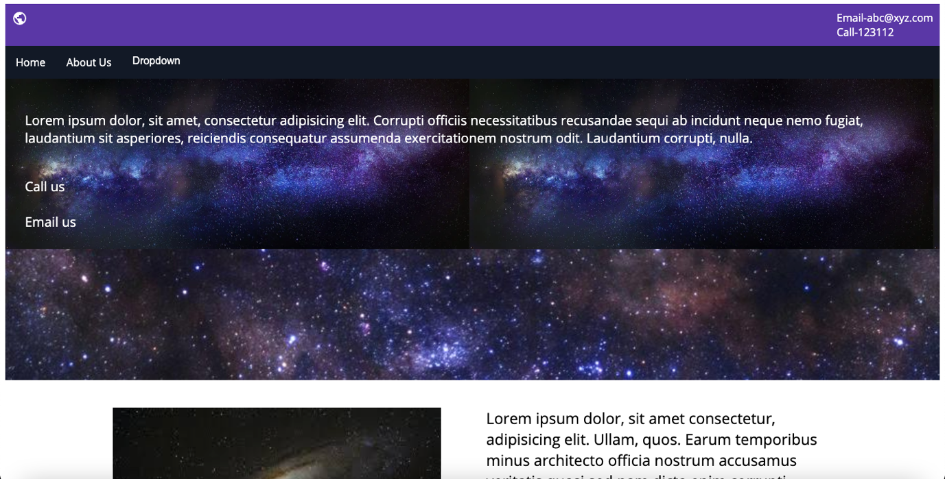

**about.html**

<html>

<head>

<title>About Us</title>

<link rel="stylesheet" type="text/css" href="../css/style.css">

<!-- font -->

<link rel="preconnect" href="https://fonts.googleapis.com">

<link rel="preconnect" href="https://fonts.gstatic.com" crossorigin>

<link href="https://fonts.googleapis.com/css2?family=Open+Sans&display=swap" rel="stylesheet">

<!-- icon -->

<link href = "https://fonts.googleapis.com/icon?family=Material+Icons" rel = "stylesheet">

<link rel="stylesheet" type="text/css" href="https://cdnjs.cloudflare.com/ajax/libs/animate.css/4.1.1/animate.min.css">

<link rel="stylesheet" type="text/css" href="../css/animate.css">

</head>

<body>

<header class="header">

<i class = "material-icons">public</i>

Email-abc@xyz.com<br> Call-123112

</header>

<nav class="navbar">

<a href="index.html">Home</a>

<a href="#">About Us</a>

<div class="dropdown">

<button class="dropbtn">Dropdown

<i class="fa fa-caret-down"></i>

</button>

<div class="dropdown-content">

<a href="#">Link 1</a>

<a href="#">Link 2</a>

<a href="#">Link 3</a>

</div>

</div>

</nav>

<div class="parallax"></div>

<section>

<h2 class="animate__animated animate__heartBeat">About Company</h2>

<article class="wow slideInLeft">Lorem, ipsum dolor sit amet consectetur adipisicing elit. Architecto eveniet tempora adipisci velit explicabo error dolorem, sed cumque vitae possimus odit reiciendis et distinctio ipsam consequatur quos sint enim, facere. Lorem, ipsum dolor sit amet consectetur adipisicing elit. Magnam libero saepe, unde architecto asperiores nisi aut molestias hic nihil ea ut eveniet dolorum dicta qui non quis assumenda laborum adipisci!</article><br><br>

<div class="parallax"></div>

<h2 class="animate__animated animate__heartBeat">About Devs</h2>

<article class="wow slideInLeft">Lorem ipsum, dolor sit amet consectetur adipisicing elit. Dignissimos voluptatem porro vero quae, ex iure, debitis repudiandae quidem natus, amet blanditiis omnis quibusdam quasi recusandae fugiat distinctio. Sed in, molestiae.</article>

</section>

<br>

<div class="parallax"></div>

<footer class="footer">

<hr>

<div class="divf">

<div class="f">

<h2>Explore</h2>

<a href="">Home</a><br>

<a href="">About Us</a><br>

<a href="">Contact Us</a>

</div>

<div class="f">

<h2>Visit</h2>

Address-#abc,st.-4,qaz<br>

Email-abc@xyz.com<br>

Phone no.-123112

</div>

<div class="f">

<h2>Follow</h2>

<a href="">Twitter</a><br>

<a href="">Instagram</a><br>

<a href="">Linkedin</a>

</div>

<div class="f">

<h2>Legal</h2>

<a href="">Terms</a><br>

<a href="">Policies</a><br><br><br>

</div>

</div>

<hr>

<i class="material-icons">copyright</i>2021 Rohit. All Rights Reserved.

</footer>

<script src="../js//wow.js"></script>

<script>

wow = new WOW(

{

animateClass: 'animated',

offset: 100,

callback: function(box) {

console.log("WOW: animating <" + box.tagName.toLowerCase() + ">")

}

}

);

wow.init();

document.getElementById('moar').onclick = function() {

var section = document.createElement('section');

section.className = 'section--purple wow fadeInDown';

this.parentNode.insertBefore(section, this);

};

</script>

</body>

</html>

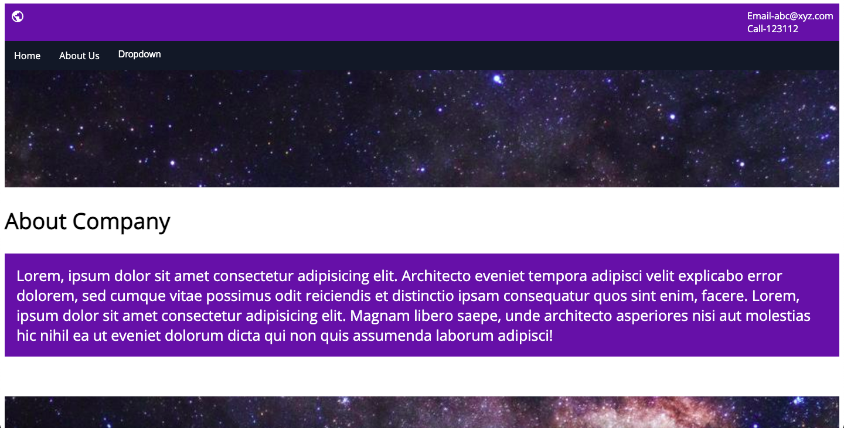

**Assignment Week-2**

**Create a Website (minimum 4 pages) for a Restaurant**

**index.html**

<!DOCTYPE html>

<html lang="en">

<head>

<meta charset="utf-8">

<title>Restaurant</title>

<meta content="width=device-width, initial-scale=1.0" name="viewport">

<meta content="Free Website Template" name="keywords">

<meta content="Free Website Template" name="description">

<!-- Favicon -->

<link href="img/favicon.ico" rel="icon">

<!-- CSS Libraries -->

<link href="https://stackpath.bootstrapcdn.com/bootstrap/4.4.1/css/bootstrap.min.css" rel="stylesheet">

<link href="https://cdnjs.cloudflare.com/ajax/libs/font-awesome/5.10.0/css/all.min.css" rel="stylesheet">

<link href="lib/animate/animate.min.css" rel="stylesheet">

<link href="lib/owlcarousel/assets/owl.carousel.min.css" rel="stylesheet">

<link href="lib/flaticon/font/flaticon.css" rel="stylesheet">

<link href="lib/tempusdominus/css/tempusdominus-bootstrap-4.min.css" rel="stylesheet" />

<!-- Template Stylesheet -->

<link href="css/style.css" rel="stylesheet">

</head>

<body>

<!-- Nav Bar Start -->

<div class="navbar navbar-expand-lg bg-light navbar-light">

<div class="container-fluid">

<a href="index.html" class="navbar-brand">BURGER <span>KING</span></a>

<button type="button" class="navbar-toggler" data-toggle="collapse" data-target="#navbarCollapse">

<span class="navbar-toggler-icon"></span>

</button>

<div class="collapse navbar-collapse justify-content-between" id="navbarCollapse">

<div class="navbar-nav ml-auto">

<a href="index.html" class="nav-item nav-link active">Home</a>

<a href="team.html" class="nav-item nav-link">Chef</a>

<a href="menu.html" class="nav-item nav-link">Menu</a>

<a href="booking.html" class="nav-item nav-link">Booking</a>

<a href="contact.html" class="nav-item nav-link">Contact</a>

</div>

</div>

</div>

</div>

<!-- Nav Bar End -->

<!-- Carousel Start -->

<div class="carousel">

<div class="container-fluid">

<div class="owl-carousel">

<div class="carousel-item">

<div class="carousel-img">

<img src="https://media.istockphoto.com/photos/chinese-food-blank-background-picture-id545286388?k=6&m=545286388&s=612x612&w=0&h=hfqhFja1j8UhcydHJyBzjtzkTdXpooxOzAAqhJuM74o=" alt="Image">

</div>

<div class="carousel-text">

<h1>Best <span>Quality</span> Ingredients</h1>

<p>

Lorem ipsum dolor sit amet elit. Phasellus ut mollis mauris. Vivamus egestas eleifend dui ac consequat at lectus in malesuada

</p>

<div class="carousel-btn">

<a class="btn custom-btn" href="">View Menu</a>

<a class="btn custom-btn" href="">Book Table</a>

</div>

</div>

</div>

<div class="carousel-item">

<div class="carousel-img">

<img src="https://d4t7t8y8xqo0t.cloudfront.net/resized/1080X/group%2F4834%2Fmenu%2Fmenu720190816054509.jpg" alt="Image">

</div>

<div class="carousel-text">

<h1>World’s <span>Best</span> Chef</h1>

<p>

Morbi sagittis turpis id suscipit feugiat. Suspendisse eu augue urna. Morbi sagittis, orci sodales varius fermentum, tortor

</p>

<div class="carousel-btn">

<a class="btn custom-btn" href="">View Menu</a>

<a class="btn custom-btn" href="">Book Table</a>

</div>

</div>

</div>

<div class="carousel-item">

<div class="carousel-img">

<img src="https://static.onecms.io/wp-content/uploads/sites/43/2020/05/18/image-2000.jpg" alt="Image">

</div>

<div class="carousel-text">

<h1>Fastest Order <span>Delivery</span></h1>

<p>

Sed ultrices, est eget feugiat accumsan, dui nibh egestas tortor, ut rhoncus nibh ligula euismod quam. Proin pellentesque odio

</p>

<div class="carousel-btn">

<a class="btn custom-btn" href="">View Menu</a>

<a class="btn custom-btn" href="">Book Table</a>

</div>

</div>

</div>

</div>

</div>

</div>

<!-- Carousel End -->

<!-- Booking Start -->

<div class="booking">

<div class="container">

<div class="row align-items-center">

<div class="col-lg-7">

<div class="booking-content">

<div class="section-header">

<p>Book A Table</p>

<h2>Book Your Table For Private Dinners & Happy Hours</h2>

</div>

<div class="about-text">

<p>

Lorem ipsum dolor sit amet, consectetur adipiscing elit. Phasellus nec pretium mi. Curabitur facilisis ornare velit non vulputate. Aliquam metus tortor, auctor id gravida condimentum, viverra quis sem.

</p>

<p>

Lorem ipsum dolor sit amet, consectetur adipiscing elit. Phasellus nec pretium mi. Curabitur facilisis ornare velit non vulputate. Aliquam metus tortor, auctor id gravida condimentum, viverra quis sem. Curabitur non nisl nec nisi scelerisque maximus. Aenean consectetur convallis porttitor. Aliquam interdum at lacus non blandit.

</p>

</div>

</div>

</div>

<div class="col-lg-5">

<div class="booking-form">

<form>

<div class="control-group">

<div class="input-group">

<input type="text" class="form-control" placeholder="Name" required="required" />

<div class="input-group-append">

<div class="input-group-text"><i class="far fa-user"></i></div>

</div>

</div>

</div>

<div class="control-group">

<div class="input-group">

<input type="email" class="form-control" placeholder="Email" required="required" />

<div class="input-group-append">

<div class="input-group-text"><i class="far fa-envelope"></i></div>

</div>

</div>

</div>

<div class="control-group">

<div class="input-group">

<input type="text" class="form-control" placeholder="Mobile" required="required" />

<div class="input-group-append">

<div class="input-group-text"><i class="fa fa-mobile-alt"></i></div>

</div>

</div>

</div>

<div class="control-group">

<div class="input-group date" id="date" data-target-input="nearest">

<input type="text" class="form-control datetimepicker-input" placeholder="Date" data-target="#date" data-toggle="datetimepicker"/>

<div class="input-group-append" data-target="#date" data-toggle="datetimepicker">

<div class="input-group-text"><i class="far fa-calendar-alt"></i></div>

</div>

</div>

</div>

<div class="control-group">

<div class="input-group time" id="time" data-target-input="nearest">

<input type="text" class="form-control datetimepicker-input" placeholder="Time" data-target="#time" data-toggle="datetimepicker"/>

<div class="input-group-append" data-target="#time" data-toggle="datetimepicker">

<div class="input-group-text"><i class="far fa-clock"></i></div>

</div>

</div>

</div>

<div class="control-group">

<div class="input-group">

<select class="custom-select form-control">

<option selected>Guest</option>

<option value="1">1 Guest</option>

<option value="2">2 Guest</option>

<option value="3">3 Guest</option>

<option value="4">4 Guest</option>

<option value="5">5 Guest</option>

<option value="6">6 Guest</option>

<option value="7">7 Guest</option>

<option value="8">8 Guest</option>

<option value="9">9 Guest</option>

<option value="10">10 Guest</option>

</select>

<div class="input-group-append">

<div class="input-group-text"><i class="fa fa-chevron-down"></i></div>

</div>

</div>

</div>

<div>

<button class="btn custom-btn" type="submit">Book Now</button>

</div>

</form>

</div>

</div>

</div>

</div>

</div>

<!-- Booking End -->

<!-- Food Start -->

<div class="food">

<div class="container">

<div class="row align-items-center">

<div class="col-md-4">

<div class="food-item">

<i class="flaticon-burger"></i>

<h2>Burgers</h2>

<p>

Lorem ipsum dolor sit amet elit. Phasel nec pretium mi. Curabit facilis ornare velit non vulputa. Aliquam metus tortor auctor quis sem.

</p>

<a href="">View Menu</a>

</div>

</div>

<div class="col-md-4">

<div class="food-item">

<i class="flaticon-snack"></i>

<h2>Snacks</h2>

<p>

Lorem ipsum dolor sit amet elit. Phasel nec pretium mi. Curabit facilis ornare velit non vulputa. Aliquam metus tortor auctor quis sem.

</p>

<a href="">View Menu</a>

</div>

</div>

<div class="col-md-4">

<div class="food-item">

<i class="flaticon-cocktail"></i>

<h2>Beverages</h2>

<p>

Lorem ipsum dolor sit amet elit. Phasel nec pretium mi. Curabit facilis ornare velit non vulputa. Aliquam metus tortor auctor quis sem.

</p>

<a href="">View Menu</a>

</div>

</div>

</div>

</div>

</div>

<!-- Food End -->

<!-- Menu Start -->

<div class="menu">

<div class="container">

<div class="section-header text-center">

<p>Food Menu</p>

<h2>Delicious Food Menu</h2>

</div>

<div class="menu-tab">

<ul class="nav nav-pills justify-content-center">

<li class="nav-item">

<a class="nav-link active" data-toggle="pill" href="#burgers">Burgers</a>

</li>

<li class="nav-item">

<a class="nav-link" data-toggle="pill" href="#snacks">Snacks</a>

</li>

<li class="nav-item">

<a class="nav-link" data-toggle="pill" href="#beverages">Beverages</a>

</li>

</ul>

<div class="tab-content">

<div id="burgers" class="container tab-pane active">

<div class="row">

<div class="col-lg-7 col-md-12">

<div class="menu-item">

<div class="menu-img">

<img src="https://hips.hearstapps.com/hmg-prod.s3.amazonaws.com/images/7-craziest-restaurant-dishes-burger-1455274802.jpg" alt="Image">

</div>

<div class="menu-text">

<h3><span>Mini cheese Burger</span> <strong>$9.00</strong></h3>

<p>Lorem ipsum dolor sit amet elit. Phasel nec preti facil</p>

</div>

</div>

<div class="menu-item">

<div class="menu-img">

<img src="https://hips.hearstapps.com/hmg-prod.s3.amazonaws.com/images/7-craziest-restaurant-dishes-burger-1455274802.jpg" alt="Image">

</div>

<div class="menu-text">

<h3><span>Double size burger</span> <strong>$11.00</strong></h3>

<p>Lorem ipsum dolor sit amet elit. Phasel nec preti facil</p>

</div>

</div>

<div class="menu-item">

<div class="menu-img">

<img src="https://hips.hearstapps.com/hmg-prod.s3.amazonaws.com/images/7-craziest-restaurant-dishes-burger-1455274802.jpg" alt="Image">

</div>

<div class="menu-text">

<h3><span>Bacon, EGG and Cheese</span> <strong>$13.00</strong></h3>

<p>Lorem ipsum dolor sit amet elit. Phasel nec preti facil</p>

</div>

</div>

<div class="menu-item">

<div class="menu-img">

<img src="https://hips.hearstapps.com/hmg-prod.s3.amazonaws.com/images/7-craziest-restaurant-dishes-burger-1455274802.jpg" alt="Image">

</div>

<div class="menu-text">

<h3><span>Pulled porx Burger</span> <strong>$18.00</strong></h3>

<p>Lorem ipsum dolor sit amet elit. Phasel nec preti facil</p>

</div>

</div>

<div class="menu-item">

<div class="menu-img">

<img src="https://hips.hearstapps.com/hmg-prod.s3.amazonaws.com/images/7-craziest-restaurant-dishes-burger-1455274802.jpg" alt="Image">

</div>

<div class="menu-text">

<h3><span>Fried chicken Burger</span> <strong>$22.00</strong></h3>

<p>Lorem ipsum dolor sit amet elit. Phasel nec preti facil</p>

</div>

</div>

</div>

<div class="col-lg-5 d-none d-lg-block">

<img src="https://hips.hearstapps.com/hmg-prod.s3.amazonaws.com/images/7-craziest-restaurant-dishes-burger-1455274802.jpg" alt="Image">

</div>

</div>

</div>

<div id="snacks" class="container tab-pane fade">

<div class="row">

<div class="col-lg-7 col-md-12">

<div class="menu-item">

<div class="menu-img">

<img src="https://i0.wp.com/dishonfish.com/wp-content/uploads/2019/03/pokebowls-1.jpg?fit=736%2C1104&ssl=1" alt="Image">

</div>

<div class="menu-text">

<h3><span>Corn Tikki - Spicy fried Aloo</span> <strong>$15.00</strong></h3>

<p>Lorem ipsum dolor sit amet elit. Phasel nec preti facil</p>

</div>

</div>

<div class="menu-item">

<div class="menu-img">

<img src="https://i0.wp.com/dishonfish.com/wp-content/uploads/2019/03/pokebowls-1.jpg?fit=736%2C1104&ssl=1" alt="Image">

</div>

<div class="menu-text">

<h3><span>Bread besan Toast</span> <strong>$35.00</strong></h3>

<p>Lorem ipsum dolor sit amet elit. Phasel nec preti facil</p>

</div>

</div>

<div class="menu-item">

<div class="menu-img">

<img src="https://rukminim1.flixcart.com/image/416/416/jraycnk0/book/0/4/1/dineout-presents-secret-recipes-iconic-restaurants-dishes-of-original-imafd3kyywtfsgfq.jpeg?q=70" alt="Image">

</div>

<div class="menu-text">

<h3><span>Healthy soya nugget snacks</span> <strong>$20.00</strong></h3>

<p>Lorem ipsum dolor sit amet elit. Phasel nec preti facil</p>

</div>

</div>

<div class="menu-item">

<div class="menu-img">

<img src="https://explorebeaufortsc.com/wp-content/uploads/2019/08/qonbayfriedshrimp.jpg" alt="Image">

</div>

<div class="menu-text">

<h3><span>Tandoori Soya Chunks</span> <strong>$30.00</strong></h3>

<p>Lorem ipsum dolor sit amet elit. Phasel nec preti facil</p>

</div>

</div>

</div>

<div class="col-lg-5 d-none d-lg-block">

<img src="https://images.pexels.com/photos/5317/food-salad-restaurant-person.jpg?auto=compress&cs=tinysrgb&dpr=1&w=400" alt="Image">

</div>

</div>

</div>

<div id="beverages" class="container tab-pane fade">

<div class="row">

<div class="col-lg-7 col-md-12">

<div class="menu-item">

<div class="menu-img">

<img src="https://images.unsplash.com/photo-1560512823-829485b8bf24?ixid=MnwxMjA3fDB8MHxzZWFyY2h8NXx8Zm9vZCUyMGFuZCUyMGJldmVyYWdlfGVufDB8fDB8fA%3D%3D&ixlib=rb-1.2.1&auto=format&fit=crop&w=500&q=60" alt="Image">

</div>

<div class="menu-text">

<h3><span>Single Cup Brew</span> <strong>$7.00</strong></h3>

<p>Lorem ipsum dolor sit amet elit. Phasel nec preti facil</p>

</div>

</div>

<div class="menu-item">

<div class="menu-img">

<img src="https://images.unsplash.com/photo-1560512823-829485b8bf24?ixid=MnwxMjA3fDB8MHxzZWFyY2h8NXx8Zm9vZCUyMGFuZCUyMGJldmVyYWdlfGVufDB8fDB8fA%3D%3D&ixlib=rb-1.2.1&auto=format&fit=crop&w=500&q=60" alt="Image">

</div>

<div class="menu-text">

<h3><span>Caffe Americano</span> <strong>$9.00</strong></h3>

<p>Lorem ipsum dolor sit amet elit. Phasel nec preti facil</p>

</div>

</div>

<div class="menu-item">

<div class="menu-img">

<img src="https://images.unsplash.com/photo-1594312153972-2447167966d3?ixid=MnwxMjA3fDB8MHxzZWFyY2h8M3x8Zm9vZCUyMGFuZCUyMGJldmVyYWdlfGVufDB8fDB8fA%3D%3D&ixlib=rb-1.2.1&auto=format&fit=crop&w=500&q=60" alt="Image">

</div>

<div class="menu-text">

<h3><span>Caramel Macchiato</span> <strong>$15.00</strong></h3>

<p>Lorem ipsum dolor sit amet elit. Phasel nec preti facil</p>

</div>

</div>

<div class="menu-item">

<div class="menu-img">

<img src="https://images.unsplash.com/photo-1594312153972-2447167966d3?ixid=MnwxMjA3fDB8MHxzZWFyY2h8M3x8Zm9vZCUyMGFuZCUyMGJldmVyYWdlfGVufDB8fDB8fA%3D%3D&ixlib=rb-1.2.1&auto=format&fit=crop&w=500&q=60" alt="Image">

</div>

<div class="menu-text">

<h3><span>Standard black coffee</span> <strong>$8.00</strong></h3>

<p>Lorem ipsum dolor sit amet elit. Phasel nec preti facil</p>

</div>

</div>

<div class="menu-item">

<div class="menu-img">

<img src="https://images.unsplash.com/photo-1594312153972-2447167966d3?ixid=MnwxMjA3fDB8MHxzZWFyY2h8M3x8Zm9vZCUyMGFuZCUyMGJldmVyYWdlfGVufDB8fDB8fA%3D%3D&ixlib=rb-1.2.1&auto=format&fit=crop&w=500&q=60" alt="Image">

</div>

<div class="menu-text">

<h3><span>Standard black coffee</span> <strong>$12.00</strong></h3>

<p>Lorem ipsum dolor sit amet elit. Phasel nec preti facil</p>

</div>

</div>

</div>

<div class="col-lg-5 d-none d-lg-block">

<img src="https://images.unsplash.com/photo-1594312153972-2447167966d3?ixid=MnwxMjA3fDB8MHxzZWFyY2h8M3x8Zm9vZCUyMGFuZCUyMGJldmVyYWdlfGVufDB8fDB8fA%3D%3D&ixlib=rb-1.2.1&auto=format&fit=crop&w=500&q=60" alt="Image">

</div>

</div>

</div>

</div>

</div>

</div>

</div>

<!-- Menu End -->

<!-- Team Start -->

<div class="team">

<div class="container">

<div class="section-header text-center">

<p>Our Team</p>

<h2>Our Master Chef</h2>

</div>

<div class="row">

<div class="col-lg-3 col-md-6">

<div class="team-item">

<div class="team-img">

<img src="https://images.unsplash.com/photo-1512485800893-b08ec1ea59b1?ixid=MnwxMjA3fDB8MHxzZWFyY2h8MTF8fHJlc3RhdXJhbnQlMjBjaGVmfGVufDB8fDB8fA%3D%3D&ixlib=rb-1.2.1&auto=format&fit=crop&w=500&q=60" alt="Image">

<div class="team-social">

<a href=""><i class="fab fa-twitter"></i></a>

<a href=""><i class="fab fa-facebook-f"></i></a>

<a href=""><i class="fab fa-linkedin-in"></i></a>

<a href=""><i class="fab fa-instagram"></i></a>

</div>

</div>

<div class="team-text">

<h2>Adam Phillips</h2>

<p>CEO, Co Founder</p>

</div>

</div>

</div>

<div class="col-lg-3 col-md-6">

<div class="team-item">

<div class="team-img">

<img src="https://images.unsplash.com/photo-1470114755716-3e1124c6c3bd?ixid=MnwxMjA3fDB8MHxzZWFyY2h8MjJ8fHJlc3RhdXJhbnQlMjBjaGVmfGVufDB8fDB8fA%3D%3D&ixlib=rb-1.2.1&auto=format&fit=crop&w=500&q=60" alt="Image">

<div class="team-social">

<a href=""><i class="fab fa-twitter"></i></a>

<a href=""><i class="fab fa-facebook-f"></i></a>

<a href=""><i class="fab fa-linkedin-in"></i></a>

<a href=""><i class="fab fa-instagram"></i></a>

</div>

</div>

<div class="team-text">

<h2>Dylan Adams</h2>

<p>Master Chef</p>

</div>

</div>

</div>

<div class="col-lg-3 col-md-6">

<div class="team-item">

<div class="team-img">

<img src="https://images.unsplash.com/photo-1532635211-8ec15f2ce05c?ixid=MnwxMjA3fDB8MHxzZWFyY2h8NXx8cmVzdGF1cmFudCUyMGNoZWZ8ZW58MHx8MHx8&ixlib=rb-1.2.1&auto=format&fit=crop&w=500&q=60" alt="Image">

<div class="team-social">

<a href=""><i class="fab fa-twitter"></i></a>

<a href=""><i class="fab fa-facebook-f"></i></a>

<a href=""><i class="fab fa-linkedin-in"></i></a>

<a href=""><i class="fab fa-instagram"></i></a>

</div>

</div>

<div class="team-text">

<h2>Jhon Doe</h2>

<p>Master Chef</p>

</div>

</div>

</div>

<div class="col-lg-3 col-md-6">

<div class="team-item">

<div class="team-img">

<img src="https://images.unsplash.com/photo-1574966740429-6158cb530208?ixid=MnwxMjA3fDB8MHxzZWFyY2h8MzZ8fHJlc3RhdXJhbnQlMjBjaGVmfGVufDB8fDB8fA%3D%3D&ixlib=rb-1.2.1&auto=format&fit=crop&w=500&q=60" alt="Image">

<div class="team-social">

<a href=""><i class="fab fa-twitter"></i></a>

<a href=""><i class="fab fa-facebook-f"></i></a>

<a href=""><i class="fab fa-linkedin-in"></i></a>

<a href=""><i class="fab fa-instagram"></i></a>

</div>

</div>

<div class="team-text">

<h2>Josh Dunn</h2>

<p>Master Chef</p>

</div>

</div>

</div>

</div>

</div>

</div>

<!-- Team End -->

<!-- Testimonial Start -->

<div class="testimonial">

<div class="container">

<div class="owl-carousel testimonials-carousel">

<div class="testimonial-item">

<div class="testimonial-img">

<img src="https://images.unsplash.com/photo-1554774853-d50f9c681ae2?ixid=MnwxMjA3fDB8MHxzZWFyY2h8MTB8fHJlc3RhdXJhbnQlMjBtYW5hZ2VyfGVufDB8fDB8fA%3D%3D&ixlib=rb-1.2.1&auto=format&fit=crop&w=500&q=60" alt="Image">

</div>

<p>

Lorem ipsum dolor sit amet elit. Phasel nec preti mi. Curabit facilis ornare velit non vulput

</p>

<h2>Client Name</h2>

<h3>Profession</h3>

</div>

<div class="testimonial-item">

<div class="testimonial-img">

<img src="https://images.unsplash.com/photo-1620397721535-fc1856bb312f?ixid=MnwxMjA3fDB8MHxzZWFyY2h8MTJ8fHJlc3RhdXJhbnQlMjBtYW5hZ2VyfGVufDB8fDB8fA%3D%3D&ixlib=rb-1.2.1&auto=format&fit=crop&w=500&q=60" alt="Image">

</div>

<p>

Lorem ipsum dolor sit amet elit. Phasel nec preti mi. Curabit facilis ornare velit non vulput

</p>

<h2>Client Name</h2>

<h3>Profession</h3>

</div>

<div class="testimonial-item">

<div class="testimonial-img">

<img src="https://images.unsplash.com/photo-1555421689-43cad7100750?ixid=MnwxMjA3fDB8MHxzZWFyY2h8Nnx8cmVzdGF1cmFudCUyMG1hbmFnZXJ8ZW58MHx8MHx8&ixlib=rb-1.2.1&auto=format&fit=crop&w=500&q=60" alt="Image">

</div>

<p>

Lorem ipsum dolor sit amet elit. Phasel nec preti mi. Curabit facilis ornare velit non vulput

</p>

<h2>Client Name</h2>

<h3>Profession</h3>

</div>

<div class="testimonial-item">

<div class="testimonial-img">

<img src="https://images.unsplash.com/photo-1587837073080-448bc6a2329b?ixid=MnwxMjA3fDB8MHxzZWFyY2h8Mzd8fHJlc3RhdXJhbnQlMjBtYW5hZ2VyfGVufDB8fDB8fA%3D%3D&ixlib=rb-1.2.1&auto=format&fit=crop&w=500&q=60" alt="Image">

</div>

<p>

Lorem ipsum dolor sit amet elit. Phasel nec preti mi. Curabit facilis ornare velit non vulput

</p>

<h2>Client Name</h2>

<h3>Profession</h3>

</div>

</div>

</div>

</div>

<!-- Testimonial End -->

<!-- Contact Start -->

<div class="contact">

<div class="container">

<div class="section-header text-center">

<p>Contact Us</p>

<h2>Contact For Any Query</h2>

</div>

<div class="row align-items-center contact-information">

<div class="col-md-6 col-lg-3">

<div class="contact-info">

<div class="contact-icon">

<i class="fa fa-map-marker-alt"></i>

</div>

<div class="contact-text">

<h3>Address</h3>

<p>123 Street, NY, USA</p>

</div>

</div>

</div>

<div class="col-md-6 col-lg-3">

<div class="contact-info">

<div class="contact-icon">

<i class="fa fa-phone-alt"></i>

</div>

<div class="contact-text">

<h3>Call Us</h3>

<p>+012 345 6789</p>

</div>

</div>

</div>

<div class="col-md-6 col-lg-3">

<div class="contact-info">

<div class="contact-icon">

<i class="fa fa-envelope"></i>

</div>

<div class="contact-text">

<h3>Email Us</h3>

<p>info@example.com</p>

</div>

</div>

</div>

<div class="col-md-6 col-lg-3">

<div class="contact-info">

<div class="contact-icon">

<i class="fa fa-share"></i>

</div>

<div class="contact-text">

<h3>Follow Us</h3>

<div class="contact-social">

<a href=""><i class="fab fa-twitter"></i></a>

<a href=""><i class="fab fa-facebook-f"></i></a>

<a href=""><i class="fab fa-youtube"></i></a>

<a href=""><i class="fab fa-instagram"></i></a>

<a href=""><i class="fab fa-linkedin-in"></i></a>

</div>

</div>

</div>

</div>

</div>

<div class="row contact-form">

<div class="col-md-6">

<iframe src="https://www.google.com/maps/embed?pb=!1m18!1m12!1m3!1d3001156.4288297426!2d-78.01371936852176!3d42.72876761954724!2m3!1f0!2f0!3f0!3m2!1i1024!2i768!4f13.1!3m3!1m2!1s0x4ccc4bf0f123a5a9%3A0xddcfc6c1de189567!2sNew%20York%2C%20USA!5e0!3m2!1sen!2sbd!4v1600663868074!5m2!1sen!2sbd" frameborder="0" style="border:0;" allowfullscreen="" aria-hidden="false" tabindex="0"></iframe>

</div>

<div class="col-md-6">

<div id="success"></div>

<form name="sentMessage" id="contactForm" novalidate="novalidate">

<div class="control-group">

<input type="text" class="form-control" id="name" placeholder="Your Name" required="required" data-validation-required-message="Please enter your name" />

<p class="help-block text-danger"></p>

</div>

<div class="control-group">

<input type="email" class="form-control" id="email" placeholder="Your Email" required="required" data-validation-required-message="Please enter your email" />

<p class="help-block text-danger"></p>

</div>

<div class="control-group">

<input type="text" class="form-control" id="subject" placeholder="Subject" required="required" data-validation-required-message="Please enter a subject" />

<p class="help-block text-danger"></p>

</div>

<div class="control-group">

<textarea class="form-control" id="message" placeholder="Message" required="required" data-validation-required-message="Please enter your message"></textarea>

<p class="help-block text-danger"></p>

</div>

<div>

<button class="btn custom-btn" type="submit" id="sendMessageButton">Send Message</button>

</div>

</form>

</div>

</div>

</div>

</div>

<!-- Contact End -->

<!-- Footer Start -->

<div class="footer">

<div class="container">

<div class="row">

<div class="col-lg-7">

<div class="row">

<div class="col-md-6">

<div class="footer-contact">

<h2>Our Address</h2>

<p><i class="fa fa-map-marker-alt"></i>123 Street, New York, USA</p>

<p><i class="fa fa-phone-alt"></i>+012 345 67890</p>

<p><i class="fa fa-envelope"></i>info@example.com</p>

<div class="footer-social">

<a href=""><i class="fab fa-twitter"></i></a>

<a href=""><i class="fab fa-facebook-f"></i></a>

<a href=""><i class="fab fa-youtube"></i></a>

<a href=""><i class="fab fa-instagram"></i></a>

<a href=""><i class="fab fa-linkedin-in"></i></a>

</div>

</div>

</div>

<div class="col-md-6">

<div class="footer-link">

<h2>Quick Links</h2>

<a href="">Terms of use</a>

<a href="">Privacy policy</a>

<a href="">Cookies</a>

<a href="">Help</a>

<a href="">FQAs</a>

</div>

</div>

</div>

</div>

<div class="col-lg-5">

<div class="footer-newsletter">

<h2>Newsletter</h2>

<p>

Lorem ipsum dolor sit amet elit. Quisque eu lectus a leo dictum nec non quam. Tortor eu placerat rhoncus, lorem quam iaculis felis, sed lacus neque id eros.

</p>

<div class="form">

<input class="form-control" placeholder="Email goes here">

<button class="btn custom-btn">Submit</button>

</div>

</div>

</div>

</div>

</div>

<div class="copyright">

<div class="container">

<p>Copyright &copy; <a href="#">Rohit</a>, All Right Reserved.</p>

</div>

</div>

</div>

<!-- Footer End -->

<a href="#" class="back-to-top"><i class="fa fa-chevron-up"></i></a>

<!-- JavaScript Libraries -->

<script src="https://code.jquery.com/jquery-3.4.1.min.js"></script>

<script src="https://stackpath.bootstrapcdn.com/bootstrap/4.4.1/js/bootstrap.bundle.min.js"></script>

<script src="lib/easing/easing.min.js"></script>

<script src="lib/owlcarousel/owl.carousel.min.js"></script>

<script src="lib/tempusdominus/js/moment.min.js"></script>

<script src="lib/tempusdominus/js/moment-timezone.min.js"></script>

<script src="lib/tempusdominus/js/tempusdominus-bootstrap-4.min.js"></script>

<!-- Contact Javascript File -->

<script src="mail/jqBootstrapValidation.min.js"></script>

<script src="mail/contact.js"></script>

<!-- Template Javascript -->

<script src="js/main.js"></script>

</body>

</html>

**style.css**

@import url('https://fonts.googleapis.com/css2?family=Raleway&family=Roboto&display=swap');

/*******************************/

/********* General CSS *********/

/*******************************/

body {

color: #757575;

background: #ffffff;

font-family: 'Raleway', sans-serif;

}

h1,

h2,

h3,

h4,

h5,

h6 {

color: #454545;

font-family: 'Roboto', sans-serif;

}

a {

font-family: 'Roboto', sans-serif;

font-weight: 600;

color: #fb5a32;

transition: .3s;

}

a:hover,

a:active,

a:focus {

color: #0a9a52;

outline: none;

text-decoration: none;

}

.btn.custom-btn {

padding: 12px 25px;

font-family: 'Roboto', sans-serif;

font-size: 16px;

font-weight: 600;

color: #ffffff;

background: #fbaf32;

border: 2px solid #fbaf32;

border-radius: 5px;

transition: .5s;

}

.btn.custom-btn:hover {

color: #b70ae2;

background: transparent;

}

.btn.custom-btn:focus,

.form-control:focus,

.custom-select:focus {

box-shadow: none;

}

.container-fluid {

max-width: 1366px;

}

.back-to-top {

position: fixed;

display: none;

background: #fbaf32;

width: 44px;

height: 44px;

text-align: center;

line-height: 1;

font-size: 22px;

right: 15px;

bottom: 15px;

border-radius: 5px;

transition: background 0.5s;

z-index: 9;

}

.back-to-top i {

color: #ffffff;

padding-top: 10px;

}

.back-to-top:hover {

background: #719a0a;

}

[class^="flaticon-"]:before, [class*=" flaticon-"]:before,

[class^="flaticon-"]:after, [class*=" flaticon-"]:after {

font-size: inherit;

margin-left: 0;

}

/**********************************/

/*********** Nav Bar CSS **********/

/**********************************/

.navbar {

position: relative;

transition: .5s;

z-index: 999;

}

.navbar.nav-sticky {

position: fixed;

top: 0;

width: 100%;

box-shadow: 0 2px 5px rgba(0, 0, 0, .3);

}

.navbar .navbar-brand {

margin: 0;

color: #fbaf32;

font-size: 45px;

line-height: 0px;

font-weight: 700;

font-family: 'Roboto', sans-serif;

transition: .5s;

}

.navbar .navbar-brand span {

color: #719a0a;

}

.navbar .navbar-brand:hover {

color: #fb4932;

}

.navbar .navbar-brand:hover span {

color: #fb8c32;

}

.navbar .navbar-brand img {

max-width: 100%;

max-height: 40px;

}

.navbar .dropdown-menu {

margin-top: 0;

border: 0;

border-radius: 0;

background: #f8f9fa;

}

@media (min-width: 992px) {

.navbar {

position: absolute;

width: 100%;

padding: 30px 60px;

background: transparent !important;

z-index: 9;

}

.navbar.nav-sticky {

padding: 10px 60px;

background: #ffffff !important;

}

.navbar .navbar-brand {

color: #fbaf32;

}

.navbar.nav-sticky .navbar-brand {

color: #fbaf32;

}

.navbar-light .navbar-nav .nav-link,

.navbar-light .navbar-nav .nav-link:focus {

padding: 10px 10px 8px 10px;

font-family: 'Roboto', sans-serif;

color: #ffffff;

font-size: 18px;

font-weight: 600;

}

.navbar-light.nav-sticky .navbar-nav .nav-link,

.navbar-light.nav-sticky .navbar-nav .nav-link:focus {

color: #666666;

}

.navbar-light .navbar-nav .nav-link:hover,

.navbar-light .navbar-nav .nav-link.active {

color: #fbaf32;

}

.navbar-light.nav-sticky .navbar-nav .nav-link:hover,

.navbar-light.nav-sticky .navbar-nav .nav-link.active {

color: #fbaf32;

}

}

@media (max-width: 991.98px) {

.navbar {

padding: 15px;

background: #ffffff !important;

}

.navbar .navbar-brand {

color: #fbaf32;

}

.navbar .navbar-nav {

margin-top: 15px;

}

.navbar a.nav-link {

padding: 5px;

}

.navbar .dropdown-menu {

box-shadow: none;

}

}

/*******************************/

/********** Hero CSS ***********/

/*******************************/

.carousel {

position: relative;

width: 100%;

height: 100vh;

min-height: 400px;

background: #ffffff;

}

.carousel .container-fluid {

padding: 0;

}

.carousel .carousel-item {

position: relative;

width: 100%;

height: 100vh;

display: flex;

align-items: center;

justify-content: center;

flex-direction: column;

}

.carousel .carousel-img {

position: relative;

width: 100%;

height: 100%;

text-align: right;

overflow: hidden;

}

.carousel .carousel-img::after {

position: absolute;

content: "";

top: 0;

right: 0;

bottom: 0;

left: 0;

background: rgba(0, 0, 0, 0.6);

z-index: 1;

}

.carousel .carousel-img img {

width: 100%;

height: 100%;

object-fit: cover;

}

.carousel .carousel-text {

position: absolute;

max-width: 700px;

height: calc(100vh - 35px);

display: flex;

align-items: center;

justify-content: center;

flex-direction: column;

z-index: 2;

}

.carousel .carousel-text h1 {

text-align: center;

color: #ffffff;

font-size: 60px;

font-weight: 700;

margin-bottom: 30px;

}

.carousel .carousel-text h1 span {

color: #fbaf32;

}

.carousel .carousel-text p {

color: #ffffff;

text-align: center;

font-size: 20px;

margin-bottom: 35px;

}

.carousel .carousel-btn .btn:last-child {

margin-left: 10px;

background: #719a0a;

border-color: #719a0a;

}

.carousel .carousel-btn .btn:last-child:hover {

color: #719a0a;

background: transparent;

}

.carousel .animated {

-webkit-animation-duration: 1s;

animation-duration: 1s;

}

@media (max-width: 991.98px) {

.carousel,

.carousel .carousel-item,

.carousel .carousel-text {

height: calc(100vh - 105px);

}

.carousel .carousel-text h1 {

font-size: 35px;

}

.carousel .carousel-text p {

font-size: 16px;

}

.carousel .carousel-text .btn {

padding: 12px 30px;

font-size: 15px;

letter-spacing: 0;

}

}

@media (max-width: 767.98px) {

.carousel,

.carousel .carousel-item,

.carousel .carousel-text {

height: calc(100vh - 70px);

}

.carousel .carousel-text h1 {

font-size: 30px;

}

.carousel .carousel-text .btn {

padding: 10px 25px;

font-size: 15px;

letter-spacing: 0;

}

}

@media (max-width: 575.98px) {

.carousel .carousel-text h1 {

font-size: 25px;

}

.carousel .carousel-text .btn {

padding: 8px 20px;

font-size: 14px;

letter-spacing: 0;

}

}

/*******************************/

/******* Page Header CSS *******/

/*******************************/

.page-header {

position: relative;

margin-bottom: 45px;

padding: 150px 0 90px 0;

text-align: center;

background: linear-gradient(rgba(0, 0, 0, .5), rgba(0, 0, 0, .5)), url(../img/page-header.jpg);

background-position: center;

background-repeat: no-repeat;

background-size: cover;

}

.page-header h2 {

position: relative;

color: #fbaf32;

font-size: 60px;

font-weight: 700;

}

.page-header a {

position: relative;

padding: 0 12px;

font-size: 20px;

text-transform: uppercase;

color: #ffffff;

}

.page-header a:hover {

color: #ffffff;

}

.page-header a::after {

position: absolute;

content: "/";

width: 8px;

height: 8px;

top: -1px;

right: -7px;

text-align: center;

color: #fbaf32;

}

.page-header a:last-child::after {

display: none;

}

@media (max-width: 767.98px) {

.page-header h2 {

font-size: 35px;

}

.page-header a {

font-size: 18px;

}

}

/*******************************/

/******* Section Header ********/

/*******************************/

.section-header {

position: relative;

margin-bottom: 45px;

}

.section-header p {

color: #719a0a;

margin-bottom: 5px;

position: relative;

font-size: 20px;

}

.section-header h2 {

margin: 0;

position: relative;

font-size: 45px;

font-weight: 700;

}

@media (max-width: 991.98px) {

.section-header h2 {

font-size: 40px;

font-weight: 600;

}

}

@media (max-width: 767.98px) {

.section-header h2 {

font-size: 35px;

font-weight: 600;

}

}

@media (max-width: 575.98px) {

.section-header h2 {

font-size: 30px;

font-weight: 600;

}

}

/*******************************/

/********* Booking CSS *********/

/*******************************/

.booking {

position: relative;

width: 100%;

margin-bottom: 45px;

background: rgba(0, 0, 0, .04);

}

.booking .booking-content {

padding: 45px 0 15px 0;

}

.booking .booking-content .section-header {

margin-bottom: 30px;

}

.booking .booking-form {

padding: 60px 30px;

background: #fbaf32;

}

.booking .booking-form .control-group {

margin-bottom: 15px;

}

.booking .booking-form .input-group-text {

position: absolute;

padding: 0;

border: none;

background: none;

top: 15px;

right: 15px;

color: #ffffff;

font-size: 14px;

}

.booking .booking-form .form-control {

height: 45px;

font-size: 14px;

color: #ffffff;

padding: 0 15px;

border-radius: 5px !important;

border: 1px solid #ffffff;

background: transparent;

}

.booking .booking-form select.form-control {

padding: 0 10px;

}

.booking .booking-form .form-control::placeholder {

color: #ffffff;

opacity: 1;

}

.booking .booking-form .form-control:-ms-input-placeholder,

.booking .booking-form .form-control::-ms-input-placeholder {

color: #ffffff;

}

.booking .booking-form .input-group [data-toggle="datetimepicker"] {

cursor: default;

}

.booking .booking-form .btn.custom-btn {

width: 100%;

color: #fbaf32;

background: #ffffff;

border: 1px solid #ffffff;

}

.booking .booking-form .btn.custom-btn:hover {

color: #ffffff;

background: transparent;

}

/*******************************/

/********** Menu CSS ***********/

/*******************************/

.food {

position: relative;

width: 100%;

padding: 90px 0 60px 0;

margin: 45px 0;

background: rgba(0, 0, 0, .04);

}

.food .food-item {

position: relative;

width: 100%;

margin-bottom: 30px;

padding: 50px 30px 30px;

text-align: center;

background: #ffffff;

border-radius: 15px;

box-shadow: 0 0 30px rgba(0, 0, 0, .08);

transition: .3s;

}

.food .food-item:hover {

box-shadow: none;

}

.food .food-item i {

position: relative;

display: inline-block;

color: #fbaf32;

font-size: 60px;

line-height: 60px;

margin-bottom: 20px;

transition: .3s;

}

.food .food-item:hover i {

color: #719a0a;

}

.food .food-item i::after {

position: absolute;

content: "";

width: calc(100% + 20px);

height: calc(100% + 20px);

top: -20px;

left: -15px;

border: 3px dotted #fbaf32;

border-right: transparent;

border-bottom: transparent;

border-radius: 100px;

transition: .3s;

}

.food .food-item:hover i::after {

border: 3px dotted #719a0a;

border-right: transparent;

border-bottom: transparent;

}

.food .food-item h2 {

font-size: 30px;

font-weight: 700;

}

.food .food-item a {

position: relative;

font-size: 16px;

}

.food .food-item a::after {

position: absolute;

content: "";

width: 50px;

height: 1px;

bottom: 0;

left: calc(50% - 25px);

background: #fbaf32;

transition: .3s;

}

.food .food-item a:hover::after {

width: 100%;

left: 0;

background: #719a0a;

}

/*******************************/

/*********** Menu CSS **********/

/*******************************/

.menu {

position: relative;

padding: 45px 0 15px 0;

}

.menu .menu-tab {

position: relative;

}

.menu .menu-tab img {

max-width: 100%;

border-radius: 15px;

}

.menu .menu-tab .nav.nav-pills .nav-link {

color: #ffffff;

background: #fbaf32;

border-radius: 5px;

margin: 0 5px;

}

.menu .menu-tab .nav.nav-pills .nav-link:hover,

.menu .menu-tab .nav.nav-pills .nav-link.active {

color: #ffffff;

background: #719a0a;

}

.menu .menu-tab .tab-content {

padding: 30px 0 0 0;

background: transparent;

}

.menu .menu-tab .tab-content .container {

padding: 0;

}

.menu .menu-item {

position: relative;

margin-bottom: 30px;

display: flex;

align-items: center;

}

.menu .menu-img {

width: 80px;

margin-right: 20px;

}

.menu .menu-img img {

width: 100%;

border-radius: 100px;

}

.menu .menu-text {

width: calc(100% - 100px);

}

.menu .menu-text h3 {

position: relative;

display: block;

font-size: 22px;

font-weight: 700;

}

.menu .menu-text h3::after {

position: absolute;

content: "";

width: 100%;

height: 0;

top: 13px;

left: 0;

border-top: 2px dotted #cccccc;

z-index: -1;

}

.menu .menu-text h3 span {

display: inline-block;

float: left;

padding-right: 5px;

background: #ffffff;

}

.menu .menu-text h3 strong {

display: inline-block;

float: right;

padding-left: 5px;

color: #fbaf32;

background: #ffffff;

}

.menu .menu-text p {

position: relative;

margin: 5px 0 0 0;

float: left;

display: block;

}

@media(max-width: 575.98px) {

.menu .menu-text p,

.menu .menu-text h3,

.menu .menu-text h3 span,

.menu .menu-text h3 strong {

display: block;

float: none;

padding: 0;

margin: 0;

}

.menu .menu-text h3 {

font-size: 18px;

margin-bottom: 0;

}

.menu .menu-text h3 span {

margin-bottom: 3px;

}

.menu .menu-text h3::after {

display: none;

}

}

/*******************************/

/*********** Team CSS **********/

/*******************************/

.team {

position: relative;

width: 100%;

padding: 45px 0 15px 0;

}

.team .team-item {

position: relative;

margin-bottom: 30px;

background: #ffffff;

}

.team .team-img {

position: relative;

border-radius: 15px 15px 0 0;

overflow: hidden;

}

.team .team-img img {

position: relative;

width: 100%;

margin-top: 15px;

transform: scale(1.1);

transition: .3s;

}

.team .team-item:hover img {

margin-top: 0;

margin-bottom: 15px;

}

.team .team-social {

position: absolute;

width: 100%;

height: 100%;

top: 0;

left: 0;

display: flex;

align-items: center;

justify-content: center;

transition: .5s;

}

.team .team-social a {

position: relative;

margin: 0 3px;

margin-top: 100px;

width: 40px;

height: 40px;

display: flex;

align-items: center;

justify-content: center;

border-radius: 40px;

font-size: 16px;

color: #ffffff;

background: #fbaf32;

opacity: 0;

}

.team .team-social a:hover {

color: #ffffff;

background: #719a0a;

}

.team .team-item:hover .team-social {

background: rgba(256, 256, 256, .5);

}

.team .team-item:hover .team-social a:first-child {

opacity: 1;

margin-top: 0;

transition: .3s 0s;

}

.team .team-item:hover .team-social a:nth-child(2) {

opacity: 1;

margin-top: 0;

transition: .3s .1s;

}

.team .team-item:hover .team-social a:nth-child(3) {

opacity: 1;

margin-top: 0;

transition: .3s .2s;

}

.team .team-item:hover .team-social a:nth-child(4) {

opacity: 1;

margin-top: 0;

transition: .3s .3s;

}

.team .team-text {

position: relative;

padding: 25px 15px;

text-align: center;

background: #ffffff;

border: 1px solid rgba(0, 0, 0, .07);

border-top: none;

border-radius: 0 0 15px 15px;

}

.team .team-text h2 {

font-size: 22px;

font-weight: 700;

}

.team .team-text p {

margin: 0;

font-size: 16px;

}

/*******************************/

/******* Testimonial CSS *******/

/*******************************/

.testimonial {

position: relative;

width: 100%;

padding: 90px 0;

margin: 45px 0;

background: rgba(0, 0, 0, .04);

}

.testimonial .testimonials-carousel {

position: relative;

width: calc(100% + 30px);

margin: 0 -15px;

}

.testimonial .testimonial-item {

position: relative;

margin: 15px;

padding: 30px;

display: flex;

align-items: center;

justify-content: center;

flex-direction: column;

background: #ffffff;

border-radius: 15px;

box-shadow: 0 0 15px rgba(0, 0, 0, .08);

transition: .3s;

overflow: hidden;

}

.testimonial .testimonial-item:hover {

box-shadow: none;

}

.testimonial .testimonial-img {

position: relative;

width: 100px;

border-radius: 100px;

margin-bottom: 20px;

overflow: hidden;

}

.testimonial .testimonial-img img {

width: 100%;

border-radius: 100px;

}

.testimonial .testimonial-item p {

text-align: center;

margin-bottom: 10px;

}

.testimonial .testimonial-item h2 {

position: relative;

font-size: 18px;

font-weight: 700;

margin-bottom: 2px;

}

.testimonial .testimonial-item h3 {

color: #999999;

font-size: 16px;

font-weight: 600;

margin: 0;

}

.testimonial .owl-dots {

margin-top: 10px;

text-align: center;

}

.testimonial .owl-dot {

display: inline-block;

margin: 0 5px;

width: 12px;

height: 12px;

border-radius: 50%;

background: #fbaf32;

}

.testimonial .owl-dot.active {

background: #719a0a;

}

/**********************************/

/*********** Sidebar CSS **********/

/**********************************/

.sidebar {

position: relative;

width: 100%;

}

@media(max-width: 991.98px) {

.sidebar {

margin-top: 45px;

}

}

.sidebar .sidebar-widget {

position: relative;

margin-bottom: 45px;

}

.sidebar .sidebar-widget .widget-title {

position: relative;

margin-bottom: 30px;

padding-bottom: 5px;

font-size: 25px;

font-weight: 700;

}

.sidebar .sidebar-widget .widget-title::after {

position: absolute;

content: "";

width: 60px;

height: 2px;

bottom: 0;

left: 0;

background: #fbaf32;

}

.sidebar .sidebar-widget .search-widget {

position: relative;

}

.sidebar .search-widget input {

height: 50px;

border: 1px solid #dddddd;

border-radius: 5px;

}

.sidebar .search-widget input:focus {

box-shadow: none;

}

.sidebar .search-widget .btn {

position: absolute;

top: 6px;

right: 15px;

height: 40px;

padding: 0;

font-size: 25px;

color: #fbaf32;

background: none;

border-radius: 0;

border: none;

transition: .3s;

}

.sidebar .search-widget .btn:hover {

color: #719a0a;

}

.sidebar .sidebar-widget .recent-post {

position: relative;

}

.sidebar .sidebar-widget .tab-post {

position: relative;

}

.sidebar .tab-post .nav.nav-pills .nav-link {

color: #ffffff;

background: #fbaf32;

border-radius: 0;

}

.sidebar .tab-post .nav.nav-pills .nav-link:hover,

.sidebar .tab-post .nav.nav-pills .nav-link.active {

color: #ffffff;

background: #719a0a;

}

.sidebar .tab-post .tab-content {

padding: 15px 0 0 0;

background: transparent;

}

.sidebar .tab-post .tab-content .container {

padding: 0;

}

.sidebar .sidebar-widget .category-widget {

position: relative;

}

.sidebar .category-widget ul {

margin: 0;

padding: 0;

list-style: none;

}

.sidebar .category-widget ul li {

margin: 0 0 12px 22px;

}

.sidebar .category-widget ul li:last-child {

margin-bottom: 0;

}

.sidebar .category-widget ul li a {

display: inline-block;

line-height: 23px;

}

.sidebar .category-widget ul li::before {

position: absolute;

content: '\f105';

font-family: 'Roboto';

font-weight: 900;

color: #fbaf32;

left: 1px;

}

.sidebar .category-widget ul li span {

display: inline-block;

float: right;

}

.sidebar .sidebar-widget .tag-widget {

position: relative;

margin: -5px -5px;

}

.single .tag-widget a {

margin: 5px;

display: inline-block;

padding: 7px 15px;

font-size: 14px;

font-weight: 400;

color: #fbaf32;

border: 1px solid #dddddd;

border-radius: 5px;

}

.single .tag-widget a:hover {

color: #ffffff;

background: #fbaf32;

border-color: #fbaf32;

}

.sidebar .image-widget {

display: block;

width: 100%;

overflow: hidden;

}

.sidebar .image-widget img {

max-width: 100%;

transition: .3s;

}

.sidebar .image-widget img:hover {

transform: scale(1.1);

}

/*******************************/

/********* Contact CSS *********/

/*******************************/

.contact {

position: relative;

width: 100%;

padding: 45px 0 15px 0;

}

.contact .contact-information {

min-height: 150px;

margin: 0 0 30px 0;

padding: 30px 15px 0 15px;

background: rgba(0, 0, 0, .04);

}

.contact .contact-info {

position: relative;

display: flex;

align-items: center;

margin-bottom: 30px;

}

.contact .contact-icon {

position: relative;

width: 50px;

height: 50px;

display: flex;

align-items: center;

justify-content: center;

background: #fbaf32;

border-radius: 50px;

}

.contact .contact-icon i {

font-size: 18px;

color: #ffffff;

}

.contact .contact-text {

position: relative;

width: calc(100% - 50px);

display: flex;

flex-direction: column;

padding-left: 15px;

}

.contact .contact-text h3 {

font-size: 18px;

font-weight: 700;

color: #719a0a;

}

.contact .contact-text p {

margin: 0;

font-size: 16px;

color: #454545;

}

.contact .contact-social a {

margin-right: 10px;

font-size: 18px;

color: #fbaf32;

}

.contact .contact-social a:hover {

color: #719a0a;

}

.contact .contact-form iframe {

width: 100%;

height: 380px;

border-radius: 15px;

margin-bottom: 25px;

}

.contact .contact-form input {

padding: 15px;

background: none;

border-radius: 5px;

border: 1px solid rgba(0, 0, 0, .1);

}

.contact .contact-form textarea {

height: 150px;

padding: 8px 15px;

background: none;

border-radius: 5px;

border: 1px solid rgba(0, 0, 0, .1);

}

.contact .help-block ul {

margin: 0;

padding: 0;

list-style-type: none;

}

/*******************************/

/********* Footer CSS **********/

/*******************************/

.footer {

position: relative;

margin-top: 45px;

padding-top: 90px;

background: rgba(0, 0, 0, .04);

}

.footer .footer-contact,

.footer .footer-link,

.footer .footer-newsletter {

position: relative;

margin-bottom: 45px;

color: #454545;

}

.footer .footer-contact h2,

.footer .footer-link h2,

.footer .footer-newsletter h2 {

position: relative;

margin-bottom: 30px;

padding-bottom: 10px;

font-size: 22px;

font-weight: 700;

color: #fbaf32;

}

.footer .footer-contact h2::after,

.footer .footer-link h2::after,

.footer .footer-newsletter h2::after {

position: absolute;

content: "";

width: 45px;

height: 2px;

bottom: 0;

left: 0;

background: #719a0a;

}

.footer .footer-link a {

display: block;

margin-bottom: 10px;

color: #454545;

transition: .3s;

}

.footer .footer-link a::before {

position: relative;

content: "\f105";

font-family: "Roboto";

font-weight: 900;

margin-right: 10px;

color: #fbaf32;

}

.footer .footer-link a:hover {

color: #fbaf32;

letter-spacing: 1px;

}

.footer .footer-contact p i {

width: 25px;

color: #fbaf32;

}

.footer .footer-social {

position: relative;

margin-top: 20px;

display: flex;

}

.footer .footer-social a {

display: inline-block;

margin-right: 5px;

width: 35px;

height: 35px;

display: flex;

align-items: center;

justify-content: center;

background: #fbaf32;

border-radius: 35px;

font-size: 16px;

color: #ffffff;

}

.footer .footer-social a:hover {

background: #719a0a;

}

.footer .footer-social a:last-child {

margin: 0;

}

.footer .footer-newsletter .form {

position: relative;

width: 100%;

}

.footer .footer-newsletter input {

height: 60px;

background: transparent;

border: 1px solid #fbaf32;

border-radius: 5px;

}

.footer .footer-newsletter .btn {

position: absolute;

top: 8px;

right: 8px;

height: 44px;

padding: 8px 20px;

font-size: 14px;

font-weight: 700;

}

.footer .copyright {

position: relative;

width: 100%;

padding: 30px 0;

text-align: center;

background: #ffffff;

}

.footer .copyright p {

margin: 0;

display: inline-block;

color: #454545;

}

.footer .copyright p a {

color: #fbaf32;

}

.footer .copyright p a:hover {

color: #719a0a;

}

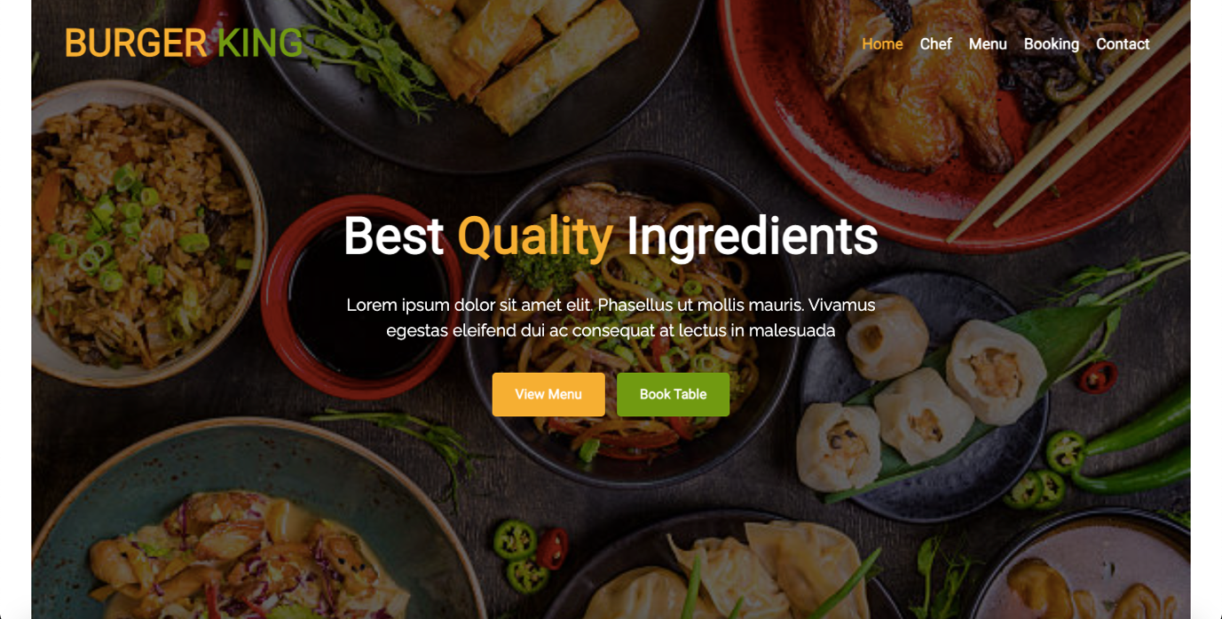

**team.html**

<!DOCTYPE html>

<html lang="en">

<head>

<meta charset="utf-8">

<title>Restaurant</title>

<meta content="width=device-width, initial-scale=1.0" name="viewport">

<meta content="Free Website Template" name="keywords">

<meta content="Free Website Template" name="description">

<!-- Favicon -->

<link href="img/favicon.ico" rel="icon">

<!-- CSS Libraries -->

<link href="https://stackpath.bootstrapcdn.com/bootstrap/4.4.1/css/bootstrap.min.css" rel="stylesheet">

<link href="https://cdnjs.cloudflare.com/ajax/libs/font-awesome/5.10.0/css/all.min.css" rel="stylesheet">

<link href="lib/animate/animate.min.css" rel="stylesheet">

<link href="lib/owlcarousel/assets/owl.carousel.min.css" rel="stylesheet">

<link href="lib/flaticon/font/flaticon.css" rel="stylesheet">

<link href="lib/tempusdominus/css/tempusdominus-bootstrap-4.min.css" rel="stylesheet" />

<!-- Template Stylesheet -->

<link href="css/style.css" rel="stylesheet">

</head>

<body>

<!-- Nav Bar Start -->

<div class="navbar navbar-expand-lg bg-light navbar-light">

<div class="container-fluid">

<a href="index.html" class="navbar-brand">BURGER <span>KING</span></a>

<button type="button" class="navbar-toggler" data-toggle="collapse" data-target="#navbarCollapse">

<span class="navbar-toggler-icon"></span>

</button>

<div class="collapse navbar-collapse justify-content-between" id="navbarCollapse">

<div class="navbar-nav ml-auto">

<a href="index.html" class="nav-item nav-link">Home</a>

<a href="team.html" class="nav-item nav-link active">Chef</a>

<a href="menu.html" class="nav-item nav-link">Menu</a>

<a href="booking.html" class="nav-item nav-link">Booking</a>

<a href="contact.html" class="nav-item nav-link">Contact</a>

</div>

</div>

</div>

</div>

<!-- Nav Bar End -->

<!-- Page Header Start -->

<div class="page-header">

<div class="container">

<div class="row">

<div class="col-12">

<h2>Master Chef</h2>

</div>

<div class="col-12">

<a href="">Home</a>

<a href="">Chef</a>

</div>

</div>

</div>

</div>

<!-- Page Header End -->

<!-- Team Start -->

<div class="team">

<div class="container">

<div class="section-header text-center">

<p>Our Team</p>

<h2>Our Master Chef</h2>

</div>

<div class="row">

<div class="col-lg-3 col-md-6">

<div class="team-item">

<div class="team-img">

<img src="https://images.unsplash.com/flagged/photo-1567194974473-c866a1ba88d5?ixid=MnwxMjA3fDB8MHxzZWFyY2h8Mnx8bWFuYWdlcnxlbnwwfHwwfHw%3D&ixlib=rb-1.2.1&auto=format&fit=crop&w=500&q=60" alt="Image">

<div class="team-social">

<a href=""><i class="fab fa-twitter"></i></a>

<a href=""><i class="fab fa-facebook-f"></i></a>

<a href=""><i class="fab fa-linkedin-in"></i></a>

<a href=""><i class="fab fa-instagram"></i></a>

</div>

</div>

<div class="team-text">

<h2>Adam Phillips</h2>

<p>CEO, Co Founder</p>

</div>

</div>

</div>

<div class="col-lg-3 col-md-6">

<div class="team-item">

<div class="team-img">

<img src="https://images.unsplash.com/flagged/photo-1575623196339-2ce1a4e7e9f0?ixid=MnwxMjA3fDB8MHxzZWFyY2h8N3x8bWFuYWdlcnxlbnwwfHwwfHw%3D&ixlib=rb-1.2.1&auto=format&fit=crop&w=500&q=60" alt="Image">

<div class="team-social">

<a href=""><i class="fab fa-twitter"></i></a>

<a href=""><i class="fab fa-facebook-f"></i></a>

<a href=""><i class="fab fa-linkedin-in"></i></a>

<a href=""><i class="fab fa-instagram"></i></a>

</div>

</div>

<div class="team-text">

<h2>Dylan Adams</h2>

<p>Master Chef</p>

</div>

</div>

</div>

<div class="col-lg-3 col-md-6">

<div class="team-item">

<div class="team-img">

<img src="https://images.unsplash.com/photo-1556157382-97eda2d62296?ixid=MnwxMjA3fDB8MHxzZWFyY2h8MjB8fG1hbmFnZXJ8ZW58MHx8MHx8&ixlib=rb-1.2.1&auto=format&fit=crop&w=500&q=60" alt="Image">

<div class="team-social">

<a href=""><i class="fab fa-twitter"></i></a>

<a href=""><i class="fab fa-facebook-f"></i></a>

<a href=""><i class="fab fa-linkedin-in"></i></a>

<a href=""><i class="fab fa-instagram"></i></a>

</div>

</div>

<div class="team-text">

<h2>Jhon Doe</h2>

<p>Master Chef</p>

</div>

</div>

</div>

<div class="col-lg-3 col-md-6">

<div class="team-item">

<div class="team-img">

<img src="https://images.unsplash.com/photo-1616434116710-c45ce99c1a77?ixid=MnwxMjA3fDB8MHxzZWFyY2h8MzN8fG1hbmFnZXJ8ZW58MHx8MHx8&ixlib=rb-1.2.1&auto=format&fit=crop&w=500&q=60" alt="Image">

<div class="team-social">

<a href=""><i class="fab fa-twitter"></i></a>

<a href=""><i class="fab fa-facebook-f"></i></a>

<a href=""><i class="fab fa-linkedin-in"></i></a>

<a href=""><i class="fab fa-instagram"></i></a>

</div>

</div>

<div class="team-text">

<h2>Josh Dunn</h2>

<p>Master Chef</p>

</div>

</div>

</div>

<div class="col-lg-3 col-md-6">

<div class="team-item">

<div class="team-img">

<img src="https://images.unsplash.com/flagged/photo-1567194974473-c866a1ba88d5?ixid=MnwxMjA3fDB8MHxzZWFyY2h8Mnx8bWFuYWdlcnxlbnwwfHwwfHw%3D&ixlib=rb-1.2.1&auto=format&fit=crop&w=500&q=60" alt="Image">

<div class="team-social">

<a href=""><i class="fab fa-twitter"></i></a>

<a href=""><i class="fab fa-facebook-f"></i></a>

<a href=""><i class="fab fa-linkedin-in"></i></a>

<a href=""><i class="fab fa-instagram"></i></a>

</div>

</div>

<div class="team-text">

<h2>Adam Phillips</h2>

<p>CEO, Co Founder</p>

</div>

</div>

</div>

<div class="col-lg-3 col-md-6">

<div class="team-item">

<div class="team-img">

<img src="https://images.unsplash.com/flagged/photo-1575623196339-2ce1a4e7e9f0?ixid=MnwxMjA3fDB8MHxzZWFyY2h8N3x8bWFuYWdlcnxlbnwwfHwwfHw%3D&ixlib=rb-1.2.1&auto=format&fit=crop&w=500&q=60" alt="Image">

<div class="team-social">

<a href=""><i class="fab fa-twitter"></i></a>

<a href=""><i class="fab fa-facebook-f"></i></a>

<a href=""><i class="fab fa-linkedin-in"></i></a>

<a href=""><i class="fab fa-instagram"></i></a>

</div>

</div>

<div class="team-text">

<h2>Dylan Adams</h2>

<p>Master Chef</p>

</div>

</div>

</div>

<div class="col-lg-3 col-md-6">

<div class="team-item">

<div class="team-img">

<img src="https://images.unsplash.com/photo-1556157382-97eda2d62296?ixid=MnwxMjA3fDB8MHxzZWFyY2h8MjB8fG1hbmFnZXJ8ZW58MHx8MHx8&ixlib=rb-1.2.1&auto=format&fit=crop&w=500&q=60" alt="Image">

<div class="team-social">

<a href=""><i class="fab fa-twitter"></i></a>

<a href=""><i class="fab fa-facebook-f"></i></a>

<a href=""><i class="fab fa-linkedin-in"></i></a>

<a href=""><i class="fab fa-instagram"></i></a>

</div>

</div>

<div class="team-text">

<h2>Jhon Doe</h2>

<p>Master Chef</p>

</div>

</div>

</div>

<div class="col-lg-3 col-md-6">

<div class="team-item">

<div class="team-img">

<img src="https://images.unsplash.com/photo-1616434116710-c45ce99c1a77?ixid=MnwxMjA3fDB8MHxzZWFyY2h8MzN8fG1hbmFnZXJ8ZW58MHx8MHx8&ixlib=rb-1.2.1&auto=format&fit=crop&w=500&q=60" alt="Image">

<div class="team-social">

<a href=""><i class="fab fa-twitter"></i></a>

<a href=""><i class="fab fa-facebook-f"></i></a>

<a href=""><i class="fab fa-linkedin-in"></i></a>

<a href=""><i class="fab fa-instagram"></i></a>

</div>

</div>

<div class="team-text">

<h2>Josh Dunn</h2>

<p>Master Chef</p>

</div>

</div>

</div>

</div>

</div>

</div>

<!-- Team End -->

<!-- Footer Start -->

<div class="footer">

<div class="container">

<div class="row">

<div class="col-lg-7">

<div class="row">

<div class="col-md-6">

<div class="footer-contact">

<h2>Our Address</h2>

<p><i class="fa fa-map-marker-alt"></i>123 Street, New York, USA</p>

<p><i class="fa fa-phone-alt"></i>+012 345 67890</p>

<p><i class="fa fa-envelope"></i>info@example.com</p>

<div class="footer-social">

<a href=""><i class="fab fa-twitter"></i></a>

<a href=""><i class="fab fa-facebook-f"></i></a>

<a href=""><i class="fab fa-youtube"></i></a>

<a href=""><i class="fab fa-instagram"></i></a>

<a href=""><i class="fab fa-linkedin-in"></i></a>

</div>

</div>

</div>

<div class="col-md-6">

<div class="footer-link">

<h2>Quick Links</h2>

<a href="">Terms of use</a>

<a href="">Privacy policy</a>

<a href="">Cookies</a>

<a href="">Help</a>

<a href="">FQAs</a>

</div>

</div>

</div>

</div>

<div class="col-lg-5">

<div class="footer-newsletter">

<h2>Newsletter</h2>

<p>

Lorem ipsum dolor sit amet elit. Quisque eu lectus a leo dictum nec non quam. Tortor eu placerat rhoncus, lorem quam iaculis felis, sed lacus neque id eros.

</p>

<div class="form">

<input class="form-control" placeholder="Email goes here">

<button class="btn custom-btn">Submit</button>

</div>

</div>

</div>

</div>

</div>

<div class="copyright">

<div class="container">

<p>Copyright &copy; <a href="#">Rohit</a>, All Right Reserved.</p>

</div>

</div>

</div>

<!-- Footer End -->

<a href="#" class="back-to-top"><i class="fa fa-chevron-up"></i></a>

<!-- JavaScript Libraries -->

<script src="https://code.jquery.com/jquery-3.4.1.min.js"></script>

<script src="https://stackpath.bootstrapcdn.com/bootstrap/4.4.1/js/bootstrap.bundle.min.js"></script>

<script src="lib/easing/easing.min.js"></script>

<script src="lib/owlcarousel/owl.carousel.min.js"></script>

<script src="lib/tempusdominus/js/moment.min.js"></script>

<script src="lib/tempusdominus/js/moment-timezone.min.js"></script>

<script src="lib/tempusdominus/js/tempusdominus-bootstrap-4.min.js"></script>

<!-- Contact Javascript File -->

<script src="mail/jqBootstrapValidation.min.js"></script>

<script src="mail/contact.js"></script>

<!-- Template Javascript -->

<script src="js/main.js"></script>

</body>

</html>



**menu.html**

<!DOCTYPE html>

<html lang="en">

<head>

<meta charset="utf-8">

<title>Restaurant</title>

<meta content="width=device-width, initial-scale=1.0" name="viewport">

<meta content="Free Website Template" name="keywords">

<meta content="Free Website Template" name="description">

<!-- Favicon -->

<link href="img/favicon.ico" rel="icon">

<!-- CSS Libraries -->

<link href="https://stackpath.bootstrapcdn.com/bootstrap/4.4.1/css/bootstrap.min.css" rel="stylesheet">

<link href="https://cdnjs.cloudflare.com/ajax/libs/font-awesome/5.10.0/css/all.min.css" rel="stylesheet">

<link href="lib/animate/animate.min.css" rel="stylesheet">

<link href="lib/owlcarousel/assets/owl.carousel.min.css" rel="stylesheet">

<link href="lib/flaticon/font/flaticon.css" rel="stylesheet">

<link href="lib/tempusdominus/css/tempusdominus-bootstrap-4.min.css" rel="stylesheet" />

<!-- Template Stylesheet -->

<link href="css/style.css" rel="stylesheet">

</head>

<body>

<!-- Nav Bar Start -->

<div class="navbar navbar-expand-lg bg-light navbar-light">

<div class="container-fluid">

<a href="index.html" class="navbar-brand">BURGER <span>KING</span></a>

<button type="button" class="navbar-toggler" data-toggle="collapse" data-target="#navbarCollapse">

<span class="navbar-toggler-icon"></span>

</button>

<div class="collapse navbar-collapse justify-content-between" id="navbarCollapse">

<div class="navbar-nav ml-auto">

<a href="index.html" class="nav-item nav-link">Home</a>

<a href="team.html" class="nav-item nav-link">Chef</a>

<a href="menu.html" class="nav-item nav-link active">Menu</a>

<a href="booking.html" class="nav-item nav-link">Booking</a>

<a href="contact.html" class="nav-item nav-link">Contact</a>

</div>

</div>

</div>

</div>

<!-- Nav Bar End -->

<!-- Page Header Start -->

<div class="page-header mb-0">

<div class="container">

<div class="row">

<div class="col-12">

<h2>Food Menu</h2>

</div>

<div class="col-12">

<a href="">Home</a>

<a href="">Menu</a>

</div>

</div>

</div>

</div>

<!-- Page Header End -->

<!-- Food Start -->

<div class="food mt-0">

<div class="container">

<div class="row align-items-center">

<div class="col-md-4">

<div class="food-item">

<i class="flaticon-burger"></i>

<h2>Burgers</h2>

<p>

Lorem ipsum dolor sit amet elit. Phasel nec pretium mi. Curabit facilis ornare velit non vulputa. Aliquam metus tortor auctor quis sem.

</p>

<a href="">View Menu</a>

</div>

</div>

<div class="col-md-4">

<div class="food-item">

<i class="flaticon-snack"></i>

<h2>Snacks</h2>

<p>

Lorem ipsum dolor sit amet elit. Phasel nec pretium mi. Curabit facilis ornare velit non vulputa. Aliquam metus tortor auctor quis sem.

</p>

<a href="">View Menu</a>

</div>

</div>

<div class="col-md-4">

<div class="food-item">

<i class="flaticon-cocktail"></i>

<h2>Beverages</h2>

<p>

Lorem ipsum dolor sit amet elit. Phasel nec pretium mi. Curabit facilis ornare velit non vulputa. Aliquam metus tortor auctor quis sem.

</p>

<a href="">View Menu</a>

</div>

</div>

</div>

</div>

</div>

<!-- Food End -->

<!-- Menu Start -->

<div class="menu">

<div class="container">

<div class="section-header text-center">

<p>Food Menu</p>

<h2>Delicious Food Menu</h2>

</div>

<div class="menu-tab">

<ul class="nav nav-pills justify-content-center">

<li class="nav-item">

<a class="nav-link active" data-toggle="pill" href="#burgers">Burgers</a>

</li>

<li class="nav-item">

<a class="nav-link" data-toggle="pill" href="#snacks">Snacks</a>

</li>

<li class="nav-item">

<a class="nav-link" data-toggle="pill" href="#beverages">Beverages</a>

</li>

</ul>

<div class="tab-content">

<div id="burgers" class="container tab-pane active">

<div class="row">

<div class="col-lg-7 col-md-12">

<div class="menu-item">

<div class="menu-img">

<img src="img/menu-burger.jpg" alt="Image">

</div>

<div class="menu-text">

<h3><span>Mini cheese Burger</span> <strong>$9.00</strong></h3>

<p>Lorem ipsum dolor sit amet elit. Phasel nec preti facil</p>

</div>

</div>

<div class="menu-item">

<div class="menu-img">

<img src="https://images.unsplash.com/photo-1502998070258-dc1338445ac2?ixid=MnwxMjA3fDB8MHxzZWFyY2h8Mnx8cmVzdGF1cmFudCUyMGZvb2R8ZW58MHx8MHx8&ixlib=rb-1.2.1&auto=format&fit=crop&w=500&q=60" alt="Image">

</div>

<div class="menu-text">

<h3><span>Double size burger</span> <strong>$11.00</strong></h3>

<p>Lorem ipsum dolor sit amet elit. Phasel nec preti facil</p>

</div>

</div>

<div class="menu-item">

<div class="menu-img">

<img src="https://images.unsplash.com/photo-1502998070258-dc1338445ac2?ixid=MnwxMjA3fDB8MHxzZWFyY2h8Mnx8cmVzdGF1cmFudCUyMGZvb2R8ZW58MHx8MHx8&ixlib=rb-1.2.1&auto=format&fit=crop&w=500&q=60" alt="Image">

</div>

<div class="menu-text">

<h3><span>Bacon, EGG and Cheese</span> <strong>$13.00</strong></h3>

<p>Lorem ipsum dolor sit amet elit. Phasel nec preti facil</p>

</div>

</div>

<div class="menu-item">

<div class="menu-img">

<img src="https://images.unsplash.com/photo-1502998070258-dc1338445ac2?ixid=MnwxMjA3fDB8MHxzZWFyY2h8Mnx8cmVzdGF1cmFudCUyMGZvb2R8ZW58MHx8MHx8&ixlib=rb-1.2.1&auto=format&fit=crop&w=500&q=60" alt="Image">

</div>

<div class="menu-text">

<h3><span>Pulled porx Burger</span> <strong>$18.00</strong></h3>

<p>Lorem ipsum dolor sit amet elit. Phasel nec preti facil</p>

</div>

</div>

<div class="menu-item">

<div class="menu-img">

<img src="https://images.unsplash.com/photo-1502998070258-dc1338445ac2?ixid=MnwxMjA3fDB8MHxzZWFyY2h8Mnx8cmVzdGF1cmFudCUyMGZvb2R8ZW58MHx8MHx8&ixlib=rb-1.2.1&auto=format&fit=crop&w=500&q=60" alt="Image">

</div>

<div class="menu-text">

<h3><span>Fried chicken Burger</span> <strong>$22.00</strong></h3>

<p>Lorem ipsum dolor sit amet elit. Phasel nec preti facil</p>

</div>

</div>

</div>

<div class="col-lg-5 d-none d-lg-block">

<img src="https://images.unsplash.com/photo-1502998070258-dc1338445ac2?ixid=MnwxMjA3fDB8MHxzZWFyY2h8Mnx8cmVzdGF1cmFudCUyMGZvb2R8ZW58MHx8MHx8&ixlib=rb-1.2.1&auto=format&fit=crop&w=500&q=60" alt="Image">

</div>

</div>

</div>

<div id="snacks" class="container tab-pane fade">

<div class="row">

<div class="col-lg-7 col-md-12">

<div class="menu-item">

<div class="menu-img">

<img src="https://images.unsplash.com/photo-1466978913421-dad2ebd01d17?ixid=MnwxMjA3fDB8MHxzZWFyY2h8MTF8fHJlc3RhdXJhbnQlMjBmb29kfGVufDB8fDB8fA%3D%3D&ixlib=rb-1.2.1&auto=format&fit=crop&w=500&q=60" alt="Image">

</div>

<div class="menu-text">

<h3><span>Corn Tikki - Spicy fried Aloo</span> <strong>$15.00</strong></h3>

<p>Lorem ipsum dolor sit amet elit. Phasel nec preti facil</p>

</div>

</div>

<div class="menu-item">

<div class="menu-img">

<img src="https://images.unsplash.com/photo-1466978913421-dad2ebd01d17?ixid=MnwxMjA3fDB8MHxzZWFyY2h8MTF8fHJlc3RhdXJhbnQlMjBmb29kfGVufDB8fDB8fA%3D%3D&ixlib=rb-1.2.1&auto=format&fit=crop&w=500&q=60" alt="Image">

</div>

<div class="menu-text">

<h3><span>Bread besan Toast</span> <strong>$35.00</strong></h3>

<p>Lorem ipsum dolor sit amet elit. Phasel nec preti facil</p>

</div>

</div>

<div class="menu-item">

<div class="menu-img">

<img src="https://images.unsplash.com/photo-1522906456132-bac22adad34e?ixid=MnwxMjA3fDB8MHxzZWFyY2h8N3x8cmVzdGF1cmFudCUyMGZvb2R8ZW58MHx8MHx8&ixlib=rb-1.2.1&auto=format&fit=crop&w=500&q=60" alt="Image">

</div>

<div class="menu-text">

<h3><span>Healthy soya nugget snacks</span> <strong>$20.00</strong></h3>

<p>Lorem ipsum dolor sit amet elit. Phasel nec preti facil</p>

</div>

</div>

<div class="menu-item">

<div class="menu-img">

<img src="https://images.unsplash.com/photo-1617902271850-21d560795d60?ixid=MnwxMjA3fDB8MHxzZWFyY2h8MjV8fHJlc3RhdXJhbnQlMjBmb29kfGVufDB8fDB8fA%3D%3D&ixlib=rb-1.2.1&auto=format&fit=crop&w=500&q=60" alt="Image">

</div>

<div class="menu-text">

<h3><span>Tandoori Soya Chunks</span> <strong>$30.00</strong></h3>

<p>Lorem ipsum dolor sit amet elit. Phasel nec preti facil</p>

</div>

</div>

</div>

<div class="col-lg-5 d-none d-lg-block">

<img src="https://images.unsplash.com/photo-1600891964599-f61ba0e24092?ixid=MnwxMjA3fDB8MHxzZWFyY2h8Mzh8fHJlc3RhdXJhbnQlMjBmb29kfGVufDB8fDB8fA%3D%3D&ixlib=rb-1.2.1&auto=format&fit=crop&w=500&q=60" alt="Image">

</div>

</div>

</div>

<div id="beverages" class="container tab-pane fade">

<div class="row">

<div class="col-lg-7 col-md-12">

<div class="menu-item">

<div class="menu-img">

<img src="https://images.unsplash.com/photo-1523567830207-96731740fa71?ixid=MnwxMjA3fDB8MHxzZWFyY2h8MTV8fHJlc3RhdXJhbnQlMjBmb29kfGVufDB8fDB8fA%3D%3D&ixlib=rb-1.2.1&auto=format&fit=crop&w=500&q=60" alt="Image">

</div>

<div class="menu-text">

<h3><span>Single Cup Brew</span> <strong>$7.00</strong></h3>

<p>Lorem ipsum dolor sit amet elit. Phasel nec preti facil</p>

</div>

</div>

<div class="menu-item">

<div class="menu-img">

<img src="https://images.unsplash.com/photo-1523567830207-96731740fa71?ixid=MnwxMjA3fDB8MHxzZWFyY2h8MTV8fHJlc3RhdXJhbnQlMjBmb29kfGVufDB8fDB8fA%3D%3D&ixlib=rb-1.2.1&auto=format&fit=crop&w=500&q=60" alt="Image">

</div>

<div class="menu-text">

<h3><span>Caffe Americano</span> <strong>$9.00</strong></h3>

<p>Lorem ipsum dolor sit amet elit. Phasel nec preti facil</p>

</div>

</div>

<div class="menu-item">

<div class="menu-img">

<img src="https://images.unsplash.com/photo-1523567830207-96731740fa71?ixid=MnwxMjA3fDB8MHxzZWFyY2h8MTV8fHJlc3RhdXJhbnQlMjBmb29kfGVufDB8fDB8fA%3D%3D&ixlib=rb-1.2.1&auto=format&fit=crop&w=500&q=60" alt="Image">

</div>

<div class="menu-text">

<h3><span>Caramel Macchiato</span> <strong>$15.00</strong></h3>

<p>Lorem ipsum dolor sit amet elit. Phasel nec preti facil</p>

</div>

</div>

<div class="menu-item">

<div class="menu-img">

<img src="https://images.unsplash.com/photo-1523567830207-96731740fa71?ixid=MnwxMjA3fDB8MHxzZWFyY2h8MTV8fHJlc3RhdXJhbnQlMjBmb29kfGVufDB8fDB8fA%3D%3D&ixlib=rb-1.2.1&auto=format&fit=crop&w=500&q=60" alt="Image">

</div>

<div class="menu-text">

<h3><span>Standard black coffee</span> <strong>$8.00</strong></h3>

<p>Lorem ipsum dolor sit amet elit. Phasel nec preti facil</p>

</div>

</div>

<div class="menu-item">

<div class="menu-img">

<img src="https://images.unsplash.com/photo-1523567830207-96731740fa71?ixid=MnwxMjA3fDB8MHxzZWFyY2h8MTV8fHJlc3RhdXJhbnQlMjBmb29kfGVufDB8fDB8fA%3D%3D&ixlib=rb-1.2.1&auto=format&fit=crop&w=500&q=60" alt="Image">

</div>

<div class="menu-text">

<h3><span>Standard black coffee</span> <strong>$12.00</strong></h3>

<p>Lorem ipsum dolor sit amet elit. Phasel nec preti facil</p>

</div>

</div>

</div>

<div class="col-lg-5 d-none d-lg-block">

<img src="https://images.unsplash.com/photo-1523567830207-96731740fa71?ixid=MnwxMjA3fDB8MHxzZWFyY2h8MTV8fHJlc3RhdXJhbnQlMjBmb29kfGVufDB8fDB8fA%3D%3D&ixlib=rb-1.2.1&auto=format&fit=crop&w=500&q=60" alt="Image">

</div>

</div>

</div>

</div>

</div>

</div>

</div>

<!-- Menu End -->

<!-- Footer Start -->

<div class="footer">

<div class="container">

<div class="row">

<div class="col-lg-7">

<div class="row">

<div class="col-md-6">

<div class="footer-contact">

<h2>Our Address</h2>

<p><i class="fa fa-map-marker-alt"></i>123 Street, New York, USA</p>

<p><i class="fa fa-phone-alt"></i>+012 345 67890</p>

<p><i class="fa fa-envelope"></i>info@example.com</p>

<div class="footer-social">

<a href=""><i class="fab fa-twitter"></i></a>

<a href=""><i class="fab fa-facebook-f"></i></a>

<a href=""><i class="fab fa-youtube"></i></a>

<a href=""><i class="fab fa-instagram"></i></a>

<a href=""><i class="fab fa-linkedin-in"></i></a>

</div>

</div>

</div>

<div class="col-md-6">

<div class="footer-link">

<h2>Quick Links</h2>

<a href="">Terms of use</a>

<a href="">Privacy policy</a>

<a href="">Cookies</a>

<a href="">Help</a>

<a href="">FQAs</a>

</div>

</div>

</div>

</div>

<div class="col-lg-5">

<div class="footer-newsletter">

<h2>Newsletter</h2>

<p>

Lorem ipsum dolor sit amet elit. Quisque eu lectus a leo dictum nec non quam. Tortor eu placerat rhoncus, lorem quam iaculis felis, sed lacus neque id eros.

</p>

<div class="form">

<input class="form-control" placeholder="Email goes here">

<button class="btn custom-btn">Submit</button>

</div>

</div>

</div>

</div>

</div>

<div class="copyright">

<div class="container">

<p>Copyright &copy; <a href="#">Rohit</a>, All Right Reserved.</p>

</div>

</div>

</div>

<!-- Footer End -->

<a href="#" class="back-to-top"><i class="fa fa-chevron-up"></i></a>

<!-- JavaScript Libraries -->

<script src="https://code.jquery.com/jquery-3.4.1.min.js"></script>

<script src="https://stackpath.bootstrapcdn.com/bootstrap/4.4.1/js/bootstrap.bundle.min.js"></script>

<script src="lib/easing/easing.min.js"></script>

<script src="lib/owlcarousel/owl.carousel.min.js"></script>

<script src="lib/tempusdominus/js/moment.min.js"></script>

<script src="lib/tempusdominus/js/moment-timezone.min.js"></script>

<script src="lib/tempusdominus/js/tempusdominus-bootstrap-4.min.js"></script>

<!-- Contact Javascript File -->

<script src="mail/jqBootstrapValidation.min.js"></script>

<script src="mail/contact.js"></script>

<!-- Template Javascript -->

<script src="js/main.js"></script>

</body>

</html>

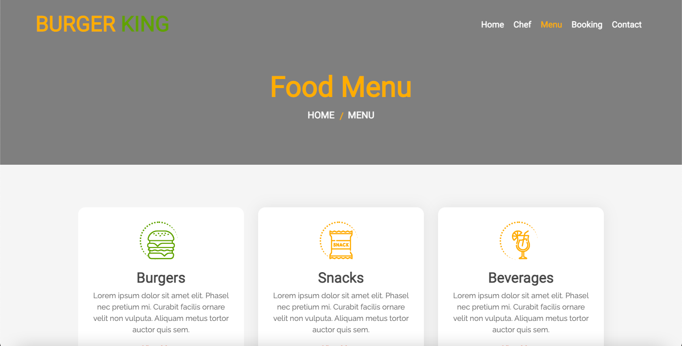

**booking.html**

<!DOCTYPE html>

<html lang="en">

<head>

<meta charset="utf-8">

<title>Restaurant</title>

<meta content="width=device-width, initial-scale=1.0" name="viewport">

<meta content="Free Website Template" name="keywords">

<meta content="Free Website Template" name="description">

<!-- Favicon -->

<link href="img/favicon.ico" rel="icon">

<!-- CSS Libraries -->

<link href="https://stackpath.bootstrapcdn.com/bootstrap/4.4.1/css/bootstrap.min.css" rel="stylesheet">

<link href="https://cdnjs.cloudflare.com/ajax/libs/font-awesome/5.10.0/css/all.min.css" rel="stylesheet">

<link href="lib/animate/animate.min.css" rel="stylesheet">

<link href="lib/owlcarousel/assets/owl.carousel.min.css" rel="stylesheet">

<link href="lib/flaticon/font/flaticon.css" rel="stylesheet">

<link href="lib/tempusdominus/css/tempusdominus-bootstrap-4.min.css" rel="stylesheet" />

<!-- Template Stylesheet -->

<link href="css/style.css" rel="stylesheet">

</head>

<body>

<!-- Nav Bar Start -->

<div class="navbar navbar-expand-lg bg-light navbar-light">

<div class="container-fluid">

<a href="index.html" class="navbar-brand">BURGER <span>KING</span></a>

<button type="button" class="navbar-toggler" data-toggle="collapse" data-target="#navbarCollapse">

<span class="navbar-toggler-icon"></span>

</button>

<div class="collapse navbar-collapse justify-content-between" id="navbarCollapse">

<div class="navbar-nav ml-auto">

<a href="index.html" class="nav-item nav-link">Home</a>

<a href="team.html" class="nav-item nav-link">Chef</a>

<a href="menu.html" class="nav-item nav-link">Menu</a>

<a href="booking.html" class="nav-item nav-link active">Booking</a>

<a href="contact.html" class="nav-item nav-link">Contact</a>

</div>

</div>

</div>

</div>

<!-- Nav Bar End -->

<!-- Page Header Start -->

<div class="page-header mb-0">

<div class="container">

<div class="row">

<div class="col-12">

<h2>Book A Table</h2>

</div>

<div class="col-12">

<a href="">Home</a>

<a href="">Booking</a>

</div>

</div>

</div>

</div>

<!-- Page Header End -->

<!-- Booking Start -->

<div class="booking">

<div class="container">

<div class="row align-items-center">

<div class="col-lg-7">

<div class="booking-content">

<div class="section-header">

<p>Book A Table</p>

<h2>Book Your Table For Private Dinners & Happy Hours</h2>

</div>

<div class="about-text">

<p>

Lorem ipsum dolor sit amet, consectetur adipiscing elit. Phasellus nec pretium mi. Curabitur facilisis ornare velit non vulputate. Aliquam metus tortor, auctor id gravida condimentum, viverra quis sem.

</p>

<p>

Lorem ipsum dolor sit amet, consectetur adipiscing elit. Phasellus nec pretium mi. Curabitur facilisis ornare velit non vulputate. Aliquam metus tortor, auctor id gravida condimentum, viverra quis sem. Curabitur non nisl nec nisi scelerisque maximus. Aenean consectetur convallis porttitor. Aliquam interdum at lacus non blandit.

</p>

</div>

</div>

</div>

<div class="col-lg-5">

<div class="booking-form">

<form>

<div class="control-group">

<div class="input-group">

<input type="text" class="form-control" placeholder="Name" required="required" />

<div class="input-group-append">

<div class="input-group-text"><i class="far fa-user"></i></div>

</div>

</div>

</div>

<div class="control-group">

<div class="input-group">

<input type="email" class="form-control" placeholder="Email" required="required" />

<div class="input-group-append">

<div class="input-group-text"><i class="far fa-envelope"></i></div>

</div>

</div>

</div>

<div class="control-group">

<div class="input-group">

<input type="text" class="form-control" placeholder="Mobile" required="required" />

<div class="input-group-append">

<div class="input-group-text"><i class="fa fa-mobile-alt"></i></div>

</div>

</div>

</div>

<div class="control-group">

<div class="input-group date" id="date" data-target-input="nearest">

<input type="text" class="form-control datetimepicker-input" placeholder="Date" data-target="#date" data-toggle="datetimepicker"/>

<div class="input-group-append" data-target="#date" data-toggle="datetimepicker">

<div class="input-group-text"><i class="far fa-calendar-alt"></i></div>

</div>

</div>

</div>

<div class="control-group">

<div class="input-group time" id="time" data-target-input="nearest">

<input type="text" class="form-control datetimepicker-input" placeholder="Time" data-target="#time" data-toggle="datetimepicker"/>

<div class="input-group-append" data-target="#time" data-toggle="datetimepicker">

<div class="input-group-text"><i class="far fa-clock"></i></div>

</div>

</div>

</div>

<div class="control-group">

<div class="input-group">

<select class="custom-select form-control">

<option selected>Guest</option>

<option value="1">1 Guest</option>

<option value="2">2 Guest</option>

<option value="3">3 Guest</option>

<option value="4">4 Guest</option>

<option value="5">5 Guest</option>

<option value="6">6 Guest</option>

<option value="7">7 Guest</option>

<option value="8">8 Guest</option>

<option value="9">9 Guest</option>

<option value="10">10 Guest</option>

</select>

<div class="input-group-append">

<div class="input-group-text"><i class="fa fa-chevron-down"></i></div>

</div>

</div>

</div>

<div>

<button class="btn custom-btn" type="submit">Book Now</button>

</div>

</form>

</div>

</div>

</div>

</div>

</div>

<!-- Booking End -->

<!-- Menu Start -->

<div class="menu">

<div class="container">

<div class="section-header text-center">

<p>Food Menu</p>

<h2>Delicious Food Menu</h2>

</div>

<div class="menu-tab">

<ul class="nav nav-pills justify-content-center">

<li class="nav-item">

<a class="nav-link active" data-toggle="pill" href="#burgers">Burgers</a>

</li>

<li class="nav-item">

<a class="nav-link" data-toggle="pill" href="#snacks">Snacks</a>

</li>

<li class="nav-item">

<a class="nav-link" data-toggle="pill" href="#beverages">Beverages</a>

</li>

</ul>

<div class="tab-content">

<div id="burgers" class="container tab-pane active">

<div class="row">

<div class="col-lg-7 col-md-12">

<div class="menu-item">

<div class="menu-img">

<img src="https://images.unsplash.com/photo-1457460866886-40ef8d4b42a0?ixid=MnwxMjA3fDB8MHxzZWFyY2h8MTB8fHJlc3RhdXJhbnQlMjBmb29kfGVufDB8fDB8fA%3D%3D&ixlib=rb-1.2.1&auto=format&fit=crop&w=500&q=60" alt="Image">

</div>

<div class="menu-text">

<h3><span>Mini cheese Burger</span> <strong>$9.00</strong></h3>

<p>Lorem ipsum dolor sit amet elit. Phasel nec preti facil</p>

</div>

</div>

<div class="menu-item">

<div class="menu-img">

<img src="https://images.unsplash.com/photo-1457460866886-40ef8d4b42a0?ixid=MnwxMjA3fDB8MHxzZWFyY2h8MTB8fHJlc3RhdXJhbnQlMjBmb29kfGVufDB8fDB8fA%3D%3D&ixlib=rb-1.2.1&auto=format&fit=crop&w=500&q=60" alt="Image">

</div>

<div class="menu-text">

<h3><span>Double size burger</span> <strong>$11.00</strong></h3>

<p>Lorem ipsum dolor sit amet elit. Phasel nec preti facil</p>

</div>

</div>

<div class="menu-item">

<div class="menu-img">

<img src="https://images.unsplash.com/photo-1502998070258-dc1338445ac2?ixid=MnwxMjA3fDB8MHxzZWFyY2h8Mnx8cmVzdGF1cmFudCUyMGZvb2R8ZW58MHx8MHx8&ixlib=rb-1.2.1&auto=format&fit=crop&w=500&q=60" alt="Image">

</div>

<div class="menu-text">

<h3><span>Bacon, EGG and Cheese</span> <strong>$13.00</strong></h3>

<p>Lorem ipsum dolor sit amet elit. Phasel nec preti facil</p>

</div>

</div>

<div class="menu-item">

<div class="menu-img">

<img src="https://images.unsplash.com/photo-1457460866886-40ef8d4b42a0?ixid=MnwxMjA3fDB8MHxzZWFyY2h8MTB8fHJlc3RhdXJhbnQlMjBmb29kfGVufDB8fDB8fA%3D%3D&ixlib=rb-1.2.1&auto=format&fit=crop&w=500&q=60" alt="Image">

</div>

<div class="menu-text">

<h3><span>Pulled porx Burger</span> <strong>$18.00</strong></h3>

<p>Lorem ipsum dolor sit amet elit. Phasel nec preti facil</p>

</div>

</div>

<div class="menu-item">

<div class="menu-img">

<img src="https://images.unsplash.com/photo-1502998070258-dc1338445ac2?ixid=MnwxMjA3fDB8MHxzZWFyY2h8Mnx8cmVzdGF1cmFudCUyMGZvb2R8ZW58MHx8MHx8&ixlib=rb-1.2.1&auto=format&fit=crop&w=500&q=60" alt="Image">

</div>

<div class="menu-text">

<h3><span>Fried chicken Burger</span> <strong>$22.00</strong></h3>

<p>Lorem ipsum dolor sit amet elit. Phasel nec preti facil</p>

</div>

</div>

</div>

<div class="col-lg-5 d-none d-lg-block">

<img src="https://images.unsplash.com/photo-1502998070258-dc1338445ac2?ixid=MnwxMjA3fDB8MHxzZWFyY2h8Mnx8cmVzdGF1cmFudCUyMGZvb2R8ZW58MHx8MHx8&ixlib=rb-1.2.1&auto=format&fit=crop&w=500&q=60" alt="Image">

</div>

</div>

</div>

<div id="snacks" class="container tab-pane fade">

<div class="row">

<div class="col-lg-7 col-md-12">

<div class="menu-item">

<div class="menu-img">

<img src="img/menu-snack.jpg" alt="Image">

</div>

<div class="menu-text">

<h3><span>Corn Tikki - Spicy fried Aloo</span> <strong>$15.00</strong></h3>

<p>Lorem ipsum dolor sit amet elit. Phasel nec preti facil</p>

</div>

</div>

<div class="menu-item">

<div class="menu-img">

<img src="img/menu-snack.jpg" alt="Image">

</div>

<div class="menu-text">

<h3><span>Bread besan Toast</span> <strong>$35.00</strong></h3>

<p>Lorem ipsum dolor sit amet elit. Phasel nec preti facil</p>

</div>

</div>

<div class="menu-item">

<div class="menu-img">

<img src="img/menu-snack.jpg" alt="Image">

</div>

<div class="menu-text">

<h3><span>Healthy soya nugget snacks</span> <strong>$20.00</strong></h3>

<p>Lorem ipsum dolor sit amet elit. Phasel nec preti facil</p>

</div>

</div>

<div class="menu-item">

<div class="menu-img">

<img src="img/menu-snack.jpg" alt="Image">

</div>

<div class="menu-text">

<h3><span>Tandoori Soya Chunks</span> <strong>$30.00</strong></h3>

<p>Lorem ipsum dolor sit amet elit. Phasel nec preti facil</p>

</div>

</div>

</div>

<div class="col-lg-5 d-none d-lg-block">

<img src="img/menu-snack-img.jpg" alt="Image">

</div>

</div>

</div>

<div id="beverages" class="container tab-pane fade">

<div class="row">

<div class="col-lg-7 col-md-12">

<div class="menu-item">

<div class="menu-img">

<img src="img/menu-beverage.jpg" alt="Image">

</div>

<div class="menu-text">

<h3><span>Single Cup Brew</span> <strong>$7.00</strong></h3>

<p>Lorem ipsum dolor sit amet elit. Phasel nec preti facil</p>

</div>

</div>

<div class="menu-item">

<div class="menu-img">

<img src="img/menu-beverage.jpg" alt="Image">

</div>

<div class="menu-text">

<h3><span>Caffe Americano</span> <strong>$9.00</strong></h3>

<p>Lorem ipsum dolor sit amet elit. Phasel nec preti facil</p>

</div>

</div>

<div class="menu-item">

<div class="menu-img">

<img src="img/menu-beverage.jpg" alt="Image">

</div>

<div class="menu-text">

<h3><span>Caramel Macchiato</span> <strong>$15.00</strong></h3>

<p>Lorem ipsum dolor sit amet elit. Phasel nec preti facil</p>

</div>

</div>

<div class="menu-item">

<div class="menu-img">

<img src="img/menu-beverage.jpg" alt="Image">

</div>

<div class="menu-text">

<h3><span>Standard black coffee</span> <strong>$8.00</strong></h3>

<p>Lorem ipsum dolor sit amet elit. Phasel nec preti facil</p>

</div>

</div>

<div class="menu-item">

<div class="menu-img">

<img src="img/menu-beverage.jpg" alt="Image">

</div>

<div class="menu-text">

<h3><span>Standard black coffee</span> <strong>$12.00</strong></h3>

<p>Lorem ipsum dolor sit amet elit. Phasel nec preti facil</p>

</div>

</div>

</div>

<div class="col-lg-5 d-none d-lg-block">

<img src="img/menu-beverage-img.jpg" alt="Image">

</div>

</div>

</div>

</div>

</div>

</div>

</div>

<!-- Menu End -->

<!-- Footer Start -->

<div class="footer">

<div class="container">

<div class="row">

<div class="col-lg-7">

<div class="row">

<div class="col-md-6">

<div class="footer-contact">

<h2>Our Address</h2>

<p><i class="fa fa-map-marker-alt"></i>123 Street, New York, USA</p>

<p><i class="fa fa-phone-alt"></i>+012 345 67890</p>

<p><i class="fa fa-envelope"></i>info@example.com</p>

<div class="footer-social">

<a href=""><i class="fab fa-twitter"></i></a>

<a href=""><i class="fab fa-facebook-f"></i></a>

<a href=""><i class="fab fa-youtube"></i></a>

<a href=""><i class="fab fa-instagram"></i></a>

<a href=""><i class="fab fa-linkedin-in"></i></a>

</div>

</div>

</div>

<div class="col-md-6">

<div class="footer-link">

<h2>Quick Links</h2>

<a href="">Terms of use</a>

<a href="">Privacy policy</a>

<a href="">Cookies</a>

<a href="">Help</a>

<a href="">FQAs</a>

</div>

</div>

</div>

</div>

<div class="col-lg-5">

<div class="footer-newsletter">

<h2>Newsletter</h2>

<p>

Lorem ipsum dolor sit amet elit. Quisque eu lectus a leo dictum nec non quam. Tortor eu placerat rhoncus, lorem quam iaculis felis, sed lacus neque id eros.

</p>

<div class="form">

<input class="form-control" placeholder="Email goes here">

<button class="btn custom-btn">Submit</button>

</div>

</div>

</div>

</div>

</div>

<div class="copyright">

<div class="container">

<p>Copyright &copy; <a href="#">Rohit</a>, All Right Reserved.</p>

</div>

</div>

</div>

<!-- Footer End -->

<a href="#" class="back-to-top"><i class="fa fa-chevron-up"></i></a>

<!-- JavaScript Libraries -->

<script src="https://code.jquery.com/jquery-3.4.1.min.js"></script>

<script src="https://stackpath.bootstrapcdn.com/bootstrap/4.4.1/js/bootstrap.bundle.min.js"></script>

<script src="lib/easing/easing.min.js"></script>

<script src="lib/owlcarousel/owl.carousel.min.js"></script>

<script src="lib/tempusdominus/js/moment.min.js"></script>

<script src="lib/tempusdominus/js/moment-timezone.min.js"></script>

<script src="lib/tempusdominus/js/tempusdominus-bootstrap-4.min.js"></script>

<!-- Contact Javascript File -->

<script src="mail/jqBootstrapValidation.min.js"></script>

<script src="mail/contact.js"></script>

<!-- Template Javascript -->

<script src="js/main.js"></script>

</body>

</html>

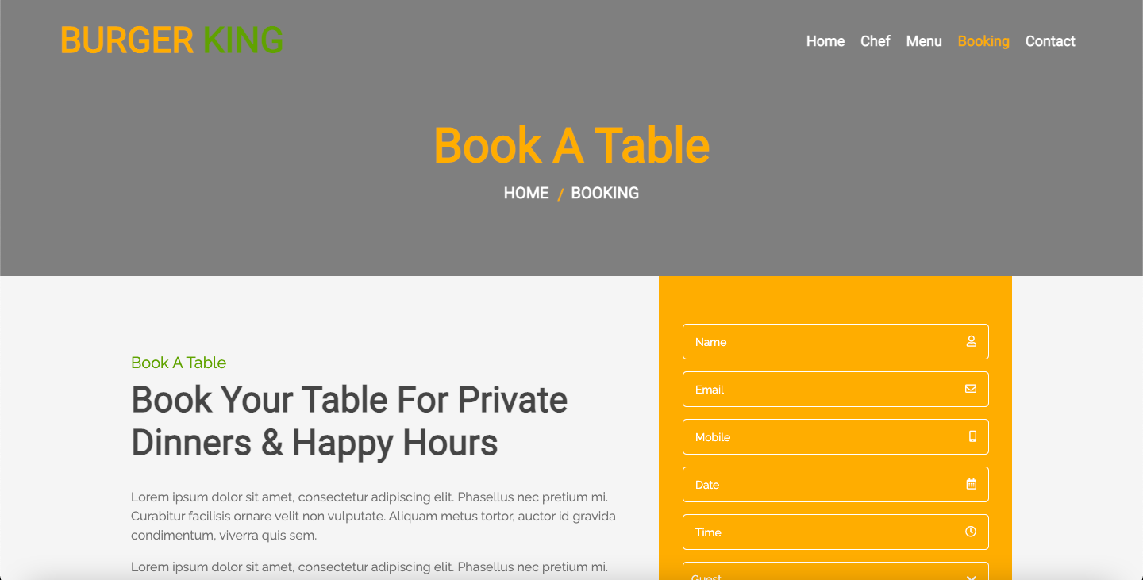

**contact.html**

<!DOCTYPE html>

<html lang="en">

<head>

<meta charset="utf-8">

<title>Restaurant</title>

<meta content="width=device-width, initial-scale=1.0" name="viewport">

<meta content="Free Website Template" name="keywords">

<meta content="Free Website Template" name="description">

<!-- Favicon -->

<link href="img/favicon.ico" rel="icon">

<!-- CSS Libraries -->

<link href="https://stackpath.bootstrapcdn.com/bootstrap/4.4.1/css/bootstrap.min.css" rel="stylesheet">

<link href="https://cdnjs.cloudflare.com/ajax/libs/font-awesome/5.10.0/css/all.min.css" rel="stylesheet">

<link href="lib/animate/animate.min.css" rel="stylesheet">

<link href="lib/owlcarousel/assets/owl.carousel.min.css" rel="stylesheet">

<link href="lib/flaticon/font/flaticon.css" rel="stylesheet">

<link href="lib/tempusdominus/css/tempusdominus-bootstrap-4.min.css" rel="stylesheet" />

<!-- Template Stylesheet -->

<link href="css/style.css" rel="stylesheet">

</head>

<body>

<!-- Nav Bar Start -->

<div class="navbar navbar-expand-lg bg-light navbar-light">

<div class="container-fluid">

<a href="index.html" class="navbar-brand">BURGER <span>KING</span></a>

<button type="button" class="navbar-toggler" data-toggle="collapse" data-target="#navbarCollapse">

<span class="navbar-toggler-icon"></span>

</button>

<div class="collapse navbar-collapse justify-content-between" id="navbarCollapse">

<div class="navbar-nav ml-auto">

<a href="index.html" class="nav-item nav-link">Home</a>

<a href="team.html" class="nav-item nav-link">Chef</a>

<a href="menu.html" class="nav-item nav-link">Menu</a>

<a href="booking.html" class="nav-item nav-link">Booking</a>

<a href="contact.html" class="nav-item nav-link active">Contact</a>

</div>

</div>

</div>

</div>

<!-- Nav Bar End -->

<!-- Page Header Start -->

<div class="page-header">

<div class="container">

<div class="row">

<div class="col-12">

<h2>Contact Us</h2>

</div>

<div class="col-12">

<a href="">Home</a>

<a href="">Contact</a>

</div>

</div>

</div>

</div>

<!-- Page Header End -->

<!-- Contact Start -->

<div class="contact">

<div class="container">

<div class="section-header text-center">

<p>Contact Us</p>

<h2>Contact For Any Query</h2>

</div>

<div class="row align-items-center contact-information">

<div class="col-md-6 col-lg-3">

<div class="contact-info">

<div class="contact-icon">

<i class="fa fa-map-marker-alt"></i>

</div>

<div class="contact-text">

<h3>Address</h3>

<p>123 Street, NY, USA</p>

</div>

</div>

</div>

<div class="col-md-6 col-lg-3">

<div class="contact-info">

<div class="contact-icon">

<i class="fa fa-phone-alt"></i>

</div>

<div class="contact-text">

<h3>Call Us</h3>

<p>+012 345 6789</p>

</div>

</div>

</div>

<div class="col-md-6 col-lg-3">

<div class="contact-info">

<div class="contact-icon">

<i class="fa fa-envelope"></i>

</div>

<div class="contact-text">

<h3>Email Us</h3>

<p>info@example.com</p>

</div>

</div>

</div>

<div class="col-md-6 col-lg-3">

<div class="contact-info">

<div class="contact-icon">

<i class="fa fa-share"></i>

</div>

<div class="contact-text">

<h3>Follow Us</h3>

<div class="contact-social">

<a href=""><i class="fab fa-twitter"></i></a>

<a href=""><i class="fab fa-facebook-f"></i></a>

<a href=""><i class="fab fa-youtube"></i></a>

<a href=""><i class="fab fa-instagram"></i></a>

<a href=""><i class="fab fa-linkedin-in"></i></a>

</div>

</div>

</div>

</div>

</div>

<div class="row contact-form">

<div class="col-md-6">

<iframe src="https://www.google.com/maps/embed?pb=!1m18!1m12!1m3!1d3001156.4288297426!2d-78.01371936852176!3d42.72876761954724!2m3!1f0!2f0!3f0!3m2!1i1024!2i768!4f13.1!3m3!1m2!1s0x4ccc4bf0f123a5a9%3A0xddcfc6c1de189567!2sNew%20York%2C%20USA!5e0!3m2!1sen!2sbd!4v1600663868074!5m2!1sen!2sbd" frameborder="0" style="border:0;" allowfullscreen="" aria-hidden="false" tabindex="0"></iframe>

</div>

<div class="col-md-6">

<div id="success"></div>

<form name="sentMessage" id="contactForm" novalidate="novalidate">

<div class="control-group">

<input type="text" class="form-control" id="name" placeholder="Your Name" required="required" data-validation-required-message="Please enter your name" />

<p class="help-block text-danger"></p>

</div>

<div class="control-group">

<input type="email" class="form-control" id="email" placeholder="Your Email" required="required" data-validation-required-message="Please enter your email" />

<p class="help-block text-danger"></p>

</div>

<div class="control-group">

<input type="text" class="form-control" id="subject" placeholder="Subject" required="required" data-validation-required-message="Please enter a subject" />

<p class="help-block text-danger"></p>

</div>

<div class="control-group">

<textarea class="form-control" id="message" placeholder="Message" required="required" data-validation-required-message="Please enter your message"></textarea>

<p class="help-block text-danger"></p>

</div>

<div>

<button class="btn custom-btn" type="submit" id="sendMessageButton">Send Message</button>

</div>

</form>

</div>

</div>

</div>

</div>

<!-- Contact End -->

<!-- Footer Start -->

<div class="footer">

<div class="container">

<div class="row">

<div class="col-lg-7">

<div class="row">

<div class="col-md-6">

<div class="footer-contact">

<h2>Our Address</h2>

<p><i class="fa fa-map-marker-alt"></i>123 Street, New York, USA</p>

<p><i class="fa fa-phone-alt"></i>+012 345 67890</p>

<p><i class="fa fa-envelope"></i>info@example.com</p>

<div class="footer-social">

<a href=""><i class="fab fa-twitter"></i></a>

<a href=""><i class="fab fa-facebook-f"></i></a>

<a href=""><i class="fab fa-youtube"></i></a>

<a href=""><i class="fab fa-instagram"></i></a>

<a href=""><i class="fab fa-linkedin-in"></i></a>

</div>

</div>

</div>

<div class="col-md-6">

<div class="footer-link">

<h2>Quick Links</h2>

<a href="">Terms of use</a>

<a href="">Privacy policy</a>

<a href="">Cookies</a>

<a href="">Help</a>

<a href="">FQAs</a>

</div>

</div>

</div>

</div>

<div class="col-lg-5">

<div class="footer-newsletter">

<h2>Newsletter</h2>

<p>

Lorem ipsum dolor sit amet elit. Quisque eu lectus a leo dictum nec non quam. Tortor eu placerat rhoncus, lorem quam iaculis felis, sed lacus neque id eros.

</p>

<div class="form">

<input class="form-control" placeholder="Email goes here">

<button class="btn custom-btn">Submit</button>

</div>

</div>

</div>

</div>

</div>

<div class="copyright">

<div class="container">

<p>Copyright &copy; <a href="#">Rohit</a>, All Right Reserved.</p>

</div>

</div>

</div>

<!-- Footer End -->

<a href="#" class="back-to-top"><i class="fa fa-chevron-up"></i></a>

<!-- JavaScript Libraries -->

<script src="https://code.jquery.com/jquery-3.4.1.min.js"></script>

<script src="https://stackpath.bootstrapcdn.com/bootstrap/4.4.1/js/bootstrap.bundle.min.js"></script>

<script src="lib/easing/easing.min.js"></script>

<script src="lib/owlcarousel/owl.carousel.min.js"></script>

<script src="lib/tempusdominus/js/moment.min.js"></script>

<script src="lib/tempusdominus/js/moment-timezone.min.js"></script>

<script src="lib/tempusdominus/js/tempusdominus-bootstrap-4.min.js"></script>

<!-- Contact Javascript File -->

<script src="mail/jqBootstrapValidation.min.js"></script>

<script src="mail/contact.js"></script>

<!-- Template Javascript -->

<script src="js/main.js"></script>

</body>

</html>

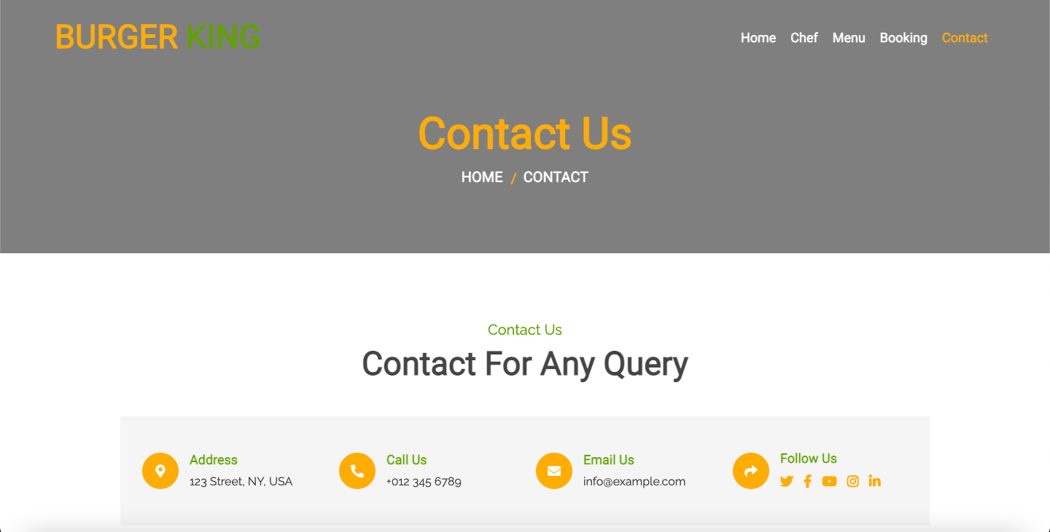

**Practical 3.1**

**1. Getting started with Responsive website design using Twitter Bootstrap, also implement the concept of Typography using Bootstrap.**

**2. Try to implement other Tags with Bootstrap that are present under CSS tab on the mentioned link.**[**https://getbootstrap.com/docs/3.4/css/#type**](https://getbootstrap.com/docs/3.4/css/#type)

**index.html**

<!doctype html>

<html lang="en">

<head>

<meta charset="utf-8">

<meta http-equiv="X-UA-Compatible" content="IE=edge">

<meta name="viewport" content="width=device-width, initial-scale=1">

<!-- The above 3 meta tags *must* come first in the head; any other head content must come *after* these tags -->

<title>Bootstrap 101 Template</title>

<!-- Bootstrap -->

<link rel="stylesheet" href="https://stackpath.bootstrapcdn.com/bootstrap/3.4.1/css/bootstrap.min.css" integrity="sha384-HSMxcRTRxnN+Bdg0JdbxYKrThecOKuH5zCYotlSAcp1+c8xmyTe9GYg1l9a69psu" crossorigin="anonymous">

<!-- HTML5 shim and Respond.js for IE8 support of HTML5 elements and media queries -->

<!-- WARNING: Respond.js doesn't work if you view the page via file:// -->

<!--[if lt IE 9]>

<script src="https://oss.maxcdn.com/html5shiv/3.7.3/html5shiv.min.js"></script>

<script src="https://oss.maxcdn.com/respond/1.4.2/respond.min.js"></script>

<![endif]-->

</head>

<body>

<h1>Hello, world!</h1>

<h1>h1. Bootstrap heading</h1>

<h2>h2. Bootstrap heading</h2>

<h3>h3. Bootstrap heading</h3>

<h4>h4. Bootstrap heading</h4>

<h5>h5. Bootstrap heading</h5>

<h6>h6. Bootstrap heading</h6>

<h1>h1. Bootstrap heading <small>Secondary text</small></h1>

<h2>h2. Bootstrap heading <small>Secondary text</small></h2>

<h3>h3. Bootstrap heading <small>Secondary text</small></h3>

<h4>h4. Bootstrap heading <small>Secondary text</small></h4>

<h5>h5. Bootstrap heading <small>Secondary text</small></h5>

<h6>h6. Bootstrap heading <small>Secondary text</small></h6>

<p>Lorem ipsum dolor sit amet consectetur adipisicing elit. Sint excepturi, quis non earum facere, sed nesciunt veritatis corrupti quasi nostrum quod vitae eligendi aperiam. Aperiam voluptates alias illo amet harum.</p>

<p class="lead">Lorem, ipsum dolor sit, amet consectetur adipisicing elit. Molestiae repudiandae repellendus maxime in tempora harum excepturi, corrupti. Ut fugit necessitatibus cumque iste, aut placeat laborum. In atque nesciunt harum porro?</p>

You can use the mark tag to <mark>highlight</mark> text.

<del>This line of text is meant to be treated as deleted text.</del>

<s>This line of text is meant to be treated as no longer accurate.</s>

<ins>This line of text is meant to be treated as an addition to the document.</ins>

<u>This line of text will render as underlined</u>

<small>This line of text is meant to be treated as fine print.</small>

<strong>rendered as bold text</strong>

<em>rendered as italicized text</em>

<p class="text-left">Left aligned text.</p>

<p class="text-center">Center aligned text.</p>

<p class="text-right">Right aligned text.</p>

<p class="text-justify">Justified text.</p>

<p class="text-nowrap">No wrap text.</p>

<p class="text-lowercase">Lowercased text.</p>

<p class="text-uppercase">Uppercased text.</p>

<p class="text-capitalize">Capitalized text.</p>

<abbr title="attribute">attr</abbr>

<abbr title="HyperText Markup Language" class="initialism">HTML</abbr>

<address>

<strong>Twitter, Inc.</strong><br>

1355 Market Street, Suite 900<br>

San Francisco, CA 94103<br>

<abbr title="Phone">P:</abbr> (123) 456-7890

</address>

<address>

<strong>Full Name</strong><br>

<a href="mailto:#">first.last@example.com</a>

</address>

<blockquote>

<p>Lorem ipsum dolor sit amet, consectetur adipiscing elit. Integer posuere erat a ante.</p>

</blockquote>

<blockquote>

<p>Lorem ipsum dolor sit amet, consectetur adipiscing elit. Integer posuere erat a ante.</p>

<footer>Someone famous in <cite title="Source Title">Source Title</cite></footer>

</blockquote>

<blockquote class="blockquote-reverse">

<p>Lorem ipsum dolor sit amet, consectetur adipiscing elit. Integer posuere erat a ante.</p>

<footer>Someone famous in <cite title="Source Title">Source Title</cite></footer>

</blockquote>

<ul>

<li>vds</li>

<li>vsd</li>

<li>sdzg</li>

</ul>

<ol>

<li>efw</li>

<li>fzb</li>

<li>feFe</li>

</ol>

<ul class="list-unstyled">

<li>egre</li>

<li>gewwg</li>

<li>efeefs</li>

</ul>

<ul class="list-inline">

<li>ef</li>

<li>eg</li>

<li>esged</li>

</ul>

<dl>

<dt>qazwsx</dt>

<dd>qazwsx</dd>

</dl>

<dl class="dl-horizontal">

<dt>qazwsx</dt>

<dd>qazwsx</dd>

</dl>

For example, <code>&lt;section&gt;</code> should be wrapped as inline.

To switch directories, type <kbd>cd</kbd> followed by the name of the directory.<br>

To edit settings, press <kbd><kbd>ctrl</kbd> + <kbd>,</kbd></kbd>

<pre>&lt;p&gt;Sample text here...&lt;/p&gt;</pre>

<var>y</var> = <var>m</var><var>x</var> + <var>b</var>

<samp>This text is meant to be treated as sample output from a computer program.</samp>

<!-- jQuery (necessary for Bootstrap's JavaScript plugins) -->

<script src="https://code.jquery.com/jquery-1.12.4.min.js" integrity="sha384-nvAa0+6Qg9clwYCGGPpDQLVpLNn0fRaROjHqs13t4Ggj3Ez50XnGQqc/r8MhnRDZ" crossorigin="anonymous"></script>

<!-- Include all compiled plugins (below), or include individual files as needed -->

<script src="https://stackpath.bootstrapcdn.com/bootstrap/3.4.1/js/bootstrap.min.js" integrity="sha384-aJ21OjlMXNL5UyIl/XNwTMqvzeRMZH2w8c5cRVpzpU8Y5bApTppSuUkhZXN0VxHd" crossorigin="anonymous"></script>

</body>

</html>

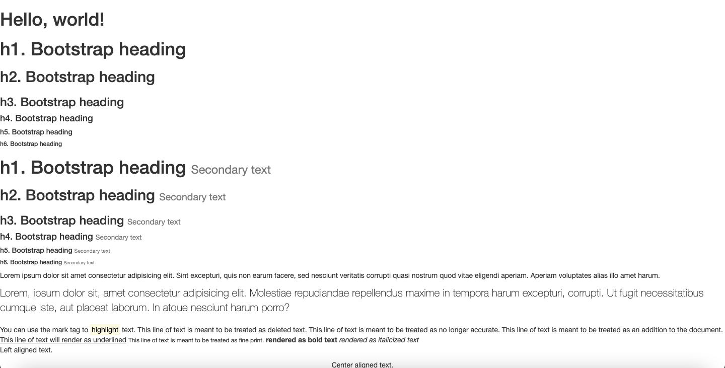

**Practical 3.2(a)**

**Create a webpage using Table, Forms, Buttons and other elements of Twitter Bootstrap.**

**index.html**

<!doctype html>

<html lang="en">

<head>

<meta charset="utf-8">

<meta http-equiv="X-UA-Compatible" content="IE=edge">

<meta name="viewport" content="width=device-width, initial-scale=1">

<link rel="stylesheet" type="text/css" href="../CSS/style.css">

<!-- The above 3 meta tags *must* come first in the head; any other head content must come *after* these tags -->

<title>Bootstrap 101 Template</title>

<!-- Bootstrap -->

<link rel="stylesheet" href="https://stackpath.bootstrapcdn.com/bootstrap/3.4.1/css/bootstrap.min.css" crossorigin="anonymous">

<!-- HTML5 shim and Respond.js for IE8 support of HTML5 elements and media queries -->

<!-- WARNING: Respond.js doesn't work if you view the page via file:// -->

<!--[if lt IE 9]>

<script src="https://oss.maxcdn.com/html5shiv/3.7.3/html5shiv.min.js"></script>

<script src="https://oss.maxcdn.com/respond/1.4.2/respond.min.js"></script>

<![endif]-->

</head>

<body>

<table class="table">

<tr>

<td>First Name</td>

<td>Last Name</td>

<td>Username</td>

</tr>

<tr>

<td>Rey</td>

<td>Mysterio</td>

<td>162</td>

</tr>

<tr>

<td>Shawn</td>

<td>Michaels</td>

<td>186</td>

</tr>

</table>

<br>

<div class="container">

<table class="table">

<tr>

<td>First Name</td>

<td>Last Name</td>

<td>Username</td>

</tr>

<tr>

<td>Booker</td>

<td>T</td>

<td>183</td>

</tr>

</table>

<h3>Striped Table</h3>

<div class="container">

<table class="table table-striped">

<tr>

<td>First Name</td>

<td>Last Name</td>

<td>Username</td>

</tr>

<tr>

<td>Ben</td>

<td>Stokes</td>

<td>271</td>

</tr>

</table>

</div>

<h3>Bordered Table</h3>

<div class="container">

<table class="table table-bordered">

<tr>

<td>First Name</td>

<td>Last Name</td>

<td>Username</td>

</tr>

<tr>

<td>Joe</td>

<td>Root</td>

<td>163</td>

</tr>

</table>

</div>

<h3>Hover Table</h3>

<div class="container">

<table class="table table-hover">

<tr>

<td>First Name</td>

<td>Last Name</td>

<td>Username</td>

</tr>

<tr>

<td>Jimmy</td>

<td>Nesham</td>

<td>421</td>

</tr>

</table>

</div>

<h3>Condensed Table</h3>

<div class="container">

<table class="table table-condensed">

<tr>

<td>First Name</td>

<td>Last Name</td>

<td>Username</td>

</tr>

<tr>

<td>kl</td>

<td>Rahul</td>

<td>182</td>

</tr>

<tr>

<td>Kane</td>

<td>Williamson</td>

<td>344</td>

</tr>

</table>

</div>

<div class="container">

<p class="red">Lorem ipsum, dolor sit, amet consectetur adipisicing elit. Quis obcaecati molestiae excepturi nobis debitis quo veniam. Sunt dolore, quaerat pariatur repellat fuga excepturi, porro! Commodi, aut. Minus nesciunt sed doloribus.

<table class="table table-condensed">

<tr class="active">

<td>First Name</td>

<td>Last Name</td>

<td>Username</td>

</tr>

<tr>

<td>Virat</td>

<td>Kohli</td>

<td>182</td>

</tr>

<tr>

<td>Rohit</td>

<td>Sharma</td>

<td>344</td>

</tr>

</table>

</div>

<form>

<div class="form-group">

<label for="exampleInputEmail1">Email address</label>

<input type="email" class="form-control" id="exampleInputEmail1" placeholder="Email">

</div>

<div class="form-group">

<label for="exampleInputPassword1">Password</label>

<input type="password" class="form-control" id="exampleInputPassword1" placeholder="Password">

</div>

<div class="form-group">

<label for="exampleInputFile">File input</label>

<input type="file" id="exampleInputFile">

<p class="help-block">Example block-level help text here.</p>

</div>

<div class="checkbox">

<label>

<input type="checkbox"> Check me out

</label>

</div>

<button type="submit" class="btn btn-default">Submit</button>

</form>

<h3>Inline Form</h3>

<form class="form-inline">

<div class="form-group">

<label for="exampleInputName2">Name</label>

<input type="text" class="form-control" id="exampleInputName2" placeholder="Jane Doe">

</div>

<div class="form-group">

<label for="exampleInputEmail2">Email</label>

<input type="email" class="form-control" id="exampleInputEmail2" placeholder="jane.doe@example.com">

</div>

<button type="submit" class="btn btn-default">Send invitation</button>

</form>

<h3>Horizontal Form</h3>

<form class="form-horizontal">

<div class="form-group">

<label for="inputEmail3" class="col-sm-2 control-label">Email</label>

<div class="col-sm-10">

<input type="email" class="form-control" id="inputEmail3" placeholder="Email">

</div>

</div>

<div class="form-group">

<label for="inputPassword3" class="col-sm-2 control-label">Password</label>

<div class="col-sm-10">

<input type="password" class="form-control" id="inputPassword3" placeholder="Password">

</div>

</div>

<div class="form-group">

<div class="col-sm-offset-2 col-sm-10">

<div class="checkbox">

<label>

<input type="checkbox"> Remember me

</label>

</div>

</div>

</div>

<div class="form-group">

<div class="col-sm-offset-2 col-sm-10">

<button type="submit" class="btn btn-default">Sign in</button>

</div>

</div>

</form>

<h3>Checkboxes and Radios</h3>

<div class="checkbox">

<label>

<input type="checkbox" value="">

Option one is this and that&mdash;be sure to include why it's great

</label>

</div>

<div class="checkbox disabled">

<label>

<input type="checkbox" value="" disabled>

Option two is disabled

</label>

</div>

<div class="radio">

<label>

<input type="radio" name="optionsRadios" id="optionsRadios1" value="option1" checked>

Option one is this and that&mdash;be sure to include why it's great

</label>

</div>

<div class="radio">

<label>

<input type="radio" name="optionsRadios" id="optionsRadios2" value="option2">

Option two can be something else and selecting it will deselect option one

</label>

</div>

<div class="radio disabled">

<label>

<input type="radio" name="optionsRadios" id="optionsRadios3" value="option3" disabled>

Option three is disabled

</label>

</div>

<h3>Disabled fieldset</h3>

<form>

<fieldset disabled>

<div class="form-group">

<label for="disabledTextInput">Disabled input</label>

<input type="text" id="disabledTextInput" class="form-control" placeholder="Disabled input">

</div>

<div class="form-group">

<label for="disabledSelect">Disabled select menu</label>

<select id="disabledSelect" class="form-control">

<option>Disabled select</option>

</select>

</div>

<div class="checkbox">

<label>

<input type="checkbox"> Can't check this

</label>

</div>

<button type="submit" class="btn btn-primary">Submit</button>

</fieldset>

</form>

<h3>Control sizing</h3>

<input class="form-control input-lg" type="text" placeholder=".input-lg">

<input class="form-control" type="text" placeholder="Default input">

<input class="form-control input-sm" type="text" placeholder=".input-sm">

<select class="form-control input-lg">...</select>

<select class="form-control">...</select>

<select class="form-control input-sm">...</select>

<h3>Button Tags</h3>

<a class="btn btn-default" href="#" role="button">Link</a>

<button class="btn btn-default" type="submit">Button</button>

<input class="btn btn-default" type="button" value="Input">

<input class="btn btn-default" type="submit" value="Submit">

<h3>Options</h3>

<!-- Standard button -->

<button type="button" class="btn btn-default">Default</button>

<!-- Provides extra visual weight and identifies the primary action in a set of buttons -->

<button type="button" class="btn btn-primary">Primary</button>

<!-- Indicates a successful or positive action -->

<button type="button" class="btn btn-success">Success</button>

<!-- Contextual button for informational alert messages -->

<button type="button" class="btn btn-info">Info</button>

<!-- Indicates caution should be taken with this action -->

<button type="button" class="btn btn-warning">Warning</button>

<!-- Indicates a dangerous or potentially negative action -->

<button type="button" class="btn btn-danger">Danger</button>

<!-- Deemphasize a button by making it look like a link while maintaining button behavior -->

<button type="button" class="btn btn-link">Link</button>

<h3>Sizes</h3>

<p>

<button type="button" class="btn btn-primary btn-lg">Large button</button>

<button type="button" class="btn btn-default btn-lg">Large button</button>

</p>

<p>

<button type="button" class="btn btn-primary">Default button</button>

<button type="button" class="btn btn-default">Default button</button>

</p>

<p>

<button type="button" class="btn btn-primary btn-sm">Small button</button>

<button type="button" class="btn btn-default btn-sm">Small button</button>

</p>

<p>

<button type="button" class="btn btn-primary btn-xs">Extra small button</button>

<button type="button" class="btn btn-default btn-xs">Extra small button</button>

</p>

<h3>Active State</h3>

<button type="button" class="btn btn-primary btn-lg active">Primary button</button>

<button type="button" class="btn btn-default btn-lg active">Button</button>

<h3>IMAGES</h3>

<h3>Responsive Image</h3>

<img src="../images/c1.jpg" class="img-responsive" alt="Responsive image">

<h3>Image Shapes</h3>

<img src="../images/c1.jpg" alt="..." class="img-rounded">

<img src="../images/c1.jpg" alt="..." class="img-circle">

<img src="../images/c1.jpg" alt="..." class="img-thumbnail">

<!-- jQuery (necessary for Bootstrap's JavaScript plugins) -->

<script src="https://code.jquery.com/jquery-1.12.4.min.js" crossorigin="anonymous"></script>

<!-- Include all compiled plugins (below), or include individual files as needed -->

<script src="https://stackpath.bootstrapcdn.com/bootstrap/3.4.1/js/bootstrap.min.js" crossorigin="anonymous"></script>

</body>

</html>

**style.css**

.red{

color:#ff0000;

}

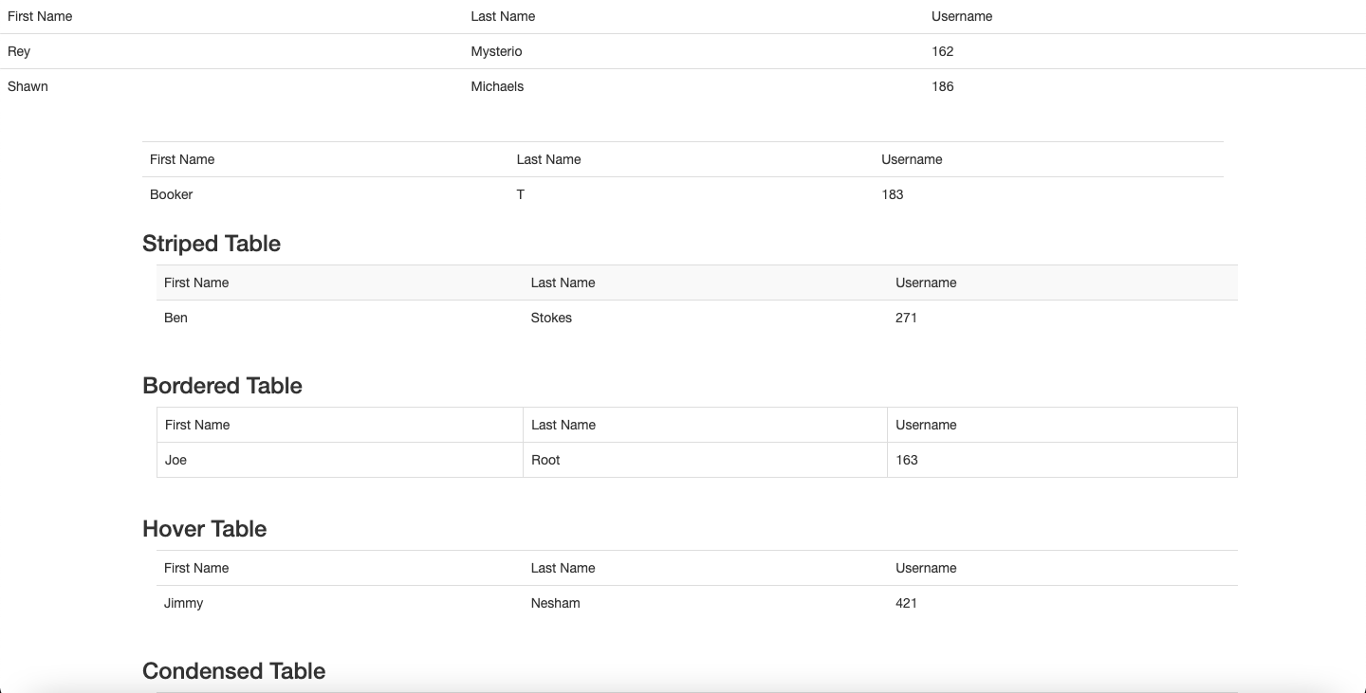

**Practical 3.2(b)**

**Implement the concept of Grid System in Bootstrap, also create webpages same as mentioned Week 1 (Box Model Assignment).**

**div1.html**

<!doctype html>

<html lang="en">

<head>

<meta charset="utf-8">

<meta http-equiv="X-UA-Compatible" content="IE=edge">

<meta name="viewport" content="width=device-width, initial-scale=1">

<title>Div1</title>

<link rel="stylesheet" href="https://stackpath.bootstrapcdn.com/bootstrap/3.4.1/css/bootstrap.min.css" integrity="sha384-HSMxcRTRxnN+Bdg0JdbxYKrThecOKuH5zCYotlSAcp1+c8xmyTe9GYg1l9a69psu" crossorigin="anonymous">

<link rel="stylesheet" href="css/div1.css">

</head>

<body>

<div class="container">

<div class="row">

<div class="col-md-6 lb"></div>

<div class="col-md-6 db"></div>

</div>

<div class="row">

<div class="col-md-6 b"></div>

<div class="col-md-6 g"></div>

</div>

<div class="row">

<div class="col-md-6 lb"></div>

<div class="col-md-6 db"></div>

</div>

<div class="row">

<div class="col-md-6 b"></div>

<div class="col-md-6 g"></div>

</div>

<div class="row">

<div class="col-md-6 lb"></div>

<div class="col-md-6 db"></div>

</div>

<div class="row">

<div class="col-md-6 b"></div>

<div class="col-md-6 g"></div>

</div>

</div>

<script src="https://code.jquery.com/jquery-1.12.4.min.js" integrity="sha384-nvAa0+6Qg9clwYCGGPpDQLVpLNn0fRaROjHqs13t4Ggj3Ez50XnGQqc/r8MhnRDZ" crossorigin="anonymous"></script>

<script src="https://stackpath.bootstrapcdn.com/bootstrap/3.4.1/js/bootstrap.min.js" integrity="sha384-aJ21OjlMXNL5UyIl/XNwTMqvzeRMZH2w8c5cRVpzpU8Y5bApTppSuUkhZXN0VxHd" crossorigin="anonymous"></script>

</body>

</html>

**div1.css**

.col-md-6 {

height: 100px;

}

.lb {

background-color: #356AA0;

}

.db {

background-color: #183350;

}

.b {

background-color: #000000;

}

.g {

background-color: #97CE01;

}

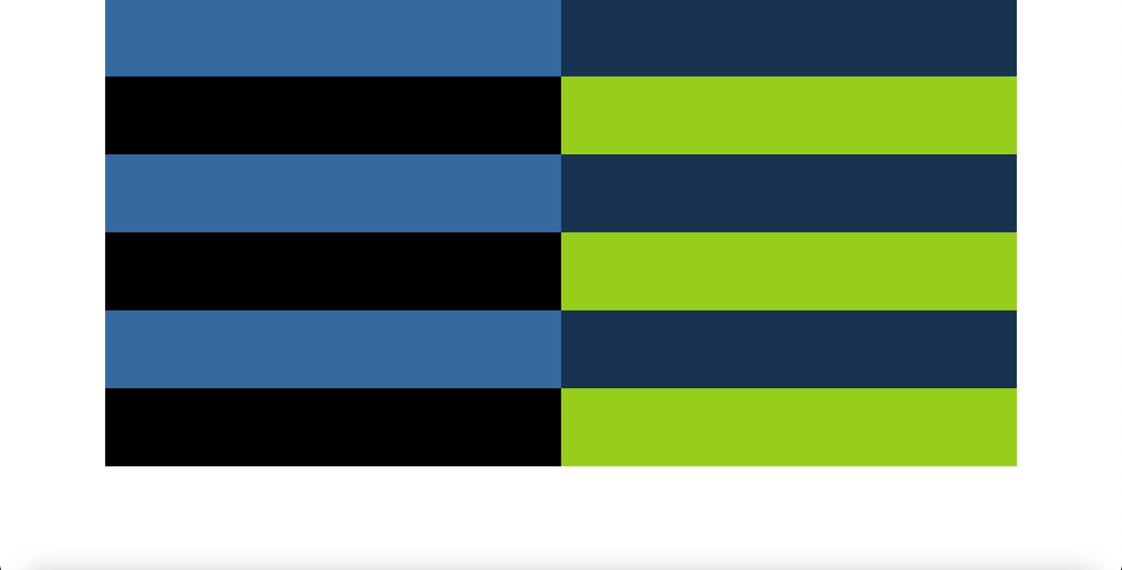

**div1fluid.html**

<!doctype html>

<html lang="en">

<head>

<meta charset="utf-8">

<meta http-equiv="X-UA-Compatible" content="IE=edge">

<meta name="viewport" content="width=device-width, initial-scale=1">

<title>Div1 (Fluid)</title>

<link rel="stylesheet" href="https://stackpath.bootstrapcdn.com/bootstrap/3.4.1/css/bootstrap.min.css" integrity="sha384-HSMxcRTRxnN+Bdg0JdbxYKrThecOKuH5zCYotlSAcp1+c8xmyTe9GYg1l9a69psu" crossorigin="anonymous">

<link rel="stylesheet" href="css/div1.css">

</head>

<body>

<div class="container-fluid">

<div class="row">

<div class="col-md-6 lb"></div>

<div class="col-md-6 db"></div>

</div>

<div class="row">

<div class="col-md-6 b"></div>

<div class="col-md-6 g"></div>

</div>

<div class="row">

<div class="col-md-6 lb"></div>

<div class="col-md-6 db"></div>

</div>

<div class="row">

<div class="col-md-6 b"></div>

<div class="col-md-6 g"></div>

</div>

<div class="row">

<div class="col-md-6 lb"></div>

<div class="col-md-6 db"></div>

</div>

<div class="row">

<div class="col-md-6 b"></div>

<div class="col-md-6 g"></div>

</div>

</div>

<script src="https://code.jquery.com/jquery-1.12.4.min.js" integrity="sha384-nvAa0+6Qg9clwYCGGPpDQLVpLNn0fRaROjHqs13t4Ggj3Ez50XnGQqc/r8MhnRDZ" crossorigin="anonymous"></script>

<script src="https://stackpath.bootstrapcdn.com/bootstrap/3.4.1/js/bootstrap.min.js" integrity="sha384-aJ21OjlMXNL5UyIl/XNwTMqvzeRMZH2w8c5cRVpzpU8Y5bApTppSuUkhZXN0VxHd" crossorigin="anonymous"></script>

</body>

</html>

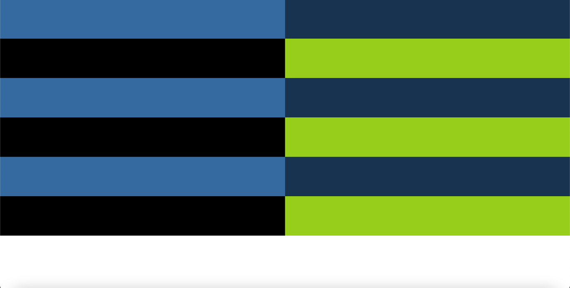

**div2.html**

<!doctype html>

<html lang="en">

<head>

<meta charset="utf-8">

<meta http-equiv="X-UA-Compatible" content="IE=edge">

<meta name="viewport" content="width=device-width, initial-scale=1">

<title>Div2</title>

<link rel="stylesheet" href="https://stackpath.bootstrapcdn.com/bootstrap/3.4.1/css/bootstrap.min.css" integrity="sha384-HSMxcRTRxnN+Bdg0JdbxYKrThecOKuH5zCYotlSAcp1+c8xmyTe9GYg1l9a69psu" crossorigin="anonymous">

<link rel="stylesheet" href="css/div2.css">

</head>

<body>

<div class="container">

<div class="row">

<div class="col-md-3 lblue"></div>

<div class="col-md-3 lgreen"></div>

<div class="col-md-4 black"></div>

<div class="col-md-2 yellow"></div>

</div>

<div class="row">

<div class="col-md-3 green"></div>

<div class="col-md-7 blue"></div>

<div class="col-md-2 teal"></div>

</div>

<div class="row">

<div class="col-md-5 red"></div>

<div class="col-md-5 dgreen"></div>

<div class="col-md-1 pink"></div>

<div class="col-md-1 dpgreen"></div>

</div>

<div class="row">

<div class="col-md-2 yellow"></div>

<div class="col-md-4 black"></div>

<div class="col-md-3 lgreen"></div>

<div class="col-md-3 lblue"></div>

</div>

<div class="row">

<div class="col-md-2 teal"></div>

<div class="col-md-7 blue"></div>

<div class="col-md-3 green"></div>

</div>

<div class="row">

<div class="col-md-1 dpgreen"></div>

<div class="col-md-1 pink"></div>

<div class="col-md-5 dgreen"></div>

<div class="col-md-5 red"></div>

</div>

</div>

<script src="https://code.jquery.com/jquery-1.12.4.min.js" integrity="sha384-nvAa0+6Qg9clwYCGGPpDQLVpLNn0fRaROjHqs13t4Ggj3Ez50XnGQqc/r8MhnRDZ" crossorigin="anonymous"></script>

<script src="https://stackpath.bootstrapcdn.com/bootstrap/3.4.1/js/bootstrap.min.js" integrity="sha384-aJ21OjlMXNL5UyIl/XNwTMqvzeRMZH2w8c5cRVpzpU8Y5bApTppSuUkhZXN0VxHd" crossorigin="anonymous"></script>

</body>

</html>

**div2.css**

.col-md-1,.col-md-2,.col-md-3,.col-md-4,.col-md-5,.col-md-7 {

height: 100px;

}

.lblue {

background-color: #356AA0;

}

.lgreen {

background-color: #19B64D;

}

.black {

background-color: #0B1401;

}

.yellow {

background-color: #C9F30B;

}

.green {

background-color: #57A035;

}

.blue {

background-color: #1732B5;

}

.teal {

background-color: #078675;

}

.red {

background-color: #BF1515;

}

.dgreen {

background-color: #8EB618;

}

.pink {

background-color: #EA2FD6;

}

.dpgreen {

background-color: #558608;

}

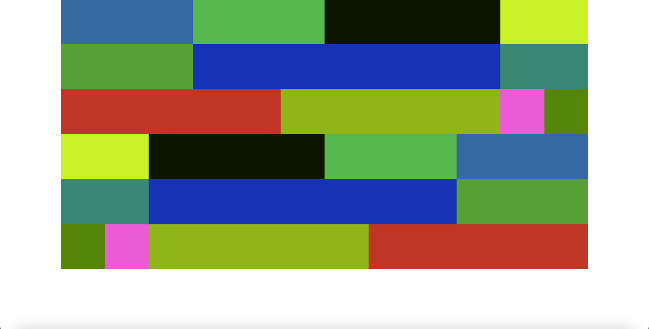

**div2fluid.html**

<!doctype html>

<html lang="en">

<head>

<meta charset="utf-8">

<meta http-equiv="X-UA-Compatible" content="IE=edge">

<meta name="viewport" content="width=device-width, initial-scale=1">

<title>Div2 (Fluid)</title>

<link rel="stylesheet" href="https://stackpath.bootstrapcdn.com/bootstrap/3.4.1/css/bootstrap.min.css" integrity="sha384-HSMxcRTRxnN+Bdg0JdbxYKrThecOKuH5zCYotlSAcp1+c8xmyTe9GYg1l9a69psu" crossorigin="anonymous">

<link rel="stylesheet" href="css/div2.css">

</head>

<body>

<div class="container-fluid">

<div class="row">

<div class="col-md-3 lblue"></div>

<div class="col-md-3 lgreen"></div>

<div class="col-md-4 black"></div>

<div class="col-md-2 yellow"></div>

</div>

<div class="row">

<div class="col-md-3 green"></div>

<div class="col-md-7 blue"></div>

<div class="col-md-2 teal"></div>

</div>

<div class="row">

<div class="col-md-5 red"></div>

<div class="col-md-5 dgreen"></div>

<div class="col-md-1 pink"></div>

<div class="col-md-1 dpgreen"></div>

</div>

<div class="row">

<div class="col-md-2 yellow"></div>

<div class="col-md-4 black"></div>

<div class="col-md-3 lgreen"></div>

<div class="col-md-3 lblue"></div>

</div>

<div class="row">

<div class="col-md-2 teal"></div>

<div class="col-md-7 blue"></div>

<div class="col-md-3 green"></div>

</div>

<div class="row">

<div class="col-md-1 dpgreen"></div>

<div class="col-md-1 pink"></div>

<div class="col-md-5 dgreen"></div>

<div class="col-md-5 red"></div>

</div>

</div>

<script src="https://code.jquery.com/jquery-1.12.4.min.js" integrity="sha384-nvAa0+6Qg9clwYCGGPpDQLVpLNn0fRaROjHqs13t4Ggj3Ez50XnGQqc/r8MhnRDZ" crossorigin="anonymous"></script>

<script src="https://stackpath.bootstrapcdn.com/bootstrap/3.4.1/js/bootstrap.min.js" integrity="sha384-aJ21OjlMXNL5UyIl/XNwTMqvzeRMZH2w8c5cRVpzpU8Y5bApTppSuUkhZXN0VxHd" crossorigin="anonymous"></script>

</body>

</html>



**div3.html**

<!doctype html>

<html lang="en">

<head>

<meta charset="utf-8">

<meta http-equiv="X-UA-Compatible" content="IE=edge">

<meta name="viewport" content="width=device-width, initial-scale=1">

<title>Div3</title>

<link rel="stylesheet" href="https://stackpath.bootstrapcdn.com/bootstrap/3.4.1/css/bootstrap.min.css" integrity="sha384-HSMxcRTRxnN+Bdg0JdbxYKrThecOKuH5zCYotlSAcp1+c8xmyTe9GYg1l9a69psu" crossorigin="anonymous">

<link rel="stylesheet" href="css/div3.css">

</head>

<body>

<div class="container">

<div class="row">

<div class="col-md-3 lblue"></div>

<div class="col-md-7">

<div class="row">

<div class="col-md-12 half magenta"></div>

</div>

<div class="row">

<div class="col-md-12 half navyb"></div>

</div>

</div>

<div class="col-md-2 yellow"></div>

</div>

<div class="row">

<div class="col-md-3 green"></div>

<div class="col-md-7 blue"></div>

<div class="col-md-2">

<div class="row">

<div class="col-md-12 half navyb"></div>

</div>

<div class="row">

<div class="col-md-6 half seag"></div>

<div class="col-md-6 half teal"></div>

</div>

</div>

</div>

<div class="row">

<div class="col-md-5 red"></div>

<div class="col-md-5 dgreen"></div>

<div class="col-md-1 pink"></div>

<div class="col-md-1">

<div class="row">

<div class="col-md-12 third green1"></div>

</div>

<div class="row">

<div class="col-md-12 third fadedb"></div>

</div>

<div class="row">

<div class="col-md-12 third green2"></div>

</div>

</div>

</div>

<div class="row">

<div class="col-md-2 yellow"></div>

<div class="col-md-4">

<div class="row">

<div class="col-md-12 third black"></div>

</div>

<div class="row">

<div class="col-md-12 third fadedb"></div>

</div>

<div class="row">

<div class="col-md-12 third black"></div>

</div>

</div>

<div class="col-md-3 lgreen"></div>

<div class="col-md-3 fadedb"></div>

</div>

<div class="row">

<div class="col-md-2 teal"></div>

<div class="col-md-4 blue"></div>

<div class="col-md-3">

<div class="row">

<div class="col-md-12 half lightb"></div>

<div class="col-md-12 half blue"></div>

</div>

</div>

<div class="col-md-3 green"></div>

</div>

<div class="row">

<div class="col-md-1 green2"></div>

<div class="col-md-1 pink"></div>

<div class="col-md-5 dgreen"></div>

<div class="col-md-5">

<div class="row">

<div class="col-md-12 third red"></div>

</div>

<div class="row">

<div class="col-md-12 third lightb"></div>

</div>

<div class="row">

<div class="col-md-12 third red"></div>

</div>

</div>

</div>

</div>

<script src="https://code.jquery.com/jquery-1.12.4.min.js" integrity="sha384-nvAa0+6Qg9clwYCGGPpDQLVpLNn0fRaROjHqs13t4Ggj3Ez50XnGQqc/r8MhnRDZ" crossorigin="anonymous"></script>

<script src="https://stackpath.bootstrapcdn.com/bootstrap/3.4.1/js/bootstrap.min.js" integrity="sha384-aJ21OjlMXNL5UyIl/XNwTMqvzeRMZH2w8c5cRVpzpU8Y5bApTppSuUkhZXN0VxHd" crossorigin="anonymous"></script>

</body>

</html>

**div3.css**

.col-md-1,.col-md-2,.col-md-3,.col-md-4,.col-md-5,.col-md-6,.col-md-7,.col-md-8,.col-md-9,.col-md-10,.col-md-11,.col-md-12 {

height: 150px;

}

.half {

height: 75px;

}

.third {

height: 50px;

}

.lblue {

background-color: #356AA0;

}

.magenta {

background-color: #A03579;

}

.navyb {

background-color: #2B1752;

}

.yellow {

background-color: #C9F30B;

}

.green {

background-color: #57A035;

}

.blue {

background-color: #1732B5;

}

.seag {

background-color: #185351;

}

.teal {

background-color: #078675;

}

.red {

background-color: #BF1515;

}

.dgreen {

background-color: #8EB618;

}

.pink {

background-color: #EA2FD6;

}

.green1 {

background-color: #419207;

}

.green2 {

background-color: #558608;

}

.black {

background-color: #0B1401;

}

.fadedb {

background-color: #076392;

}

.lgreen {

background-color: #19B64D;

}

.lightb {

background-color: #1283BD;

}

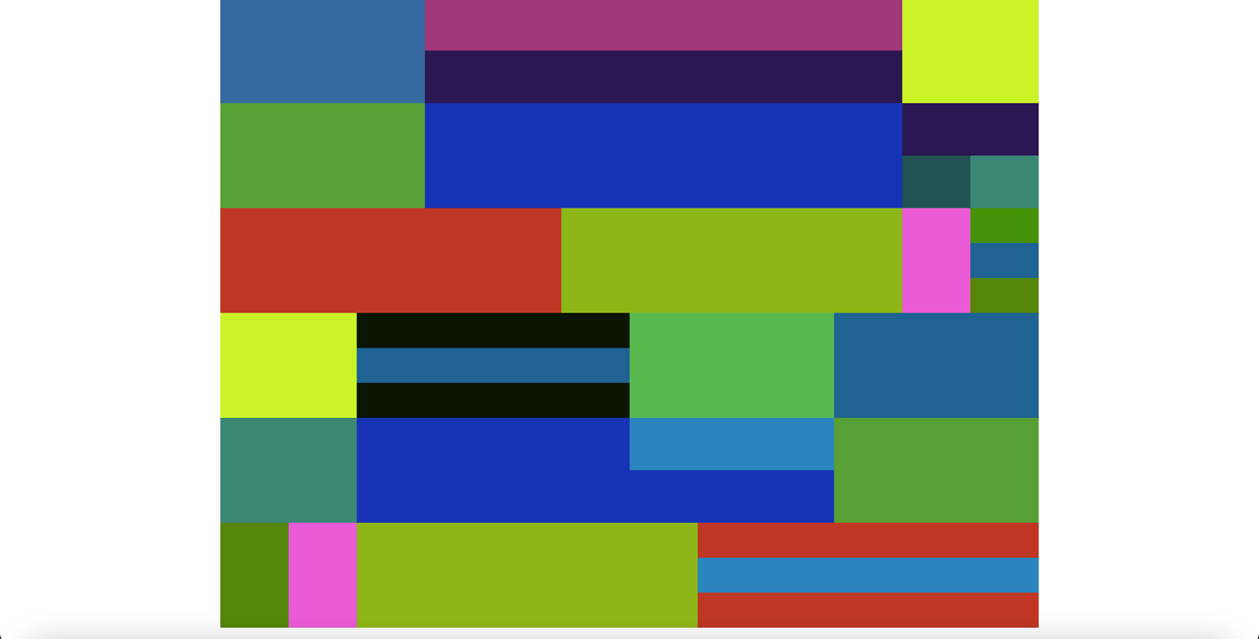

**div3fluid.html**

<!doctype html>

<html lang="en">

<head>

<meta charset="utf-8">

<meta http-equiv="X-UA-Compatible" content="IE=edge">

<meta name="viewport" content="width=device-width, initial-scale=1">

<title>Div3 (Fluid)</title>

<link rel="stylesheet" href="https://stackpath.bootstrapcdn.com/bootstrap/3.4.1/css/bootstrap.min.css" integrity="sha384-HSMxcRTRxnN+Bdg0JdbxYKrThecOKuH5zCYotlSAcp1+c8xmyTe9GYg1l9a69psu" crossorigin="anonymous">

<link rel="stylesheet" href="css/div3.css">

</head>

<body>

<div class="container-fluid">

<div class="row">

<div class="col-md-3 lblue"></div>

<div class="col-md-7">

<div class="row">

<div class="col-md-12 half magenta"></div>

</div>

<div class="row">

<div class="col-md-12 half navyb"></div>

</div>

</div>

<div class="col-md-2 yellow"></div>

</div>

<div class="row">

<div class="col-md-3 green"></div>

<div class="col-md-7 blue"></div>

<div class="col-md-2">

<div class="row">

<div class="col-md-12 half navyb"></div>

</div>

<div class="row">

<div class="col-md-6 half seag"></div>

<div class="col-md-6 half teal"></div>

</div>

</div>

</div>

<div class="row">

<div class="col-md-5 red"></div>

<div class="col-md-5 dgreen"></div>

<div class="col-md-1 pink"></div>

<div class="col-md-1">

<div class="row">

<div class="col-md-12 third green1"></div>

</div>

<div class="row">

<div class="col-md-12 third fadedb"></div>

</div>

<div class="row">

<div class="col-md-12 third green2"></div>

</div>

</div>

</div>

<div class="row">

<div class="col-md-2 yellow"></div>

<div class="col-md-4">

<div class="row">

<div class="col-md-12 third black"></div>

</div>

<div class="row">

<div class="col-md-12 third fadedb"></div>

</div>

<div class="row">

<div class="col-md-12 third black"></div>

</div>

</div>

<div class="col-md-3 lgreen"></div>

<div class="col-md-3 fadedb"></div>

</div>

<div class="row">

<div class="col-md-2 teal"></div>

<div class="col-md-4 blue"></div>

<div class="col-md-3">

<div class="row">

<div class="col-md-12 half lightb"></div>

<div class="col-md-12 half blue"></div>

</div>

</div>

<div class="col-md-3 green"></div>

</div>

<div class="row">

<div class="col-md-1 green2"></div>

<div class="col-md-1 pink"></div>

<div class="col-md-5 dgreen"></div>

<div class="col-md-5">

<div class="row">

<div class="col-md-12 third red"></div>

</div>

<div class="row">

<div class="col-md-12 third lightb"></div>

</div>

<div class="row">

<div class="col-md-12 third red"></div>

</div>

</div>

</div>

</div>

<script src="https://code.jquery.com/jquery-1.12.4.min.js" integrity="sha384-nvAa0+6Qg9clwYCGGPpDQLVpLNn0fRaROjHqs13t4Ggj3Ez50XnGQqc/r8MhnRDZ" crossorigin="anonymous"></script>

<script src="https://stackpath.bootstrapcdn.com/bootstrap/3.4.1/js/bootstrap.min.js" integrity="sha384-aJ21OjlMXNL5UyIl/XNwTMqvzeRMZH2w8c5cRVpzpU8Y5bApTppSuUkhZXN0VxHd" crossorigin="anonymous"></script>

</body>

</html>

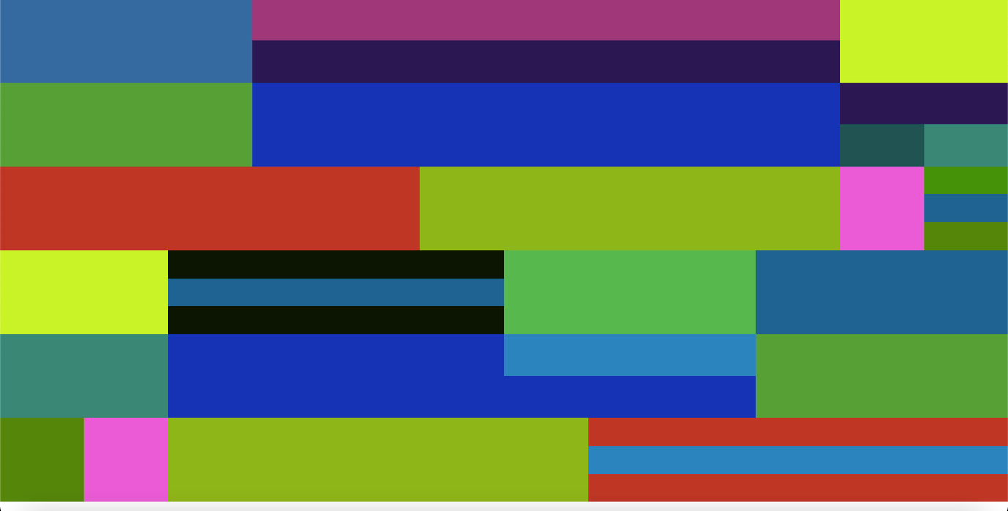

**grid1.html**

<!doctype html>

<html lang="en">

<head>

<meta charset="utf-8">

<meta http-equiv="X-UA-Compatible" content="IE=edge">

<meta name="viewport" content="width=device-width, initial-scale=1">

<title>Grid1</title>

<link rel="stylesheet" href="https://stackpath.bootstrapcdn.com/bootstrap/3.4.1/css/bootstrap.min.css" integrity="sha384-HSMxcRTRxnN+Bdg0JdbxYKrThecOKuH5zCYotlSAcp1+c8xmyTe9GYg1l9a69psu" crossorigin="anonymous">

<link rel="stylesheet" href="css/grid1.css">

</head>

<body>

<div class="container">

<div class="row">

<div class="col-md-1">.col-md-1</div>

<div class="col-md-1">.col-md-1</div>

<div class="col-md-1">.col-md-1</div>

<div class="col-md-1">.col-md-1</div>

<div class="col-md-1">.col-md-1</div>

<div class="col-md-1">.col-md-1</div>

<div class="col-md-1">.col-md-1</div>

<div class="col-md-1">.col-md-1</div>

<div class="col-md-1">.col-md-1</div>

<div class="col-md-1">.col-md-1</div>

<div class="col-md-1">.col-md-1</div>

<div class="col-md-1">.col-md-1</div>

</div>

<div class="row">

<div class="col-md-1">.col-md-1</div>

<div class="col-md-1">.col-md-1</div>

<div class="col-md-1">.col-md-1</div>

<div class="col-md-1">.col-md-1</div>

<div class="col-md-1">.col-md-1</div>

<div class="col-md-1">.col-md-1</div>

<div class="col-md-1">.col-md-1</div>

<div class="col-md-1">.col-md-1</div>

<div class="col-md-1">.col-md-1</div>

<div class="col-md-1">.col-md-1</div>

<div class="col-md-2">.col-md-2</div>

</div>

<div class="row">

<div class="col-md-1">.col-md-1</div>

<div class="col-md-1">.col-md-1</div>

<div class="col-md-1">.col-md-1</div>

<div class="col-md-1">.col-md-1</div>

<div class="col-md-1">.col-md-1</div>

<div class="col-md-1">.col-md-1</div>

<div class="col-md-1">.col-md-1</div>

<div class="col-md-1">.col-md-1</div>

<div class="col-md-2">.col-md-2</div>

<div class="col-md-2">.col-md-2</div>

</div>

<div class="row">

<div class="col-md-1">.col-md-1</div>

<div class="col-md-1">.col-md-1</div>

<div class="col-md-1">.col-md-1</div>

<div class="col-md-1">.col-md-1</div>

<div class="col-md-1">.col-md-1</div>

<div class="col-md-1">.col-md-1</div>

<div class="col-md-1">.col-md-1</div>

<div class="col-md-2">.col-md-2</div>

<div class="col-md-3">.col-md-3</div>

</div>

<div class="row">

<div class="col-md-1">.col-md-1</div>

<div class="col-md-1">.col-md-1</div>

<div class="col-md-1">.col-md-1</div>

<div class="col-md-1">.col-md-1</div>

<div class="col-md-1">.col-md-1</div>

<div class="col-md-1">.col-md-1</div>

<div class="col-md-3">.col-md-3</div>

<div class="col-md-3">.col-md-3</div>

</div>

<div class="row">

<div class="col-md-1">.col-md-1</div>

<div class="col-md-1">.col-md-1</div>

<div class="col-md-1">.col-md-1</div>

<div class="col-md-1">.col-md-1</div>

<div class="col-md-2">.col-md-2</div>

<div class="col-md-3">.col-md-3</div>

<div class="col-md-3">.col-md-3</div>

</div>

<div class="row">

<div class="col-md-1">.col-md-1</div>

<div class="col-md-1">.col-md-1</div>

<div class="col-md-2">.col-md-2</div>

<div class="col-md-2">.col-md-2</div>

<div class="col-md-3">.col-md-3</div>

<div class="col-md-3">.col-md-3</div>

</div>

<div class="row">

<div class="col-md-1">.col-md-1</div>

<div class="col-md-2">.col-md-2</div>

<div class="col-md-3">.col-md-3</div>

<div class="col-md-3">.col-md-3</div>

<div class="col-md-3">.col-md-3</div>

</div>

<div class="row">

<div class="col-md-1">.col-md-1</div>

<div class="col-md-3">.col-md-3</div>

<div class="col-md-4">.col-md-4</div>

<div class="col-md-4">.col-md-4</div>

</div>

<div class="row">

<div class="col-md-2">.col-md-2</div>

<div class="col-md-4">.col-md-4</div>

<div class="col-md-6">.col-md-6</div>

</div>

<div class="row">

<div class="col-md-6">.col-md-6</div>

<div class="col-md-6">.col-md-6</div>

</div>

<div class="row">

<div class="col-md-12">.col-md-12</div>

</div>

</div>

<script src="https://code.jquery.com/jquery-1.12.4.min.js" integrity="sha384-nvAa0+6Qg9clwYCGGPpDQLVpLNn0fRaROjHqs13t4Ggj3Ez50XnGQqc/r8MhnRDZ" crossorigin="anonymous"></script>

<script src="https://stackpath.bootstrapcdn.com/bootstrap/3.4.1/js/bootstrap.min.js" integrity="sha384-aJ21OjlMXNL5UyIl/XNwTMqvzeRMZH2w8c5cRVpzpU8Y5bApTppSuUkhZXN0VxHd" crossorigin="anonymous"></script>

</body>

</html>

**grid1.css**

.container {

color: white;

}

.col-md-1,.col-md-2,.col-md-3,.col-md-4,.col-md-6,.col-md-12 {

height: 50px;

}

.col-md-1 {

background-color: wheat;

}

.col-md-2 {

background-color: blue;

}

.col-md-3 {

background-color: green;

}

.col-md-4 {

background-color: yellow;

}

.col-md-6 {

background-color: red;

}

.col-md-12 {

background-color: orange;

}

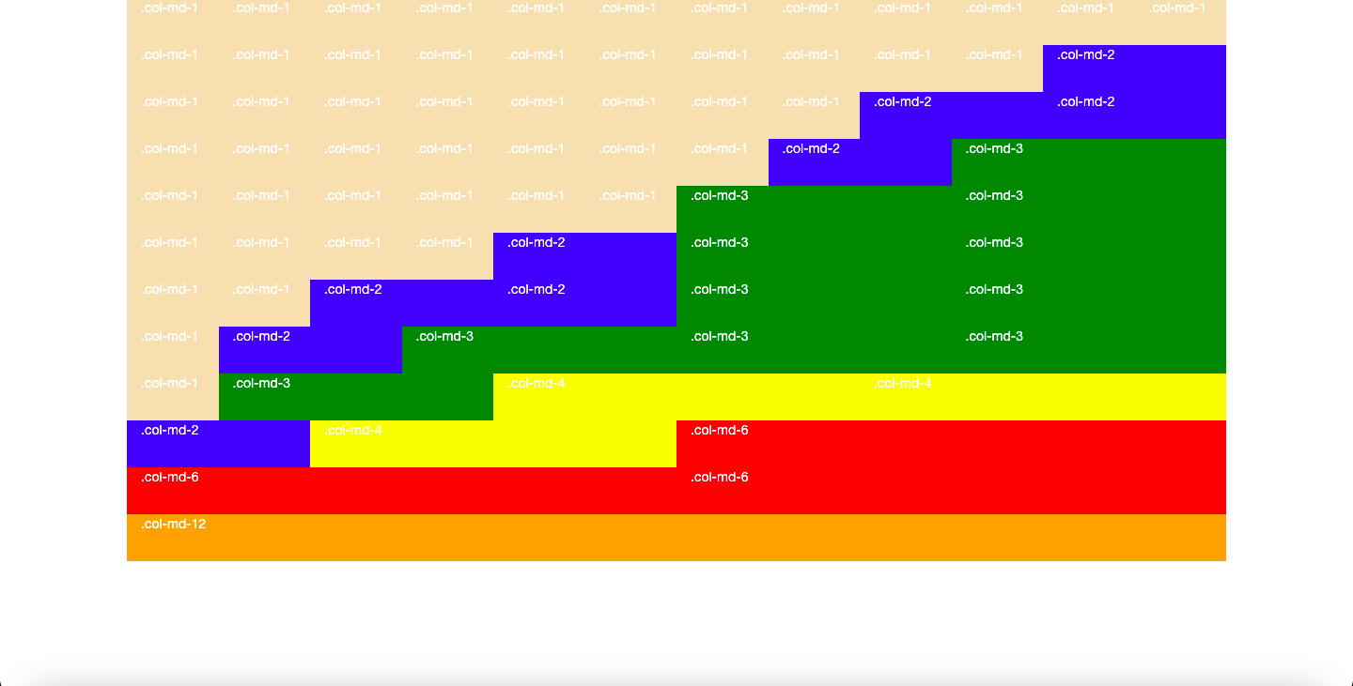

**grid1fluid.html**

<!doctype html>

<html lang="en">

<head>

<meta charset="utf-8">

<meta http-equiv="X-UA-Compatible" content="IE=edge">

<meta name="viewport" content="width=device-width, initial-scale=1">

<title>Grid1 (Fluid)</title>

<link rel="stylesheet" href="https://stackpath.bootstrapcdn.com/bootstrap/3.4.1/css/bootstrap.min.css" integrity="sha384-HSMxcRTRxnN+Bdg0JdbxYKrThecOKuH5zCYotlSAcp1+c8xmyTe9GYg1l9a69psu" crossorigin="anonymous">

<link rel="stylesheet" href="css/grid1fluid.css">

</head>

<body>

<div class="container-fluid">

<div class="row">

<div class="col-md-1">.col-md-1</div>

<div class="col-md-1">.col-md-1</div>

<div class="col-md-1">.col-md-1</div>

<div class="col-md-1">.col-md-1</div>

<div class="col-md-1">.col-md-1</div>

<div class="col-md-1">.col-md-1</div>

<div class="col-md-1">.col-md-1</div>

<div class="col-md-1">.col-md-1</div>

<div class="col-md-1">.col-md-1</div>

<div class="col-md-1">.col-md-1</div>

<div class="col-md-1">.col-md-1</div>

<div class="col-md-1">.col-md-1</div>

</div>

<div class="row">

<div class="col-md-1">.col-md-1</div>

<div class="col-md-1">.col-md-1</div>

<div class="col-md-1">.col-md-1</div>

<div class="col-md-1">.col-md-1</div>

<div class="col-md-1">.col-md-1</div>

<div class="col-md-1">.col-md-1</div>

<div class="col-md-1">.col-md-1</div>

<div class="col-md-1">.col-md-1</div>

<div class="col-md-1">.col-md-1</div>

<div class="col-md-1">.col-md-1</div>

<div class="col-md-2">.col-md-2</div>

</div>

<div class="row">

<div class="col-md-1">.col-md-1</div>

<div class="col-md-1">.col-md-1</div>

<div class="col-md-1">.col-md-1</div>

<div class="col-md-1">.col-md-1</div>

<div class="col-md-1">.col-md-1</div>

<div class="col-md-1">.col-md-1</div>

<div class="col-md-1">.col-md-1</div>

<div class="col-md-1">.col-md-1</div>

<div class="col-md-2">.col-md-2</div>

<div class="col-md-2">.col-md-2</div>

</div>

<div class="row">

<div class="col-md-1">.col-md-1</div>

<div class="col-md-1">.col-md-1</div>

<div class="col-md-1">.col-md-1</div>

<div class="col-md-1">.col-md-1</div>

<div class="col-md-1">.col-md-1</div>

<div class="col-md-1">.col-md-1</div>

<div class="col-md-1">.col-md-1</div>

<div class="col-md-2">.col-md-2</div>

<div class="col-md-3">.col-md-3</div>

</div>

<div class="row">

<div class="col-md-1">.col-md-1</div>

<div class="col-md-1">.col-md-1</div>

<div class="col-md-1">.col-md-1</div>

<div class="col-md-1">.col-md-1</div>

<div class="col-md-1">.col-md-1</div>

<div class="col-md-1">.col-md-1</div>

<div class="col-md-3">.col-md-3</div>

<div class="col-md-3">.col-md-3</div>

</div>

<div class="row">

<div class="col-md-1">.col-md-1</div>

<div class="col-md-1">.col-md-1</div>

<div class="col-md-1">.col-md-1</div>

<div class="col-md-1">.col-md-1</div>

<div class="col-md-2">.col-md-2</div>

<div class="col-md-3">.col-md-3</div>

<div class="col-md-3">.col-md-3</div>

</div>

<div class="row">

<div class="col-md-1">.col-md-1</div>

<div class="col-md-1">.col-md-1</div>

<div class="col-md-2">.col-md-2</div>

<div class="col-md-2">.col-md-2</div>

<div class="col-md-3">.col-md-3</div>

<div class="col-md-3">.col-md-3</div>

</div>

<div class="row">

<div class="col-md-1">.col-md-1</div>

<div class="col-md-2">.col-md-2</div>

<div class="col-md-3">.col-md-3</div>

<div class="col-md-3">.col-md-3</div>

<div class="col-md-3">.col-md-3</div>

</div>

<div class="row">

<div class="col-md-1">.col-md-1</div>

<div class="col-md-3">.col-md-3</div>

<div class="col-md-4">.col-md-4</div>

<div class="col-md-4">.col-md-4</div>

</div>

<div class="row">

<div class="col-md-2">.col-md-2</div>

<div class="col-md-4">.col-md-4</div>

<div class="col-md-6">.col-md-6</div>

</div>

<div class="row">

<div class="col-md-6">.col-md-6</div>

<div class="col-md-6">.col-md-6</div>

</div>

<div class="row">

<div class="col-md-12">.col-md-12</div>

</div>

</div>

<script src="https://code.jquery.com/jquery-1.12.4.min.js" integrity="sha384-nvAa0+6Qg9clwYCGGPpDQLVpLNn0fRaROjHqs13t4Ggj3Ez50XnGQqc/r8MhnRDZ" crossorigin="anonymous"></script>

<script src="https://stackpath.bootstrapcdn.com/bootstrap/3.4.1/js/bootstrap.min.js" integrity="sha384-aJ21OjlMXNL5UyIl/XNwTMqvzeRMZH2w8c5cRVpzpU8Y5bApTppSuUkhZXN0VxHd" crossorigin="anonymous"></script>

</body>

</html>

**grid1fluid.css**

.container-fluid {

color: white;

}

.col-md-1 {

background-color: wheat;

}

.col-md-2 {

background-color: blue;

}

.col-md-3 {

background-color: green;

}

.col-md-4 {

background-color: yellow;

}

.col-md-6 {

background-color: red;

}

.col-md-12 {

background-color: orange;

}

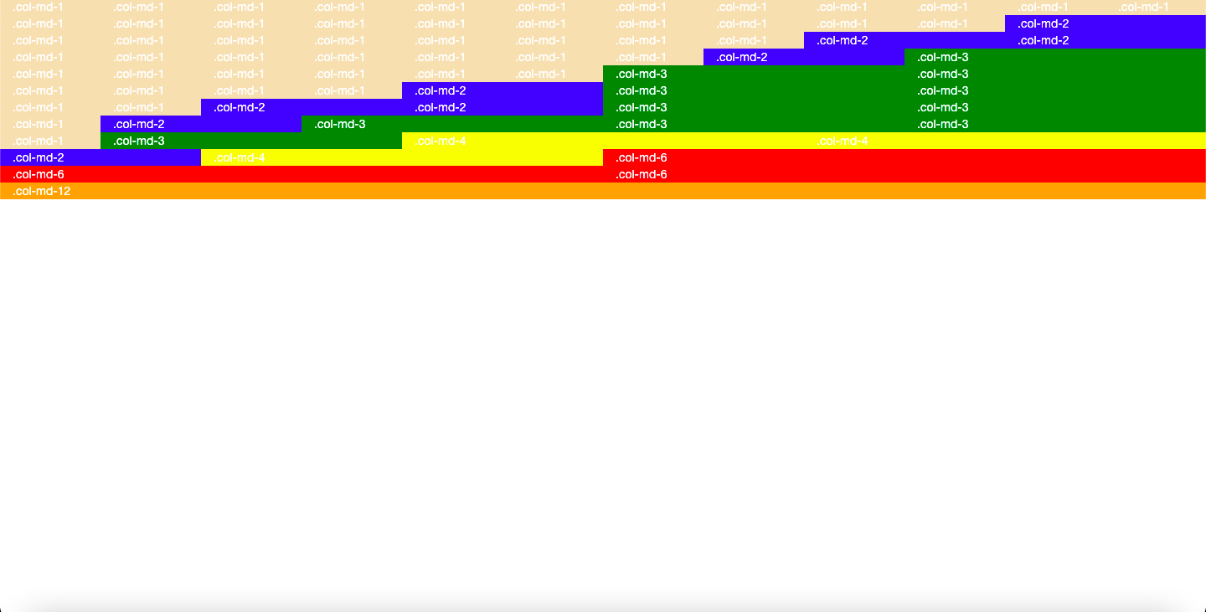

**Practical 3.3**

1. **Create a webpage using different Column Classes for different screen sizes**
2. **Create a same Facebook pages (2 pages) using Bootstrap that were given in Week1**

**div1.html**

<!doctype html>

<html lang="en">

<head>

<meta charset="utf-8">

<meta http-equiv="X-UA-Compatible" content="IE=edge">

<meta name="viewport" content="width=device-width, initial-scale=1">

<title>Div1</title>

<link rel="stylesheet" href="https://stackpath.bootstrapcdn.com/bootstrap/3.4.1/css/bootstrap.min.css" integrity="sha384-HSMxcRTRxnN+Bdg0JdbxYKrThecOKuH5zCYotlSAcp1+c8xmyTe9GYg1l9a69psu" crossorigin="anonymous">

<link rel="stylesheet" href="../css/div1.css">

</head>

<body>

<div class="container">

<div class="row">

<div class="col-xs-4 col-sm-5 col-md-6 col-lg-7 lb"></div>

<div class="col-xs-8 col-sm-7 col-md-6 col-lg-5 db"></div>

</div>

<div class="row">

<div class="col-xs-4 col-sm-5 col-md-6 col-lg-7 b"></div>

<div class="col-xs-8 col-sm-7 col-md-6 col-lg-5 g"></div>

</div>

<div class="row">

<div class="col-xs-4 col-sm-5 col-md-6 col-lg-7 lb"></div>

<div class="col-xs-8 col-sm-7 col-md-6 col-lg-5 db"></div>

</div>

<div class="row">

<div class="col-xs-4 col-sm-5 col-md-6 col-lg-7 b"></div>

<div class="col-xs-8 col-sm-7 col-md-6 col-lg-5 g"></div>

</div>

<div class="row">

<div class="col-xs-4 col-sm-5 col-md-6 col-lg-7 lb"></div>

<div class="col-xs-8 col-sm-7 col-md-6 col-lg-5 db"></div>

</div>

<div class="row">

<div class="col-xs-4 col-sm-5 col-md-6 col-lg-7 b"></div>

<div class="col-xs-8 col-sm-7 col-md-6 col-lg-5 g"></div>

</div>

</div>

<script src="https://code.jquery.com/jquery-1.12.4.min.js" integrity="sha384-nvAa0+6Qg9clwYCGGPpDQLVpLNn0fRaROjHqs13t4Ggj3Ez50XnGQqc/r8MhnRDZ" crossorigin="anonymous"></script>

<script src="https://stackpath.bootstrapcdn.com/bootstrap/3.4.1/js/bootstrap.min.js" integrity="sha384-aJ21OjlMXNL5UyIl/XNwTMqvzeRMZH2w8c5cRVpzpU8Y5bApTppSuUkhZXN0VxHd" crossorigin="anonymous"></script>

</body>

</html>

**div1.css**

.col-md-6 {

height: 100px;

}

.lb {

background-color: #356AA0;

}

.db {

background-color: #183350;

}

.b {

background-color: #000000;

}

.g {

background-color: #97CE01;

}

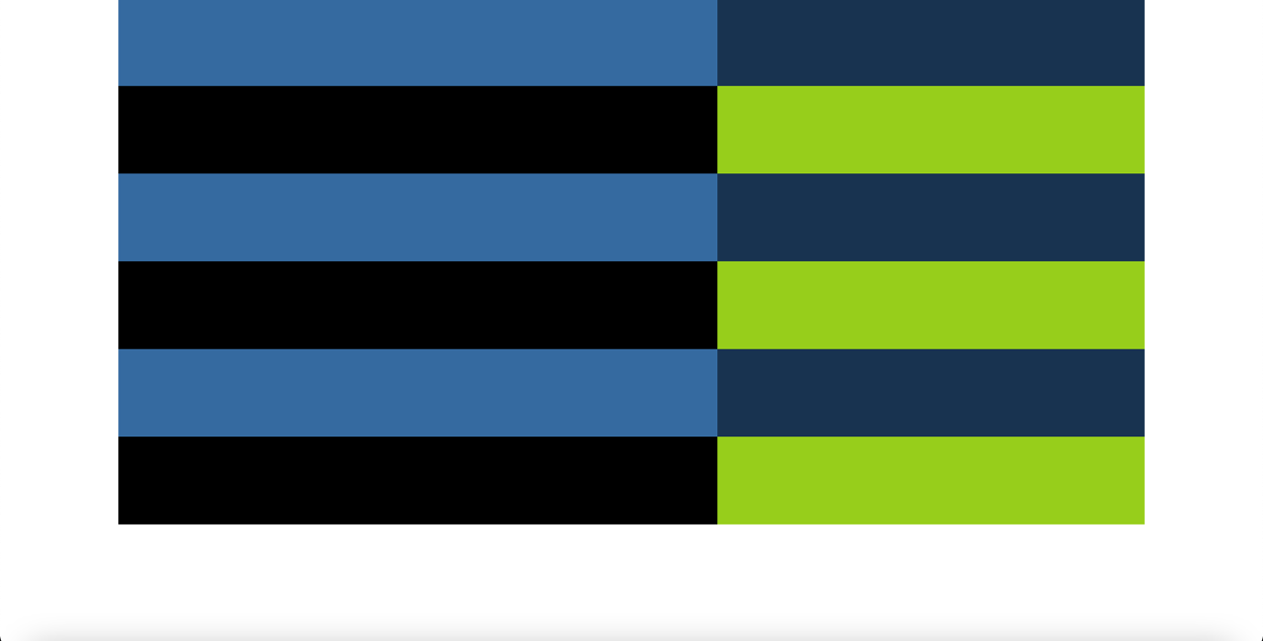

**index.html**

<!DOCTYPE html>

<html lang="en">

<head>

<meta charset="UTF-8">

<title>Facebook</title>

<link rel="stylesheet" href="libs/css/bootstrap.min.css">

<link rel="stylesheet" href="style/main.css">

</head>

<body>

<nav class="navbar navbar-expand-lg navbar-light bg-light app-navbar">

<h1 class="navbar-brand">facebook</h1>

<button class="navbar-toggler" type="button" data-toggle="collapse" data-target="#navbarSupportedContent"

aria-controls="navbarSupportedContent" aria-expanded="false" aria-label="Toggle navigation">

<span class="navbar-toggler-icon"></span>

</button>

<div class="collapse navbar-collapse" id="navbarSupportedContent">

<div class="ml-auto">

<div class="form-group d-inline-block mb-0">

<label for="exampleInputEmail1" class="mb-0 text-white">Email or Phone</label>

<input type="email" class="form-control" id="exampleInputEmail1" aria-describedby="emailHelp"

placeholder="Enter email">

<input type="checkbox"><span class="text-white"> &nbsp Remember me</span>

</div>

<div class="form-group d-inline-block mb-0">

<label for="exampleInputPassword1" class="mb-0 text-white">Password</label>

<input type="password" class="form-control" id="exampleInputPassword1" placeholder="Enter Password">

<a href="#" class="text-white">Forgotten account?</a>

</div>

<button type="button" class="btn btn-primary btn-sm signin-btn">Log in</button>

</div>

</div>

</nav>

<div class="container-fluid padding-right">

<div class="row padding-zero">

<div class="col-sm-7 mt-8 padding-zero">

<p><br>Facebook helps you connect and share with the people in your life.</p>

<img src="images/facebook5a.jpeg"></img>

</div>

<div class="col-sm-5 mt-4 padding-zero">

<h2>Create an account</h2>

<p>Its free and it always will be</p>

<div class="form-group row">

<div class="col-sm-5">

<input type="password" class="form-control " id="inputPassword" placeholder="First Name">

</div>

<div class="col-sm-5">

<input type="password" class="form-control " id="inputPassword" placeholder="Surname">

</div>

</div>

<div class="form-group row">

<div class="col-sm-10">

<input type="text" class="form-control" id="inputPassword"

placeholder="Mobile number or email address">

</div>

</div>

<div class="form-group row">

<div class="col-sm-10">

<input type="password" class="form-control" id="inputPassword" placeholder="Password">

</div>

</div>

<div>

<h3>Birthday</h3>

</div>

<div class="form-group row no-gutters">

<div class="col-sm-2 ">

<select class="form-control">

<option>1</option>

<option>2</option>

<option>3</option>

<option>4</option>

<option>5</option>

<option>6</option>

<option>7</option>

<option>8</option>

<option>9</option>

<option>10</option>

<option>11</option>

<option>12</option>

<option>13</option>

<option>14</option>

<option>15</option>

<option>16</option>

<option>17</option>

<option>18</option>

<option>19</option>

<option>20</option>

<option>21</option>

<option>22</option>

<option>23</option>

<option>24</option>

<option>25</option>

<option>26</option>

<option>27</option>

<option>28</option>

<option>29</option>

<option>30</option>

<option>31</option>

</select>

</div>

<div class="col-sm-2 ">

<select class="form-control">

<option>jan</option>

<option>feb</option>

<option>mar</option>

<option>apr</option>

<option>may</option>

<option>jun</option>

<option>july</option>

<option>aug</option>

<option>sep</option>

<option>oct</option>

<option>nov</option>

<option>dec</option>

</select>

</div>

<div class="col-sm-2 ">

<select class="form-control">

<option>1970</option>

<option>1972</option>

<option>1974</option>

<option>1976</option>

<option>1978</option>

<option>1980</option>

<option>1982</option>

<option>1984</option>

<option>1986</option>

<option>1988</option>

<option>1990</option>

<option>1992</option>

<option>1993</option>

<option>1994</option>

<option>1995</option>

<option>1996</option>

<option>1997</option>

<option>1998</option>

<option>1999</option>

<option>2000</option>

<option>2001</option>

<option>2002</option>

<option>2003</option>

</select>

</div>

<div class="col-sm-5 ">

<a href="" class="pl">Why do I need to provide my date of birth?</a>

</div>

</div>

<label class="radio-inline">

<input type="radio" name="inlineRadioOptions" id="inlineRadio1" value="option1"> <b> Male </b>

</label>

&nbsp; &nbsp;

<label class="radio-inline">

<input type="radio" name="inlineRadioOptions" id="inlineRadio2" value="option2"> <b> Female </b>

</label>

<div class="form-group">

<p>By clicking Sign Up, you agree to our <a href="">Terms</a>, <a href="">Data Policy</a>, including our <a href="">Cookie Use</a>. You may recieve SMS notificaiton from us and may opt out at any time</p>

<div class="form-group col-sm-6 padding-zero">

<div class="btn btn-success btn-block ">Sign Up</div>

</div>

</div>

</div>

</div>

</div>

</body>

</html>

**main.css**

body {

background: linear-gradient(white, #d3d8e8);

}

.padding-zero {

padding-left: 0;

width: 100%;

}

.padding-right{

padding-left: 5rem;

}

.app-navbar {

background: #3b5b96 !important;

padding-top: 0;

padding-bottom: 0;

}

.app-navbar .navbar-brand {

color: #fff;

font-size: 38px;

margin-left: 49px;

font-weight: bold;

}

.signin-btn {

vertical-align: top;

margin-top: 27px;

}

.text-white {

color: white;

}

.col-sm-7 img {

height: 250px;

width: 450px;

}

.col-sm-7 p {

margin-top: 20px;

font-size: 18px;

font-family: arial;

font-weight: bold;

color: #0e385f;

width: 450px;

}

.col-sm-3 .pl {

font-size: 14px;

}

.row .terms {

color: #424242;

font-size: 15px;

}

.ml-auto {

margin-right: 73px;

}

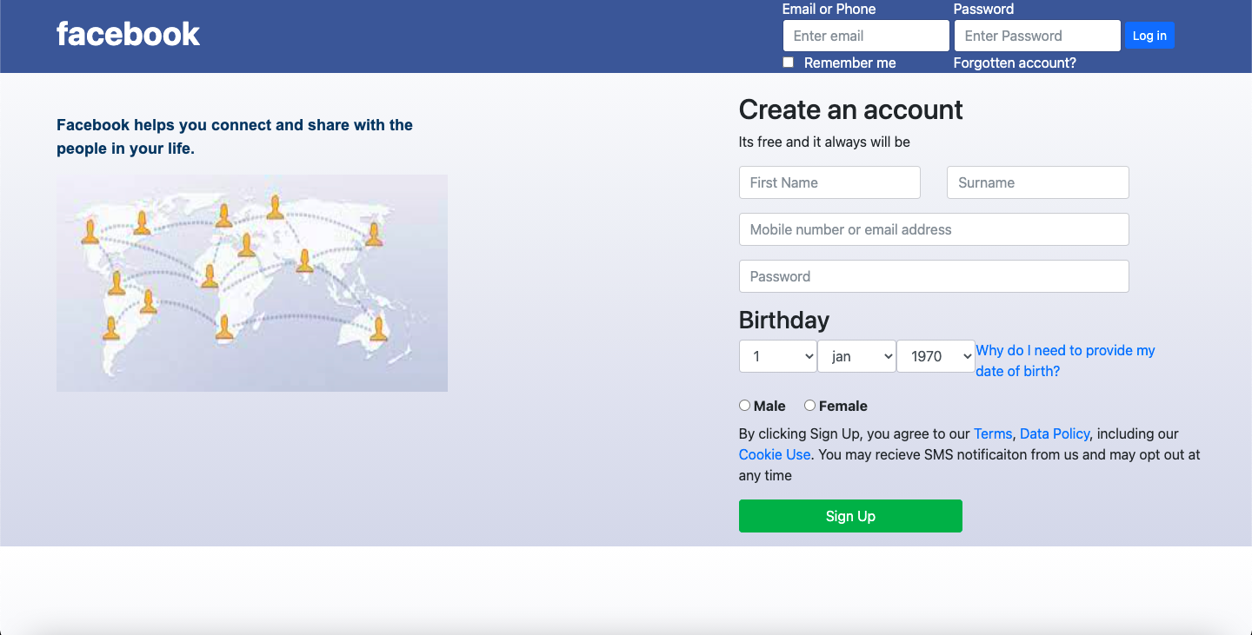

**fb2.html**

<!DOCTYPE html>

<html>

<head>

<title>Facebook Login Page</title>

<meta charset="utf-8">

<meta name="viewport" content="width=device-width, initial-scale=1">

<meta name="description" content="">

<link href="https://fonts.googleapis.com/css?family=Nunito+Sans:300i,400,700&display=swap" rel="stylesheet">

<link rel="stylesheet" href="https://stackpath.bootstrapcdn.com/bootstrap/5.0.0-alpha1/css/bootstrap.min.css">

<link rel="stylesheet" type="text/css" href="../css/fb2.css">

</head>

<body>

<div class="container">

<div class="row align-items-center justify-content-center vh-100">

<div class="col-md-7">

<img src="https://static.xx.fbcdn.net/rsrc.php/y8/r/dF5SId3UHWd.svg" class="w-50">

<h3>Facebook helps you connect and share with the people in your life.</h3>

</div>

<div class="col-md-5">

<form class="login-form" action="#">

<div class="mb-3">

<input type="text" class="form-control" placeholder="Email address or phone number"

required>

</div>

<div class="mb-3">

<input type="password" class="form-control" placeholder="Password"

required>

</div>

<button type="button" class="btn btn-custom btn-lg btn-block mt-3">Login</button>

<div class="text-center pt-3 pb-3">

<a href="#" class="">Forgotten password?</a>

<hr>

<button type="button" class="btn btn-success btn-lg mt-3">Create New Account</button>

</div>

</form>

<p class="pt-3 text-center"><b>Create a Page</b> for a celebrity, band or business.</p>

</div>

</div>

</div>

</body>

</html>

**fb2.css**

body{

background-color: #f0f2f5;

font-family: "Nunito Sans";

}

.login-form{

border-radius: 8px;

box-shadow: 0 2px 4px rgba(0, 0, 0, .1), 0 8px 16px rgba(0, 0, 0, .1);

background-color: #fff;

padding: 25px;

}

h3{

padding-left:30px;

padding-right: 20px;

}

.btn-custom{

background-color: #1877f2;

border: none;

border-radius: 6px;

font-size: 20px;

line-height: 28px;

color: #fff;

font-weight:700;

height: 48px;

}

.btn-custom{

color: #fff !important;

}

input{

height: 52px;

font-size: 18px !important;

color: #f2f2f2;

}

.form-control:focus{

box-shadow: 0 0 0 0 rgba(13,110,253,.25);

}

a{

text-decoration: none;

}

a:hover{

text-decoration: underline;

}

@media(max-width: 768px){

.col-md-7,p{

display: none;

}

input{

font-size: 16px !important;

}

.login-form{

box-shadow: none;

}

}

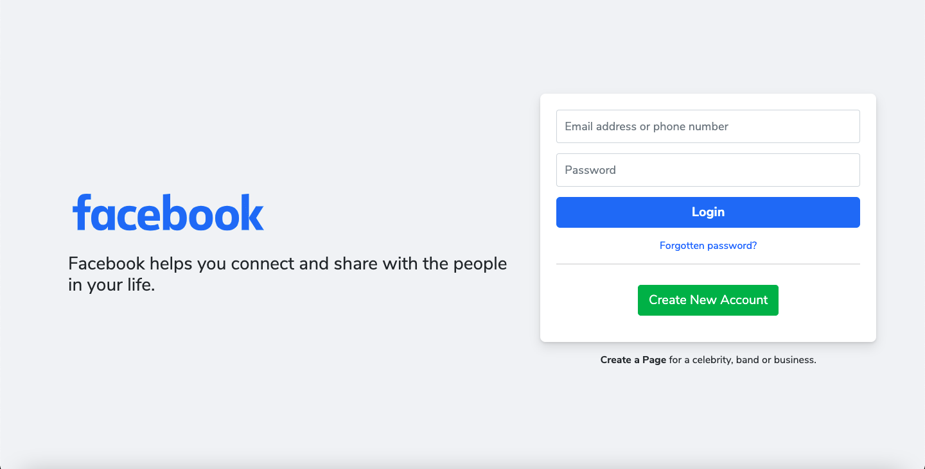

**Practical 3.4(a)**

1. **Create a table using Bootstrap**
2. **Implementation of Dropdown, Dropup and Buttons with different sizes using Bootstrap components.**

**table.html**

<!doctype html>

<html lang="en">

<head>

<meta charset="utf-8">

<meta http-equiv="X-UA-Compatible" content="IE=edge">

<meta name="viewport" content="width=device-width, initial-scale=1">

<!-- The above 3 meta tags *must* come first in the head; any other head content must come *after* these tags -->

<title>Table</title>

<!-- Bootstrap -->

<link rel="stylesheet" href="https://stackpath.bootstrapcdn.com/bootstrap/3.4.1/css/bootstrap.min.css" integrity="sha384-HSMxcRTRxnN+Bdg0JdbxYKrThecOKuH5zCYotlSAcp1+c8xmyTe9GYg1l9a69psu" crossorigin="anonymous">

<script src="https://oss.maxcdn.com/html5shiv/3.7.3/html5shiv.min.js"></script>

<script src="https://oss.maxcdn.com/respond/1.4.2/respond.min.js"></script>

</head>

<style type="text/css">

.table-bordered > tbody > tr > td{

border:10px solid white;

}</style>

<body>

<div class="container">

<table class="table table-bordered" style="background-color: #356aa0; color: white; height: 300px; text-align: center;">

<tr>

<td rowspan="2">Name</td>

<td colspan="3">Year</td>

<td rowspan="2">Blank</td>

</tr>

<tr>

<td>Sec</td>

<td>Group</td>

<td>Year</td>

</tr>

</table>

</div>

<!-- jQuery (necessary for Bootstrap's JavaScript plugins) -->

<script src="https://code.jquery.com/jquery-1.12.4.min.js" integrity="sha384-nvAa0+6Qg9clwYCGGPpDQLVpLNn0fRaROjHqs13t4Ggj3Ez50XnGQqc/r8MhnRDZ" crossorigin="anonymous"></script>

<!-- Include all compiled plugins (below), or include individual files as needed -->

<script src="https://stackpath.bootstrapcdn.com/bootstrap/3.4.1/js/bootstrap.min.js" integrity="sha384-aJ21OjlMXNL5UyIl/XNwTMqvzeRMZH2w8c5cRVpzpU8Y5bApTppSuUkhZXN0VxHd" crossorigin="anonymous"></script>

</body>

</html>

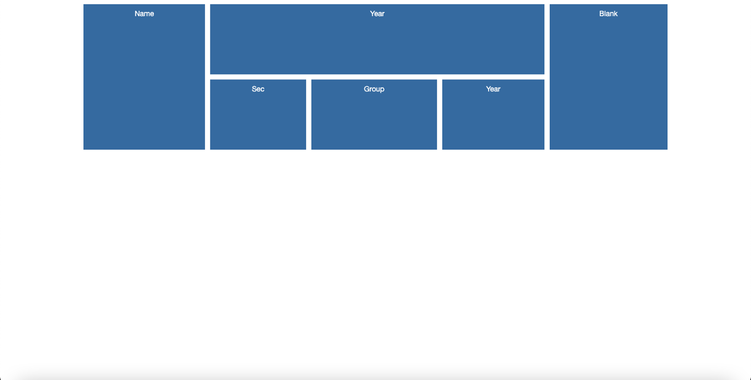

**buttons.html**

<!doctype html>

<html lang="en">

<head>

<meta charset="utf-8">

<meta http-equiv="X-UA-Compatible" content="IE=edge">

<meta name="viewport" content="width=device-width, initial-scale=1">

<!-- The above 3 meta tags *must* come first in the head; any other head content must come *after* these tags -->

<title>Bootstrap 101 Template</title>

<!-- Bootstrap -->

<link rel="stylesheet" href="https://stackpath.bootstrapcdn.com/bootstrap/3.4.1/css/bootstrap.min.css" integrity="sha384-HSMxcRTRxnN+Bdg0JdbxYKrThecOKuH5zCYotlSAcp1+c8xmyTe9GYg1l9a69psu" crossorigin="anonymous">

<!-- HTML5 shim and Respond.js for IE8 support of HTML5 elements and media queries -->

<!-- WARNING: Respond.js doesn't work if you view the page via file:// -->

<!--[if lt IE 9]>

<script src="https://oss.maxcdn.com/html5shiv/3.7.3/html5shiv.min.js"></script>

<script src="https://oss.maxcdn.com/respond/1.4.2/respond.min.js"></script>

<![endif]-->

</head>

<body>

<div class="row">

<div class="container">

<div class="col-lg-4 col-md-4 col-sm-6 col-xs-12 first"><i class="glyphicon

glyphicon-eject"></i>Hello This is 1st</div>

<div class="col-lg-4 col-md-4 col-sm-6 col-xs-12 first"><i class="glyphicon

glyphicon-eject"></i>Hello This is 2nd</div>

<div class="col-lg-4 col-md-4 col-sm-6 col-xs-12 first"><i class="glyphicon

glyphicon-eject"></i>Hello This is 3rd</div>

</div>

</div>

<h3>Dropdown</h3>

<div class="dropdown">

<button class="btn btn-default dropdown-toggle" type="button" id="dropdownMenu1" data-toggle="dropdown" aria-haspopup="true" aria-expanded="true">

Dropdown

<span class="caret"></span>

</button>

<ul class="dropdown-menu" aria-labelledby="dropdownMenu1">

<li><a href="#">Action</a></li>

<li><a href="#">Another action</a></li>

<li><a href="#">Something else here</a></li>

<li role="separator" class="divider"></li>

<li><a href="#">Separated link</a></li>

</ul>

</div>

<h3>Dropup</h3>

<div class="dropup">

<button class="btn btn-default dropdown-toggle" type="button" id="dropdownMenu2" data-toggle="dropdown" aria-haspopup="true" aria-expanded="false">

Dropup

<span class="caret"></span>

</button>

<ul class="dropdown-menu" aria-labelledby="dropdownMenu2">

<li><a href="#">Action</a></li>

<li><a href="#">Another action</a></li>

<li><a href="#">Something else here</a></li>

<li role="separator" class="divider"></li>

<li><a href="#">Separated link</a></li>

</ul>

</div>

<h3>Dropdown Headers</h3>

<div class="dropdown">

<button class="btn btn-default dropdown-toggle" type="button" id="dropdownMenu1" data-toggle="dropdown" aria-haspopup="true" aria-expanded="true">

Dropdown

<span class="caret"></span>

</button>

<ul class="dropdown-menu" aria-labelledby="dropdownMenu3">

<li><a href="#">Action</a></li>

<li><a href="#">Another action</a></li>

<li><a href="#">Something else here</a></li>

<li class="dropdown-header">Dropdown header</li>

<li><a href="#">Separated link</a></li>

</ul>

<h3>Divider</h3>

<div class="dropdown">

<button class="btn btn-default dropdown-toggle" type="button" id="dropdownMenu1" data-toggle="dropdown" aria-haspopup="true" aria-expanded="true">

Dropdown

<span class="caret"></span>

</button>

<ul class="dropdown-menu" aria-labelledby="dropdownMenuDivider">

<li><a href="#">Action</a></li>

<li><a href="#">Another action</a></li>

<li><a href="#">Something else here</a></li>

<li role="separator" class="divider"></li>

<li><a href="#">Separated link</a></li>

</ul>

<br>

<h3>Nesting</h3>

<div class="btn-group" role="group" aria-label="...">

<button type="button" class="btn btn-default">1</button>

<button type="button" class="btn btn-default">2</button>

<div class="btn-group" role="group">

<button type="button" class="btn btn-default dropdown-toggle" data-toggle="dropdown" aria-haspopup="true" aria-expanded="false">

Dropdown

<span class="caret"></span>

</button>

<ul class="dropdown-menu">

<li><a href="#">Dropdown link</a></li>

<li><a href="#">Dropdown link</a></li>

</ul>

</div>

</div>

<h3>Button Series</h3>

<div class="btn-group" role="group" aria-label="...">

<button type="button" class="btn btn-default">Left</button>

<button type="button" class="btn btn-default">Middle</button>

<button type="button" class="btn btn-default">Right</button>

</div>

<h3>Button Toolbar</h3>

<div class="btn-toolbar" role="toolbar" aria-label="...">

<div class="btn-group" role="group" aria-label="..."> <button type="button" class="btn btn-default">1234</button></div>

<div class="btn-group" role="group" aria-label="..."> <button type="button" class="btn btn-default">567</button></div>

<div class="btn-group" role="group" aria-label="..."> <button type="button" class="btn btn-default">8</button></div>

</div>

<h3>Sizing</h3>

<div class="btn-group btn-group-lg" role="group" aria-label="..."><button type="button" class="btn btn-default">Left</button></div>

<div class="btn-group" role="group" aria-label="..."></div>

<div class="btn-group btn-group-sm" role="group" aria-label="..."><button type="button" class="btn btn-default">Middle</button></div>

<div class="btn-group btn-group-xs" role="group" aria-label="..."><button type="button" class="btn btn-default">Right</button></div>

<h3>Single Button Dropdowns</h3>

<!-- Single button -->

<div class="btn-group">

<button type="button" class="btn btn-default dropdown-toggle" data-toggle="dropdown" aria-haspopup="true" aria-expanded="false">

Action <span class="caret"></span>

</button>

<ul class="dropdown-menu">

<li><a href="#">Action</a></li>

<li><a href="#">Another action</a></li>

<li><a href="#">Something else here</a></li>

<li role="separator" class="divider"></li>

<li><a href="#">Separated link</a></li>

</ul>

</div>

<h3>Sizing</h3>

<!-- Large button group -->

<div class="btn-group">

<button class="btn btn-default btn-lg dropdown-toggle" type="button" data-toggle="dropdown" aria-haspopup="true" aria-expanded="false">

Large button <span class="caret"></span>

</button>

<ul class="dropdown-menu">

...

</ul>

</div>

<!-- Small button group -->

<div class="btn-group">

<button class="btn btn-default btn-sm dropdown-toggle" type="button" data-toggle="dropdown" aria-haspopup="true" aria-expanded="false">

Small button <span class="caret"></span>

</button>

<ul class="dropdown-menu">

...

</ul>

</div>

<!-- Extra small button group -->

<div class="btn-group">

<button class="btn btn-default btn-xs dropdown-toggle" type="button" data-toggle="dropdown" aria-haspopup="true" aria-expanded="false">

Extra small button <span class="caret"></span>

</button>

<ul class="dropdown-menu">

...

</ul>

</div>

<!-- jQuery (necessary for Bootstrap's JavaScript plugins) -->

<script src="https://code.jquery.com/jquery-1.12.4.min.js" integrity="sha384-nvAa0+6Qg9clwYCGGPpDQLVpLNn0fRaROjHqs13t4Ggj3Ez50XnGQqc/r8MhnRDZ" crossorigin="anonymous"></script>

<!-- Include all compiled plugins (below), or include individual files as needed -->

<script src="https://stackpath.bootstrapcdn.com/bootstrap/3.4.1/js/bootstrap.min.js" integrity="sha384-aJ21OjlMXNL5UyIl/XNwTMqvzeRMZH2w8c5cRVpzpU8Y5bApTppSuUkhZXN0VxHd" crossorigin="anonymous"></script>

</body>

</html>

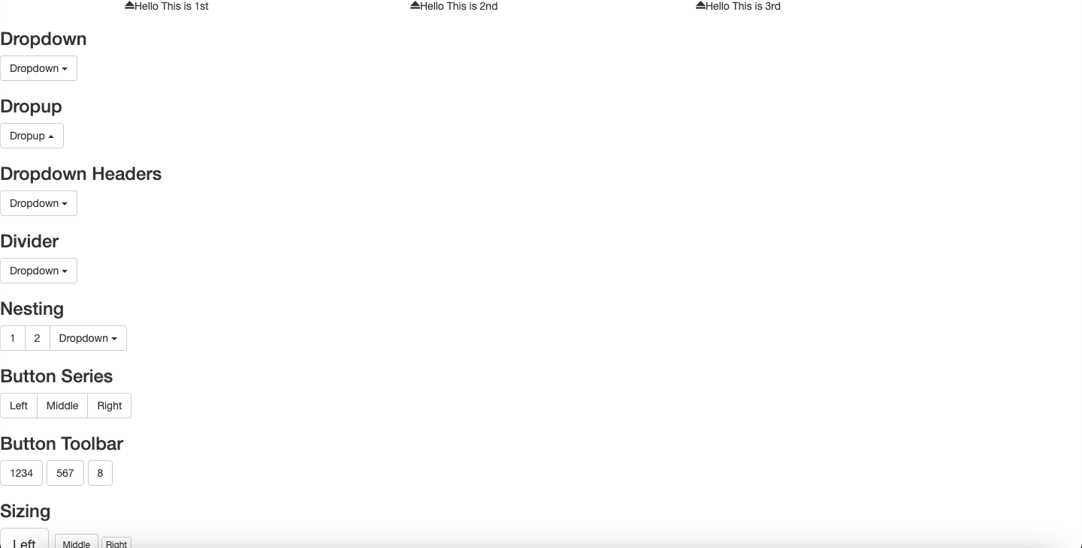

**Practical 3.4(b)**

**Implementation of Navbar in Bootstrap**

**index.html**

<!doctype html>

<html lang="en">

<head>

<meta charset="utf-8">

<meta http-equiv="X-UA-Compatible" content="IE=edge">

<meta name="viewport" content="width=device-width, initial-scale=1">

<!-- The above 3 meta tags *must* come first in the head; any other head content must come *after* these tags -->

<title>Bootstrap 101 Template</title>

<!-- Bootstrap -->

<link rel="stylesheet" href="https://stackpath.bootstrapcdn.com/bootstrap/3.4.1/css/bootstrap.min.css" integrity="sha384-HSMxcRTRxnN+Bdg0JdbxYKrThecOKuH5zCYotlSAcp1+c8xmyTe9GYg1l9a69psu" crossorigin="anonymous">

<!-- HTML5 shim and Respond.js for IE8 support of HTML5 elements and media queries -->

<!-- WARNING: Respond.js doesn't work if you view the page via file:// -->

<!--[if lt IE 9]>

<script src="https://oss.maxcdn.com/html5shiv/3.7.3/html5shiv.min.js"></script>

<script src="https://oss.maxcdn.com/respond/1.4.2/respond.min.js"></script>

<![endif]-->

</head>

<body>

<nav class="navbar navbar-default">

<div class="container-fluid">

<!-- Brand and toggle get grouped for better mobile display -->

<div class="navbar-header">

<button type="button" class="navbar-toggle collapsed" data-toggle="collapse" data-target="#bs-example-navbar-collapse-1" aria-expanded="false">

<span class="sr-only">Toggle navigation</span>

<span class="icon-bar"></span>

<span class="icon-bar"></span>

<span class="icon-bar"></span>

</button>

<a class="navbar-brand" href="#">Brand</a>

</div>

<!-- Collect the nav links, forms, and other content for toggling -->

<div class="collapse navbar-collapse" id="bs-example-navbar-collapse-1">

<ul class="nav navbar-nav">

<li class="active"><a href="#">Link <span class="sr-only">(current)</span></a></li>

<li><a href="#">Link</a></li>

<li class="dropdown">

<a href="#" class="dropdown-toggle" data-toggle="dropdown" role="button" aria-haspopup="true" aria-expanded="false">Dropdown <span class="caret"></span></a>

<ul class="dropdown-menu">

<li><a href="#">Action</a></li>

<li><a href="#">Another action</a></li>

<li><a href="#">Something else here</a></li>

<li role="separator" class="divider"></li>

<li><a href="#">Separated link</a></li>

<li role="separator" class="divider"></li>

<li><a href="#">One more separated link</a></li>

</ul>

</li>

</ul>

<form class="navbar-form navbar-left">

<div class="form-group">

<input type="text" class="form-control" placeholder="Search">

</div>

<button type="submit" class="btn btn-default">Submit</button>

</form>

<ul class="nav navbar-nav navbar-right">

<li><a href="#">Link</a></li>

<li class="dropdown">

<a href="#" class="dropdown-toggle" data-toggle="dropdown" role="button" aria-haspopup="true" aria-expanded="false">Dropdown <span class="caret"></span></a>

<ul class="dropdown-menu">

<li><a href="#">Action</a></li>

<li><a href="#">Another action</a></li>

<li><a href="#">Something else here</a></li>

<li role="separator" class="divider"></li>

<li><a href="#">Separated link</a></li>

</ul>

</li>

</ul>

</div><!-- /.navbar-collapse -->

</div><!-- /.container-fluid -->

</nav>

<!-- jQuery (necessary for Bootstrap's JavaScript plugins) -->

<script src="https://code.jquery.com/jquery-1.12.4.min.js" integrity="sha384-nvAa0+6Qg9clwYCGGPpDQLVpLNn0fRaROjHqs13t4Ggj3Ez50XnGQqc/r8MhnRDZ" crossorigin="anonymous"></script>

<!-- Include all compiled plugins (below), or include individual files as needed -->

<script src="https://stackpath.bootstrapcdn.com/bootstrap/3.4.1/js/bootstrap.min.js" integrity="sha384-aJ21OjlMXNL5UyIl/XNwTMqvzeRMZH2w8c5cRVpzpU8Y5bApTppSuUkhZXN0VxHd" crossorigin="anonymous"></script>

</body>

</html>

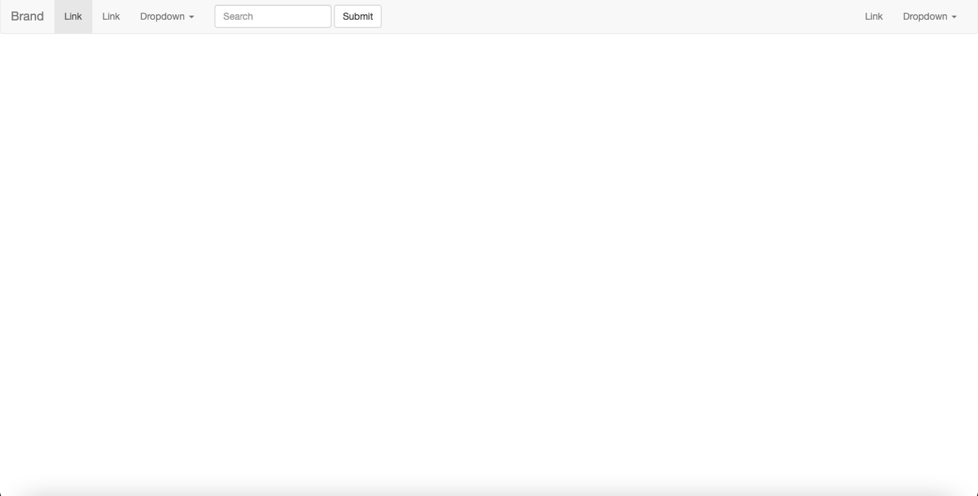

**Practical 3.5**

**Create a webpages using different Bootstrap Components - Breadcrumbs, Badges, Jumbotron, Labels, Page Header and Thumbnail etc.**

**homepage.html**

<!doctype html>

<html lang="en">

<head>

<meta charset="utf-8">

<meta http-equiv="X-UA-Compatible" content="IE=edge">

<meta name="viewport" content="width=device-width, initial-scale=1">

<!-- The above 3 meta tags *must* come first in the head; any other head content must come *after* these tags -->

<title>bootstrap</title>

<!-- Bootstrap -->

<link rel="stylesheet" href="https://stackpath.bootstrapcdn.com/bootstrap/3.4.1/css/bootstrap.min.css" integrity="sha384-HSMxcRTRxnN+Bdg0JdbxYKrThecOKuH5zCYotlSAcp1+c8xmyTe9GYg1l9a69psu" crossorigin="anonymous">

<link rel="stylesheet" type="text/css" href="../css/style.css">

</head>

<body>

<h1 class=" text-center heading"><ins> BOOTSTRAP COMPONENMTS</ins></h1>

<nav aria-label="breadcrumb .bg-dark.bg-gradient ">

<ol class="breadcrumb">

<li class="breadcrumb-item active" aria-current="page">Home</li>

<li class="breadcrumb-item"><a href="label.html">progress bars</a></li>

<li class="breadcrumb-item"><a href="badges.html">Badges</a></li>

<li class="breadcrumb-item"><a href="jumbotron.html">Jumbotron</a></li>

<li class="breadcrumb-item"><a href="pageheader.html">Page Header</a></li>

<li class="breadcrumb-item"><a href="thumbnail.html">Thumbnail</a></li>

</ol>

</nav>

<div class="container-fluid">

<div class="row">

<div class="col-sm-6">

<h2><strong>Build fast, responsive sites with Bootstrap</strong></h2>

<p>Quickly design and customize responsive mobile-first sites with Bootstrap, the world’s most popular front-end open source toolkit, featuring Sass variables and mixins, responsive grid system, extensive prebuilt components, and powerful JavaScript plugins.</p>

</div>

<div class="col-sm-6">

<img src="https://encrypted-tbn0.gstatic.com/images?q=tbn:ANd9GcTMemPz_kjTqM1leIwZSzRwqKUN_2doin6v2R7vsegH7pODzjwU7dxN2Hs5jUKwIIBmdX8&usqp=CAU" width="500px" height="500px" margin-left="45px">

</div>

<!-- jQuery (necessary for Bootstrap's JavaScript plugins) -->

<script src="https://code.jquery.com/jquery-1.12.4.min.js" integrity="sha384-nvAa0+6Qg9clwYCGGPpDQLVpLNn0fRaROjHqs13t4Ggj3Ez50XnGQqc/r8MhnRDZ" crossorigin="anonymous"></script>

<!-- Include all compiled plugins (below), or include individual files as needed -->

<script src="https://stackpath.bootstrapcdn.com/bootstrap/3.4.1/js/bootstrap.min.js" integrity="sha384-aJ21OjlMXNL5UyIl/XNwTMqvzeRMZH2w8c5cRVpzpU8Y5bApTppSuUkhZXN0VxHd" crossorigin="anonymous"></script>

</body>

</html>

**style.css**

body{

margin:40px 5px;

background-color:lightgreen;

}

h1{

color:purple;

font-weight: bold;

margin-bottom: 25px;

}

.head{

height:

}

.col-sm-6 p{

font-size:30px;

}

.badge-primary{

background-color:#007bff ;

}

.badge-success{

background-color: #28a745;

}

.bg-success{

background-color:#28a745!important;

}

.bg-info{

background-color:#17a2b8!important;

}

.bg-warning{

background-color: #ffc107!important;

}

.bg-danger{

background-color: #dc3545!important;

}

.col-sm-10{

font-size:30px;

margin-left: 50px;

}

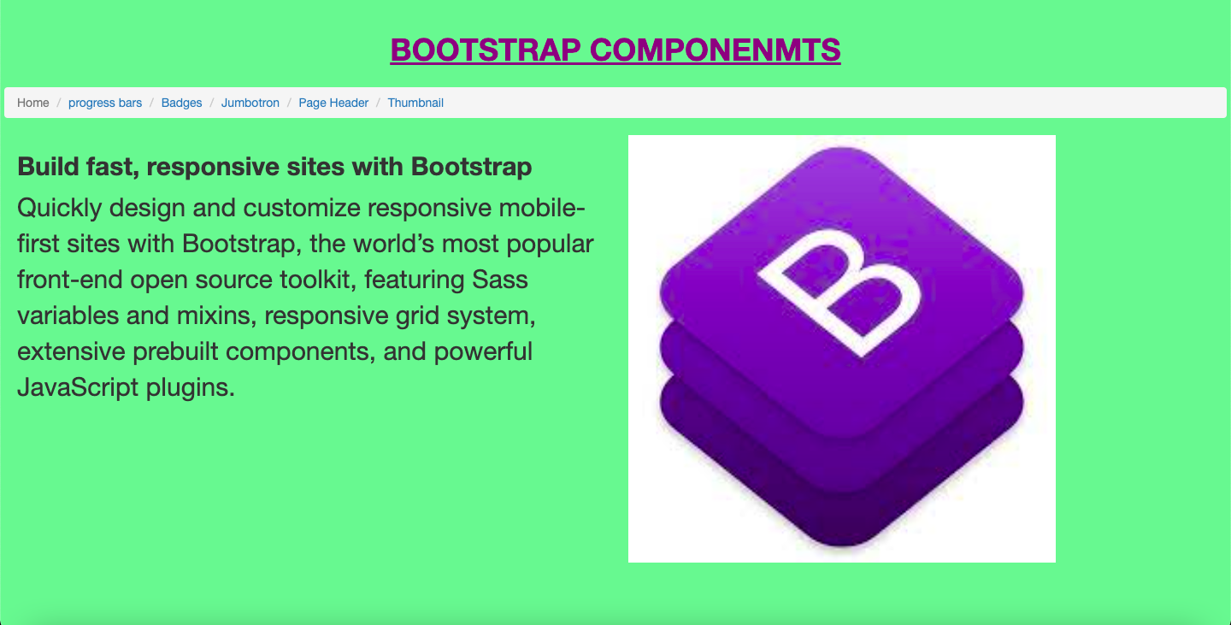

**label.html**

<!doctype html>

<html lang="en">

<head>

<meta charset="utf-8">

<meta http-equiv="X-UA-Compatible" content="IE=edge">

<meta name="viewport" content="width=device-width, initial-scale=1">

<!-- The above 3 meta tags *must* come first in the head; any other head content must come *after* these tags -->

<title>labels</title>

<!-- Bootstrap -->

<link rel="stylesheet" href="https://stackpath.bootstrapcdn.com/bootstrap/3.4.1/css/bootstrap.min.css" integrity="sha384-HSMxcRTRxnN+Bdg0JdbxYKrThecOKuH5zCYotlSAcp1+c8xmyTe9GYg1l9a69psu" crossorigin="anonymous">

<link rel="stylesheet" type="text/css" href="../css/style.css">

</head>

<body>

<h1 class=" text-center heading"><ins>PROGRESS BARS</ins></h1>

<ol class="breadcrumb">

<li class="breadcrumb-item"><a href="homepage.html">Home</a></li>

<li class="breadcrumb-item active" aria-current="page"><a href="#">progress bars</a></li>

<li class="breadcrumb-item"><a href="badges.html">Badges</a></li>

<li class="breadcrumb-item"><a href="jumbotron.html">Jumbotron</a></li>

<li class="breadcrumb-item"><a href="pageheader.html">Page Header</a></li>

<li class="breadcrumb-item" ><a href="thumbnail.html">Thumbnail</a></li>

</ol>

</nav>

<div class="container-fluid">

<div class="row">

<div class="col-sm-6">

<h2><strong>Labels</strong></h2>

<p>Add labels to your progress bars by placing text within the .progress-bar.</p>

<div class="progress">

<div class="progress-bar" role="progressbar" style="width: 25%;" aria-valuenow="25" aria-valuemin="0" aria-valuemax="100">25%</div>

</div>

</div>

<div class="col-sm-6">

<h2><strong>Height</strong></h2>

<p> We only set a height value on the .progress, so if you change that value the inner .progress-bar will automatically resize accordingly.</p>

<div class="progress" style="height: 1px;">

<div class="progress-bar" role="progressbar" style="width: 25%;" aria-valuenow="25" aria-valuemin="0" aria-valuemax="100"></div>

</div>

<div class="progress" style="height: 20px;">

<div class="progress-bar" role="progressbar" style="width: 25%;" aria-valuenow="25" aria-valuemin="0" aria-valuemax="100"></div>

</div>

</div>

<div class="container-fluid">

<div class="row">

<div class="col-sm-6">

<h2><strong>Backgrounds</strong></h2>

<p>Use background utility classes to change the appearance of individual progress bars.</p>

<div class="progress">

<div class="progress-bar bg-success" role="progressbar" style="width: 25%" aria-valuenow="25" aria-valuemin="0" aria-valuemax="100"></div>

</div>

<div class="progress">

<div class="progress-bar bg-info" role="progressbar" style="width: 50%" aria-valuenow="50" aria-valuemin="0" aria-valuemax="100"></div>

</div>

<div class="progress">

<div class="progress-bar bg-warning" role="progressbar" style="width: 75%" aria-valuenow="75" aria-valuemin="0" aria-valuemax="100"></div>

</div>

<div class="progress">

<div class="progress-bar bg-danger" role="progressbar" style="width: 100%" aria-valuenow="100" aria-valuemin="0" aria-valuemax="100">

</div>

<div class="col-sm-6">

<h2><strong>Multiple bars</strong></h2>

<p> Include multiple progress bars in a progress component if you need.</p>

<div class="progress">

<div class="progress-bar" role="progressbar" style="width: 15%" aria-valuenow="15" aria-valuemin="0" aria-valuemax="100"></div>

<div class="progress-bar bg-success" role="progressbar" style="width: 30%" aria-valuenow="30" aria-valuemin="0" aria-valuemax="100"></div>

<div class="progress-bar bg-info" role="progressbar" style="width: 20%" aria-valuenow="20" aria-valuemin="0" aria-valuemax="100"></div>

</div>

</div>

</div>

</div>

<div class="container-fluid">

<div class="row">

<div class="col-sm-6">

<h2><strong>Striped</strong></h2>

<p>Add .progress-bar-striped to any .progress-bar to apply a stripe via CSS gradient over the progress bar’s background color.</p>

<div class="progress">

<div class="progress-bar progress-bar-striped" role="progressbar" style="width: 10%" aria-valuenow="10" aria-valuemin="0" aria-valuemax="100"></div>

</div>

<div class="progress">

<div class="progress-bar progress-bar-striped bg-success" role="progressbar" style="width: 25%" aria-valuenow="25" aria-valuemin="0" aria-valuemax="100"></div>

</div>

<div class="progress">

<div class="progress-bar progress-bar-striped bg-info" role="progressbar" style="width: 50%" aria-valuenow="50" aria-valuemin="0" aria-valuemax="100"></div>

</div>

<div class="progress">

<div class="progress-bar progress-bar-striped bg-warning" role="progressbar" style="width: 75%" aria-valuenow="75" aria-valuemin="0" aria-valuemax="100"></div>

</div>

<div class="progress">

<div class="progress-bar progress-bar-striped bg-danger" role="progressbar" style="width: 100%" aria-valuenow="100" aria-valuemin="0" aria-valuemax="100"></div>

</div>

</div>

</div>

<!-- jQuery (necessary for Bootstrap's JavaScript plugins) -->

<script src="https://code.jquery.com/jquery-1.12.4.min.js" integrity="sha384-nvAa0+6Qg9clwYCGGPpDQLVpLNn0fRaROjHqs13t4Ggj3Ez50XnGQqc/r8MhnRDZ" crossorigin="anonymous"></script>

<!-- Include all compiled plugins (below), or include individual files as needed -->

<script src="https://stackpath.bootstrapcdn.com/bootstrap/3.4.1/js/bootstrap.min.js" integrity="sha384-aJ21OjlMXNL5UyIl/XNwTMqvzeRMZH2w8c5cRVpzpU8Y5bApTppSuUkhZXN0VxHd" crossorigin="anonymous"></script>

</body>

</html>

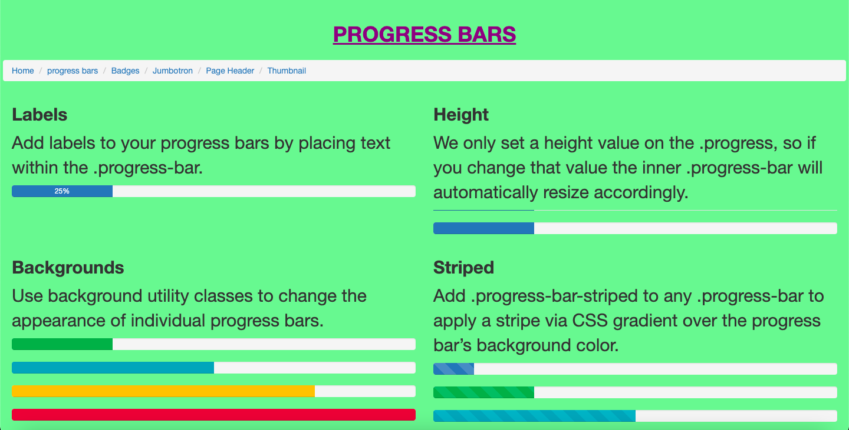

**badges.html**

<!doctype html>

<html lang="en">

<head>

<meta charset="utf-8">

<meta http-equiv="X-UA-Compatible" content="IE=edge">

<meta name="viewport" content="width=device-width, initial-scale=1">

<!-- The above 3 meta tags *must* come first in the head; any other head content must come *after* these tags -->

<title>badges</title>

<!-- Bootstrap -->

<link rel="stylesheet" href="https://stackpath.bootstrapcdn.com/bootstrap/3.4.1/css/bootstrap.min.css" integrity="sha384-HSMxcRTRxnN+Bdg0JdbxYKrThecOKuH5zCYotlSAcp1+c8xmyTe9GYg1l9a69psu" crossorigin="anonymous">

<link rel="stylesheet" type="text/css" href="../css/style.css">

</head>

<body>

<h1 class=" text-center heading"><ins>BADGES</ins></h1>

<nav aria-label="breadcrumb .bg-dark.bg-gradient ">

<ol class="breadcrumb">

<li class="breadcrumb-item"><a href="homepage.html">Home</a></li>

<li class="breadcrumb-item"><a href="label.html">progress bars</a></li>

<li class="breadcrumb-item active" aria-current="page"><a href="#">Badges</a></li>

<li class="breadcrumb-item"><a href="jumbotron.html">Jumbotron</a></li>

<li class="breadcrumb-item"><a href="pageheader.html">Page Header</a></li>

<li class="breadcrumb-item"><a href="thumbnail.html">Thumbnail</a></li>

</ol>

</nav>

<div class="container-fluid">

<div class="row">

<div class="col-sm-7">

<h2><strong>Documentation and examples for badges, our small count and labeling component.</strong></h2>

</div>

<div class="container-fluid">

<div class="row">

<div class="col-sm-6">

<h2><strong>Example</strong>

<p>Badges scale to match the size of the immediate parent element by using relative font sizing and em units.</p>

<h1>Example heading <span class="badge badge-secondary">New</span></h1>

</div>

<div class="col-sm-6">

<h2>Badges can be used as part of links or buttons to provide a counter.</h2>

<button type="button" class="btn btn-primary">

Notifications <span class="badge badge-light">4</span>

</button>

<h2>Badges can be used as part of links or buttons to provide a counter.</h2>

<button type="button" class="btn btn-primary">

Profile <span class="badge badge-light">9</span>

<span class="sr-only">unread messages</span>

</button>

</div>

</div>

<div class="row">

<div class="col-sm-6">

<h2><strong>Contextual variations</strong></h2>

<p>Add any of the below mentioned modifier classes to change the appearance of a badge.</p>

<span class="badge badge-primary">Primary</span>

<span class="badge badge-secondary">Secondary</span>

</div>

<div class="col-sm-6">

<h2><strong>Pill badges </strong>

<p>Use the .badge-pill modifier class to make badges more rounded (with a larger border-radius and additional horizontal</p>

<span class="badge badge-pill badge-primary">Primary</span>

<span class="badge badge-pill badge-secondary">Secondary</span>

<span class="badge badge-pill badge-success">Success</span>

</div>

</div>

<!-- jQuery (necessary for Bootstrap's JavaScript plugins) -->

<script src="https://code.jquery.com/jquery-1.12.4.min.js" integrity="sha384-nvAa0+6Qg9clwYCGGPpDQLVpLNn0fRaROjHqs13t4Ggj3Ez50XnGQqc/r8MhnRDZ" crossorigin="anonymous"></script>

<!-- Include all compiled plugins (below), or include individual files as needed -->

<script src="https://stackpath.bootstrapcdn.com/bootstrap/3.4.1/js/bootstrap.min.js" integrity="sha384-aJ21OjlMXNL5UyIl/XNwTMqvzeRMZH2w8c5cRVpzpU8Y5bApTppSuUkhZXN0VxHd" crossorigin="anonymous"></script>

</body>

</html>

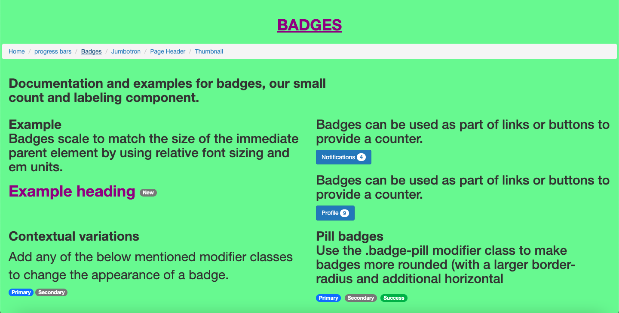

**jumbotron.html**

<!doctype html>

<html lang="en">

<head>

<meta charset="utf-8">

<meta http-equiv="X-UA-Compatible" content="IE=edge">

<meta name="viewport" content="width=device-width, initial-scale=1">

<!-- The above 3 meta tags *must* come first in the head; any other head content must come *after* these tags -->

<title>JUMBOTRON</title>

<!-- Bootstrap -->

<link rel="stylesheet" href="https://stackpath.bootstrapcdn.com/bootstrap/3.4.1/css/bootstrap.min.css" integrity="sha384-HSMxcRTRxnN+Bdg0JdbxYKrThecOKuH5zCYotlSAcp1+c8xmyTe9GYg1l9a69psu" crossorigin="anonymous">

<link rel="stylesheet" type="text/css" href="../css/style.css">

</head>

<body>

<h1 class=" text-center heading"><ins>JUMBOTRON</ins></h1>

<nav aria-label="breadcrumb .bg-dark.bg-gradient ">

<ol class="breadcrumb">

<li class="breadcrumb-item"><a href="homepage.html">Home</a></li>

<li class="breadcrumb-item"><a href="label.html">progress bars</a></li>

<li class="breadcrumb-item"><a href="badges.html">Badges</a></li>

<li class="breadcrumb-item active" aria-current="page"><a href="#">Jumbotron</a></li>

<li class="breadcrumb-item"><a href="pageheader.html">Page Header</a></li>

<li class="breadcrumb-item"><a href="thumbnail.html">Thumbnail</a></li>

</ol>

</nav>

<div class="container-fluid">

<div class="row">

<div class="col-sm-6">

<h2><strong>Jumbotron</strong></h2>

<p>Lightweight, flexible component for showcasing hero unit style content.</p>

<div class="jumbotron">

<h1 class="display-4">Hello, world!</h1>

<p class="lead">This is a simple hero unit, a simple jumbotron-style component for calling extra attention to featured content or information.</p>

<hr class="my-4">

<p>It uses utility classes for typography and spacing to space content out within the larger container.</p>

<p class="lead">

<a class="btn btn-primary btn-lg" href="#" role="button">Learn more</a>

</p>

</div>

</div>

<div class="col-sm-6">

<h2><strong>Fluid jumbotron</strong></h2>

<p> To make the jumbotron full width, and without rounded corners, add the .jumbotron-fluid modifier class and add a .container or .container-fluid within.</p>

<div class="jumbotron jumbotron-fluid">

<div class="container">

<h1 class="display-4">Fluid jumbotron</h1>

<p class="lead">This is a modified jumbotron that occupies the entire horizontal space of its parent.</p>

</div>

</div>

</div>

<!-- jQuery (necessary for Bootstrap's JavaScript plugins) -->

<script src="https://code.jquery.com/jquery-1.12.4.min.js" integrity="sha384-nvAa0+6Qg9clwYCGGPpDQLVpLNn0fRaROjHqs13t4Ggj3Ez50XnGQqc/r8MhnRDZ" crossorigin="anonymous"></script>

<!-- Include all compiled plugins (below), or include individual files as needed -->

<script src="https://stackpath.bootstrapcdn.com/bootstrap/3.4.1/js/bootstrap.min.js" integrity="sha384-aJ21OjlMXNL5UyIl/XNwTMqvzeRMZH2w8c5cRVpzpU8Y5bApTppSuUkhZXN0VxHd" crossorigin="anonymous"></script>

</body>

</html>

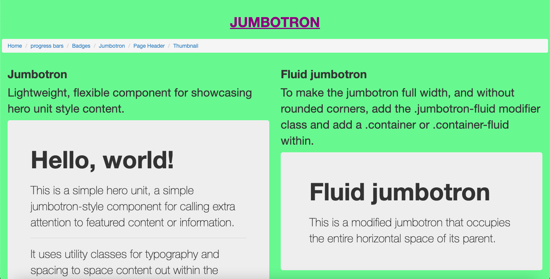

**pageheader.html**

<!doctype html>

<html lang="en">

<head>

<meta charset="utf-8">

<meta http-equiv="X-UA-Compatible" content="IE=edge">

<meta name="viewport" content="width=device-width, initial-scale=1">

<!-- The above 3 meta tags *must* come first in the head; any other head content must come *after* these tags -->

<title>page header</title>

<!-- Bootstrap -->

<link rel="stylesheet" href="https://stackpath.bootstrapcdn.com/bootstrap/3.4.1/css/bootstrap.min.css" integrity="sha384-HSMxcRTRxnN+Bdg0JdbxYKrThecOKuH5zCYotlSAcp1+c8xmyTe9GYg1l9a69psu" crossorigin="anonymous">

<link rel="stylesheet" type="text/css" href="../css/style.css">

</head>

<body>

<h1 class=" text-center heading"><ins>PAGE HEADER</ins></h1>

<nav aria-label="breadcrumb .bg-dark.bg-gradient ">

<ol class="breadcrumb">

<li class="breadcrumb-item"><a href="homepage.html">Home</a></li>

<li class="breadcrumb-item"><a href="label.html">progress bars</a></li>

<li class="breadcrumb-item"><a href="badges.html">Badges</a></li>

<li class="breadcrumb-item"><a href="jumbotron.html">Jumbotron</a></li>

<li class="breadcrumb-item active" aria-current="page"><a href="pageheader.html">Page Header</a></li>

<li class="breadcrumb-item"><a href="thumbnail.html">Thumbnail</a></li>

</ol>

</nav>

<div class="container-fluid">

<div class="row">

<div class="col-sm-10">

<h2><strong>Page header </strong></h2>

<p>A page header is like a section divider.</p><br>

<p>The .page-header class adds a horizontal line under the heading (+ adds some extra space around the element):</p>

<div class="page-header">

<h1>Example Page Header</h1>

</div>

<p>This is some text.</p>

<p>This is another text.</p>

</div>

</div>

</div>

<!-- jQuery (necessary for Bootstrap's JavaScript plugins) -->

<script src="https://code.jquery.com/jquery-1.12.4.min.js" integrity="sha384-nvAa0+6Qg9clwYCGGPpDQLVpLNn0fRaROjHqs13t4Ggj3Ez50XnGQqc/r8MhnRDZ" crossorigin="anonymous"></script>

<!-- Include all compiled plugins (below), or include individual files as needed -->

<script src="https://stackpath.bootstrapcdn.com/bootstrap/3.4.1/js/bootstrap.min.js" integrity="sha384-aJ21OjlMXNL5UyIl/XNwTMqvzeRMZH2w8c5cRVpzpU8Y5bApTppSuUkhZXN0VxHd" crossorigin="anonymous"></script>

</body>

</html>

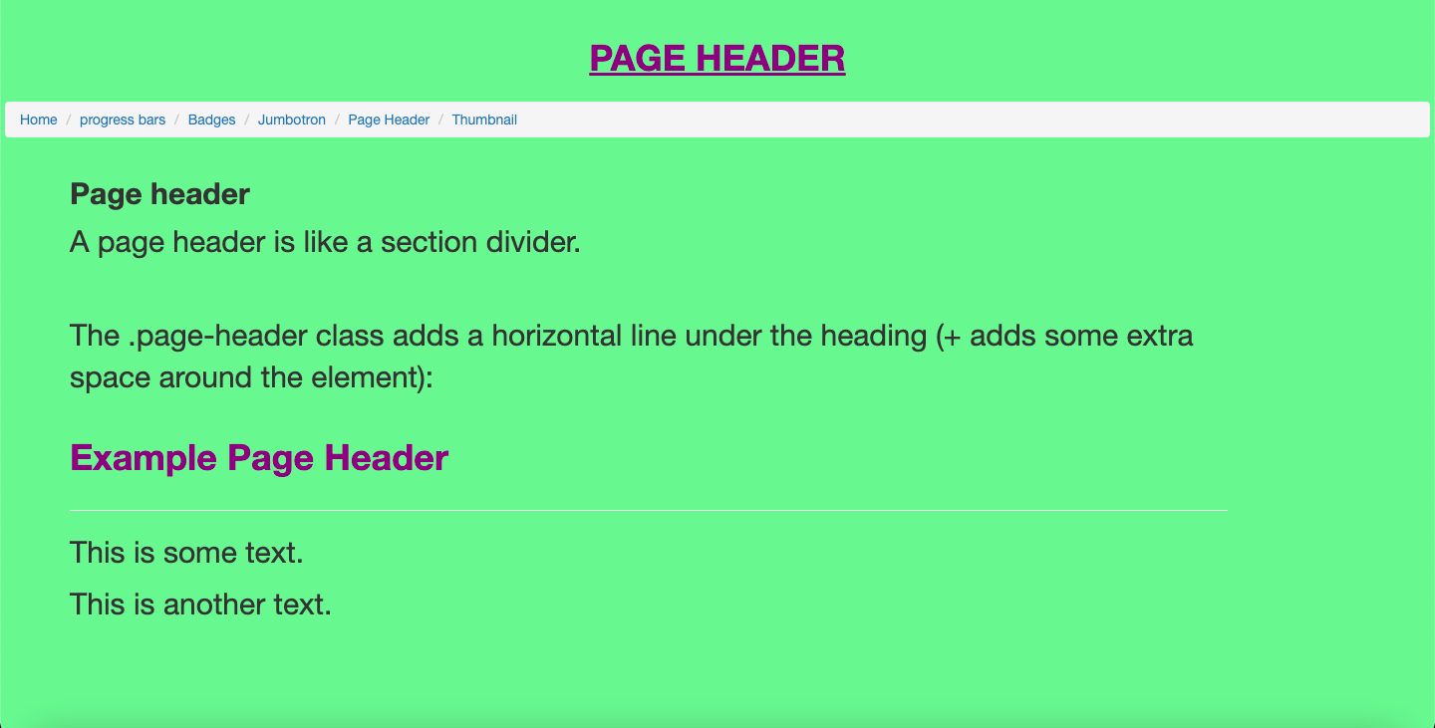

**thumbnail.html**

<!doctype html>

<html lang="en">

<head>

<meta charset="utf-8">

<meta http-equiv="X-UA-Compatible" content="IE=edge">

<meta name="viewport" content="width=device-width, initial-scale=1">

<!-- The above 3 meta tags *must* come first in the head; any other head content must come *after* these tags -->

<title>thumbnail</title>

<!-- Bootstrap -->

<link rel="stylesheet" href="https://stackpath.bootstrapcdn.com/bootstrap/3.4.1/css/bootstrap.min.css" integrity="sha384-HSMxcRTRxnN+Bdg0JdbxYKrThecOKuH5zCYotlSAcp1+c8xmyTe9GYg1l9a69psu" crossorigin="anonymous">

<link rel="stylesheet" type="text/css" href="../css/style.css">

</head>

<body>

<h1 class=" text-center heading"><ins>Image Thumbnail</ins></h1>

<nav aria-label="breadcrumb .bg-dark.bg-gradient ">

<ol class="breadcrumb">

<li class="breadcrumb-item"><a href="homepage.html">Home</a></li>

<li class="breadcrumb-item"><a href="label.html">progress bars</a></li>

<li class="breadcrumb-item"><a href="badges.html">Badges</a></li>

<li class="breadcrumb-item"><a href="jumbotron.html">Jumbotron</a></li>

<li class="breadcrumb-item"><a href="pageheader.html">Page Header</a></li>

<li class="breadcrumb-item active" aria-current="page"><a href="#">Thumbnail</a></li>

</ol>

</nav>

<div class="container-fluid">

<div class="row">

<div class="col-sm-10">

<h2><strong> Image thumbnail</strong></h2>

<p>In addition to our border-radius utilities, you can use .img-thumbnail to give an image a rounded 1px border appearance.</p>

<img src="https://camo.githubusercontent.com/c3e073e60477a9a4543b5f7a941364acc9c9b4b19f783254c2ba06ca97232bde/68747470733a2f2f69636f6e732e676574626f6f7473747261702e636f6d2f6173736574732f696d672f69636f6e732d6865726f2e706e67" alt="..." class="img-thumbnail">

</div>

</div>

</div>

<!-- jQuery (necessary for Bootstrap's JavaScript plugins) -->

<script src="https://code.jquery.com/jquery-1.12.4.min.js" integrity="sha384-nvAa0+6Qg9clwYCGGPpDQLVpLNn0fRaROjHqs13t4Ggj3Ez50XnGQqc/r8MhnRDZ" crossorigin="anonymous"></script>

<!-- Include all compiled plugins (below), or include individual files as needed -->

<script src="https://stackpath.bootstrapcdn.com/bootstrap/3.4.1/js/bootstrap.min.js" integrity="sha384-aJ21OjlMXNL5UyIl/XNwTMqvzeRMZH2w8c5cRVpzpU8Y5bApTppSuUkhZXN0VxHd" crossorigin="anonymous"></script>

</body>

</html>

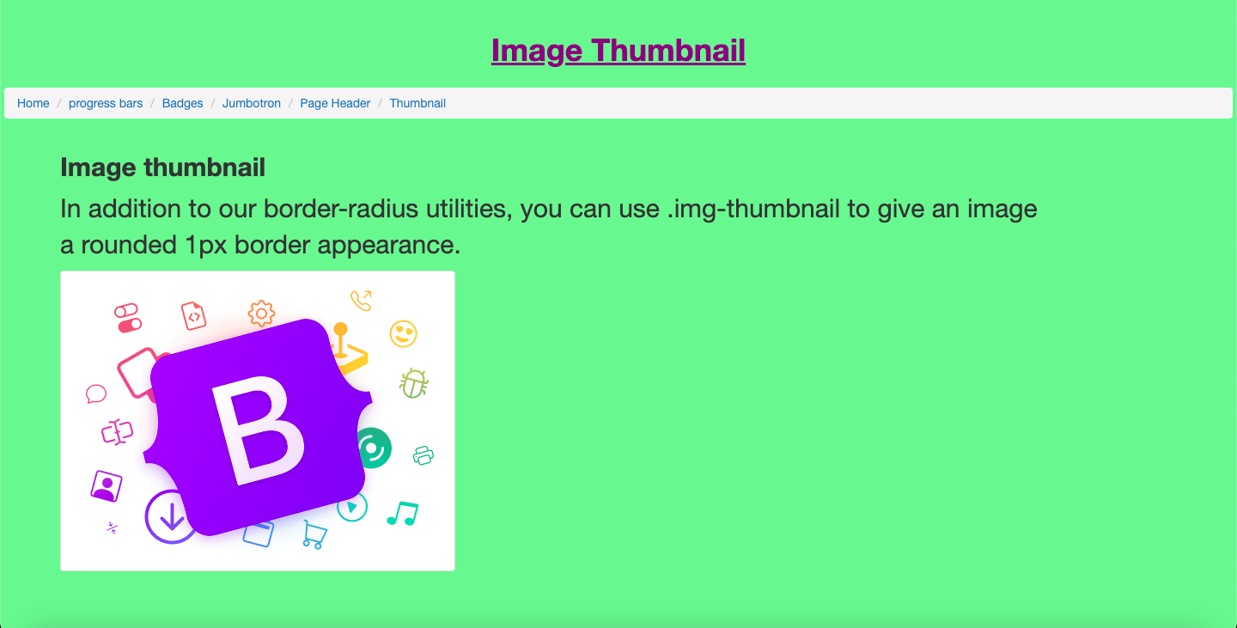

**Assignment Week-3**

**Create a responsive Website and follow mentioned website layouts.**

**Need to create 4 webpage Website, also use each and every component of Bootstrap that we had discussed till now.**

**index.html**

<!DOCTYPE html>

<html lang="en">

<head>

<meta charset="utf-8">

<meta content="width=device-width, initial-scale=1.0" name="viewport">

<title>Eterna</title>

<meta content="" name="description">

<meta content="" name="keywords">

<!-- Favicons -->

<link href="assets/img/favicon.png" rel="icon">

<link href="assets/img/apple-touch-icon.png" rel="apple-touch-icon">

<!-- Google Fonts -->

<link href="https://fonts.googleapis.com/css?family=Open+Sans:300,300i,400,400i,600,600i,700,700i|Raleway:300,300i,400,400i,500,500i,600,600i,700,700i|Poppins:300,300i,400,400i,500,500i,600,600i,700,700i" rel="stylesheet">

<!-- Vendor CSS Files -->

<link href="assets/vendor/animate.css/animate.min.css" rel="stylesheet">

<link href="assets/vendor/bootstrap/css/bootstrap.min.css" rel="stylesheet">

<link href="assets/vendor/bootstrap-icons/bootstrap-icons.css" rel="stylesheet">

<link href="assets/vendor/boxicons/css/boxicons.min.css" rel="stylesheet">

<link href="assets/vendor/glightbox/css/glightbox.min.css" rel="stylesheet">

<link href="assets/vendor/swiper/swiper-bundle.min.css" rel="stylesheet">

<!-- Template Main CSS File -->

<link href="assets/css/style.css" rel="stylesheet">

<!-- =======================================================

* Template Name: Eterna - v4.3.0

* Template URL: https://bootstrapmade.com/eterna-free-multipurpose-bootstrap-template/

* Author: BootstrapMade.com

* License: https://bootstrapmade.com/license/

======================================================== -->

</head>

<body>

<!-- ======= Top Bar ======= -->

<section id="topbar" class="d-flex align-items-center">

<div class="container d-flex justify-content-center justify-content-md-between">

<div class="contact-info d-flex align-items-center">

<i class="bi bi-envelope d-flex align-items-center"><a href="mailto:contact@example.com">contact@example.com</a></i>

<i class="bi bi-phone d-flex align-items-center ms-4"><span>+1 5589 55488 55</span></i>

</div>

<div class="social-links d-none d-md-flex align-items-center">

<a href="#" class="twitter"><i class="bi bi-twitter"></i></a>

<a href="#" class="facebook"><i class="bi bi-facebook"></i></a>

<a href="#" class="instagram"><i class="bi bi-instagram"></i></a>

<a href="#" class="linkedin"><i class="bi bi-linkedin"></i></i></a>

</div>

</div>

</section>

<!-- ======= Header ======= -->

<header id="header" class="d-flex align-items-center">

<div class="container d-flex justify-content-between align-items-center">

<div class="logo">

<h1><a href="index.html">Eterna</a></h1>

<!-- Uncomment below if you prefer to use an image logo -->

<!-- <a href="index.html"><img src="assets/img/logo.png" alt="" class="img-fluid"></a>-->

</div>

<nav id="navbar" class="navbar">

<ul>

<li><a class="active" href="index.html">Home</a></li>

<li><a href="about.html">About</a></li>

<li><a href="services.html">Services</a></li>

<li><a href="portfolio.html">Portfolio</a></li>

<li><a href="team.html">Team</a></li>

<li><a href="pricing.html">Pricing</a></li>

<li><a href="blog.html">Blog</a></li>

<li class="dropdown"><a href="#"><span>Drop Down</span> <i class="bi bi-chevron-down"></i></a>

<ul>

<li><a href="#">Drop Down 1</a></li>

<li class="dropdown"><a href="#"><span>Deep Drop Down</span> <i class="bi bi-chevron-right"></i></a>

<ul>

<li><a href="#">Deep Drop Down 1</a></li>

<li><a href="#">Deep Drop Down 2</a></li>

<li><a href="#">Deep Drop Down 3</a></li>

<li><a href="#">Deep Drop Down 4</a></li>

<li><a href="#">Deep Drop Down 5</a></li>

</ul>

</li>

<li><a href="#">Drop Down 2</a></li>

<li><a href="#">Drop Down 3</a></li>

<li><a href="#">Drop Down 4</a></li>

</ul>

</li>

<li><a href="contact.html">Contact</a></li>

</ul>

<i class="bi bi-list mobile-nav-toggle"></i>

</nav><!-- .navbar -->

</div>

</header><!-- End Header -->

<!-- ======= Hero Section ======= -->

<section id="hero">

<div class="hero-container">

<div id="heroCarousel" data-bs-interval="5000" class="carousel slide carousel-fade" data-bs-ride="carousel">

<ol class="carousel-indicators" id="hero-carousel-indicators"></ol>

<div class="carousel-inner" role="listbox">

<!-- Slide 1 -->

<div class="carousel-item active" style="background: url(https://images.pexels.com/photos/443383/pexels-photo-443383.jpeg?auto=compress&cs=tinysrgb&dpr=1&w=500.jpg)">

<div class="carousel-container">

<div class="carousel-content">

<h2 class="animate__animated animate__fadeInDown">Welcome to <span>Eterna</span></h2>

<p class="animate__animated animate__fadeInUp">Ut velit est quam dolor ad a aliquid qui aliquid. Sequi ea ut et est quaerat sequi nihil ut aliquam. Occaecati alias dolorem mollitia ut. Similique ea voluptatem. Esse doloremque accusamus repellendus deleniti vel. Minus et tempore modi architecto.</p>

<a href="" class="btn-get-started animate__animated animate__fadeInUp">Read More</a>

</div>

</div>

</div>

<!-- Slide 2 -->

<div class="carousel-item" style="background: url(https://images.pexels.com/photos/3184436/pexels-photo-3184436.jpeg?auto=compress&cs=tinysrgb&dpr=1&w=500.jpg)">

<div class="carousel-container">

<div class="carousel-content">

<h2 class="animate__animated fanimate__adeInDown">Lorem <span>Ipsum Dolor</span></h2>

<p class="animate__animated animate__fadeInUp">Ut velit est quam dolor ad a aliquid qui aliquid. Sequi ea ut et est quaerat sequi nihil ut aliquam. Occaecati alias dolorem mollitia ut. Similique ea voluptatem. Esse doloremque accusamus repellendus deleniti vel. Minus et tempore modi architecto.</p>

<a href="" class="btn-get-started animate__animated animate__fadeInUp">Read More</a>

</div>

</div>

</div>

<!-- Slide 3 -->

<div class="carousel-item" style="background: url(https://images.pexels.com/photos/188035/pexels-photo-188035.jpeg?auto=compress&cs=tinysrgb&dpr=1&w=500.jpg)">

<div class="carousel-container">

<div class="carousel-content">

<h2 class="animate__animated animate__fadeInDown">Sequi ea <span>Dime Lara</span></h2>

<p class="animate__animated animate__fadeInUp">Ut velit est quam dolor ad a aliquid qui aliquid. Sequi ea ut et est quaerat sequi nihil ut aliquam. Occaecati alias dolorem mollitia ut. Similique ea voluptatem. Esse doloremque accusamus repellendus deleniti vel. Minus et tempore modi architecto.</p>

<a href="" class="btn-get-started animate__animated animate__fadeInUp">Read More</a>

</div>

</div>

</div>

</div>

<a class="carousel-control-prev" href="#heroCarousel" role="button" data-bs-slide="prev">

<span class="carousel-control-prev-icon bi bi-chevron-left" aria-hidden="true"></span>

</a>

<a class="carousel-control-next" href="#heroCarousel" role="button" data-bs-slide="next">

<span class="carousel-control-next-icon bi bi-chevron-right" aria-hidden="true"></span>

</a>

</div>

</div>

</section><!-- End Hero -->

<main id="main">

<!-- ======= Featured Section ======= -->

<section id="featured" class="featured">

<div class="container">

<div class="row">

<div class="col-lg-4">

<div class="icon-box">

<i class="bi bi-card-checklist"></i>

<h3><a href="">Lorem Ipsum</a></h3>

<p>Voluptatum deleniti atque corrupti quos dolores et quas molestias excepturi sint occaecati cupiditate non provident</p>

</div>

</div>

<div class="col-lg-4 mt-4 mt-lg-0">

<div class="icon-box">

<i class="bi bi-bar-chart"></i>

<h3><a href="">Dolor Sitema</a></h3>

<p>Minim veniam, quis nostrud exercitation ullamco laboris nisi ut aliquip ex ea commodo consequat tarad limino ata</p>

</div>

</div>

<div class="col-lg-4 mt-4 mt-lg-0">

<div class="icon-box">

<i class="bi bi-binoculars"></i>

<h3><a href="">Sed ut perspiciatis</a></h3>

<p>Duis aute irure dolor in reprehenderit in voluptate velit esse cillum dolore eu fugiat nulla pariatur</p>

</div>

</div>

</div>

</div>

</section><!-- End Featured Section -->

<!-- ======= About Section ======= -->

<section id="about" class="about">

<div class="container">

<div class="row">

<div class="col-lg-6">

<img src="https://thumbs.dreamstime.com/b/multi-ethnic-millennial-employees-company-members-different-ethnicity-international-corporate-department-photographed-office-179767939.jpg" class="img-fluid" alt="">

</div>

<div class="col-lg-6 pt-4 pt-lg-0 content">

<h3>Voluptatem dignissimos provident quasi corporis voluptates sit assumenda.</h3>

<p class="fst-italic">

Lorem ipsum dolor sit amet, consectetur adipiscing elit, sed do eiusmod tempor incididunt ut labore et dolore

magna aliqua.

</p>

<ul>

<li><i class="bi bi-check-circle"></i> Ullamco laboris nisi ut aliquip ex ea commodo consequat.</li>

<li><i class="bi bi-check-circle"></i> Duis aute irure dolor in reprehenderit in voluptate velit.</li>

<li><i class="bi bi-check-circle"></i> Ullamco laboris nisi ut aliquip ex ea commodo consequat. Duis aute irure dolor in reprehenderit in voluptate trideta storacalaperda mastiro dolore eu fugiat nulla pariatur.</li>

</ul>

<p>

Ullamco laboris nisi ut aliquip ex ea commodo consequat. Duis aute irure dolor in reprehenderit in voluptate

velit esse cillum dolore eu fugiat nulla pariatur. Excepteur sint occaecat cupidatat non proident, sunt in

culpa qui officia deserunt mollit anim id est laborum

</p>

</div>

</div>

</div>

</section><!-- End About Section -->

<!-- ======= Services Section ======= -->

<section id="services" class="services">

<div class="container">

<div class="row">

<div class="col-lg-4 col-md-6 d-flex align-items-stretch">

<div class="icon-box">

<div class="icon"><i class="bx bxl-dribbble"></i></div>

<h4><a href="">Lorem Ipsum</a></h4>

<p>Voluptatum deleniti atque corrupti quos dolores et quas molestias excepturi</p>

</div>

</div>

<div class="col-lg-4 col-md-6 d-flex align-items-stretch mt-4 mt-md-0">

<div class="icon-box">

<div class="icon"><i class="bx bx-file"></i></div>

<h4><a href="">Sed ut perspiciatis</a></h4>

<p>Duis aute irure dolor in reprehenderit in voluptate velit esse cillum dolore</p>

</div>

</div>

<div class="col-lg-4 col-md-6 d-flex align-items-stretch mt-4 mt-lg-0">

<div class="icon-box">

<div class="icon"><i class="bx bx-tachometer"></i></div>

<h4><a href="">Magni Dolores</a></h4>

<p>Excepteur sint occaecat cupidatat non proident, sunt in culpa qui officia</p>

</div>

</div>

<div class="col-lg-4 col-md-6 d-flex align-items-stretch mt-4">

<div class="icon-box">

<div class="icon"><i class="bx bx-world"></i></div>

<h4><a href="">Nemo Enim</a></h4>

<p>At vero eos et accusamus et iusto odio dignissimos ducimus qui blanditiis</p>

</div>

</div>

<div class="col-lg-4 col-md-6 d-flex align-items-stretch mt-4">

<div class="icon-box">

<div class="icon"><i class="bx bx-slideshow"></i></div>

<h4><a href="">Dele cardo</a></h4>

<p>Quis consequatur saepe eligendi voluptatem consequatur dolor consequuntur</p>

</div>

</div>

<div class="col-lg-4 col-md-6 d-flex align-items-stretch mt-4">

<div class="icon-box">

<div class="icon"><i class="bx bx-arch"></i></div>

<h4><a href="">Divera don</a></h4>

<p>Modi nostrum vel laborum. Porro fugit error sit minus sapiente sit aspernatur</p>

</div>

</div>

</div>

</div>

</section><!-- End Services Section -->

<!-- ======= Clients Section ======= -->

<section id="clients" class="clients">

<div class="container">

<div class="section-title">

<h2>Clients</h2>

<p>Magnam dolores commodi suscipit. Necessitatibus eius consequatur ex aliquid fuga eum quidem. Sit sint consectetur velit. Quisquam quos quisquam cupiditate. Et nemo qui impedit suscipit alias ea. Quia fugiat sit in iste officiis commodi quidem hic quas.</p>

</div>

<div class="clients-slider swiper-container">

<div class="swiper-wrapper align-items-center">

<div class="swiper-slide"><img src="assets/img/clients/client-1.png" class="img-fluid" alt=""></div>

<div class="swiper-slide"><img src="assets/img/clients/client-2.png" class="img-fluid" alt=""></div>

<div class="swiper-slide"><img src="assets/img/clients/client-3.png" class="img-fluid" alt=""></div>

<div class="swiper-slide"><img src="assets/img/clients/client-4.png" class="img-fluid" alt=""></div>

<div class="swiper-slide"><img src="assets/img/clients/client-5.png" class="img-fluid" alt=""></div>

<div class="swiper-slide"><img src="assets/img/clients/client-6.png" class="img-fluid" alt=""></div>

<div class="swiper-slide"><img src="assets/img/clients/client-7.png" class="img-fluid" alt=""></div>

<div class="swiper-slide"><img src="assets/img/clients/client-8.png" class="img-fluid" alt=""></div>

</div>

<div class="swiper-pagination"></div>

</div>

</div>

</section><!-- End Clients Section -->

</main><!-- End #main -->

<!-- ======= Footer ======= -->

<footer id="footer">

<div class="footer-newsletter">

<div class="container">

<div class="row">

<div class="col-lg-6">

<h4>Our Newsletter</h4>

<p>Tamen quem nulla quae legam multos aute sint culpa legam noster magna</p>

</div>

<div class="col-lg-6">

<form action="" method="post">

<input type="email" name="email"><input type="submit" value="Subscribe">

</form>

</div>

</div>

</div>

</div>

<div class="footer-top">

<div class="container">

<div class="row">

<div class="col-lg-3 col-md-6 footer-links">

<h4>Useful Links</h4>

<ul>

<li><i class="bx bx-chevron-right"></i> <a href="#">Home</a></li>

<li><i class="bx bx-chevron-right"></i> <a href="#">About us</a></li>

<li><i class="bx bx-chevron-right"></i> <a href="#">Services</a></li>

<li><i class="bx bx-chevron-right"></i> <a href="#">Terms of service</a></li>

<li><i class="bx bx-chevron-right"></i> <a href="#">Privacy policy</a></li>

</ul>

</div>

<div class="col-lg-3 col-md-6 footer-links">

<h4>Our Services</h4>

<ul>

<li><i class="bx bx-chevron-right"></i> <a href="#">Web Design</a></li>

<li><i class="bx bx-chevron-right"></i> <a href="#">Web Development</a></li>

<li><i class="bx bx-chevron-right"></i> <a href="#">Product Management</a></li>

<li><i class="bx bx-chevron-right"></i> <a href="#">Marketing</a></li>

<li><i class="bx bx-chevron-right"></i> <a href="#">Graphic Design</a></li>

</ul>

</div>

<div class="col-lg-3 col-md-6 footer-contact">

<h4>Contact Us</h4>

<p>

A108 Adam Street <br>

New York, NY 535022<br>

United States <br><br>

<strong>Phone:</strong> +1 5589 55488 55<br>

<strong>Email:</strong> info@example.com<br>

</p>

</div>

<div class="col-lg-3 col-md-6 footer-info">

<h3>About Eterna</h3>

<p>Cras fermentum odio eu feugiat lide par naso tierra. Justo eget nada terra videa magna derita valies darta donna mare fermentum iaculis eu non diam phasellus.</p>

<div class="social-links mt-3">

<a href="#" class="twitter"><i class="bx bxl-twitter"></i></a>

<a href="#" class="facebook"><i class="bx bxl-facebook"></i></a>

<a href="#" class="instagram"><i class="bx bxl-instagram"></i></a>

<a href="#" class="google-plus"><i class="bx bxl-skype"></i></a>

<a href="#" class="linkedin"><i class="bx bxl-linkedin"></i></a>

</div>

</div>

</div>

</div>

</div>

<div class="container">

<div class="copyright">

&copy; Copyright <strong><span>Eterna</span></strong>. All Rights Reserved

</div>

<div class="credits">

Designed by Rohit

</div>

</div>

</footer><!-- End Footer -->

<a href="#" class="back-to-top d-flex align-items-center justify-content-center"><i class="bi bi-arrow-up-short"></i></a>

<!-- Vendor JS Files -->

<script src="assets/vendor/bootstrap/js/bootstrap.bundle.min.js"></script>

<script src="assets/vendor/glightbox/js/glightbox.min.js"></script>

<script src="assets/vendor/isotope-layout/isotope.pkgd.min.js"></script>

<script src="assets/vendor/php-email-form/validate.js"></script>

<script src="assets/vendor/purecounter/purecounter.js"></script>

<script src="assets/vendor/swiper/swiper-bundle.min.js"></script>

<script src="assets/vendor/waypoints/noframework.waypoints.js"></script>

<!-- Template Main JS File -->

<script src="assets/js/main.js"></script>

</body>

</html>

**style.css**

/*--------------------------------------------------------------

# General

--------------------------------------------------------------*/

body {

font-family: "Open Sans", sans-serif;

color: #444444;

}

a {

color: #e96b56;

text-decoration: none;

}

a:hover {

color: #e6573f;

text-decoration: none;

}

h1, h2, h3, h4, h5, h6 {

font-family: "Raleway", sans-serif;

}

/*--------------------------------------------------------------

# Back to top button

--------------------------------------------------------------*/

.back-to-top {

position: fixed;

visibility: hidden;

opacity: 0;

right: 15px;

bottom: 15px;

z-index: 996;

background: #e96b56;

width: 40px;

height: 40px;

border-radius: 4px;

transition: all 0.4s;

}

.back-to-top i {

font-size: 28px;

color: #fff;

line-height: 0;

}

.back-to-top:hover {

background: #ee8b7a;

color: #fff;

}

.back-to-top.active {

visibility: visible;

opacity: 1;

}

/*--------------------------------------------------------------

# Top Bar

--------------------------------------------------------------*/

#topbar {

background: #545454;

padding: 10px 0;

font-size: 14px;

}

#topbar .contact-info i {

font-style: normal;

color: #e96b56;

}

#topbar .contact-info i a, #topbar .contact-info i span {

padding-left: 5px;

color: #fff;

}

#topbar .contact-info i a {

line-height: 0;

transition: 0.3s;

}

#topbar .contact-info i a:hover {

color: #e96b56;

}

#topbar .social-links a {

color: #bababa;

line-height: 0;

transition: 0.3s;

margin-left: 10px;

}

#topbar .social-links a:hover {

color: white;

}

/*--------------------------------------------------------------

# Header

--------------------------------------------------------------*/

#header {

height: 70px;

transition: all 0.5s;

z-index: 997;

transition: all 0.5s;

background: #fff;

box-shadow: 0px 0px 20px 0px rgba(0, 0, 0, 0.1);

}

#header .logo h1 {

font-size: 26px;

padding: 0 0 0 8px;

margin: 11px 0;

line-height: 1;

font-weight: 700;

letter-spacing: 1px;

text-transform: uppercase;

font-family: "Poppins", sans-serif;

border-left: 8px solid #e96b56;

}

#header .logo h1 a, #header .logo h1 a:hover {

color: #545454;

text-decoration: none;

}

#header .logo img {

padding: 0;

margin: 0;

max-height: 40px;

}

.scrolled-offset {

margin-top: 70px;

}

/*--------------------------------------------------------------

# Navigation Menu

--------------------------------------------------------------*/

/**

* Desktop Navigation

*/

.navbar {

padding: 0;

}

.navbar ul {

margin: 0;

padding: 0;

display: flex;

list-style: none;

align-items: center;

}

.navbar li {

position: relative;

}

.navbar a, .navbar a:focus {

display: flex;

align-items: center;

justify-content: space-between;

padding: 10px 0 10px 30px;

font-family: "Poppins", sans-serif;

font-size: 14px;

color: #545454;

white-space: nowrap;

transition: 0.3s;

}

.navbar a i, .navbar a:focus i {

font-size: 12px;

line-height: 0;

margin-left: 5px;

}

.navbar a:hover, .navbar .active, .navbar .active:focus, .navbar li:hover > a {

color: #e96b56;

}

.navbar .getstarted {

background: #e96b56;

padding: 8px 20px;

margin-left: 30px;

border-radius: 4px;

color: #fff;

}

.navbar .getstarted:hover {

color: #fff;

background: #ec7f6d;

}

.navbar .dropdown ul {

display: block;

position: absolute;

left: 24px;

top: calc(100% + 30px);

margin: 0;

padding: 10px 0;

z-index: 99;

opacity: 0;

visibility: hidden;

background: #fff;

box-shadow: 0px 0px 30px rgba(127, 137, 161, 0.25);

transition: 0.3s;

}

.navbar .dropdown ul li {

min-width: 200px;

}

.navbar .dropdown ul a {

padding: 10px 20px;

font-size: 14px;

text-transform: none;

color: #545454;

}

.navbar .dropdown ul a i {

font-size: 12px;

}

.navbar .dropdown ul a:hover, .navbar .dropdown ul .active:hover, .navbar .dropdown ul li:hover > a {

color: #e96b56;

}

.navbar .dropdown:hover > ul {

opacity: 1;

top: 100%;

visibility: visible;

}

.navbar .dropdown .dropdown ul {

top: 0;

left: calc(100% - 30px);

visibility: hidden;

}

.navbar .dropdown .dropdown:hover > ul {

opacity: 1;

top: 0;

left: 100%;

visibility: visible;

}

@media (max-width: 1366px) {

.navbar .dropdown .dropdown ul {

left: -90%;

}

.navbar .dropdown .dropdown:hover > ul {

left: -100%;

}

}

/**

* Mobile Navigation

*/

.mobile-nav-toggle {

color: #545454;

font-size: 28px;

cursor: pointer;

display: none;

line-height: 0;

transition: 0.5s;

}

.mobile-nav-toggle.bi-x {

color: #fff;

}

@media (max-width: 991px) {

.mobile-nav-toggle {

display: block;

}

.navbar ul {

display: none;

}

}

.navbar-mobile {

position: fixed;

overflow: hidden;

top: 0;

right: 0;

left: 0;

bottom: 0;

background: rgba(59, 59, 59, 0.9);

transition: 0.3s;

z-index: 999;

}

.navbar-mobile .mobile-nav-toggle {

position: absolute;

top: 15px;

right: 15px;

}

.navbar-mobile ul {

display: block;

position: absolute;

top: 55px;

right: 15px;

bottom: 15px;

left: 15px;

padding: 10px 0;

background-color: #fff;

overflow-y: auto;

transition: 0.3s;

}

.navbar-mobile a {

padding: 10px 20px;

font-size: 15px;

color: #545454;

}

.navbar-mobile a:hover, .navbar-mobile .active, .navbar-mobile li:hover > a {

color: #e96b56;

}

.navbar-mobile .getstarted {

margin: 15px;

}

.navbar-mobile .dropdown ul {

position: static;

display: none;

margin: 10px 20px;

padding: 10px 0;

z-index: 99;

opacity: 1;

visibility: visible;

background: #fff;

box-shadow: 0px 0px 30px rgba(127, 137, 161, 0.25);

}

.navbar-mobile .dropdown ul li {

min-width: 200px;

}

.navbar-mobile .dropdown ul a {

padding: 10px 20px;

}

.navbar-mobile .dropdown ul a i {

font-size: 12px;

}

.navbar-mobile .dropdown ul a:hover, .navbar-mobile .dropdown ul .active:hover, .navbar-mobile .dropdown ul li:hover > a {

color: #e96b56;

}

.navbar-mobile .dropdown > .dropdown-active {

display: block;

}

/*--------------------------------------------------------------

# Hero Section

--------------------------------------------------------------*/

#hero {

width: 100%;

height: 70vh;

background-color: rgba(59, 59, 59, 0.8);

overflow: hidden;

padding: 0;

margin-bottom: -120px;

position: relative;

z-index: 1;

}

#hero .carousel-item {

width: 100%;

height: 70vh;

background-size: cover;

background-position: center;

background-repeat: no-repeat;

background-position: center center;

}

#hero .carousel-item::before {

content: '';

background-color: rgba(255, 255, 255, 0.6);

position: absolute;

top: 0;

right: 0;

left: 0;

bottom: 0;

}

#hero .carousel-container {

display: flex;

justify-content: center;

align-items: center;

position: absolute;

bottom: 0;

top: 0;

left: 0;

right: 0;

padding-bottom: 120px;

}

#hero .carousel-content {

text-align: center;

}

#hero h2 {

color: #2e2e2e;

margin-bottom: 30px;

font-size: 48px;

font-weight: 700;

}

#hero h2 span {

color: #e96b56;

}

#hero p {

width: 80%;

-webkit-animation-delay: 0.4s;

animation-delay: 0.4s;

margin: 0 auto 30px auto;

color: arken(#545454, 15);

}

#hero .carousel-inner .carousel-item {

transition-property: opacity;

background-position: center top;

}

#hero .carousel-inner .carousel-item,

#hero .carousel-inner .active.carousel-item-start,

#hero .carousel-inner .active.carousel-item-end {

opacity: 0;

}

#hero .carousel-inner .active,

#hero .carousel-inner .carousel-item-next.carousel-item-start,

#hero .carousel-inner .carousel-item-prev.carousel-item-end {

opacity: 1;

transition: 0.5s;

}

#hero .carousel-inner .carousel-item-next,

#hero .carousel-inner .carousel-item-prev,

#hero .carousel-inner .active.carousel-item-start,

#hero .carousel-inner .active.carousel-item-end {

left: 0;

transform: translate3d(0, 0, 0);

}

#hero .carousel-control-prev, #hero .carousel-control-next {

width: 10%;

}

#hero .carousel-control-next-icon, #hero .carousel-control-prev-icon {

background: none;

font-size: 48px;

line-height: 1;

width: auto;

height: auto;

color: #545454;

}

#hero .carousel-indicators li {

cursor: pointer;

background: #e96b56;

overflow: hidden;

border: 0;

width: 12px;

height: 12px;

border-radius: 50px;

margin-bottom: 180px;

opacity: .2;

}

#hero .carousel-indicators li.active {

opacity: 1;

}

#hero .btn-get-started {

font-family: "Raleway", sans-serif;

font-weight: 500;

font-size: 14px;

letter-spacing: 1px;

display: inline-block;

padding: 12px 32px;

border-radius: 50px;

transition: 0.5s;

line-height: 1;

margin: 10px;

color: #fff;

-webkit-animation-delay: 0.8s;

animation-delay: 0.8s;

border: 2px solid #e96b56;

background: #e96b56;

}

#hero .btn-get-started:hover {

background: transparent;

color: #e96b56;

text-decoration: none;

}

@media (max-height: 768px), (max-width: 1200px) {

#hero {

margin-bottom: 60px;

}

#hero .carousel-container {

padding-bottom: 0;

}

#hero .carousel-indicators li {

margin-bottom: 0;

}

}

@media (max-width: 768px) {

#hero {

height: 90vh;

}

#hero .carousel-item {

height: 90vh;

}

}

@media (min-width: 1024px) {

#hero p {

width: 50%;

}

#hero .carousel-control-prev, #hero .carousel-control-next {

width: 5%;

}

}

/*--------------------------------------------------------------

# Sections General

--------------------------------------------------------------*/

section {

padding: 0 0 80px 0;

}

.section-bg {

background-color: white;

}

.section-title {

text-align: center;

padding-bottom: 30px;

}

.section-title h2 {

font-size: 28px;

font-weight: 600;

margin-bottom: 20px;

padding-bottom: 20px;

position: relative;

font-family: "Poppins", sans-serif;

}

.section-title h2::after {

content: '';

position: absolute;

display: block;

width: 50px;

height: 3px;

background: #e96b56;

bottom: 0;

left: calc(50% - 25px);

}

.section-title p {

margin-bottom: 0;

}

/*--------------------------------------------------------------

# Breadcrumbs

--------------------------------------------------------------*/

.breadcrumbs {

padding: 20px 0 20px 0;

background: #f7f7f7;

border-bottom: 1px solid #ededed;

margin-bottom: 40px;

}

.breadcrumbs h2 {

font-size: 28px;

font-weight: 700;

color: #545454;

}

.breadcrumbs ol {

display: flex;

flex-wrap: wrap;

list-style: none;

padding: 0 0 5px 0;

margin: 0;

font-size: 14px;

}

.breadcrumbs ol li + li {

padding-left: 10px;

}

.breadcrumbs ol li + li::before {

display: inline-block;

padding-right: 10px;

color: #6e6e6e;

content: "/";

}

/*--------------------------------------------------------------

# Featured

--------------------------------------------------------------*/

.featured {

position: relative;

z-index: 2;

}

.featured .icon-box {

padding: 40px 30px;

box-shadow: 0px 2px 15px rgba(0, 0, 0, 0.15);

border-radius: 10px;

background: #fff;

transition: all ease-in-out 0.3s;

height: 100%;

}

.featured .icon-box i {

color: #e96b56;

font-size: 42px;

margin-bottom: 15px;

display: block;

line-height: 0;

}

.featured .icon-box h3 {

font-weight: 700;

margin-bottom: 15px;

font-size: 20px;

}

.featured .icon-box h3 a {

color: #545454;

transition: 0.3s;

}

.featured .icon-box p {

color: #545454;

line-height: 24px;

font-size: 14px;

margin-bottom: 0;

}

.featured .icon-box:hover {

background: #e96b56;

}

.featured .icon-box:hover i, .featured .icon-box:hover h3 a, .featured .icon-box:hover p {

color: #fff;

}

/*--------------------------------------------------------------

# About

--------------------------------------------------------------*/

.about .content h3 {

font-weight: 600;

font-size: 26px;

color: #545454;

}

.about .content ul {

list-style: none;

padding: 0;

}

.about .content ul li {

padding-bottom: 10px;

}

.about .content ul i {

font-size: 20px;

padding-right: 4px;

color: #e96b56;

}

.about .content p:last-child {

margin-bottom: 0;

}

/*--------------------------------------------------------------

# Our Services

--------------------------------------------------------------*/

.services .icon-box {

text-align: center;

border: 1px solid #ededed;

padding: 80px 20px;

transition: all ease-in-out 0.3s;

}

.services .icon-box .icon {

margin: 0 auto;

width: 64px;

height: 64px;

background: #e96b56;

border-radius: 5px;

transition: all .3s ease-out 0s;

display: flex;

align-items: center;

justify-content: center;

margin-bottom: 20px;

transform-style: preserve-3d;

}

.services .icon-box .icon i {

color: #fff;

font-size: 28px;

}

.services .icon-box .icon::before {

position: absolute;

content: '';

left: -8px;

top: -8px;

height: 100%;

width: 100%;

background: #fbe2dd;

border-radius: 5px;

transition: all .3s ease-out 0s;

transform: translateZ(-1px);

}

.services .icon-box h4 {

font-weight: 700;

margin-bottom: 15px;

font-size: 24px;

}

.services .icon-box h4 a {

color: #545454;

}

.services .icon-box p {

line-height: 24px;

font-size: 14px;

margin-bottom: 0;

}

.services .icon-box:hover {

background: #e96b56;

border-color: #e96b56;

}

.services .icon-box:hover .icon {

background: #fff;

}

.services .icon-box:hover .icon i {

color: #e96b56;

}

.services .icon-box:hover .icon::before {

background: #ef9383;

}

.services .icon-box:hover h4 a, .services .icon-box:hover p {

color: #fff;

}

/*--------------------------------------------------------------

# Our Clients

--------------------------------------------------------------*/

.clients .swiper-pagination {

margin-top: 20px;

position: relative;

}

.clients .swiper-pagination .swiper-pagination-bullet {

width: 12px;

height: 12px;

background-color: #fff;

opacity: 1;

border: 1px solid #e96b56;

}

.clients .swiper-pagination .swiper-pagination-bullet-active {

background-color: #e96b56;

}

.clients .swiper-slide img {

opacity: 0.5;

transition: 0.3s;

filter: grayscale(100);

}

.clients .swiper-slide img:hover {

filter: none;

opacity: 1;

}

/*--------------------------------------------------------------

# Counts

--------------------------------------------------------------*/

.counts .count-box {

box-shadow: -10px -5px 40px 0 rgba(0, 0, 0, 0.1);

padding: 30px;

width: 100%;

}

.counts .count-box i {

display: block;

font-size: 30px;

color: #e96b56;

float: left;

line-height: 0;

}

.counts .count-box span {

font-size: 42px;

line-height: 24px;

display: block;

font-weight: 700;

color: #545454;

margin-left: 50px;

}

.counts .count-box p {

padding: 30px 0 0 0;

margin: 0;

font-family: "Raleway", sans-serif;

font-size: 14px;

}

.counts .count-box a {

font-weight: 600;

display: block;

margin-top: 20px;

color: #7a7a7a;

font-size: 15px;

font-family: "Poppins", sans-serif;

transition: ease-in-out 0.3s;

}

.counts .count-box a:hover {

color: #a1a1a1;

}

/*--------------------------------------------------------------

# Testimonials

--------------------------------------------------------------*/

.testimonials .testimonial-item {

box-sizing: content-box;

padding: 40px;

box-shadow: 0px 2px 12px rgba(0, 0, 0, 0.08);

position: relative;

background: #fff;

}

.testimonials .testimonial-item .testimonial-img {

width: 90px;

border-radius: 50px;

border: 6px solid #fff;

float: left;

margin: 0 10px 0 0;

}

.testimonials .testimonial-item h3 {

font-size: 18px;

font-weight: bold;

margin: 10px 0 5px 0;

color: #111;

}

.testimonials .testimonial-item h4 {

font-size: 14px;

color: #999;

margin: 0;

}

.testimonials .testimonial-item .quote-icon-left, .testimonials .testimonial-item .quote-icon-right {

color: white;

font-size: 26px;

}

.testimonials .testimonial-item .quote-icon-left {

display: inline-block;

left: -5px;

position: relative;

}

.testimonials .testimonial-item .quote-icon-right {

display: inline-block;

right: -5px;

position: relative;

top: 10px;

}

.testimonials .testimonial-item p {

font-style: italic;

margin: 15px 0 0 0;

padding: 0;

}

/*--------------------------------------------------------------

# Our Skills

--------------------------------------------------------------*/

.skills .content h3 {

font-weight: 700;

font-size: 26px;

color: #545454;

font-family: "Poppins", sans-serif;

margin-bottom: 20px;

}

.skills .content ul {

list-style: none;

padding: 0;

}

.skills .content ul li {

padding-bottom: 10px;

}

.skills .content ul i {

font-size: 20px;

padding-right: 4px;

color: #e96b56;

}

.skills .content p:last-child {

margin-bottom: 0;

}

.skills .progress {

height: 62px;

display: block;

background: none;

border-radius: 0;

}

.skills .progress .skill {

padding: 0;

margin: 0 0 6px 0;

text-transform: uppercase;

display: block;

font-weight: 600;

font-family: "Poppins", sans-serif;

color: #545454;

}

.skills .progress .skill .val {

float: right;

font-style: normal;

}

.skills .progress-bar-wrap {

background: #e0e0e0;

}

.skills .progress-bar {

width: 1px;

height: 10px;

transition: .9s;

background-color: #e96b56;

}

/*--------------------------------------------------------------

# Portfolio

--------------------------------------------------------------*/

.portfolio .portfolio-item {

margin-bottom: 30px;

}

.portfolio #portfolio-flters {

padding: 0;

margin: 0 auto 25px auto;

list-style: none;

text-align: center;

background: white;

border-radius: 50px;

padding: 2px 15px;

}

.portfolio #portfolio-flters li {

cursor: pointer;

display: inline-block;

padding: 8px 20px 12px 20px;

font-size: 15px;

font-weight: 500;

line-height: 1;

color: #444444;

margin: 0 4px 8px 4px;

transition: all ease-in-out 0.3s;

border-radius: 50px;

background: #f2f2f2;

}

.portfolio #portfolio-flters li:hover, .portfolio #portfolio-flters li.filter-active {

background: #e96b56;

color: #fff;

}

.portfolio #portfolio-flters li:last-child {

margin-right: 0;

}

.portfolio .portfolio-wrap {

transition: 0.3s;

position: relative;

overflow: hidden;

z-index: 1;

background: rgba(84, 84, 84, 0.6);

}

.portfolio .portfolio-wrap::before {

content: "";

background: rgba(84, 84, 84, 0.6);

position: absolute;

left: 30px;

right: 30px;

top: 30px;

bottom: 30px;

transition: all ease-in-out 0.3s;

z-index: 2;

opacity: 0;

}

.portfolio .portfolio-wrap .portfolio-info {

opacity: 0;

position: absolute;

top: 0;

left: 0;

right: 0;

bottom: 0;

text-align: center;

z-index: 3;

transition: all ease-in-out 0.3s;

display: flex;

flex-direction: column;

justify-content: center;

align-items: center;

}

.portfolio .portfolio-wrap .portfolio-info::before {

display: block;

content: "";

width: 48px;

height: 48px;

position: absolute;

top: 35px;

left: 35px;

border-top: 3px solid #fff;

border-left: 3px solid #fff;

transition: all 0.5s ease 0s;

z-index: 9994;

}

.portfolio .portfolio-wrap .portfolio-info::after {

display: block;

content: "";

width: 48px;

height: 48px;

position: absolute;

bottom: 35px;

right: 35px;

border-bottom: 3px solid #fff;

border-right: 3px solid #fff;

transition: all 0.5s ease 0s;

z-index: 9994;

}

.portfolio .portfolio-wrap .portfolio-info h4 {

font-size: 20px;

color: #fff;

font-weight: 600;

}

.portfolio .portfolio-wrap .portfolio-info p {

color: #ffffff;

font-size: 14px;

text-transform: uppercase;

padding: 0;

margin: 0;

}

.portfolio .portfolio-wrap .portfolio-links {

text-align: center;

z-index: 4;

}

.portfolio .portfolio-wrap .portfolio-links a {

color: #fff;

margin: 0 2px;

font-size: 28px;

display: inline-block;

transition: 0.3s;

}

.portfolio .portfolio-wrap .portfolio-links a:hover {

color: #e96b56;

}

.portfolio .portfolio-wrap:hover::before {

top: 0;

left: 0;

right: 0;

bottom: 0;

opacity: 1;

}

.portfolio .portfolio-wrap:hover .portfolio-info {

opacity: 1;

}

.portfolio .portfolio-wrap:hover .portfolio-info::before {

top: 15px;

left: 15px;

}

.portfolio .portfolio-wrap:hover .portfolio-info::after {

bottom: 15px;

right: 15px;

}

/*--------------------------------------------------------------

# Portfolio Details

--------------------------------------------------------------*/

.portfolio-details {

padding-top: 40px;

}

.portfolio-details .portfolio-details-slider img {

width: 100%;

}

.portfolio-details .portfolio-details-slider .swiper-pagination {

margin-top: 20px;

position: relative;

}

.portfolio-details .portfolio-details-slider .swiper-pagination .swiper-pagination-bullet {

width: 12px;

height: 12px;

background-color: #fff;

opacity: 1;

border: 1px solid #e96b56;

}

.portfolio-details .portfolio-details-slider .swiper-pagination .swiper-pagination-bullet-active {

background-color: #e96b56;

}

.portfolio-details .portfolio-info {

padding: 30px;

box-shadow: 0px 0 30px rgba(84, 84, 84, 0.08);

}

.portfolio-details .portfolio-info h3 {

font-size: 22px;

font-weight: 700;

margin-bottom: 20px;

padding-bottom: 20px;

border-bottom: 1px solid #eee;

}

.portfolio-details .portfolio-info ul {

list-style: none;

padding: 0;

font-size: 15px;

}

.portfolio-details .portfolio-info ul li + li {

margin-top: 10px;

}

.portfolio-details .portfolio-description {

padding-top: 30px;

}

.portfolio-details .portfolio-description h2 {

font-size: 26px;

font-weight: 700;

margin-bottom: 20px;

}

.portfolio-details .portfolio-description p {

padding: 0;

}

/*--------------------------------------------------------------

# Pricing

--------------------------------------------------------------*/

.pricing .row {

padding-top: 40px;

}

.pricing .box {

padding: 40px;

margin-bottom: 30px;

box-shadow: 0px 0px 30px rgba(73, 78, 92, 0.15);

background: #fff;

text-align: center;

}

.pricing h3 {

font-weight: 300;

margin-bottom: 15px;

font-size: 28px;

}

.pricing h4 {

font-size: 46px;

color: #e96b56;

font-weight: 400;

font-family: "Open Sans", sans-serif;

margin-bottom: 25px;

}

.pricing h4 span {

color: #bababa;

font-size: 18px;

display: block;

}

.pricing ul {

padding: 0;

list-style: none;

color: #999;

text-align: left;

line-height: 20px;

}

.pricing ul li {

padding-bottom: 12px;

}

.pricing ul i {

color: #e96b56;

font-size: 18px;

padding-right: 4px;

}

.pricing ul .na {

color: #ccc;

}

.pricing ul .na i {

color: #ccc;

}

.pricing ul .na span {

text-decoration: line-through;

}

.pricing .buy-btn {

background: #545454;

display: inline-block;

padding: 8px 30px;

border-radius: 20px;

color: #fff;

transition: none;

font-size: 14px;

font-weight: 400;

font-family: "Raleway", sans-serif;

transition: 0.3s;

}

.pricing .buy-btn:hover {

background: #e96b56;

}

.pricing .featured {

z-index: 10;

margin: -30px -5px 0 -5px;

}

.pricing .featured .buy-btn {

background: #e96b56;

}

.pricing .featured .buy-btn:hover {

background: #ee8b7a;

}

@media (max-width: 992px) {

.pricing .box {

max-width: 60%;

margin: 0 auto 30px auto;

}

}

@media (max-width: 767px) {

.pricing .box {

max-width: 80%;

margin: 0 auto 30px auto;

}

}

@media (max-width: 420px) {

.pricing .box {

max-width: 100%;

margin: 0 auto 30px auto;

}

}

/*--------------------------------------------------------------

# Team

--------------------------------------------------------------*/

.team .member {

text-align: center;

margin-bottom: 20px;

box-shadow: 0px 0px 12px 0px rgba(0, 0, 0, 0.1);

padding: 30px 20px;

background: #fff;

}

.team .member img {

max-width: 60%;

border-radius: 50%;

margin: 0 0 30px 0;

}

.team .member h4 {

font-weight: 700;

margin-bottom: 2px;

font-size: 18px;

}

.team .member span {

font-style: italic;

display: block;

font-size: 13px;

}

.team .member p {

padding-top: 10px;

font-size: 14px;

font-style: italic;

color: #aaaaaa;

}

.team .member .social {

margin-top: 15px;

}

.team .member .social a {

color: #919191;

transition: 0.3s;

}

.team .member .social a:hover {

color: #e96b56;

}

.team .member .social i {

font-size: 18px;

margin: 0 2px;

}

/*--------------------------------------------------------------

# Contact

--------------------------------------------------------------*/

.contact .info-box {

color: #444444;

text-align: center;

box-shadow: 0 0 30px rgba(214, 215, 216, 0.6);

padding: 20px 0 30px 0;

}

.contact .info-box i {

font-size: 32px;

color: #e96b56;

border-radius: 50%;

padding: 8px;

border: 2px dotted #fef5f4;

}

.contact .info-box h3 {

font-size: 20px;

color: #777777;

font-weight: 700;

margin: 10px 0;

}

.contact .info-box p {

padding: 0;

line-height: 24px;

font-size: 14px;

margin-bottom: 0;

}

.contact .php-email-form {

box-shadow: 0 0 30px rgba(214, 215, 216, 0.6);

padding: 30px;

}

.contact .php-email-form .validate {

display: none;

color: red;

margin: 0 0 15px 0;

font-weight: 400;

font-size: 13px;

}

.contact .php-email-form .error-message {

display: none;

color: #fff;

background: #ed3c0d;

text-align: left;

padding: 15px;

font-weight: 600;

}

.contact .php-email-form .error-message br + br {

margin-top: 25px;

}

.contact .php-email-form .sent-message {

display: none;

color: #fff;

background: #18d26e;

text-align: center;

padding: 15px;

font-weight: 600;

}

.contact .php-email-form .loading {

display: none;

background: #fff;

text-align: center;

padding: 15px;

}

.contact .php-email-form .loading:before {

content: "";

display: inline-block;

border-radius: 50%;

width: 24px;

height: 24px;

margin: 0 10px -6px 0;

border: 3px solid #18d26e;

border-top-color: #eee;

-webkit-animation: animate-loading 1s linear infinite;

animation: animate-loading 1s linear infinite;

}

.contact .php-email-form input, .contact .php-email-form textarea {

border-radius: 0;

box-shadow: none;

font-size: 14px;

}

.contact .php-email-form input:focus, .contact .php-email-form textarea:focus {

border-color: #e96b56;

}

.contact .php-email-form input {

padding: 10px 15px;

}

.contact .php-email-form textarea {

padding: 12px 15px;

}

.contact .php-email-form button[type="submit"] {

background: #e96b56;

border: 0;

border-radius: 50px;

padding: 10px 24px;

color: #fff;

transition: 0.4s;

}

.contact .php-email-form button[type="submit"]:hover {

background: #e6573f;

}

@-webkit-keyframes animate-loading {

0% {

transform: rotate(0deg);

}

100% {

transform: rotate(360deg);

}

}

@keyframes animate-loading {

0% {

transform: rotate(0deg);

}

100% {

transform: rotate(360deg);

}

}

/*--------------------------------------------------------------

# Blog

--------------------------------------------------------------*/

.blog {

padding: 40px 0 20px 0;

}

.blog .entry {

padding: 30px;

margin-bottom: 60px;

box-shadow: 0 4px 16px rgba(0, 0, 0, 0.1);

}

.blog .entry .entry-img {

max-height: 440px;

margin: -30px -30px 20px -30px;

overflow: hidden;

}

.blog .entry .entry-title {

font-size: 28px;

font-weight: bold;

padding: 0;

margin: 0 0 20px 0;

}

.blog .entry .entry-title a {

color: #545454;

transition: 0.3s;

}

.blog .entry .entry-title a:hover {

color: #e96b56;

}

.blog .entry .entry-meta {

margin-bottom: 15px;

color: #bababa;

}

.blog .entry .entry-meta ul {

display: flex;

flex-wrap: wrap;

list-style: none;

align-items: center;

padding: 0;

margin: 0;

}

.blog .entry .entry-meta ul li + li {

padding-left: 20px;

}

.blog .entry .entry-meta i {

font-size: 16px;

margin-right: 8px;

line-height: 0;

}

.blog .entry .entry-meta a {

color: #777777;

font-size: 14px;

display: inline-block;

line-height: 1;

}

.blog .entry .entry-content p {

line-height: 24px;

}

.blog .entry .entry-content .read-more {

-moz-text-align-last: right;

text-align-last: right;

}

.blog .entry .entry-content .read-more a {

display: inline-block;

background: #e96b56;

color: #fff;

padding: 6px 20px;

transition: 0.3s;

font-size: 14px;

border-radius: 4px;

}

.blog .entry .entry-content .read-more a:hover {

background: #ec7f6d;

}

.blog .entry .entry-content h3 {

font-size: 22px;

margin-top: 30px;

font-weight: bold;

}

.blog .entry .entry-content blockquote {

overflow: hidden;

background-color: #fafafa;

padding: 60px;

position: relative;

text-align: center;

margin: 20px 0;

}

.blog .entry .entry-content blockquote p {

color: #444444;

line-height: 1.6;

margin-bottom: 0;

font-style: italic;

font-weight: 500;

font-size: 22px;

}

.blog .entry .entry-content blockquote::after {

content: '';

position: absolute;

left: 0;

top: 0;

bottom: 0;

width: 3px;

background-color: #545454;

margin-top: 20px;

margin-bottom: 20px;

}

.blog .entry .entry-footer {

padding-top: 10px;

border-top: 1px solid #e6e6e6;

}

.blog .entry .entry-footer i {

color: #a1a1a1;

display: inline;

}

.blog .entry .entry-footer a {

color: #616161;

transition: 0.3s;

}

.blog .entry .entry-footer a:hover {

color: #e96b56;

}

.blog .entry .entry-footer .cats {

list-style: none;

display: inline;

padding: 0 20px 0 0;

font-size: 14px;

}

.blog .entry .entry-footer .cats li {

display: inline-block;

}

.blog .entry .entry-footer .tags {

list-style: none;

display: inline;

padding: 0;

font-size: 14px;

}

.blog .entry .entry-footer .tags li {

display: inline-block;

}

.blog .entry .entry-footer .tags li + li::before {

padding-right: 6px;

color: #6c757d;

content: ",";

}

.blog .entry .entry-footer .share {

font-size: 16px;

}

.blog .entry .entry-footer .share i {

padding-left: 5px;

}

.blog .entry-single {

margin-bottom: 30px;

}

.blog .blog-author {

padding: 20px;

margin-bottom: 30px;

box-shadow: 0 4px 16px rgba(0, 0, 0, 0.1);

}

.blog .blog-author img {

width: 120px;

margin-right: 20px;

}

.blog .blog-author h4 {

font-weight: 600;

font-size: 22px;

margin-bottom: 0px;

padding: 0;

color: #545454;

}

.blog .blog-author .social-links {

margin: 0 10px 10px 0;

}

.blog .blog-author .social-links a {

color: rgba(84, 84, 84, 0.5);

margin-right: 5px;

}

.blog .blog-author p {

font-style: italic;

color: #b7b7b7;

}

.blog .blog-comments {

margin-bottom: 30px;

}

.blog .blog-comments .comments-count {

font-weight: bold;

}

.blog .blog-comments .comment {

margin-top: 30px;

position: relative;

}

.blog .blog-comments .comment .comment-img {

margin-right: 14px;

}

.blog .blog-comments .comment .comment-img img {

width: 60px;

}

.blog .blog-comments .comment h5 {

font-size: 16px;

margin-bottom: 2px;

}

.blog .blog-comments .comment h5 a {

font-weight: bold;

color: #444444;

transition: 0.3s;

}

.blog .blog-comments .comment h5 a:hover {

color: #e96b56;

}

.blog .blog-comments .comment h5 .reply {

padding-left: 10px;

color: #545454;

}

.blog .blog-comments .comment h5 .reply i {

font-size: 20px;

}

.blog .blog-comments .comment time {

display: block;

font-size: 14px;

color: #6e6e6e;

margin-bottom: 5px;

}

.blog .blog-comments .comment.comment-reply {

padding-left: 40px;

}

.blog .blog-comments .reply-form {

margin-top: 30px;

padding: 30px;

box-shadow: 0 4px 16px rgba(0, 0, 0, 0.1);

}

.blog .blog-comments .reply-form h4 {

font-weight: bold;

font-size: 22px;

}

.blog .blog-comments .reply-form p {

font-size: 14px;

}

.blog .blog-comments .reply-form input {

border-radius: 4px;

padding: 10px 10px;

font-size: 14px;

}

.blog .blog-comments .reply-form input:focus {

box-shadow: none;

border-color: #f5bab0;

}

.blog .blog-comments .reply-form textarea {

border-radius: 4px;

padding: 10px 10px;

font-size: 14px;

}

.blog .blog-comments .reply-form textarea:focus {

box-shadow: none;

border-color: #f5bab0;

}

.blog .blog-comments .reply-form .form-group {

margin-bottom: 25px;

}

.blog .blog-comments .reply-form .btn-primary {

border-radius: 4px;

padding: 10px 20px;

border: 0;

background-color: #545454;

}

.blog .blog-comments .reply-form .btn-primary:hover {

background-color: #616161;

}

.blog .blog-pagination {

color: #878787;

}

.blog .blog-pagination ul {

display: flex;

padding: 0;

margin: 0;

list-style: none;

}

.blog .blog-pagination li {

margin: 0 5px;

transition: 0.3s;

}

.blog .blog-pagination li a {

color: #545454;

padding: 7px 16px;

display: flex;

align-items: center;

justify-content: center;

}

.blog .blog-pagination li.active, .blog .blog-pagination li:hover {

background: #e96b56;

}

.blog .blog-pagination li.active a, .blog .blog-pagination li:hover a {

color: #fff;

}

.blog .sidebar {

padding: 30px;

margin: 0 0 60px 20px;

box-shadow: 0 4px 16px rgba(0, 0, 0, 0.1);

}

.blog .sidebar .sidebar-title {

font-size: 20px;

font-weight: 700;

padding: 0 0 0 0;

margin: 0 0 15px 0;

color: #545454;

position: relative;

}

.blog .sidebar .sidebar-item {

margin-bottom: 30px;

}

.blog .sidebar .search-form form {

background: #fff;

border: 1px solid #ddd;

padding: 3px 10px;

position: relative;

}

.blog .sidebar .search-form form input[type="text"] {

border: 0;

padding: 4px;

border-radius: 4px;

width: calc(100% - 40px);

}

.blog .sidebar .search-form form button {

position: absolute;

top: 0;

right: 0;

bottom: 0;

border: 0;

background: none;

font-size: 16px;

padding: 0 15px;

margin: -1px;

background: #e96b56;

color: #fff;

transition: 0.3s;

border-radius: 0 4px 4px 0;

line-height: 0;

}

.blog .sidebar .search-form form button i {

line-height: 0;

}

.blog .sidebar .search-form form button:hover {

background: #eb7b68;

}

.blog .sidebar .categories ul {

list-style: none;

padding: 0;

}

.blog .sidebar .categories ul li + li {

padding-top: 10px;

}

.blog .sidebar .categories ul a {

color: #545454;

transition: 0.3s;

}

.blog .sidebar .categories ul a:hover {

color: #e96b56;

}

.blog .sidebar .categories ul a span {

padding-left: 5px;

color: #aaaaaa;

font-size: 14px;

}

.blog .sidebar .recent-posts .post-item + .post-item {

margin-top: 15px;

}

.blog .sidebar .recent-posts img {

width: 80px;

float: left;

}

.blog .sidebar .recent-posts h4 {

font-size: 15px;

margin-left: 95px;

font-weight: bold;

}

.blog .sidebar .recent-posts h4 a {

color: #545454;

transition: 0.3s;

}

.blog .sidebar .recent-posts h4 a:hover {

color: #e96b56;

}

.blog .sidebar .recent-posts time {

display: block;

margin-left: 95px;

font-style: italic;

font-size: 14px;

color: #aaaaaa;

}

.blog .sidebar .tags {

margin-bottom: -10px;

}

.blog .sidebar .tags ul {

list-style: none;

padding: 0;

}

.blog .sidebar .tags ul li {

display: inline-block;

}

.blog .sidebar .tags ul a {

color: #949494;

font-size: 14px;

padding: 6px 14px;

margin: 0 6px 8px 0;

border: 1px solid white;

display: inline-block;

transition: 0.3s;

}

.blog .sidebar .tags ul a:hover {

color: #fff;

border: 1px solid #e96b56;

background: #e96b56;

}

.blog .sidebar .tags ul a span {

padding-left: 5px;

color: #ededed;

font-size: 14px;

}

/*--------------------------------------------------------------

# Footer

--------------------------------------------------------------*/

#footer {

background: #404040;

padding: 0 0 30px 0;

color: #fff;

font-size: 14px;

}

#footer .footer-newsletter {

padding: 50px 0;

background: #404040;

}

#footer .footer-newsletter h4 {

font-size: 24px;

margin: 0 0 20px 0;

padding: 0;

line-height: 1;

font-weight: 600;

}

#footer .footer-newsletter form {

margin-top: 30px;

background: #fff;

padding: 6px 10px;

position: relative;

border-radius: 50px;

}

#footer .footer-newsletter form input[type="email"] {

border: 0;

padding: 8px;

width: calc(100% - 140px);

}

#footer .footer-newsletter form input[type="submit"] {

position: absolute;

top: 0;

right: 0;

bottom: 0;

border: 0;

background: none;

font-size: 16px;

padding: 0 30px;

margin: 3px;

background: #e96b56;

color: #fff;

transition: 0.3s;

border-radius: 50px;

}

#footer .footer-newsletter form input[type="submit"]:hover {

background: #e6573f;

}

#footer .footer-top {

background: #3b3b3b;

border-top: 1px solid #474747;

border-bottom: 1px solid #474747;

padding: 60px 0 30px 0;

}

#footer .footer-top .footer-info {

margin-bottom: 30px;

}

#footer .footer-top .footer-info h3 {

font-size: 18px;

margin: 0 0 20px 0;

padding: 2px 0 2px 0;

line-height: 1;

font-weight: 700;

}

#footer .footer-top .footer-info p {

font-size: 14px;

line-height: 24px;

margin-bottom: 0;

font-family: "Raleway", sans-serif;

color: #fff;

}

#footer .footer-top .social-links a {

font-size: 18px;

display: inline-block;

background: #545454;

color: #fff;

line-height: 1;

padding: 8px 0;

margin-right: 4px;

border-radius: 50%;

text-align: center;

width: 36px;

height: 36px;

transition: 0.3s;

}

#footer .footer-top .social-links a:hover {

background: #e96b56;

color: #fff;

text-decoration: none;

}

#footer .footer-top h4 {

font-size: 16px;

font-weight: bold;

color: #fff;

text-transform: uppercase;

position: relative;

padding-bottom: 12px;

}

#footer .footer-top .footer-links {

margin-bottom: 30px;

}

#footer .footer-top .footer-links ul {

list-style: none;

padding: 0;

margin: 0;

}

#footer .footer-top .footer-links ul i {

padding-right: 2px;

color: #ec7f6d;

font-size: 18px;

line-height: 1;

}

#footer .footer-top .footer-links ul li {

padding: 10px 0;

display: flex;

align-items: center;

}

#footer .footer-top .footer-links ul li:first-child {

padding-top: 0;

}

#footer .footer-top .footer-links ul a {

color: #fff;

transition: 0.3s;

display: inline-block;

line-height: 1;

}

#footer .footer-top .footer-links ul a:hover {

color: #e96b56;

}

#footer .footer-top .footer-contact {

margin-bottom: 30px;

}

#footer .footer-top .footer-contact p {

line-height: 26px;

}

#footer .copyright {

text-align: center;

padding-top: 30px;

}

#footer .credits {

padding-top: 10px;

text-align: center;

font-size: 13px;

color: #fff;

}

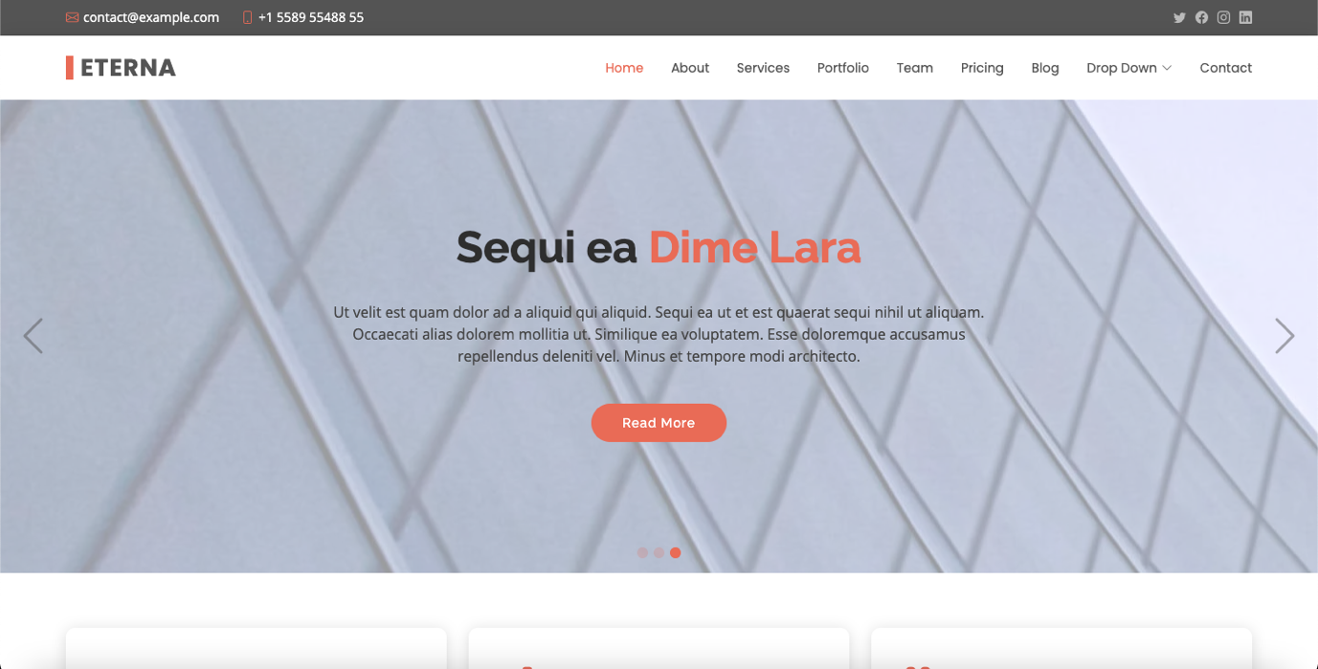

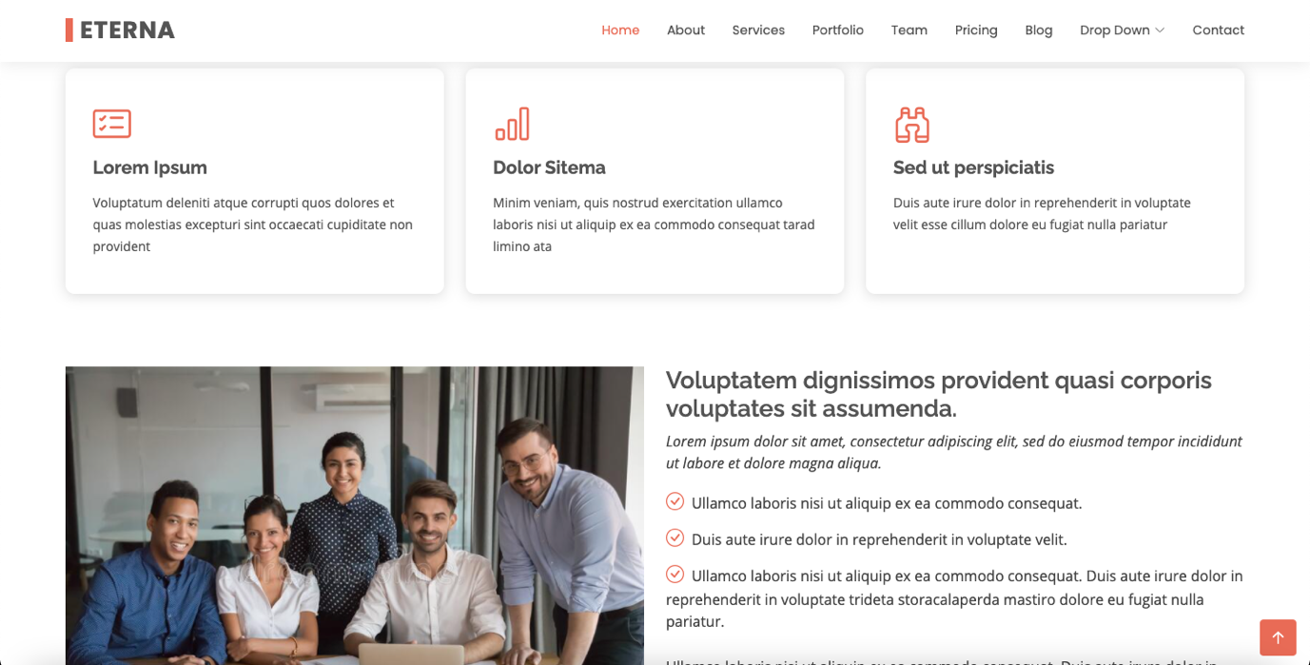

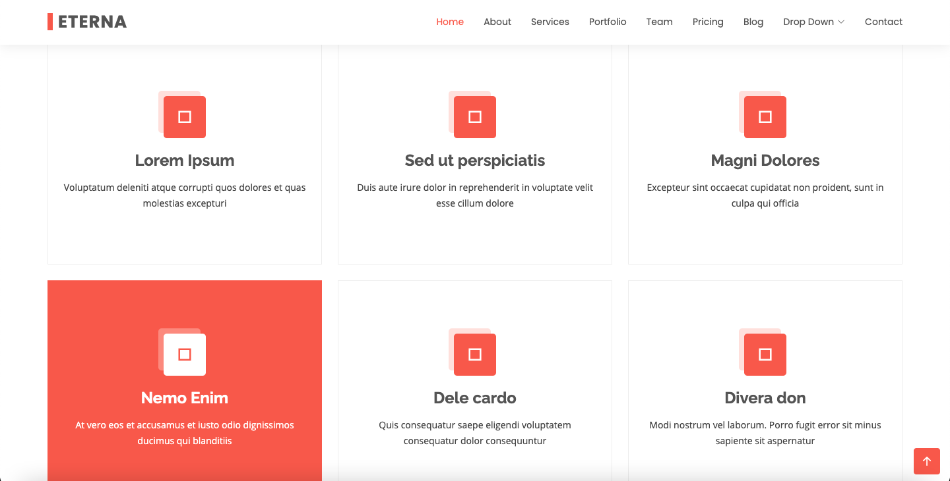

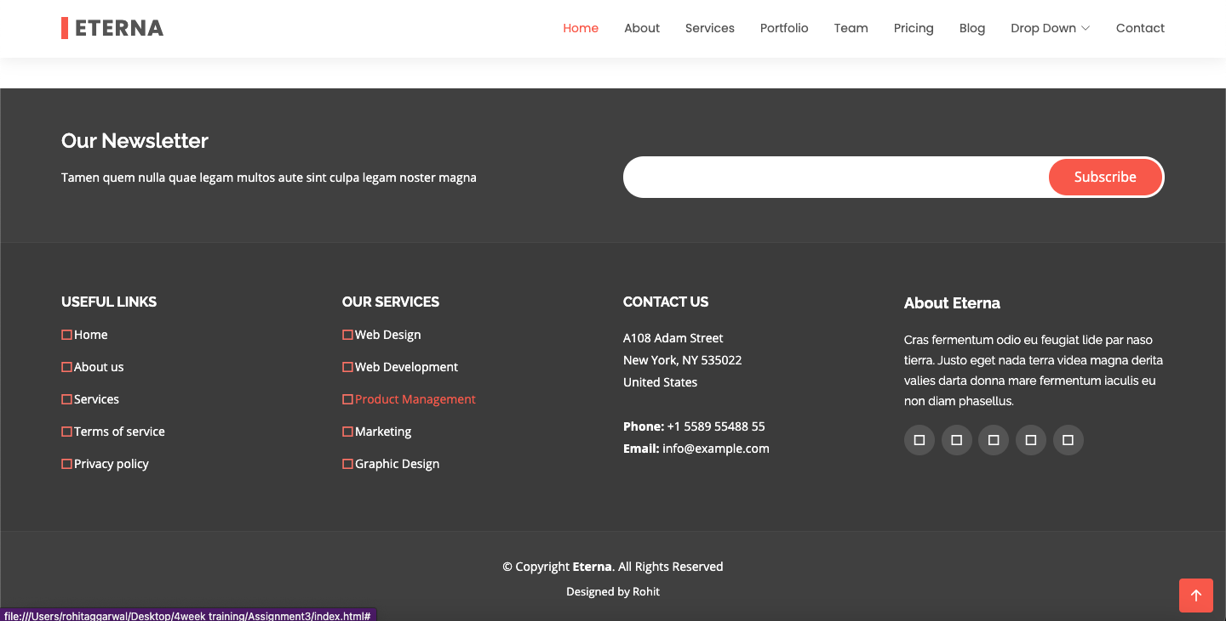

**Practical 4.1**

**Implement the design (weekly assignment 3, first layout) using Bootstrap.**

**index.html**

<!doctype html>

<html lang="en">

<head>

<meta charset="utf-8">

<meta http-equiv="X-UA-Compatible" content="IE=edge">

<meta name="viewport" content="width=device-width, initial-scale=1">

<!-- The above 3 meta tags *must* come first in the head; any other head content must come *after* these tags -->

<title>Home</title>

<link rel="stylesheet" type="text/css" href="../css/style.css">

<!-- font -->

<link rel="preconnect" href="https://fonts.googleapis.com">

<link rel="preconnect" href="https://fonts.gstatic.com" crossorigin>

<link href="https://fonts.googleapis.com/css2?family=Open+Sans&display=swap" rel="stylesheet">

<!-- icon -->

<link href = "https://fonts.googleapis.com/icon?family=Material+Icons" rel = "stylesheet">

<!-- slider -->

<link rel="stylesheet" href="../css/slider.css" type="text/css" media="screen" />

<!-- image galley -->

<link rel="stylesheet" type="text/css" href="../css/lightbox.min.css">

<!-- Bootstrap -->

<link rel="stylesheet" href="https://stackpath.bootstrapcdn.com/bootstrap/3.4.1/css/bootstrap.min.css" integrity="sha384-HSMxcRTRxnN+Bdg0JdbxYKrThecOKuH5zCYotlSAcp1+c8xmyTe9GYg1l9a69psu" crossorigin="anonymous">

<!-- HTML5 shim and Respond.js for IE8 support of HTML5 elements and media queries -->

<!-- WARNING: Respond.js doesn't work if you view the page via file:// -->

<!--[if lt IE 9]>

<script src="https://oss.maxcdn.com/html5shiv/3.7.3/html5shiv.min.js"></script>

<script src="https://oss.maxcdn.com/respond/1.4.2/respond.min.js"></script>

<![endif]-->

</head>

<body>

<div class="header">

<i class = "material-icons">public</i>

Email-abc@xyz.com<br> Call-123112

</div>

<nav class="navbar navbar-inverse">

<div class="container-fluid">

<!-- Brand and toggle get grouped for better mobile display -->

<div class="navbar-header">

<button type="button" class="navbar-toggle collapsed" data-toggle="collapse" data-target="#bs-example-navbar-collapse-1" aria-expanded="false">

<span class="sr-only">Toggle navigation</span>

<span class="icon-bar"></span>

<span class="icon-bar"></span>

<span class="icon-bar"></span>

</button>

<a class="navbar-brand" href="#">Brand</a>

</div>

<!-- Collect the nav links, forms, and other content for toggling -->

<div class="collapse navbar-collapse" id="bs-example-navbar-collapse-1">

<ul class="nav navbar-nav">

<li class="active"><a href="#">Link <span class="sr-only">(current)</span></a></li>

<li><a href="#">Link</a></li>

<li class="dropdown">

<a href="#" class="dropdown-toggle" data-toggle="dropdown" role="button" aria-haspopup="true" aria-expanded="false">Dropdown <span class="caret"></span></a>

<ul class="dropdown-menu">

<li><a href="#">Action</a></li>

<li><a href="#">Another action</a></li>

<li><a href="#">Something else here</a></li>

<li role="separator" class="divider"></li>

<li><a href="#">Separated link</a></li>

<li role="separator" class="divider"></li>

<li><a href="#">One more separated link</a></li>

</ul>

</li>

</ul>

<form class="navbar-form navbar-left">

<div class="form-group">

<input type="text" class="form-control" placeholder="Search">

</div>

<button type="submit" class="btn btn-default">Submit</button>

</form>

<ul class="nav navbar-nav navbar-right">

<li><a href="#">Link</a></li>

<li class="dropdown">

<a href="#" class="dropdown-toggle" data-toggle="dropdown" role="button" aria-haspopup="true" aria-expanded="false">Dropdown <span class="caret"></span></a>

<ul class="dropdown-menu">

<li><a href="#">Action</a></li>

<li><a href="#">Another action</a></li>

<li><a href="#">Something else here</a></li>

<li role="separator" class="divider"></li>

<li><a href="#">Separated link</a></li>

</ul>

</li>

</ul>

</div><!-- /.navbar-collapse -->

</div><!-- /.container-fluid -->

</nav>

<div class="h">

Lorem ipsum dolor, sit amet, consectetur adipisicing elit. Corrupti officiis necessitatibus recusandae sequi ab incidunt neque nemo fugiat, laudantium sit asperiores, reiciendis consequatur assumenda exercitationem nostrum odit. Laudantium corrupti, nulla.<br>

<br><br><br>

<a href="tel:123112">Call us</a><br><br>

<a href="mailto:123112">Email us</a>

</div>

<div>

<table>

<tr>

<td><img src="https://encrypted-tbn0.gstatic.com/images?q=tbn:ANd9GcRH1kzCIvgCKQy7lQB8W99K5NHJ61quuqnPZw&usqp=CAU"></td>

<td>Lorem ipsum dolor, sit amet consectetur, adipisicing elit. Ullam, quos. Earum temporibus minus architecto officia nostrum accusamus veritatis quasi sed nam dicta enim corrupti necessitatibus voluptatem, iusto, aspernatur minima commodi.</td>

</tr>

<tr>

<td>Lorem ipsum dolor sit amet consectetur adipisicing, elit. Eum, necessitatibus. Veniam repellendus impedit facere provident vitae iste, eveniet quos nulla facilis eius ex atque dignissimos. Magnam quis doloribus voluptate, architecto.</td>

<td>

<style>

.fadein { position:relative; height:300px; width:500px; }

.fadein img { position:absolute; left:0; top:0; }

</style>

<script type="text/javascript" src="http://www.hscripts.com/jquery.js"></script>

<script type="text/javascript">

$(function(){

$('.fadein img:gt(0)').hide();

setInterval(function(){$('.fadein :first-child').fadeOut().next('img').fadeIn().end().appendTo('.fadein');}, 2000);

});

</script>

<div class="fadein">

<img src="https://cdn.vox-cdn.com/thumbor/Ohs67lw4c_o3gsdWjwgRCmWdm6U=/1400x788/filters:format(jpeg)/cdn.vox-cdn.com/uploads/chorus_asset/file/13074037/hs-2014-27-a-print.0.0.1486275780.jpg" alt="Image Slideshow Script">

<img src="https://static.theprint.in/wp-content/uploads/2020/03/minor-planets.jpg" alt="Image Slideshow Script">

<img src="https://encrypted-tbn0.gstatic.com/images?q=tbn:ANd9GcTtiVrERaLq5dpJ14TbtTVEmaisX9gFUk8hhg&usqp=CAU" alt="Image Slideshow Script">

</div>

</td>

</tr>

</table>

</div>

<div>

<div class="slideshow-container">

<div class="mySlides">

<q>I love you the more in that I believe you had liked me for my own sake and for nothing else</q>

<p class="author">- John Keats</p>

</div>

<div class="mySlides">

<q>But man is not made for defeat. A man can be destroyed but not defeated.</q>

<p class="author">- Ernest Hemingway</p>

</div>

<div class="mySlides">

<q>I have not failed. I've just found 10,000 ways that won't work.</q>

<p class="author">- Thomas A. Edison</p>

</div>

<a class="prev" onclick="plusSlides(-1)">❮</a>

<a class="next" onclick="plusSlides(1)">❯</a>

</div>

<div class="dot-container">

<span class="dot" onclick="currentSlide(1)"></span>

<span class="dot" onclick="currentSlide(2)"></span>

<span class="dot" onclick="currentSlide(3)"></span>

</div>

<script>

var slideIndex = 1;

showSlides(slideIndex);

function plusSlides(n) {

showSlides(slideIndex += n);

}

function currentSlide(n) {

showSlides(slideIndex = n);

}

function showSlides(n) {

var i;

var slides = document.getElementsByClassName("mySlides");

var dots = document.getElementsByClassName("dot");

if (n > slides.length) {slideIndex = 1}

if (n < 1) {slideIndex = slides.length}

for (i = 0; i < slides.length; i++) {

slides[i].style.display = "none";

}

for (i = 0; i < dots.length; i++) {

dots[i].className = dots[i].className.replace(" active", "");

}

slides[slideIndex-1].style.display = "block";

dots[slideIndex-1].className += " active";

}

</script>

</div>

<div class="gallery">

<strong>Image Gallery</strong>

<div>

<a class="example-image-link" href="https://africanews.space/wp-content/uploads/2021/01/space-debris-junk-africa-cleanup.jpg" data-lightbox="example-set"><img class="example-image" src="https://africanews.space/wp-content/uploads/2021/01/space-debris-junk-africa-cleanup.jpg" alt=""/></a>

<a class="example-image-link" href="https://static.independent.co.uk/2021/06/04/10/DESY_GRB_still_1.jpeg?width=1200" data-lightbox="example-set"><img class="example-image" src="https://static.independent.co.uk/2021/06/04/10/DESY_GRB_still_1.jpeg?width=1200" alt="" /></a>

<a class="example-image-link" href="https://thumbs-prod.si-cdn.com/5IC2_-4TL008uHd3srmFFYh_LwU=/800x450/filters:focal(2989x1536:2990x1537)/https://public-media.si-cdn.com/filer/35/3b/353b17c0-cd7b-4625-9f97-f3c3ef59055e/gettyimages-1229960181.jpg" data-lightbox="example-set" ><img class="example-image" src="https://thumbs-prod.si-cdn.com/5IC2_-4TL008uHd3srmFFYh_LwU=/800x450/filters:focal(2989x1536:2990x1537)/https://public-media.si-cdn.com/filer/35/3b/353b17c0-cd7b-4625-9f97-f3c3ef59055e/gettyimages-1229960181.jpg" alt="" /></a>

<a class="example-image-link" href="https://encrypted-tbn0.gstatic.com/images?q=tbn:ANd9GcTna_QMTdrKfaibyBB8CeN2vQ4H6Iq4kU2RHg&usqp=CAU" data-lightbox="example-set"><img class="example-image" src="https://encrypted-tbn0.gstatic.com/images?q=tbn:ANd9GcTna_QMTdrKfaibyBB8CeN2vQ4H6Iq4kU2RHg&usqp=CAU" alt="" /></a>

<a class="example-image-link" href="https://cdn.mos.cms.futurecdn.net/Gw9wVjyJYuLAuaeM6z4n6W-1200-80.jpg" data-lightbox="example-set"><img class="example-image" src="https://cdn.mos.cms.futurecdn.net/Gw9wVjyJYuLAuaeM6z4n6W-1200-80.jpg" alt="" /></a>

<a class="example-image-link" href="https://images.ctfassets.net/cnu0m8re1exe/2DYsgTu86tZd9Yh3CfwToQ/971c67e0330015b3fd371a2f1767311b/heic0301a.jpg?fm=jpg&fl=progressive&w=660&h=433&fit=fill" data-lightbox="example-set"><img class="example-image" src="https://images.ctfassets.net/cnu0m8re1exe/2DYsgTu86tZd9Yh3CfwToQ/971c67e0330015b3fd371a2f1767311b/heic0301a.jpg?fm=jpg&fl=progressive&w=660&h=433&fit=fill" alt="" /></a>

</div>

<script src="../js/lightbox-plus-jquery.min.js"></script>

</div>

<div class="footer">

<hr>

<div class="divf">

<div class="f">

<h2>Explore</h2>

<a href="">Home</a><br>

<a href="">About Us</a><br>

<a href="">Contact Us</a>

</div>

<div class="f">

<h2>Visit</h2>

Address-#abc,st.-4,qaz<br>

Email-abc@xyz.com<br>

Phone no.-123112

</div>

<div class="f">

<h2>Follow</h2>

<a href="">Twitter</a><br>

<a href="">Instagram</a><br>

<a href="">Linkedin</a>

</div>

<div class="f">

<h2>Legal</h2>

<a href="">Terms</a><br>

<a href="">Policies</a><br><br><br>

</div>

</div>

<hr>

<i class="material-icons">copyright</i>2021 Rohit. All Rights Reserved.

</div>

<!-- jQuery (necessary for Bootstrap's JavaScript plugins) -->

<script src="https://code.jquery.com/jquery-1.12.4.min.js" integrity="sha384-nvAa0+6Qg9clwYCGGPpDQLVpLNn0fRaROjHqs13t4Ggj3Ez50XnGQqc/r8MhnRDZ" crossorigin="anonymous"></script>

<!-- Include all compiled plugins (below), or include individual files as needed -->

<script src="https://stackpath.bootstrapcdn.com/bootstrap/3.4.1/js/bootstrap.min.js" integrity="sha384-aJ21OjlMXNL5UyIl/XNwTMqvzeRMZH2w8c5cRVpzpU8Y5bApTppSuUkhZXN0VxHd" crossorigin="anonymous"></script>

</body>

</html>

**style.css**

body{

font-family: 'Open Sans', sans-serif;

}

/* header */

.header{

padding: 10px;

background-color: #5A37A6;

color: white;

display: flex;

justify-content: space-between;

}

/* Navbar */

.navbar {

overflow: hidden;

background-color: #121926;

}

.navbar a {

float: left;

font-size: 16px;

color: white;

text-align: center;

padding: 14px 16px;

text-decoration: none;

}

.dropdown {

float: left;

overflow: hidden;

}

.dropdown .dropbtn {

font-size: 16px;

border: none;

outline: none;

color: white;

padding: 14px 16px;

background-color: inherit;

margin: 0;

}

.navbar a:hover, .dropdown:hover .dropbtn {

background-color: #0D0D0D;

}

.dropdown-content {

display: none;

position: absolute;

background-color: #f9f9f9;

min-width: 160px;

box-shadow: 0px 8px 16px 0px rgba(0,0,0,0.2);

z-index: 1;

}

.dropdown-content a {

float: none;

color: black;

padding: 12px 16px;

text-decoration: none;

display: block;

text-align: left;

}

.dropdown-content a:hover {

background-color: #ddd;

}

.dropdown:hover .dropdown-content {

display: block;

}

/* header2 */

.h{

height: 200px;

background-image: url(https://image.shutterstock.com/image-photo/full-panorama-milky-way-260nw-151365275.jpg);

color: white;

padding: 30;

font-size: 20;

}

.h a{

text-decoration: none;

color: white;

}

.h a:hover{

background-color: #777E8C;

padding: 5px;]

}

table{

margin:20px auto;

width: 80%;

font-size: 23px;

}

table td {

width: 40%;

padding: 20px;

vertical-align: top;

}

table img{

width: 500px;

height: 300px;

}

.gallery{

background-color: #5A37A6;

color: white;

text-align: center;

font-size: 25px;

padding-top: 10;

}

.gallery img{

height: 300px;

width: 470px;

}

.footer{

background-color: #0D0D0D;

color: white;

padding: 30px;

}

.divf{

width: 100%;

}

.f{

width: 25%;

float: left;

}

.f a{

text-decoration: none;

color: white;

}

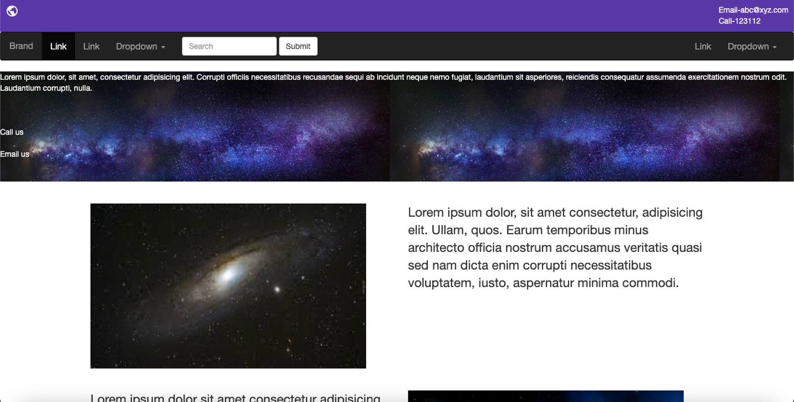

**Practical 4.2(a)**

**Design a Form using the concept of Bootstrap.**

**form.html**

<!DOCTYPE html>

<html lang="en">

<head>

<meta charset="UTF-8">

<meta name="viewport" content="width=device-width, initial-scale=1.0">

<title>form</title>

<link rel="stylesheet" type="text/css" href="style.css">

<link rel="stylesheet" type="text/css" href="https://maxcdn.bootstrapcdn.com/bootstrap/4.0.0/css/bootstrap.min.css">

<link rel="stylesheet" type="text/css" href="https://stackpath.bootstrapcdn.com/bootstrap/4.0.0/js/bootstrap.bundle.min.js">

<link rel="stylesheet" type="text/css" href="https://use.fontawesome.com/releases/v5.8.1/css/all.css">

<link rel="stylesheet" type="text/css" href="https://cdnjs.cloudflare.com/ajax/libs/jquery/3.2.1/jquery.min.js">

</head>

<body>

<div class="container">

<div class="row">

<div class="col-md-6">

<div class="card">

<form onsubmit="event.preventDefault()" class="box">

<h1>Login</h1>

<p class="text-muted"> Please enter your login and password!</p> <input type="text" name="" placeholder="Username"> <input type="password" name="" placeholder="Password"> <a class="forgot text-muted" href="#">Forgot password?</a> <input type="submit" name="" value="Login" href="#">

<div class="col-md-12">

<ul class="social-network social-circle">

<li><a href="#" class="icoFacebook" title="Facebook"><i class="fab fa-facebook-f"></i></a></li>

<li><a href="#" class="icoTwitter" title="Twitter"><i class="fab fa-twitter"></i></a></li>

<li><a href="#" class="icoGoogle" title="Google +"><i class="fab fa-google-plus"></i></a></li>

</ul>

</div>

</form>

</div>

</div>

</div>

</div>

</body>

</html>

**style.css**

body {

margin: 0;

padding: 0;

font-family: sans-serif;

background: linear-gradient(to right, #b92b27, #1565c0)

}

.card {

margin-bottom: 20px;

border: none

}

.box {

width: 500px;

padding: 40px;

position: absolute;

top: 50%;

left: 50%;

background: #191919;

;

text-align: center;

transition: 0.25s;

margin-top: 100px

}

.box input[type="text"],

.box input[type="password"] {

border: 0;

background: none;

display: block;

margin: 20px auto;

text-align: center;

border: 2px solid #3498db;

padding: 10px 10px;

width: 250px;

outline: none;

color: white;

border-radius: 24px;

transition: 0.25s

}

.box h1 {

color: white;

text-transform: uppercase;

font-weight: 500

}

.box input[type="text"]:focus,

.box input[type="password"]:focus {

width: 300px;

border-color: #2ecc71

}

.box input[type="submit"] {

border: 0;

background: none;

display: block;

margin: 20px auto;

text-align: center;

border: 2px solid #2ecc71;

padding: 14px 40px;

outline: none;

color: white;

border-radius: 24px;

transition: 0.25s;

cursor: pointer

}

.box input[type="submit"]:hover {

background: #2ecc71

}

.forgot {

text-decoration: underline

}

ul.social-network {

list-style: none;

display: inline;

margin-left: 0 !important;

padding: 0

}

ul.social-network li {

display: inline;

margin: 0 5px

}

.social-network a.icoFacebook:hover {

background-color: #3B5998

}

.social-network a.icoTwitter:hover {

background-color: #33ccff

}

.social-network a.icoGoogle:hover {

background-color: #BD3518

}

.social-network a.icoFacebook:hover i,

.social-network a.icoTwitter:hover i,

.social-network a.icoGoogle:hover i {

color: #fff

}

a.socialIcon:hover,

.socialHoverClass {

color: #44BCDD

}

.social-circle li a {

display: inline-block;

position: relative;

margin: 0 auto 0 auto;

border-radius: 50%;

text-align: center;

width: 50px;

height: 50px;

font-size: 20px

}

.social-circle li i {

margin: 0;

line-height: 50px;

text-align: center

}

.social-circle li a:hover i,

.triggeredHover {

transform: rotate(360deg);

transition: all 0.2s

}

.social-circle i {

color: #fff;

transition: all 0.8s;

transition: all 0.8s

}

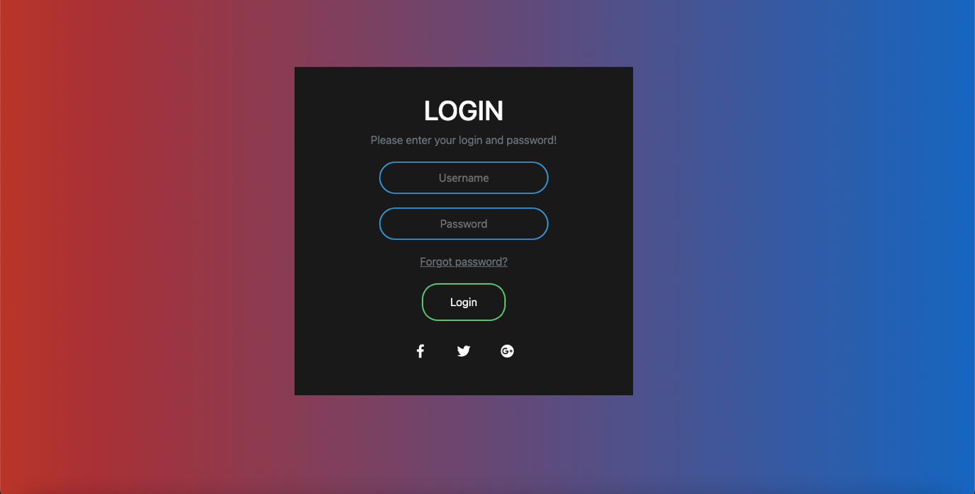

**Practical 4.2(b)**

**Apply validations (HTML5) on the Form designed in 4.2(a)**

**new.html**

<!DOCTYPE html>

<html lang="en">

<head>

<meta charset="UTF-8">

<meta name="viewport" content="width=device-width, initial-scale=1.0">

<title>form</title>

<link rel="stylesheet" type="text/css" href="style.css">

<link rel="stylesheet" type="text/css" href="https://maxcdn.bootstrapcdn.com/bootstrap/4.0.0/css/bootstrap.min.css">

<link rel="stylesheet" type="text/css" href="https://stackpath.bootstrapcdn.com/bootstrap/4.0.0/js/bootstrap.bundle.min.js">

<link rel="stylesheet" type="text/css" href="https://use.fontawesome.com/releases/v5.8.1/css/all.css">

<link rel="stylesheet" type="text/css" href="https://cdnjs.cloudflare.com/ajax/libs/jquery/3.2.1/jquery.min.js">

</head>

<body>

<div class="container">

<div class="row">

<div class="col-md-6">

<div class="card">

<form onsubmit="event.preventDefault()" class="box">

<h1>Login</h1>

<p class="text-muted"> Please enter your login and password!</p> <input type="text" name="" placeholder="Username"> <input type="password" name="" placeholder="Password"> <a class="forgot text-muted" href="#">Forgot password?</a> <input type="submit" name="" value="Login" href="#">

<p>

<label for="n1">How old are you?</label>

<!-- The pattern attribute can act as a fallback for browsers which

don't implement the number input type but support the pattern attribute.

Please note that browsers that support the pattern attribute will make it

fail silently when used with a number field.

Its usage here acts only as a fallback -->

<input type="number" min="12" max="120" step="1" id="n1" name="age"

pattern="\d+">

</p>

<p>

<label for="t1">Whom are you looking for?<abbr title="This field is mandatory" aria-label="required">*</abbr></label>

<input type="text" id="t1" name="fruit" list="l1" required

pattern="[Bb]oys|[Gg]irls">

<datalist id="l1">

<option>Boys</option>

<option>Girls</option>

</datalist>

</p>

<div class="col-md-12">

<ul class="social-network social-circle">

<li><a href="#" class="icoFacebook" title="Facebook"><i class="fab fa-facebook-f"></i></a></li>

<li><a href="#" class="icoTwitter" title="Twitter"><i class="fab fa-twitter"></i></a></li>

<li><a href="#" class="icoGoogle" title="Google +"><i class="fab fa-google-plus"></i></a></li>

</ul>

</div>

</form>

</div>

</div>

</div>

</div>

<script src="https://code.jquery.com/jquery-1.12.4.min.js" integrity="sha384-nvAa0+6Qg9clwYCGGPpDQLVpLNn0fRaROjHqs13t4Ggj3Ez50XnGQqc/r8MhnRDZ" crossorigin="anonymous"></script>

<!-- Include all compiled plugins (below), or include individual files as needed -->

<script src="https://stackpath.bootstrapcdn.com/bootstrap/3.4.1/js/bootstrap.min.js" integrity="sha384-aJ21OjlMXNL5UyIl/XNwTMqvzeRMZH2w8c5cRVpzpU8Y5bApTppSuUkhZXN0VxHd" crossorigin="anonymous"></script>

</body>

</html>

</body>

</html>

**style.css**

body {

margin: 0;

padding: 0;

font-family: sans-serif;

background: linear-gradient(to right, #00CED1, #CD5C5C)

}

.card {

margin-bottom: 20px;

border: none

}

.box {

width: 500px;

padding: 40px;

position: absolute;

top: 50%;

left: 50%;

background: #2F4F4F;

;

text-align: center;

transition: 0.25s;

margin-top: 100px

}

.box input[type="text"],

.box input[type="password"] {

border: 0;

background: none;

display: block;

margin: 20px auto;

text-align: center;

border: 2px solid #3498db;

padding: 10px 10px;

width: 250px;

outline: none;

color: white;

border-radius: 24px;

transition: 0.25s

}

.box h1 {

color: white;

text-transform: uppercase;

font-weight: 500

}

.box input[type="text"]:focus,

.box input[type="password"]:focus {

width: 300px;

border-color: #2ecc71

}

.box input[type="submit"] {

border: 0;

background: none;

display: block;

margin: 20px auto;

text-align: center;

border: 2px solid #2ecc71;

padding: 14px 40px;

outline: none;

color: white;

border-radius: 24px;

transition: 0.25s;

cursor: pointer

}

.box input[type="submit"]:hover {

background: #2ecc71

}

.forgot {

text-decoration: underline

}

ul.social-network {

list-style: none;

display: inline;

margin-left: 0 !important;

padding: 0

}

ul.social-network li {

display: inline;

margin: 0 5px

}

.social-network a.icoFacebook:hover {

background-color: #3B5998

}

.social-network a.icoTwitter:hover {

background-color: #33ccff

}

.social-network a.icoGoogle:hover {

background-color: #BD3518

}

.social-network a.icoFacebook:hover i,

.social-network a.icoTwitter:hover i,

.social-network a.icoGoogle:hover i {

color: #fff

}

a.socialIcon:hover,

.socialHoverClass {

color: #44BCDD

}

.social-circle li a {

display: inline-block;

position: relative;

margin: 0 auto 0 auto;

border-radius: 50%;

text-align: center;

width: 50px;

height: 50px;

font-size: 20px

}

.social-circle li i {

margin: 0;

line-height: 50px;

text-align: center

}

.social-circle li a:hover i,

.triggeredHover {

transform: rotate(360deg);

transition: all 0.2s

}

.social-circle i {

color: #fff;

transition: all 0.8s;

transition: all 0.8s

}

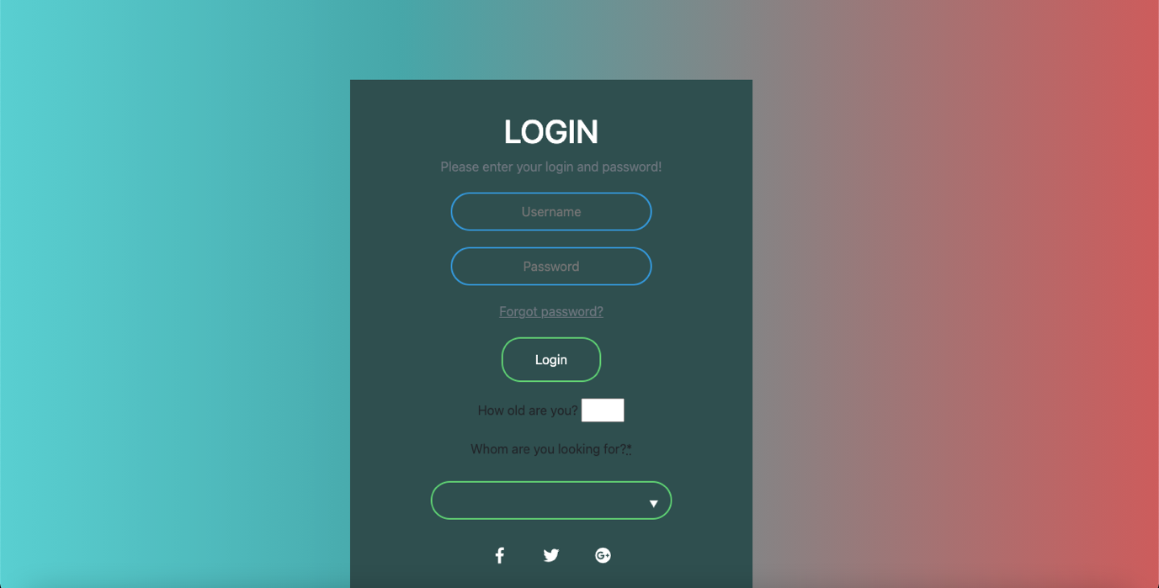

**Practical 4.4(a)**

**Implementation of Modal, Scrollspy and Tabs in Bootstrap.**

**index.html**

<!doctype html>

<html lang="en">

<head>

<meta charset="utf-8">

<meta http-equiv="X-UA-Compatible" content="IE=edge">

<meta name="viewport" content="width=device-width, initial-scale=1">

<!-- The above 3 meta tags *must* come first in the head; any other head content must come *after* these tags -->

<title>Bootstrap 101 Template</title>

<!-- Bootstrap -->

<link rel="stylesheet" href="https://stackpath.bootstrapcdn.com/bootstrap/3.4.1/css/bootstrap.min.css" integrity="sha384-HSMxcRTRxnN+Bdg0JdbxYKrThecOKuH5zCYotlSAcp1+c8xmyTe9GYg1l9a69psu" crossorigin="anonymous">

<!-- HTML5 shim and Respond.js for IE8 support of HTML5 elements and media queries -->

<!-- WARNING: Respond.js doesn't work if you view the page via file:// -->

<!--[if lt IE 9]>

<script src="https://oss.maxcdn.com/html5shiv/3.7.3/html5shiv.min.js"></script>

<script src="https://oss.maxcdn.com/respond/1.4.2/respond.min.js"></script>

<![endif]-->

</head>

<body>

<h3>Modal Examples</h3>

<!-- Button trigger modal -->

<button type="button" class="btn btn-primary btn-lg" data-toggle="modal" data-target="#myModal">

Launch demo modal

</button>

<!-- Modal -->

<div class="modal fade" id="myModal" tabindex="-1" role="dialog" aria-labelledby="myModalLabel">

<div class="modal-dialog" role="document">

<div class="modal-content">

<div class="modal-header">

<button type="button" class="close" data-dismiss="modal" aria-label="Close"><span aria-hidden="true">&times;</span></button>

<h4 class="modal-title" id="myModalLabel">Modal title</h4>

</div>

<div class="modal-body">

...

</div>

<div class="modal-footer">

<button type="button" class="btn btn-default" data-dismiss="modal">Close</button>

<button type="button" class="btn btn-primary">Save changes</button>

</div>

</div>

</div>

</div>

<h3>Optional Sizes</h3>

<!-- Large modal -->

<button type="button" class="btn btn-primary" data-toggle="modal" data-target=".bs-example-modal-lg">Large modal</button>

<div class="modal fade" tabindex="-1" role="dialog" aria-labelledby="myLargeModalLabel">

<div class="modal-dialog modal-lg" role="document">

<div class="modal-content">

...

</div>

</div>

</div>

<!-- Small modal -->

<button type="button" class="btn btn-primary" data-toggle="modal" data-target=".bs-example-modal-sm">Small modal</button>

<div class="modal fade" tabindex="-1" role="dialog" aria-labelledby="mySmallModalLabel">

<div class="modal-dialog modal-sm" role="document">

<div class="modal-content">

...

</div>

</div>

</div>

<h3>Varying modal content based on trigger button</h3>

<button type="button" class="btn btn-primary" data-toggle="modal" data-target="#exampleModal" data-whatever="@mdo">Open modal for @mdo</button>

<button type="button" class="btn btn-primary" data-toggle="modal" data-target="#exampleModal" data-whatever="@fat">Open modal for @fat</button>

<button type="button" class="btn btn-primary" data-toggle="modal" data-target="#exampleModal" data-whatever="@getbootstrap">Open modal for @getbootstrap</button>

...more buttons...

<div class="modal fade" id="exampleModal" tabindex="-1" role="dialog" aria-labelledby="exampleModalLabel">

<div class="modal-dialog" role="document">

<div class="modal-content">

<div class="modal-header">

<button type="button" class="close" data-dismiss="modal" aria-label="Close"><span aria-hidden="true">&times;</span></button>

<h4 class="modal-title" id="exampleModalLabel">New message</h4>

</div>

<div class="modal-body">

<form>

<div class="form-group">

<label for="recipient-name" class="control-label">Recipient:</label>

<input type="text" class="form-control" id="recipient-name">

</div>

<div class="form-group">

<label for="message-text" class="control-label">Message:</label>

<textarea class="form-control" id="message-text"></textarea>

</div>

</form>

</div>

<div class="modal-footer">

<button type="button" class="btn btn-default" data-dismiss="modal">Close</button>

<button type="button" class="btn btn-primary">Send message</button>

</div>

</div>

</div>

</div>

<h2>Scrollspy</h2>

<body data-spy="scroll" data-target="#navbar-example">

home

<div id="navbar-example">

<ul class="nav nav-tabs" role="tablist">

</ul>

</div>

Lorem ipsum dolor sit amet consectetur adipisicing elit. Voluptatem, dolores. Lorem ipsum dolor sit amet consectetur adipisicing elit. Numquam excepturi obcaecati atque sapiente magni voluptates quos, placeat, maiores quis, eius repudiandae fuga nemo debitis commodi voluptatem autem aliquam officia tempore. Lorem ipsum dolor sit amet consectetur adipisicing elit. Consectetur eligendi fuga deserunt optio harum repellat ab enim. Tenetur velit voluptas non harum ratione vel sunt, itaque optio, delectus nostrum! Quia. Lorem ipsum dolor sit, amet consectetur adipisicing elit. Explicabo eveniet recusandae blanditiis sapiente omnis illo, vero beatae, quibusdam, architecto obcaecati eius hic, voluptatum quam magni soluta consequatur. Molestias, voluptate, dolores. lorem

<h2>Tabs</h2>

<div>

<!-- Nav tabs -->

<ul class="nav nav-tabs" role="tablist">

<li role="presentation" class="active"><a href="#home" aria-controls="home" role="tab" data-toggle="tab">Home</a></li>

<li role="presentation"><a href="#profile" aria-controls="profile" role="tab" data-toggle="tab">Profile</a></li>

<li role="presentation"><a href="#messages" aria-controls="messages" role="tab" data-toggle="tab">Messages</a></li>

<li role="presentation"><a href="#settings" aria-controls="settings" role="tab" data-toggle="tab">Settings</a></li>

</ul>

<!-- Tab panes -->

<div class="tab-content">

<div role="tabpanel" class="tab-pane active" id="home">Lorem ipsum, dolor sit amet consectetur adipisicing elit. Animi, reiciendis.</div>

<div role="tabpanel" class="tab-pane" id="profile">Lorem ipsum, dolor sit amet consectetur adipisicing elit. Exercitationem debitis ullam quis doloremque impedit qui.</div>

<div role="tabpanel" class="tab-pane" id="messages">Lorem ipsum dolor sit amet consectetur adipisicing elit. Sed atque commodi voluptas quibusdam. Iure numquam ab ea. Similique, quisquam, debitis.</div>

<div role="tabpanel" class="tab-pane" id="settings">Lorem ipsum dolor sit amet consectetur adipisicing elit. Officiis, dolore?</div>

</div>

</div>

</body>

<!-- jQuery (necessary for Bootstrap's JavaScript plugins) -->

<script src="https://code.jquery.com/jquery-1.12.4.min.js" integrity="sha384-nvAa0+6Qg9clwYCGGPpDQLVpLNn0fRaROjHqs13t4Ggj3Ez50XnGQqc/r8MhnRDZ" crossorigin="anonymous"></script>

<!-- Include all compiled plugins (below), or include individual files as needed -->

<script src="https://stackpath.bootstrapcdn.com/bootstrap/3.4.1/js/bootstrap.min.js" integrity="sha384-aJ21OjlMXNL5UyIl/XNwTMqvzeRMZH2w8c5cRVpzpU8Y5bApTppSuUkhZXN0VxHd" crossorigin="anonymous"></script>

<script type="text/javascript">$('[data-spy="scroll"]').each(function () {

var $spy = $(this).scrollspy('refresh')

})</script>

</body>

</html>

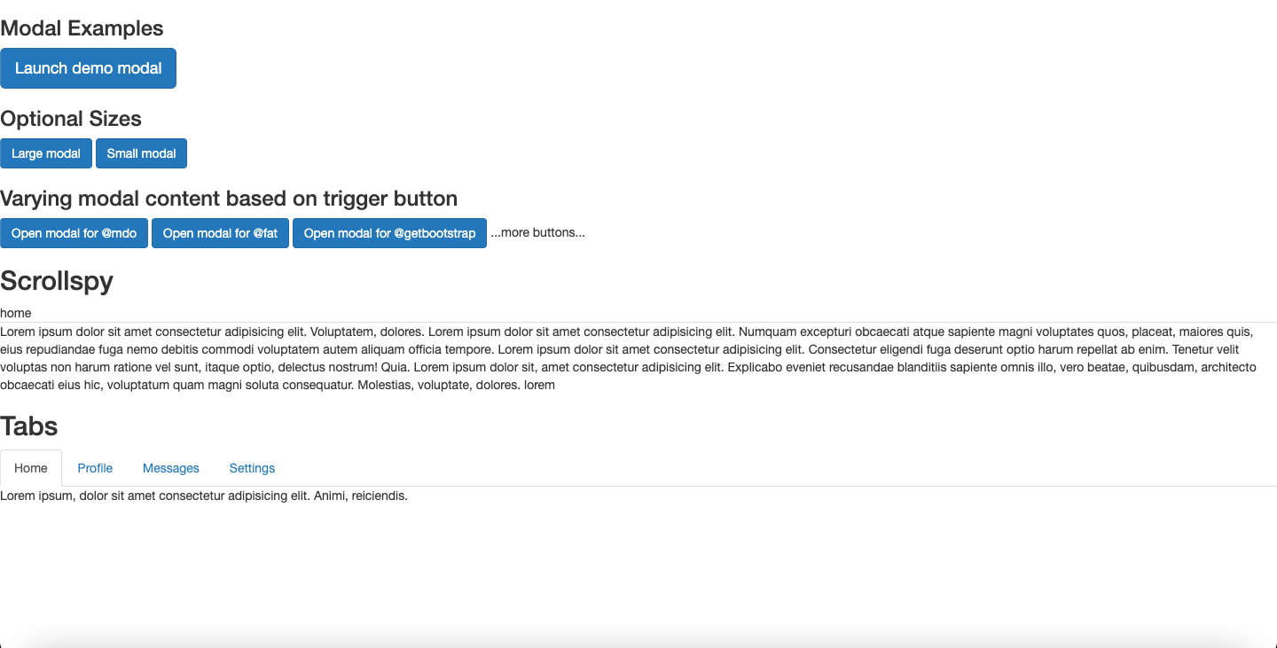

**Practical 4.4(b)**

**Implement the concept of Tooltip, Popover, Alert, Button, Collapse and Carousel using Bootstrap.**

**index.html**

<!doctype html>

<html lang="en">

<head>

<meta charset="utf-8">

<meta http-equiv="X-UA-Compatible" content="IE=edge">

<meta name="viewport" content="width=device-width, initial-scale=1">

<!-- The above 3 meta tags *must* come first in the head; any other head content must come *after* these tags -->

<title>Bootstrap 101 Template</title>

<!-- Bootstrap -->

<link rel="stylesheet" href="https://stackpath.bootstrapcdn.com/bootstrap/3.4.1/css/bootstrap.min.css" integrity="sha384-HSMxcRTRxnN+Bdg0JdbxYKrThecOKuH5zCYotlSAcp1+c8xmyTe9GYg1l9a69psu" crossorigin="anonymous">

<!-- HTML5 shim and Respond.js for IE8 support of HTML5 elements and media queries -->

<!-- WARNING: Respond.js doesn't work if you view the page via file:// -->

<!--[if lt IE 9]>

<script src="https://oss.maxcdn.com/html5shiv/3.7.3/html5shiv.min.js"></script>

<script src="https://oss.maxcdn.com/respond/1.4.2/respond.min.js"></script>

<![endif]-->

</head>

<body>

<h3>Tooltip</h3>

<button type="button" class="btn btn-default" data-toggle="tooltip" data-placement="left" title="Tooltip on left">Tooltip on left</button>

<button type="button" class="btn btn-default" data-toggle="tooltip" data-placement="top" title="Tooltip on top">Tooltip on top</button>

<button type="button" class="btn btn-default" data-toggle="tooltip" data-placement="bottom" title="Tooltip on bottom">Tooltip on bottom</button>

<button type="button" class="btn btn-default" data-toggle="tooltip" data-placement="right" title="Tooltip on right">Tooltip on right</button>

<h3>Popover</h3>

<button type="button" class="btn btn-lg btn-danger" data-toggle="popover" title="Popover title" data-content="And here's some amazing content. It's very engaging. Right?">Click to toggle popover</button>

<br>

<button type="button" class="btn btn-default" data-container="body" data-toggle="popover" data-placement="left" data-content="Vivamus sagittis lacus vel augue laoreet rutrum faucibus.">

Popover on left

</button>

<button type="button" class="btn btn-default" data-container="body" data-toggle="popover" data-placement="top" data-content="Vivamus sagittis lacus vel augue laoreet rutrum faucibus.">

Popover on top

</button>

<button type="button" class="btn btn-default" data-container="body" data-toggle="popover" data-placement="bottom" data-content="Vivamus

sagittis lacus vel augue laoreet rutrum faucibus.">

Popover on bottom

</button>

<button type="button" class="btn btn-default" data-container="body" data-toggle="popover" data-placement="right" data-content="Vivamus sagittis lacus vel augue laoreet rutrum faucibus.">

Popover on right

</button>

<h3>Dismissible Popover</h3>

<a tabindex="0" class="btn btn-lg btn-danger" role="button" data-toggle="popover" data-trigger="focus" title="Dismissible popover" data-content="And here's some amazing content. It's very engaging. Right?">Dismissible popover</a>

<h3>Buttons</h3>

<button type="button" id="myButton" data-loading-text="Loading..." class="btn btn-primary">

Loading state

</button>

<button type="button" class="btn btn-primary" data-toggle="button" aria-pressed="false">

Single toggle

</button>

<br>

<br>

<div class="btn-group" data-toggle="buttons">

<label class="btn btn-primary active">

<input type="checkbox" checked> Checkbox 1 (pre-checked)

</label>

<label class="btn btn-primary">

<input type="checkbox"> Checkbox 2

</label>

<label class="btn btn-primary">

<input type="checkbox"> Checkbox 3

</label>

</div>

<br>

<br>

<div class="btn-group" data-toggle="buttons">

<label class="btn btn-primary active">

<input type="radio" name="options" id="option1" checked> Radio 1 (preselected)

</label>

<label class="btn btn-primary">

<input type="radio" name="options" id="option2"> Radio 2

</label>

<label class="btn btn-primary">

<input type="radio" name="options" id="option3"> Radio 3

</label>

</div>

<h3>Collapse</h3>

<a class="btn btn-primary" role="button" data-toggle="collapse" href="#collapseExample" aria-expanded="false" aria-controls="collapseExample">

Link with href

</a>

<button class="btn btn-primary" type="button" data-toggle="collapse" data-target="#collapseExample" aria-expanded="false" aria-controls="collapseExample">

Button with data-target

</button>

<div class="collapse" id="collapseExample">

<div class="well">

...

</div>

</div>

<br>

<br>

<div class="panel-group" id="accordion" role="tablist" aria-multiselectable="true">

<div class="panel panel-default">

<div class="panel-heading" role="tab" id="headingOne">

<h4 class="panel-title">

<a role="button" data-toggle="collapse" data-parent="#accordion" href="#collapseOne" aria-expanded="true" aria-controls="collapseOne">

Collapsible Group Item #1

</a>

</h4>

</div>

<div id="collapseOne" class="panel-collapse collapse in" role="tabpanel" aria-labelledby="headingOne">

<div class="panel-body">

Anim pariatur cliche reprehenderit, enim eiusmod high life accusamus terry richardson ad squid. 3 wolf moon officia aute, non cupidatat skateboard dolor brunch. Food truck quinoa nesciunt laborum eiusmod. Brunch 3 wolf moon tempor, sunt aliqua put a bird on it squid single-origin coffee nulla assumenda shoreditch et. Nihil anim keffiyeh helvetica, craft beer labore wes anderson cred nesciunt sapiente ea proident. Ad vegan excepteur butcher vice lomo. Leggings occaecat craft beer farm-to-table, raw denim aesthetic synth nesciunt you probably haven't heard of them accusamus labore sustainable VHS.

</div>

</div>

</div>

<div class="panel panel-default">

<div class="panel-heading" role="tab" id="headingTwo">

<h4 class="panel-title">

<a class="collapsed" role="button" data-toggle="collapse" data-parent="#accordion" href="#collapseTwo" aria-expanded="false" aria-controls="collapseTwo">

Collapsible Group Item #2

</a>

</h4>

</div>

<div id="collapseTwo" class="panel-collapse collapse" role="tabpanel" aria-labelledby="headingTwo">

<div class="panel-body">

Anim pariatur cliche reprehenderit, enim eiusmod high life accusamus terry richardson ad squid. 3 wolf moon officia aute, non cupidatat skateboard dolor brunch. Food truck quinoa nesciunt laborum eiusmod. Brunch 3 wolf moon tempor, sunt aliqua put a bird on it squid single-origin coffee nulla assumenda shoreditch et. Nihil anim keffiyeh helvetica, craft beer labore wes anderson cred nesciunt sapiente ea proident. Ad vegan excepteur butcher vice lomo. Leggings occaecat craft beer farm-to-table, raw denim aesthetic synth nesciunt you probably haven't heard of them accusamus labore sustainable VHS.

</div>

</div>

</div>

<div class="panel panel-default">

<div class="panel-heading" role="tab" id="headingThree">

<h4 class="panel-title">

<a class="collapsed" role="button" data-toggle="collapse" data-parent="#accordion" href="#collapseThree" aria-expanded="false" aria-controls="collapseThree">

Collapsible Group Item #3

</a>

</h4>

</div>

<div id="collapseThree" class="panel-collapse collapse" role="tabpanel" aria-labelledby="headingThree">

<div class="panel-body">

Anim pariatur cliche reprehenderit, enim eiusmod high life accusamus terry richardson ad squid. 3 wolf moon officia aute, non cupidatat skateboard dolor brunch. Food truck quinoa nesciunt laborum eiusmod. Brunch 3 wolf moon tempor, sunt aliqua put a bird on it squid single-origin coffee nulla assumenda shoreditch et. Nihil anim keffiyeh helvetica, craft beer labore wes anderson cred nesciunt sapiente ea proident. Ad vegan excepteur butcher vice lomo. Leggings occaecat craft beer farm-to-table, raw denim aesthetic synth nesciunt you probably haven't heard of them accusamus labore sustainable VHS.

</div>

</div>

</div>

</div>

<h3>Carousel</h3>

<div id="carousel-example-generic" class="carousel slide" data-ride="carousel">

<!-- Indicators -->

<ol class="carousel-indicators">

<li data-target="#carousel-example-generic" data-slide-to="0" class="active"></li>

<li data-target="#carousel-example-generic" data-slide-to="1"></li>

<li data-target="#carousel-example-generic" data-slide-to="2"></li>

</ol>

<!-- Wrapper for slides -->

<div class="carousel-inner" role="listbox">

<div class="item active">

<img src="https://images.pexels.com/photos/586744/pexels-photo-586744.jpeg?auto=compress&cs=tinysrgb&dpr=1&w=500.jpg" alt="...">

<div class="carousel-caption">

...

</div>

</div>

<div class="item">

<img src="https://images.pexels.com/photos/235986/pexels-photo-235986.jpeg?auto=compress&cs=tinysrgb&dpr=1&w=500.jpg" alt="...">

<div class="carousel-caption">

...

</div>

</div>

<div class="item active">

<img src="https://images.pexels.com/photos/259915/pexels-photo-259915.jpeg?auto=compress&cs=tinysrgb&dpr=1&w=500.jpg" alt="...">

<div class="carousel-caption">

...

...

</div>

<!-- Controls -->

<a class="left carousel-control" href="#carousel-example-generic" role="button" data-slide="prev">

<span class="glyphicon glyphicon-chevron-left" aria-hidden="true"></span>

<span class="sr-only">Previous</span>

</a>

<a class="right carousel-control" href="#carousel-example-generic" role="button" data-slide="next">

<span class="glyphicon glyphicon-chevron-right" aria-hidden="true"></span>

<span class="sr-only">Next</span>

</a>

</div>

<script>

$('#myButton').on('click', function () {

var $btn = $(this).button('loading')

// business logic...

$btn.button('reset')

})

</script>

<!-- jQuery (necessary for Bootstrap's JavaScript plugins) -->

<script src="https://code.jquery.com/jquery-1.12.4.min.js" integrity="sha384-nvAa0+6Qg9clwYCGGPpDQLVpLNn0fRaROjHqs13t4Ggj3Ez50XnGQqc/r8MhnRDZ" crossorigin="anonymous"></script>

<!-- Include all compiled plugins (below), or include individual files as needed -->

<script src="https://stackpath.bootstrapcdn.com/bootstrap/3.4.1/js/bootstrap.min.js" integrity="sha384-aJ21OjlMXNL5UyIl/XNwTMqvzeRMZH2w8c5cRVpzpU8Y5bApTppSuUkhZXN0VxHd" crossorigin="anonymous"></script>

<script>$(function () {

$('[data-toggle="popover"]').popover()

})</script>

<script>$('#myAlert').on('closed.bs.alert', function () {

// do something…

})></script>

</body>

</html>

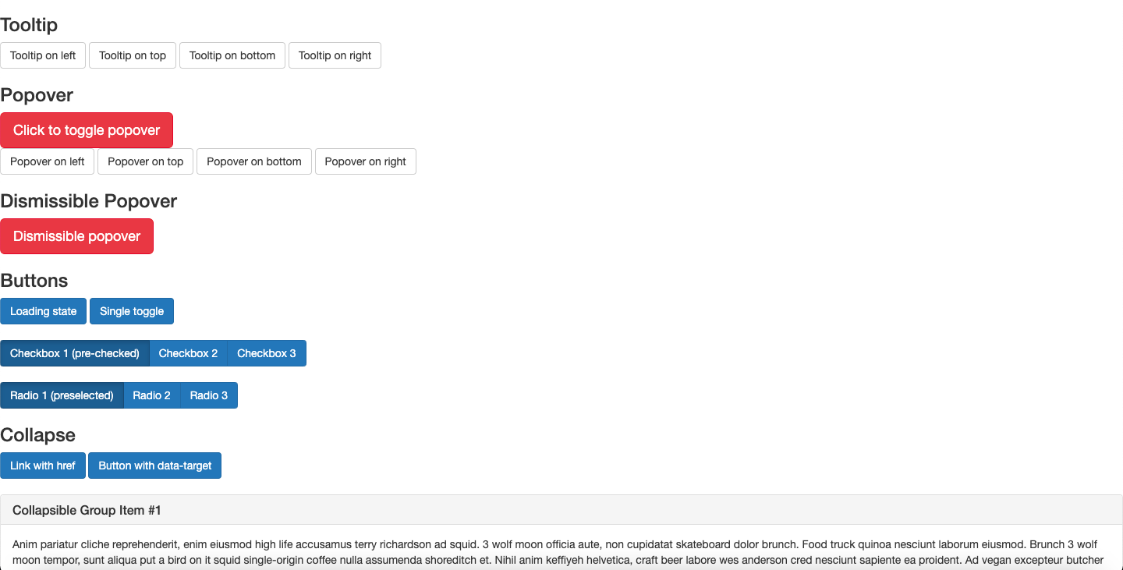

**Practical 4.5**

**Implement the concept of media query in bootstrap on different screen sizes**

**index.html**

<!doctype html>

<html lang="en">

<head>

<meta charset="utf-8">

<meta http-equiv="X-UA-Compatible" content="IE=edge">

<meta name="viewport" content="width=device-width, initial-scale=1">

<!-- The above 3 meta tags *must* come first in the head; any other head content must come *after* these tags -->

<title>Home</title>

<link rel="stylesheet" type="text/css" href="../css/style.css">

<!-- font -->

<link rel="preconnect" href="https://fonts.googleapis.com">

<link rel="preconnect" href="https://fonts.gstatic.com" crossorigin>

<link href="https://fonts.googleapis.com/css2?family=Open+Sans&display=swap" rel="stylesheet">

<!-- icon -->

<link href = "https://fonts.googleapis.com/icon?family=Material+Icons" rel = "stylesheet">

<!-- slider -->

<link rel="stylesheet" href="../css/slider.css" type="text/css" media="screen" />

<!-- image galley -->

<link rel="stylesheet" type="text/css" href="../css/lightbox.min.css">

<!-- Bootstrap -->

<link rel="stylesheet" href="https://stackpath.bootstrapcdn.com/bootstrap/3.4.1/css/bootstrap.min.css" integrity="sha384-HSMxcRTRxnN+Bdg0JdbxYKrThecOKuH5zCYotlSAcp1+c8xmyTe9GYg1l9a69psu" crossorigin="anonymous">

<!-- HTML5 shim and Respond.js for IE8 support of HTML5 elements and media queries -->

<!-- WARNING: Respond.js doesn't work if you view the page via file:// -->

<!--[if lt IE 9]>

<script src="https://oss.maxcdn.com/html5shiv/3.7.3/html5shiv.min.js"></script>

<script src="https://oss.maxcdn.com/respond/1.4.2/respond.min.js"></script>

<![endif]-->

<style type="text/css">

@media only screen and (max-width: 600px) {

body {

background-color: lightblue;

}

}

</style>

</head>

<body>

<div class="header">

<i class = "material-icons">public</i>

Email-abc@xyz.com<br> Call-123112

</div>

<nav class="navbar navbar-inverse">

<div class="container-fluid">

<!-- Brand and toggle get grouped for better mobile display -->

<div class="navbar-header">

<button type="button" class="navbar-toggle collapsed" data-toggle="collapse" data-target="#bs-example-navbar-collapse-1" aria-expanded="false">

<span class="sr-only">Toggle navigation</span>

<span class="icon-bar"></span>

<span class="icon-bar"></span>

<span class="icon-bar"></span>

</button>

<a class="navbar-brand" href="#">Brand</a>

</div>

<!-- Collect the nav links, forms, and other content for toggling -->

<div class="collapse navbar-collapse" id="bs-example-navbar-collapse-1">

<ul class="nav navbar-nav">

<li class="active"><a href="#">Link <span class="sr-only">(current)</span></a></li>

<li><a href="#">Link</a></li>

<li class="dropdown">

<a href="#" class="dropdown-toggle" data-toggle="dropdown" role="button" aria-haspopup="true" aria-expanded="false">Dropdown <span class="caret"></span></a>

<ul class="dropdown-menu">

<li><a href="#">Action</a></li>

<li><a href="#">Another action</a></li>

<li><a href="#">Something else here</a></li>

<li role="separator" class="divider"></li>

<li><a href="#">Separated link</a></li>

<li role="separator" class="divider"></li>

<li><a href="#">One more separated link</a></li>

</ul>

</li>

</ul>

<form class="navbar-form navbar-left">

<div class="form-group">

<input type="text" class="form-control" placeholder="Search">

</div>

<button type="submit" class="btn btn-default">Submit</button>

</form>

<ul class="nav navbar-nav navbar-right">

<li><a href="#">Link</a></li>

<li class="dropdown">

<a href="#" class="dropdown-toggle" data-toggle="dropdown" role="button" aria-haspopup="true" aria-expanded="false">Dropdown <span class="caret"></span></a>

<ul class="dropdown-menu">

<li><a href="#">Action</a></li>

<li><a href="#">Another action</a></li>

<li><a href="#">Something else here</a></li>

<li role="separator" class="divider"></li>

<li><a href="#">Separated link</a></li>

</ul>

</li>

</ul>

</div><!-- /.navbar-collapse -->

</div><!-- /.container-fluid -->

</nav>

<div class="h">

Lorem ipsum dolor, sit amet, consectetur adipisicing elit. Corrupti officiis necessitatibus recusandae sequi ab incidunt neque nemo fugiat, laudantium sit asperiores, reiciendis consequatur assumenda exercitationem nostrum odit. Laudantium corrupti, nulla.<br>

<br><br><br>

<a href="tel:123112">Call us</a><br><br>

<a href="mailto:123112">Email us</a>

</div>

<div>

<table>

<tr>

<td><img src="https://encrypted-tbn0.gstatic.com/images?q=tbn:ANd9GcRH1kzCIvgCKQy7lQB8W99K5NHJ61quuqnPZw&usqp=CAU"></td>

<td>Lorem ipsum dolor, sit amet consectetur, adipisicing elit. Ullam, quos. Earum temporibus minus architecto officia nostrum accusamus veritatis quasi sed nam dicta enim corrupti necessitatibus voluptatem, iusto, aspernatur minima commodi.</td>

</tr>

<tr>

<td>Lorem ipsum dolor sit amet consectetur adipisicing, elit. Eum, necessitatibus. Veniam repellendus impedit facere provident vitae iste, eveniet quos nulla facilis eius ex atque dignissimos. Magnam quis doloribus voluptate, architecto.</td>

<td>

<style>

.fadein { position:relative; height:300px; width:500px; }

.fadein img { position:absolute; left:0; top:0; }

</style>

<script type="text/javascript" src="http://www.hscripts.com/jquery.js"></script>

<script type="text/javascript">

$(function(){

$('.fadein img:gt(0)').hide();

setInterval(function(){$('.fadein :first-child').fadeOut().next('img').fadeIn().end().appendTo('.fadein');}, 2000);

});

</script>

<div class="fadein">

<img src="https://cdn.vox-cdn.com/thumbor/Ohs67lw4c_o3gsdWjwgRCmWdm6U=/1400x788/filters:format(jpeg)/cdn.vox-cdn.com/uploads/chorus_asset/file/13074037/hs-2014-27-a-print.0.0.1486275780.jpg" alt="Image Slideshow Script">

<img src="https://static.theprint.in/wp-content/uploads/2020/03/minor-planets.jpg" alt="Image Slideshow Script">

<img src="https://encrypted-tbn0.gstatic.com/images?q=tbn:ANd9GcTtiVrERaLq5dpJ14TbtTVEmaisX9gFUk8hhg&usqp=CAU" alt="Image Slideshow Script">

</div>

</td>

</tr>

</table>

</div>

<div>

<div class="slideshow-container">

<div class="mySlides">

<q>I love you the more in that I believe you had liked me for my own sake and for nothing else</q>

<p class="author">- John Keats</p>

</div>

<div class="mySlides">

<q>But man is not made for defeat. A man can be destroyed but not defeated.</q>

<p class="author">- Ernest Hemingway</p>

</div>

<div class="mySlides">

<q>I have not failed. I've just found 10,000 ways that won't work.</q>

<p class="author">- Thomas A. Edison</p>

</div>

<a class="prev" onclick="plusSlides(-1)">❮</a>

<a class="next" onclick="plusSlides(1)">❯</a>

</div>

<div class="dot-container">

<span class="dot" onclick="currentSlide(1)"></span>

<span class="dot" onclick="currentSlide(2)"></span>

<span class="dot" onclick="currentSlide(3)"></span>

</div>

<script>

var slideIndex = 1;

showSlides(slideIndex);

function plusSlides(n) {

showSlides(slideIndex += n);

}

function currentSlide(n) {

showSlides(slideIndex = n);

}

function showSlides(n) {

var i;

var slides = document.getElementsByClassName("mySlides");

var dots = document.getElementsByClassName("dot");

if (n > slides.length) {slideIndex = 1}

if (n < 1) {slideIndex = slides.length}

for (i = 0; i < slides.length; i++) {

slides[i].style.display = "none";

}

for (i = 0; i < dots.length; i++) {

dots[i].className = dots[i].className.replace(" active", "");

}

slides[slideIndex-1].style.display = "block";

dots[slideIndex-1].className += " active";

}

</script>

</div>

<div class="gallery">

<strong>Image Gallery</strong>

<div>

<a class="example-image-link" href="https://africanews.space/wp-content/uploads/2021/01/space-debris-junk-africa-cleanup.jpg" data-lightbox="example-set"><img class="example-image" src="https://africanews.space/wp-content/uploads/2021/01/space-debris-junk-africa-cleanup.jpg" alt=""/></a>

<a class="example-image-link" href="https://static.independent.co.uk/2021/06/04/10/DESY_GRB_still_1.jpeg?width=1200" data-lightbox="example-set"><img class="example-image" src="https://static.independent.co.uk/2021/06/04/10/DESY_GRB_still_1.jpeg?width=1200" alt="" /></a>

<a class="example-image-link" href="https://thumbs-prod.si-cdn.com/5IC2_-4TL008uHd3srmFFYh_LwU=/800x450/filters:focal(2989x1536:2990x1537)/https://public-media.si-cdn.com/filer/35/3b/353b17c0-cd7b-4625-9f97-f3c3ef59055e/gettyimages-1229960181.jpg" data-lightbox="example-set" ><img class="example-image" src="https://thumbs-prod.si-cdn.com/5IC2_-4TL008uHd3srmFFYh_LwU=/800x450/filters:focal(2989x1536:2990x1537)/https://public-media.si-cdn.com/filer/35/3b/353b17c0-cd7b-4625-9f97-f3c3ef59055e/gettyimages-1229960181.jpg" alt="" /></a>

<a class="example-image-link" href="https://encrypted-tbn0.gstatic.com/images?q=tbn:ANd9GcTna_QMTdrKfaibyBB8CeN2vQ4H6Iq4kU2RHg&usqp=CAU" data-lightbox="example-set"><img class="example-image" src="https://encrypted-tbn0.gstatic.com/images?q=tbn:ANd9GcTna_QMTdrKfaibyBB8CeN2vQ4H6Iq4kU2RHg&usqp=CAU" alt="" /></a>

<a class="example-image-link" href="https://cdn.mos.cms.futurecdn.net/Gw9wVjyJYuLAuaeM6z4n6W-1200-80.jpg" data-lightbox="example-set"><img class="example-image" src="https://cdn.mos.cms.futurecdn.net/Gw9wVjyJYuLAuaeM6z4n6W-1200-80.jpg" alt="" /></a>

<a class="example-image-link" href="https://images.ctfassets.net/cnu0m8re1exe/2DYsgTu86tZd9Yh3CfwToQ/971c67e0330015b3fd371a2f1767311b/heic0301a.jpg?fm=jpg&fl=progressive&w=660&h=433&fit=fill" data-lightbox="example-set"><img class="example-image" src="https://images.ctfassets.net/cnu0m8re1exe/2DYsgTu86tZd9Yh3CfwToQ/971c67e0330015b3fd371a2f1767311b/heic0301a.jpg?fm=jpg&fl=progressive&w=660&h=433&fit=fill" alt="" /></a>

</div>

<script src="../js/lightbox-plus-jquery.min.js"></script>

</div>

<div class="footer">

<hr>

<div class="divf">

<div class="f">

<h2>Explore</h2>

<a href="">Home</a><br>

<a href="">About Us</a><br>

<a href="">Contact Us</a>

</div>

<div class="f">

<h2>Visit</h2>

Address-#abc,st.-4,qaz<br>

Email-abc@xyz.com<br>

Phone no.-123112

</div>

<div class="f">

<h2>Follow</h2>

<a href="">Twitter</a><br>

<a href="">Instagram</a><br>

<a href="">Linkedin</a>

</div>

<div class="f">

<h2>Legal</h2>

<a href="">Terms</a><br>

<a href="">Policies</a><br><br><br>

</div>

</div>

<hr>

<i class="material-icons">copyright</i>2021 Rohit. All Rights Reserved.

</div>

<!-- jQuery (necessary for Bootstrap's JavaScript plugins) -->

<script src="https://code.jquery.com/jquery-1.12.4.min.js" integrity="sha384-nvAa0+6Qg9clwYCGGPpDQLVpLNn0fRaROjHqs13t4Ggj3Ez50XnGQqc/r8MhnRDZ" crossorigin="anonymous"></script>

<!-- Include all compiled plugins (below), or include individual files as needed -->

<script src="https://stackpath.bootstrapcdn.com/bootstrap/3.4.1/js/bootstrap.min.js" integrity="sha384-aJ21OjlMXNL5UyIl/XNwTMqvzeRMZH2w8c5cRVpzpU8Y5bApTppSuUkhZXN0VxHd" crossorigin="anonymous"></script>

</body>

</html>

**style.css**

body{

font-family: 'Open Sans', sans-serif;

}

/* header */

.header{

padding: 10px;

background-color: #5A37A6;

color: white;

display: flex;

justify-content: space-between;

}

/* Navbar */

.navbar {

overflow: hidden;

background-color: #121926;

}

.navbar a {

float: left;

font-size: 16px;

color: white;

text-align: center;

padding: 14px 16px;

text-decoration: none;

}

.dropdown {

float: left;

overflow: hidden;

}

.dropdown .dropbtn {

font-size: 16px;

border: none;

outline: none;

color: white;

padding: 14px 16px;

background-color: inherit;

margin: 0;

}

.navbar a:hover, .dropdown:hover .dropbtn {

background-color: #0D0D0D;

}

.dropdown-content {

display: none;

position: absolute;

background-color: #f9f9f9;

min-width: 160px;

box-shadow: 0px 8px 16px 0px rgba(0,0,0,0.2);

z-index: 1;

}

.dropdown-content a {

float: none;

color: black;

padding: 12px 16px;

text-decoration: none;

display: block;

text-align: left;

}

.dropdown-content a:hover {

background-color: #ddd;

}

.dropdown:hover .dropdown-content {

display: block;

}

/* header2 */

.h{

height: 200px;

background-image: url(https://image.shutterstock.com/image-photo/full-panorama-milky-way-260nw-151365275.jpg);

color: white;

padding: 30;

font-size: 20;

}

.h a{

text-decoration: none;

color: white;

}

.h a:hover{

background-color: #777E8C;

padding: 5px;]

}

table{

margin:20px auto;

width: 80%;

font-size: 23px;

}

table td {

width: 40%;

padding: 20px;

vertical-align: top;

}

table img{

width: 500px;

height: 300px;

}

.gallery{

background-color: #5A37A6;

color: white;

text-align: center;

font-size: 25px;

padding-top: 10;

}

.gallery img{

height: 300px;

width: 470px;

}

.footer{

background-color: #0D0D0D;

color: white;

padding: 30px;

}

.divf{

width: 100%;

}

.f{

width: 25%;

float: left;

}

.f a{

text-decoration: none;

color: white;

}

@media only screen and (max-width: 600px) {

body {

background-color: lightblue;

}

}

